Supplementary Files updated: 27 July, 2021

Table of Contents

# Supplementary Materials

## Supplementary Material 1: Changes to protocol

Any changes made to the approved procotol are “Minor amendments” as per the ISAC criteria, specifically falling under the category of “Additional methods to further control for confounding or sensitivity analysis provided these are to be reported as secondary to the main findings.”

Main changes include:

* Use of a time-varying treatment indicator, to correctly classify time-at-risk.
* Inclusion of additional covariates that are adjusted for in the main model.

# Supplementary tables

## Supplementary Table 1: STROBE Reporting Guidelines

A copy of the RECORD Checklist(1) is provided below.

**To be copied in**

## Supplementary Table 2: Definition of exposures and covariates

The code lists used to define covariates adjusted for in the fully-adjusted model (see Supplementary Table 1) were originally created for use in a previous analysis.(2) Some code lists were built on or adapted from previous published work,(3–5) and these are noted in the table.

Table 1: Definition of covariates adjusted for in the Cox PR model.

| **Covariate** | **How was the covariate defined?** |
| --- | --- |
| **Previous history of coronary arterial disease** | Presence of one or more relevant Read codes on record. |
| **Previous history of coronary bypass surgery** | Presence of one or more relevant Read codes on record. |
| **Previous history of cerebrovascular disease (including stroke)** | Presence of one or more relevant Read codes on record. |
| **Chronic illness, including cancer and arthritis** | Charlson index implemented using Read code lists. (2) Code lists based on those by Taylor et al. (3) |
| **Socioeconomic position** | 2010 English Index of Multiple Deprivation (IMD) at the ?twentile? level, where 1 represents the least deprived and 20 the most deprived. |
| **Consultation rate** | Calculated by dividing the total number of clinic visits by the length of the patient record prior to the index date to give an average annual rate. |
| **Alcohol status** | Recorded value (current, former or never). |
| **Smoking status** | Most recent of recorded value (current, former or never) or Read code indicating a recorded value. Code lists based on those by Wright et al. (4) |
| **Body Mass Index** | Recorded value if available, or a calculated value using the last recorded height and weight measurements. Measurements taken before the age of 25 were excluded to ensure adult measurements were used. |
| **Peripheral arterial disease** | Presence of one or more relevant Read codes on record. |
| **Hypertension** | Presence of one or more relevant Read codes on record. |
| **Baseline total cholesterol** | Continuous value recorded as test result ("enttype==163 & test_data1==3") |
| **Baseline LDL cholesterol** | Continuous value recorded as test result ("enttype==177 & test_data1==3") |
| **Chronic kidney disease** | Presence of one or more relevant Read codes on record. |
| **Type 1 Diabetes** | Presence of one or more relevant Read codes on record. |
| **Type 2 Diabetes** | Presence of one or more relevant Read codes on record. |

## Supplementary Table 3: Adherence and switching by drug class

Table 2: Adherence and switching by drug class.

|  | **Whole Sample** | **Statins** | **Bile acid sequestrants** | **Ezetimibe** | **Ezetimibe & Statins** | **Fibrates** | **Nicotinic acid groups** | **Omega-3 Fatty Acid Groups** |
| --- | --- | --- | --- | --- | --- | --- | --- | --- |
| **Stopped** | 6.8% (115899) | 19.0% (111798) | 55.9% (3028) | 19.6% (150) | 12.6% (16) | 12.3% (478) | 44.0% (74) | 35.6% (355) |
| **Added** | 1.6% (27470) | 4.4% (26018) | 3.5% (192) | 18.9% (145) | 3.9% (5) | 21.6% (841) | 4.2% (7) | 26.3% (262) |
| **Switched** | 0.9% (14956) | 2.0% (12014) | 11.3% (614) | 34.5% (264) | 64.6% (82) | 44.0% (1714) | 44.6% (75) | 19.4% (193) |

# Supplementary figures

## Supplementary Figure 1

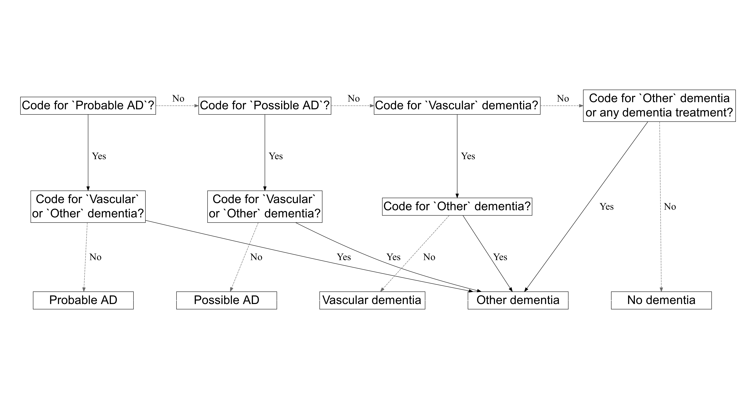

Figure 1: The algorithm used to choose between two diagnosis. This decision tree is adapted with permission from Walker *et al* (2020).(2)

## Supplementary Figure 2

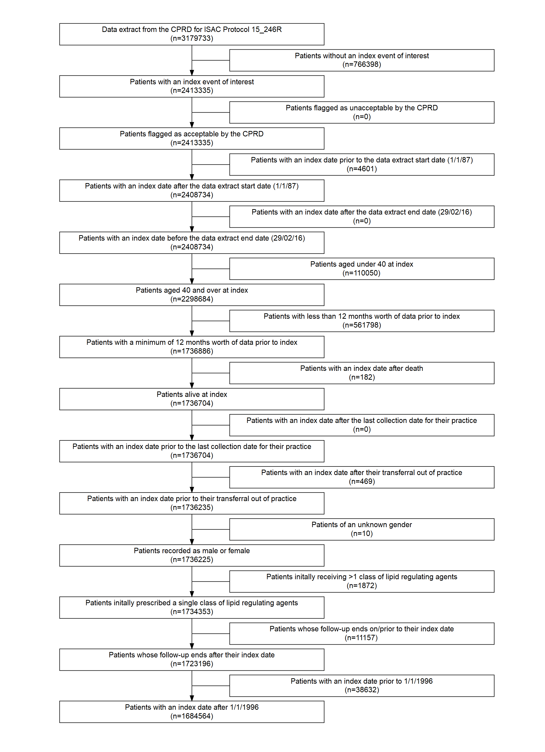

Figure 2: Attrition of participants as the eligibility criteria were applied.

## Supplementary Figure 3

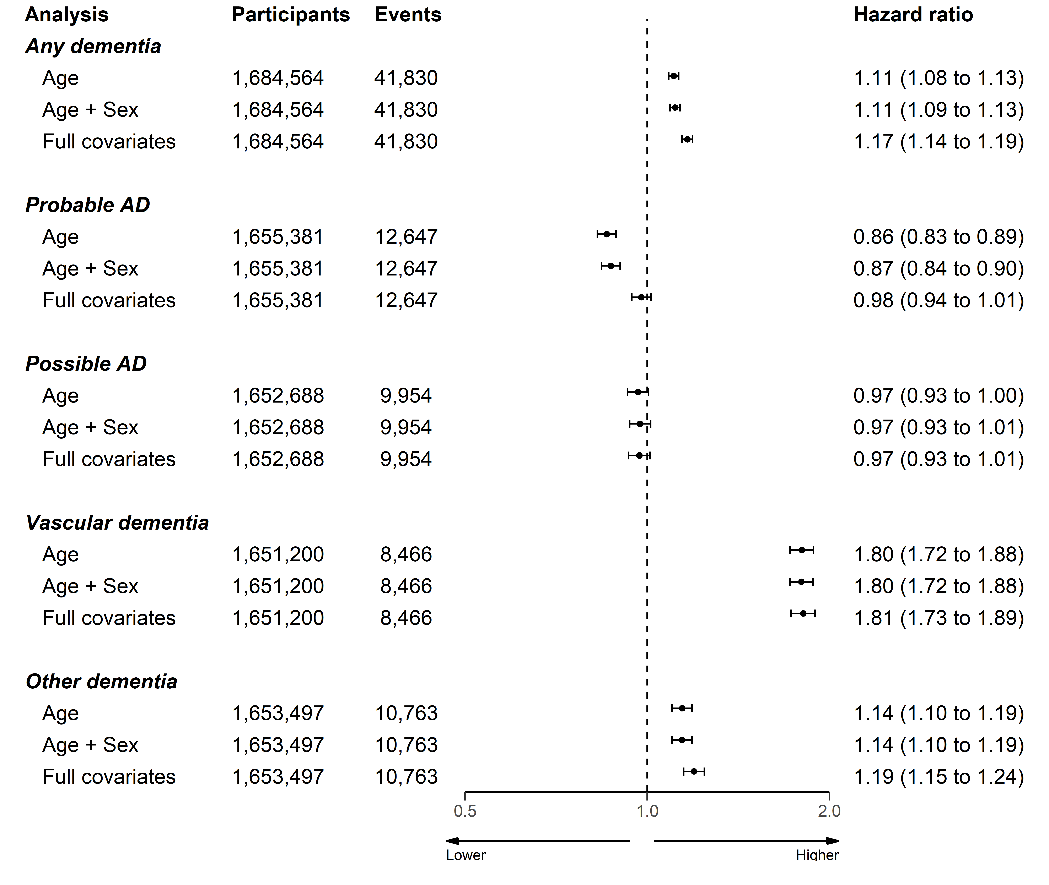

Figure 3: Association of any lipid regulating agent with a dementia or related outcome using three models adjusted for age, age and sex, and all covariates respectively.

## Supplementary Figure 4

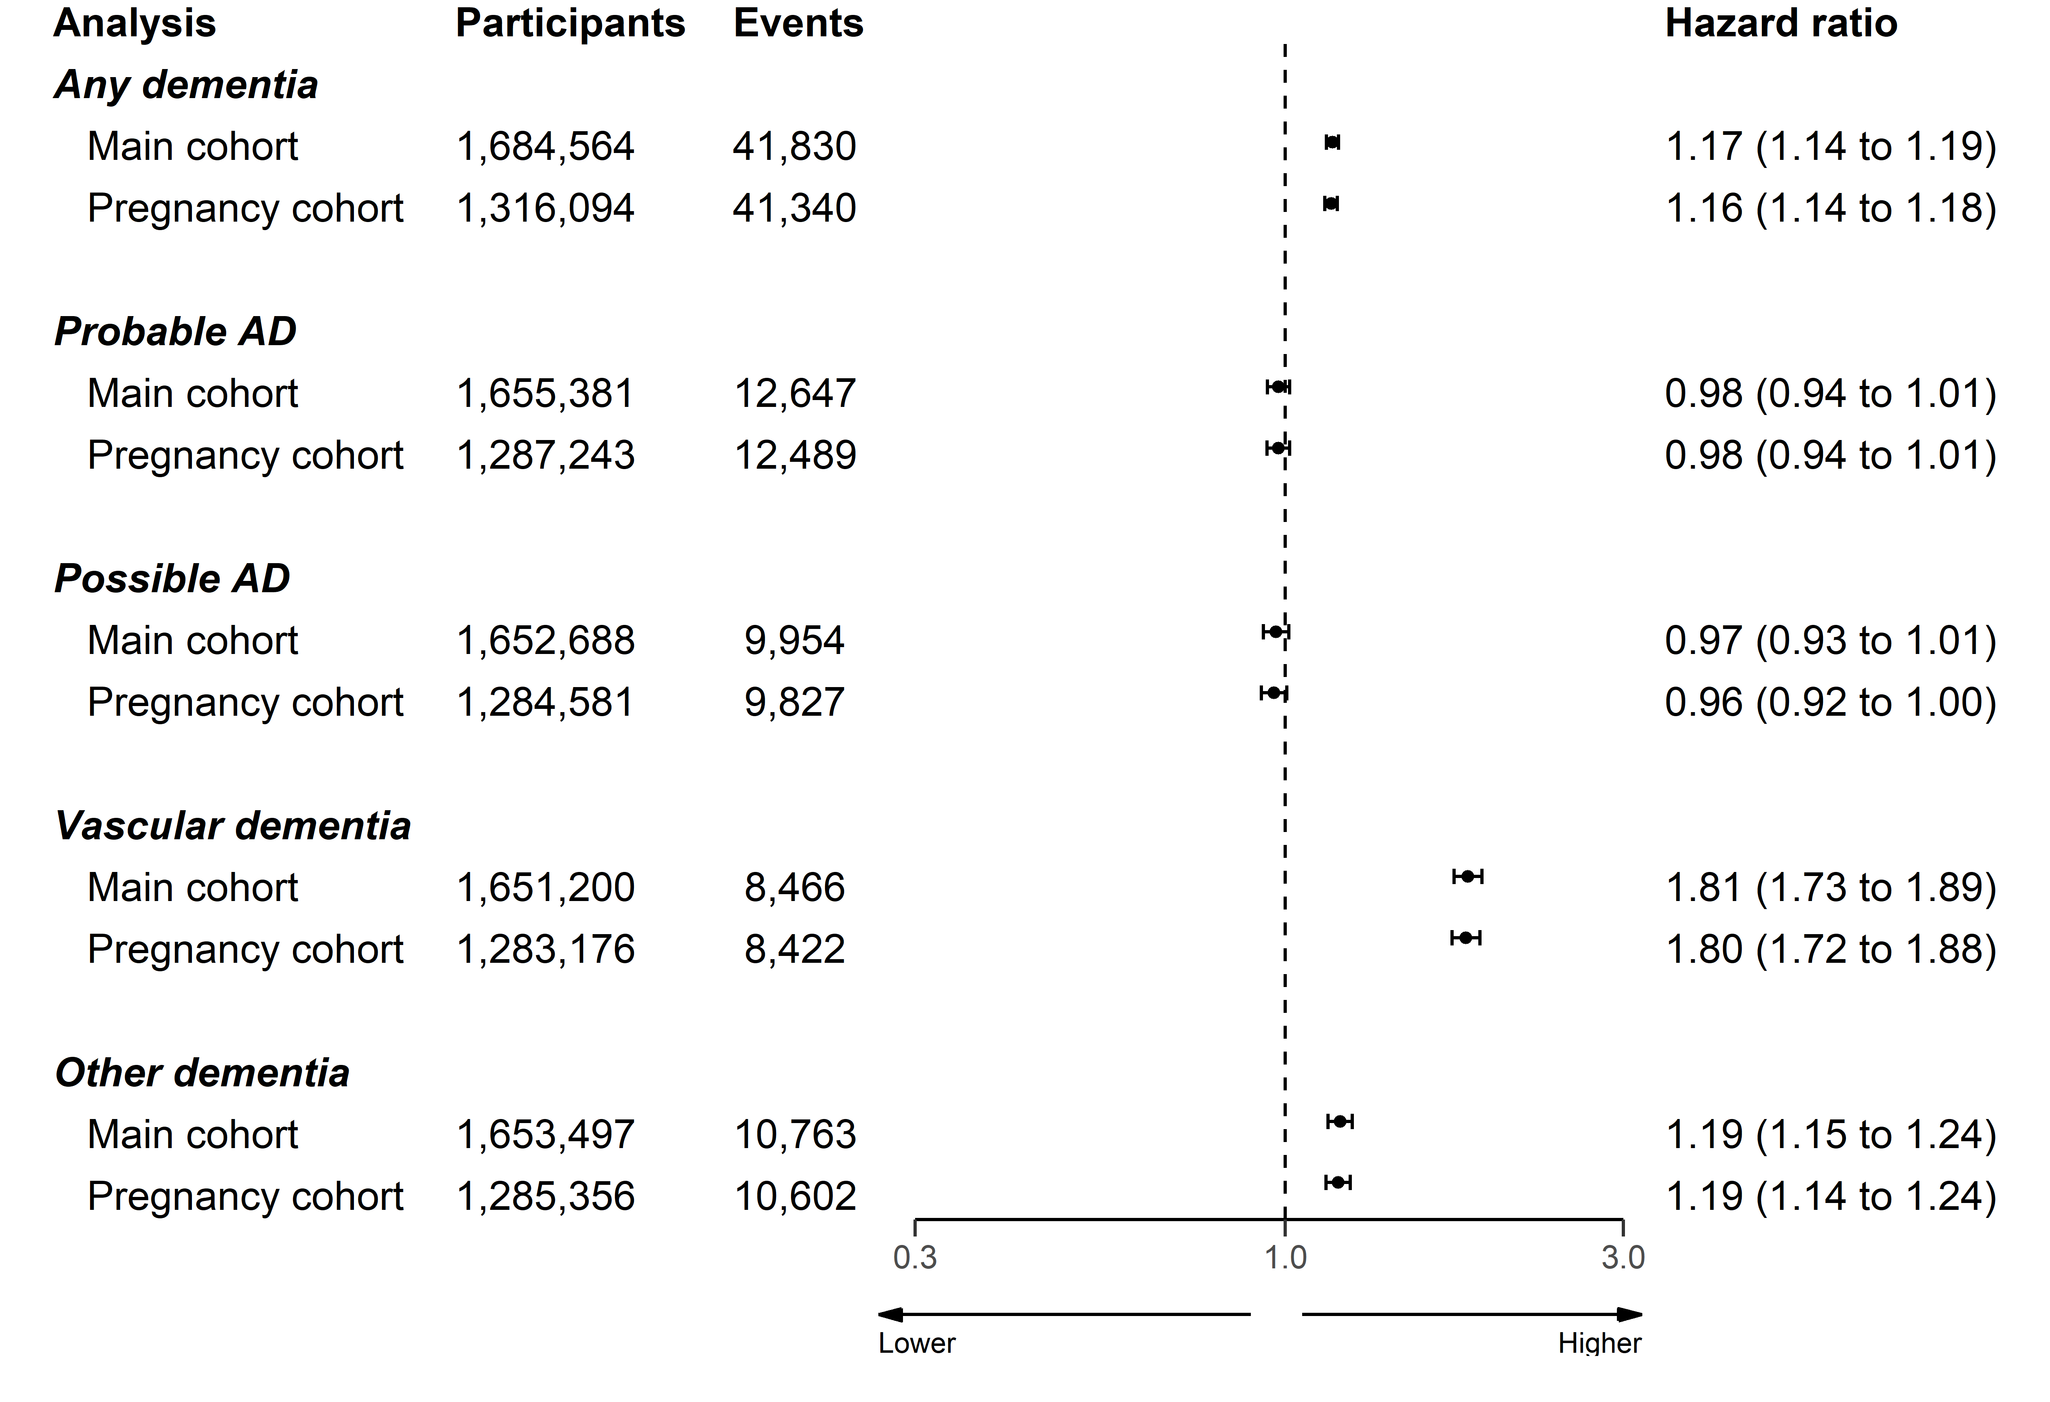

Figure 4: Association of any lipid regulating agent with a dementia or related outcome, removing participants who were less than 55 years of age at index.

## Supplementary Figure 5

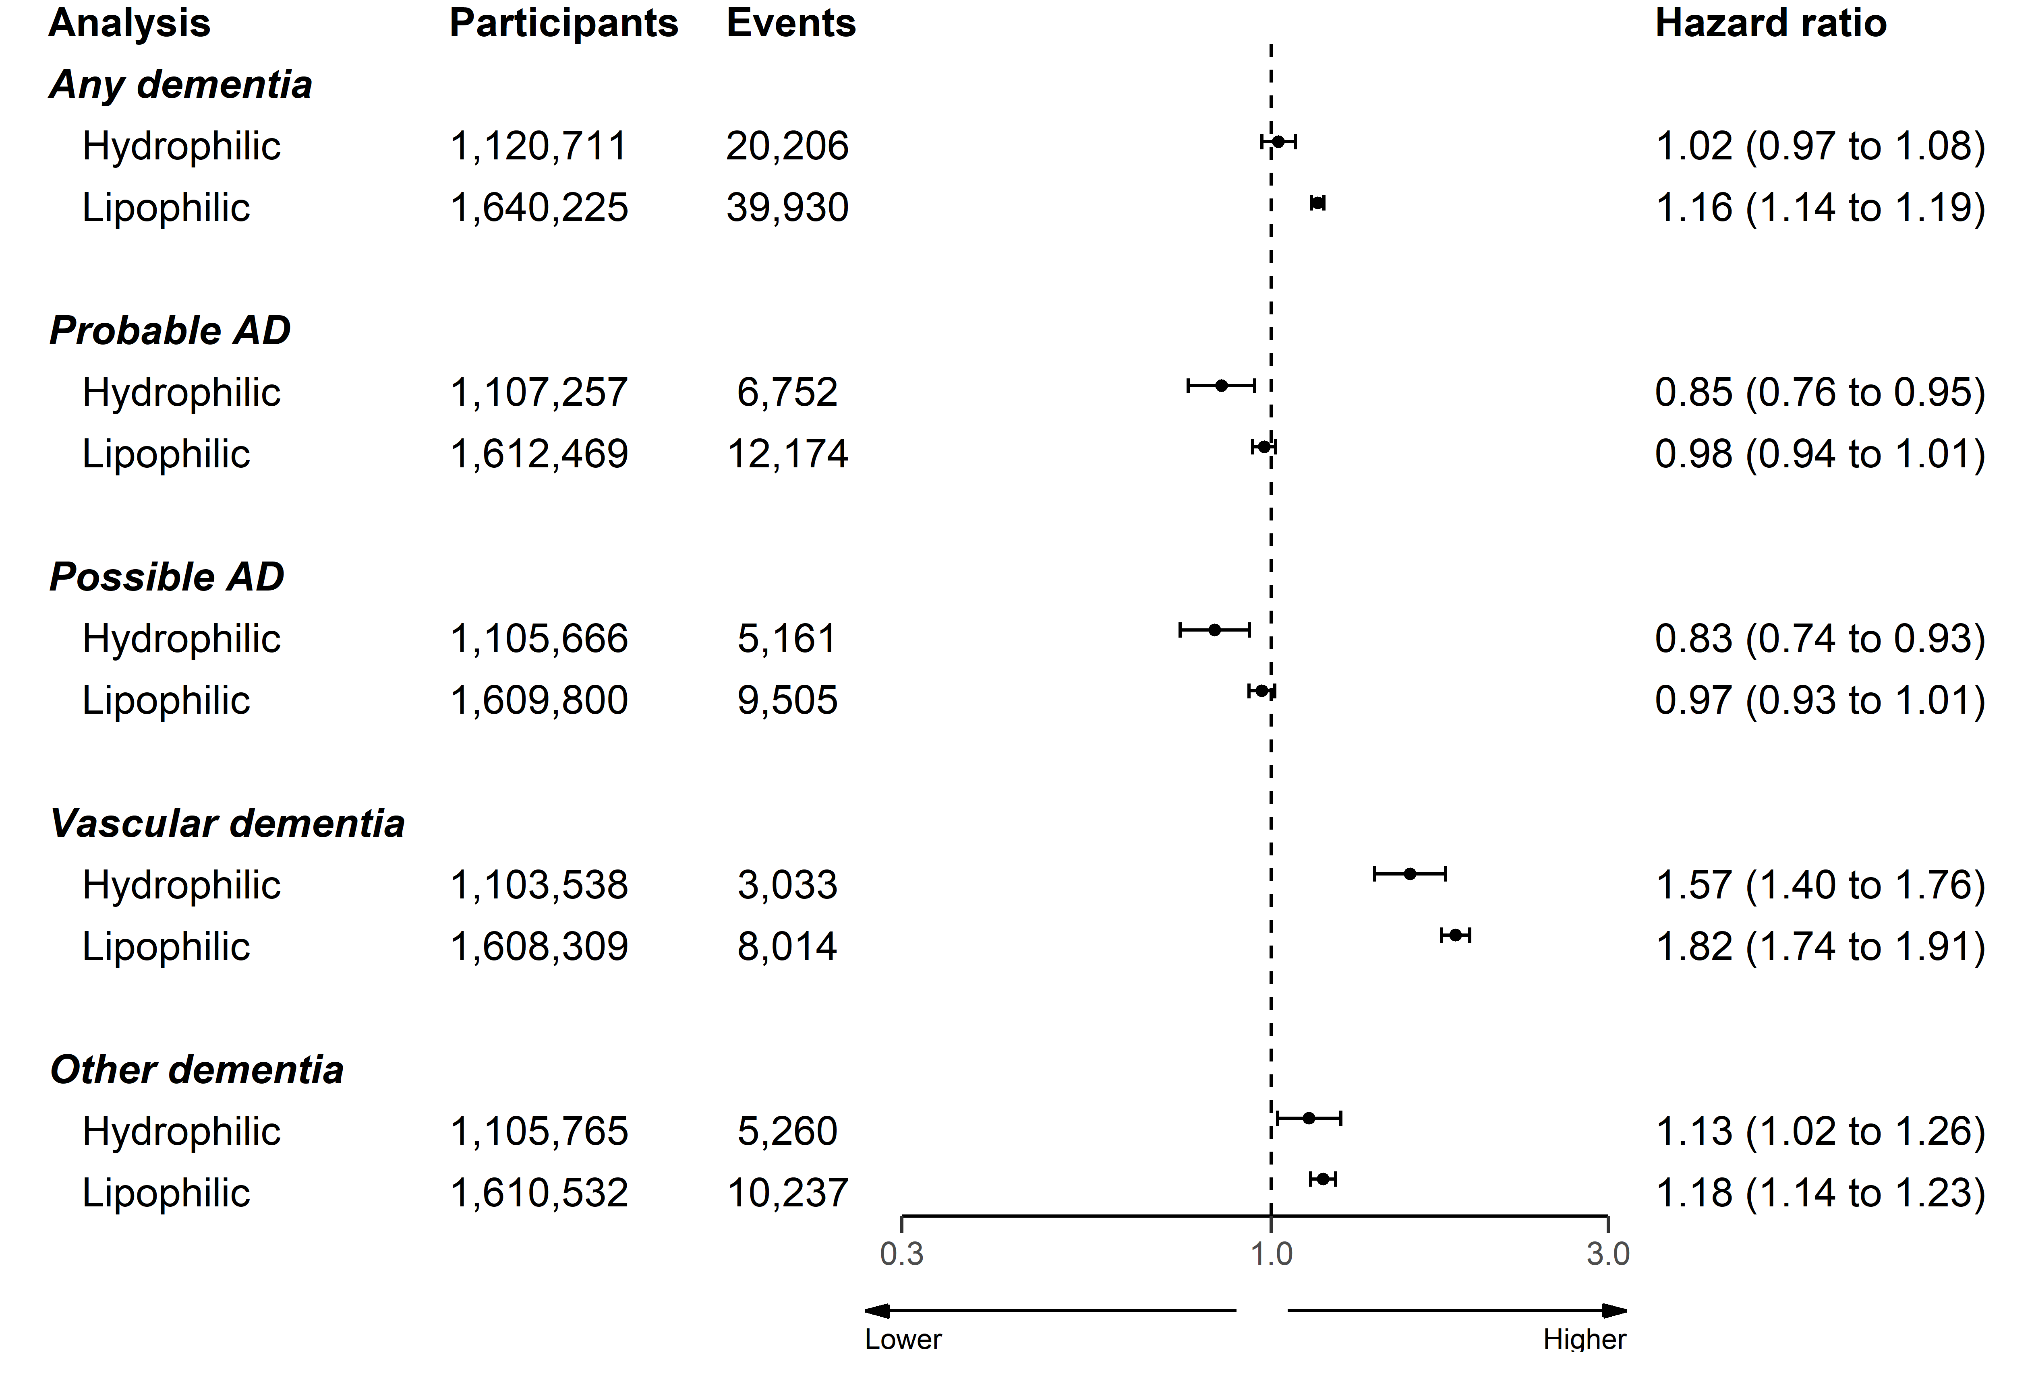

Figure 5: Association of statins with a dementia or related outcome, stratified by statin lipophilic/hydrophilic properties.

## Supplementary Figure 6

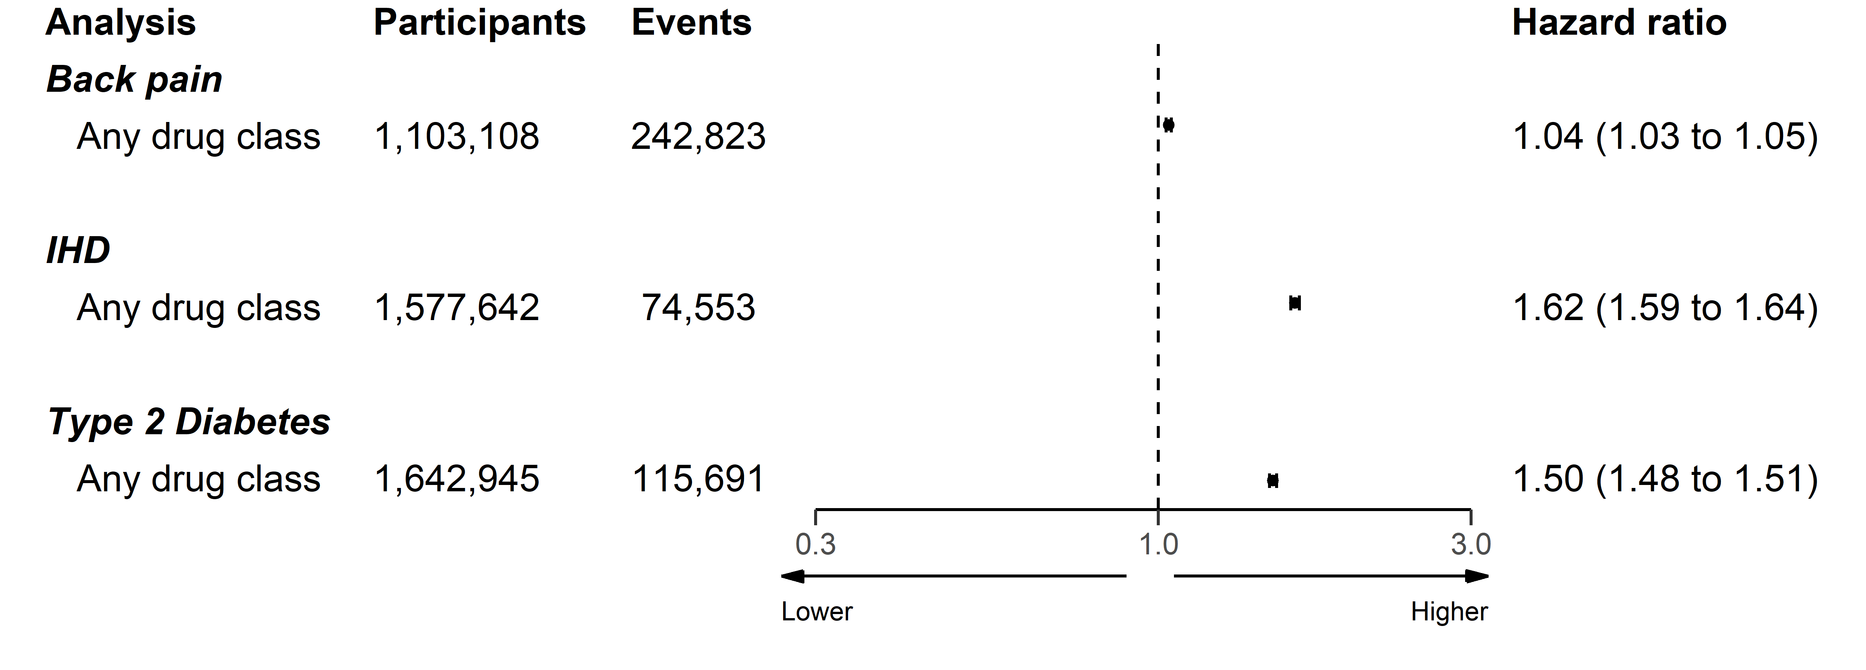

Figure 6: Association of any lipid regulating agent with backpain, ischemic heart disease (IHD), and Type 2 diabetes.

# References for supplementary materials

1. Nicholls SG, Langan SM, Sørensen HT, Petersen I, Benchimol EI. The RECORD reporting guidelines: Meeting the methodological and ethical demands of transparency in research using routinely-collected health data. Clinical epidemiology. 2016;8:389.

2. Walker VM, Davies NM, Martin RM, Kehoe PG. Comparison of Antihypertensive Drug Classes for Dementia Prevention. Epidemiology. 2020 Nov;31(6):852–9.

3. Khan NF, Perera R, Harper S, Rose PW. Adaptation and validation of the Charlson Index for Read/OXMIS coded databases. BMC Family Practice. 2010 Jan;11(1):1.

4. Taylor GMJ, Taylor AE, Thomas KH, Jones T, Martin RM, Munafò MR, et al. Effectiveness of varenicline versus nicotine replacement therapy on long-term smoking cessation in primary care: A prospective, cohort study of electronic medical records. The Lancet. 2016 Nov;388:S107.

5. Wright AK, Kontopantelis E, Emsley R, Buchan I, Sattar N, Rutter MK, et al. Life Expectancy and Cause-Specific Mortality in Type 2 Diabetes: A Population-Based Cohort Study Quantifying Relationships in Ethnic Subgroups. Diabetes Care. 2017 Mar;40(3):338–45.