

<Name-of-Software-Application>

# **CS 230 Project Software Design Template**

Version 1.0

## Table of Contents

**CS 230 Project Software Design Template**1

**Table of Contents**2

**Document Revision History**2

**Executive Summary**3

**Design Constraints**3

**System Architecture View**3

**Domain Model**3

**Evaluation**3

**Recommendations**5

## Document Revision History

| Version | Date | Author | Comments |
| --- | --- | --- | --- |
| 1.0 | 07/14/2021 | Raechel McGuire | Software design |

**Instructions**

Fill in all bracketed information on page one (the cover page), in the Document Revision History table, and below each header. Under each header, remove the bracketed prompt and write your own paragraph response covering the indicated information.

## Executive Summary

The Gaming Room would like to develop a web-based game, Draw it or lose it, a game similar to the 80’s game Win, Lose or Draw that’s available on multiple platforms. The game is currently only available for Android.

## Design Constraints

* A game will have the ability to have one or more teams involved.
* Each team will have multiple players assigned to it.
* Game and team names must be unique to allow users to check whether a name is in use when choosing a team name.
* Only one instance of the game can exist in memory at any given time. This can be accomplished by creating unique identifiers for each instance of a game, team, or player.

In addition, Draw it or Lose it is only available on Android, to make it available for other OS we need to use a cross platform language, such as java.

## System Architecture View

Please note: There is nothing required here for these projects, but this section serves as a reminder that describing the system and subsystem architecture present in the application, including physical components or tiers, may be required for other projects. A logical topology of the communication and storage aspects is also necessary to understand the overall architecture and should be provided.

## Domain Model

ProgramDriver class contains our main method and uses direct association with SingletonTester which tests if theres already an instance of GameService. GameService, Game, Team and Player classes all inherit attributes from the Entity class. GameService. GameService, Game, Team and Player each have associations 0…* or, “zero or more instances” so, Game has zero or more instances of GameService, Team has zero or more instances of Game, and Player has zero or more instances of team.

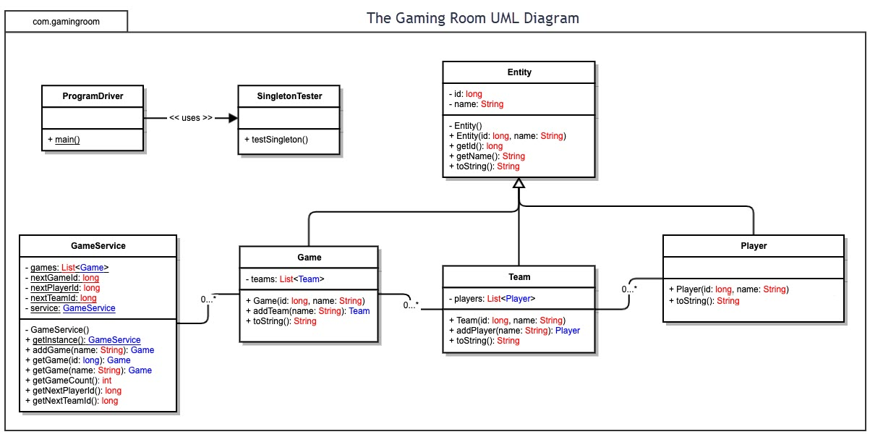

## Evaluation

Using your experience to evaluate the characteristics, advantages, and weaknesses of each operating platform (Linux, Mac, and Windows) as well as mobile devices, consider the requirements outlined below and articulate your findings for each. As you complete the table, keep in mind your client’s requirements and look at the situation holistically, as it all has to work together.

In each cell, remove the bracketed prompt and write your own paragraph response covering the indicated information.

| **Development Requirements** | **Mac** | **Linux** | **Windows** | **Mobile Devices** |
| --- | --- | --- | --- | --- |
| **Server Side** | MacOS is available for purchase on Mac apple app store for 20$  <https://www.apple.com/macos/server/> | More difficult to navigate but simple commands.  Lunix is open sourced so its free or low cost | Windows has a few server options on Microsoft.com however, they can be expensive | Mobile devices have the ability to be used as servers but aren’t well equipt for it |
| **Client Side** | Some expertise needed, must have mac to develop for mac. | Most expertise at minimum cost. Lunix isn’t as widely used so it takes someone with more expertise | Low expertise at a similar price to Macs Since windows are widely used | Mobile devices shouldn’t be too expensive with low expertise but time is an issue since youd need to work with multiple mobile devices |
| **Development Tools** | Mac is written in Swift. Mac also has HTML/CSS/Javascript  and can support libraries for python, java,php etc..  developer tools such as XCode, Ecplipse , visual studio (code) | also has HTML/CSS/Javascript  and can support libraries for python, java,php etc.. | also has HTML/CSS/Javascript  and can support libraries for python, java,php etc.. | Android : android studio (by default), java  IOS: XCode, swift |

## Recommendations

Analyze the characteristics of and techniques specific to various systems architectures and make a recommendation to The Gaming Room. Specifically, address the following:

1. **Operating Platform**: I recommend using Windows because its user friendly, most people can operate on Windows platform. Windows computers are also very cost effective and come in a variety of different styles, quality, price points and hardware. Additionally, almost every application or game will work for windows.
2. **Operating Systems Architectures**: Windows have a simple GUI and for developers, allows for a large selection of coding languages and IDE options.
3. **Storage Management**: Windows has a built in hard drive with a variety of different sizes. Additionally, Windows has a technology called Storage Spaces, a virtual disk that allows you to combine multiple disks into a storage space, so that the operating system sees them as one big disk. This can keep files safe by protecting your data from drive failures Storage spaces aloe you to create logical drives that are independent from physical drives.
4. **Memory Management**: Windows OS has a variety of memory options ranging from 8-16 GB. When more memory is needed Windows uses virtual memory, which compensates for the physical memory by copying some of RAM data into the hard disk until more RAM space is available. Because hard disk space is cheaper than RAM this is economically beneficial.
5. **Distributed Systems and Networks**: There are a variety of online game distribution platforms such as Steam , Game Jolt (Free!). You can also distribute onto the Apple App Store or Google play store.
6. **Security**: Windows 10 and Windows 8 have a firewall already built in as well as an antivirus software. Users will want to have a well chosen and protected password.