
DHC VISION - Integrated management system

Internal control system

Specialist concept
Status: IP 9
Table of contents
1 Preamble 7
2 Internal control system 7
2.1 The ICS process 8
2.1.1 Planning phase 8
2.1.2 Definition and revision phase 8
2.1.2.1 Management of policies and guidelines 9
2.1.2.1.1 Document filing structure 11
2.1.2.1.2 Creating and editing 12
2.1.2.1.3 Dealing with Attachments and Additional Information 17
2.1.2.1.4 Authorizations 18
2.1.2.1.5 Release 20
2.1.2.1.6 Versioning and revision 22
2.1.2.1.7 Change proposals 22
2.1.2.1.8 Extend validity, suspension & reactivation 23
2.1.2.1.8.1 Process for "extending validity" 24
2.1.2.1.8.2 Process for "overriding" 27
2.1.2.1.8.3 Process for reactivation 30
2.1.2.1.9 Distribution 30
2.1.2.1.9.1 Distribution by e-mail 31
2.1.2.1.9.2 Distribution for acknowledgement 31
2.1.2.1.10 Dashboard and evaluations 33
2.1.2.1.10.1 Dashboard reader 33
2.1.2.1.10.2 Reader evaluations 34
2.1.2.1.10.3 Author evaluations 34
2.1.2.1.11 Translation 35
2.1.2.1.12 Multi-client system 36
2.1.2.2 Management of the process organization/management of business processes 36
2.1.2.2.1 Process pyramid and its levels 37
2.1.2.2.2 Creating and editing 39
2.1.2.2.3 Modeling of business processes 41
2.1.2.2.4 Authorizations 43
2.1.2.2.5 Release 48
2.1.2.2.6 Versioning and revision 48
2.1.2.2.7 Extend validity, suspension & reactivation 49
2.1.2.2.7.1 Process for extending validity 50
2.1.2.2.7.2 Process for "overriding" 50
2.1.2.2.7.3 Process for reactivation 50
2.1.2.2.8 Distribution 50
2.1.2.2.9 Dashboard and evaluations 51
2.1.2.2.9.1 Dashboard reader 51
2.1.2.2.9.2 Reader evaluations 53
2.1.2.2.9.3 Author/Business Admin evaluations 53
2.1.2.2.10 Translation 54
2.1.2.2.11 Multi-client system 55
2.1.2.3 Management of the organizational structure 56
2.1.2.3.1 Creating and editing 56
2.1.2.3.2 Authorizations 57
2.1.2.3.3 Versioning and revision 57
2.1.2.3.4 Translation 57
2.1.2.3.5 Multi-client system 57
2.1.2.4 Management of IT applications 58
2.1.2.4.1 Creating and editing 58
2.1.2.4.2 Authorizations 58
2.1.2.4.3 Versioning and revision 58
2.1.2.4.4 Translation 58
2.1.2.4.5 Multi-client system 58
2.1.2.5 Management of risks and controls 59
2.1.2.5.1 Definition and Evaluation of Risks 59
2.1.2.5.1.1 Creating and editing 59
2.1.2.5.1.2 Evaluation of risks and risk treatment 61
2.1.2.5.1.3 Authorizations 65
2.1.2.5.2 Definition of controls 65
2.1.2.5.2.1 Control levels 65
2.1.2.5.2.2 Creating and editing 66
2.1.2.5.2.3 Authorizations 69
2.1.2.5.3 Release of risks and controls 70
2.1.2.5.3.1 Release of risks 70
2.1.2.5.3.2 Release of controls 70
2.1.2.5.4 Activation of controls 71
2.1.2.5.5 Versioning and revision of risks and controls 72
2.1.2.5.6 Dashboard and evaluations 72
2.1.2.5.6.1 Evaluations ICS Manager 72
2.1.2.5.6.2 Evaluations by the person responsible for control 73
2.1.2.5.6.3 Evaluations of control executors 73
2.1.2.5.7 Translation of risks and controls 73
2.1.2.5.8 Multi-client system 74
2.1.2.5.8.1 Risks in the multi-client system 74
2.1.2.5.8.2 Controls in the multi-client system 74
2.1.3 Implementation phase 74
2.1.3.1 Execution of controls 74
2.1.4 Test phase 76
2.1.4.1 Definition of test maps 76
2.1.4.2 Scoping 78
2.1.4.3 Testing 80
2.1.4.3.1 Internal testing 80
2.1.4.3.2 External testing 81
2.1.4.4 Creator of the annual report 83
2.1.4.5 Test phase in the multi-client concept 83
2.2 Roles in the internal control system 83
2.3 The ICS process in a complex corporate structure 88
2.3.1.1 Client concept for client-dependent data and processes 91
2.3.1.2 Client concept for cross-client data and processes 91
2.3.1.3 Multilingualism of clients 92
2.3.1.3.1 Surface language 93
2.3.1.3.2 Content language 94
2.4 Master data 95
2.4.1 Keyword management 95
2.4.2 Management of reference catalogs for risks and controls 95
2.5 Metadata of the most important ICS objects 97
2.5.1 Corporate process 97
2.5.2 Business process 97
2.5.3 Detailed process 98
2.5.4 Organizational unit 99
2.5.5 IT application 99
2.5.6 Document (policy/guideline/...) 100
2.5.7 Risk 102
2.5.8 Control 103
3 List of abbreviations 105

Preamble
The need to establish an "internal control system" is based on a large number of legal requirements (e.g. KonTraG, BilMoG, OR, URÄG, AktG, ISO 14971, ISO 27000, ISO 31000, SOX, Corporate Governance Code) and regulations. An ICS is an indispensable component of the GRC area in order to avert risks and associated damage to companies and to guarantee the effectiveness, efficiency and regularity of corporate actions and operational activities.
An ICS thus comprises all organizational measures that are suitable for complying with relevant laws, rules and standards, protecting the company's assets, ensuring the effectiveness and efficiency of business processes, creating an appropriate internal environment and, finally, ensuring truthful reporting. The prerequisite for an ICS that is "lived" in the company is a dedicated risk culture at all levels, combined with transparency in processes and decisions.
This document represents the described basis as a technical concept and documents the standard functions of the ICS in DHC VISION.

Internal control system
The internal control system with DHC VISION maps the entire internal control process - from process documentation to the creation and evaluation of risks, the definition and execution of associated controls through to the testing of controls by internal or external persons (e.g. auditors).
The "ICS process" is illustrated below as a PDCA cycle.
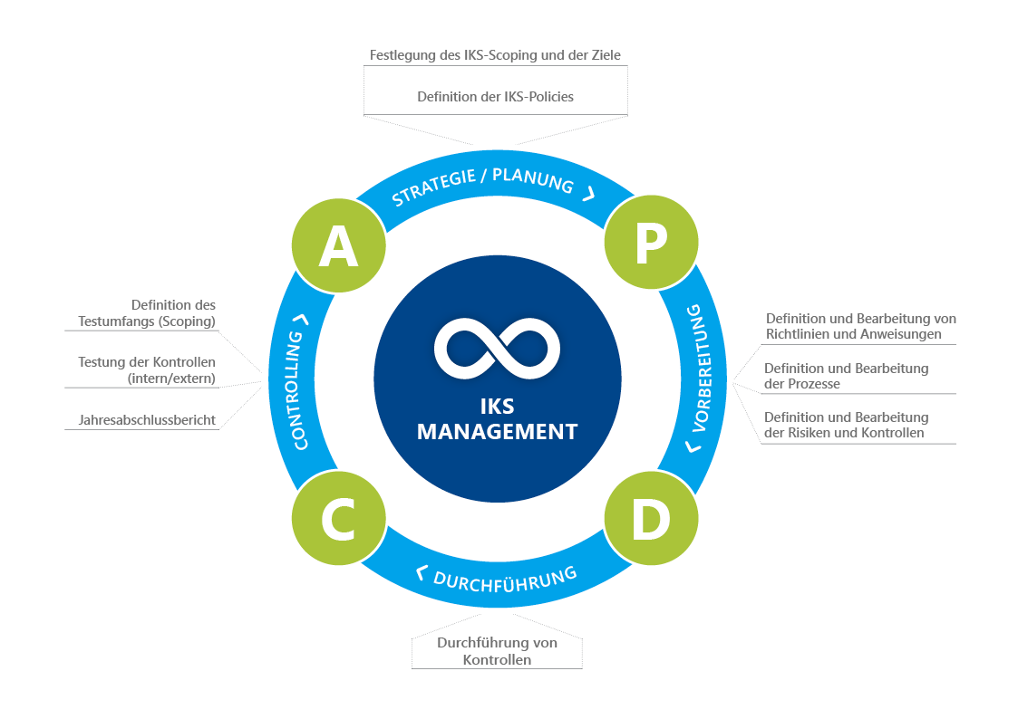
Fig. 1 PDCA cycle of the ICS process

The ICS process

Planning phase
In the planning phase, the ICS scope and the resulting objectives are defined in an ICS policy. Based on this, policies and guidelines can be created, reviewed, released and distributed, in which the overarching framework conditions and instructions for action are described.
In chapter 4.1.2.1 the handling of policies and guidelines is described in detail.

Definition and revision phase
The definition and revision phase is the phase in the ICS in which the foundations for the execution and testing of controls are created. Documents, business processes, IT applications, the organization, risks and controls form the basic framework.
With the help of documents, e.g. guidelines, procedural instructions or work instructions, the detailed instructions for action in the ICS are described, reviewed, released and distributed. Business processes are mapped transparently with the help of graphical process modeling. In the business process models, the process flow is modelled using process steps, the individual process steps are supplemented with the IT applications as supporting elements and with organizational units as executing elements. These business processes are also reviewed, released and distributed. In order to ensure and monitor the effectiveness and efficiency of the business processes, risks are then created and evaluated. Based on the definition of the risk treatment, controls can then be defined to reduce these risks.
The handling of documents (policies, guidelines, ...), business processes, risks and controls is described in detail below.

Management of policies and guidelines
Policies & Guidelines Management (P&R Management for short) enables the completely paperless management of documents, from creation and editing to release, distribution and archiving. Electronic signatures and the audit trail functionality make it possible to implement complex approval processes that also ensure complete traceability.
In order to ensure clarity and evaluation options in document and P&R management, it is necessary to differentiate between different document types and levels.
The following breakdown is an example of levels with corresponding document types. The names are also to be regarded as suggestions and may vary from company to company. It is possible to change or add to the document types in DHC VISION.
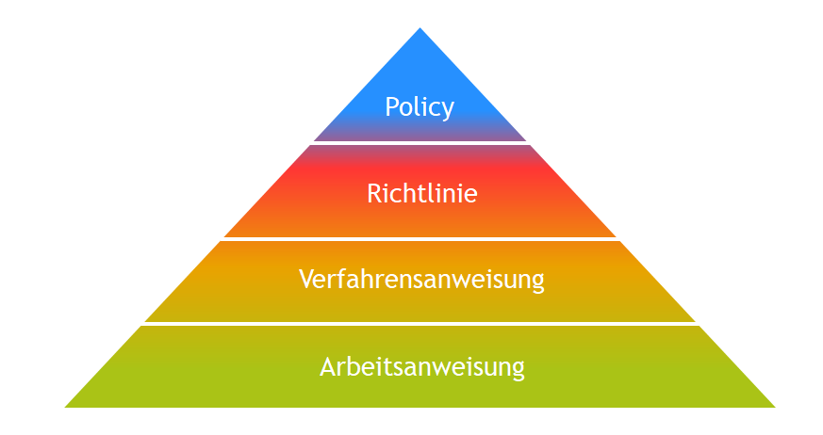
Fig. 2 Document pyramid and its levels

Level 1: Policy
Policies contain company-wide regulations and processes at a strategic level (e.g. code of conduct, travel expenses policy, ICS policy, process and organizational structure, etc.).
Level 2: Guidelines
As part of an effective governance system, guidelines document regulations and instructions. In terms of DHC VISION, policies are used for company-wide regulations, whereas guidelines describe locally defined regulations or regulations relating to a business process.
Level 3: Procedural instructions
While a guideline defines the roles, objectives and framework, procedural instructions describe the specific procedures within this framework or, in relation to processes, the process sequence and their details and responsible persons in order to achieve the objective. In DHC VISION, procedural instructions can also be equated with process instructions from process management.
Level 4: Work instructions
In many cases, special work steps, e.g. test instructions with compliance with various criteria, must be carried out in sub-processes, the description of which would go beyond the scope of a procedural instruction and thus the focus on the essentials would be lost. In addition, these detailed steps are usually only relevant for a few departments. They should therefore be documented in work instructions. Work instructions can then be supplemented with additional forms and checklists.
In addition to the differentiation between document levels and document types for better structuring and evaluation options, DHC VISION also supports the targeted storage of documents specific to the addressee of a document, which is described below.

Document filing structure
DHC VISION provides different variants of document filing structures. In addition to the central management of documents in the "Policies, guidelines and documents" view, the database integration also makes it possible to automatically link documents already in the system with processes, organizational units, risks and other documents and Master data (e.g. IT applications).
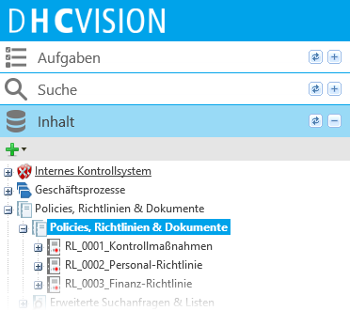
Fig. 3 Central document storage in the "Policies, guidelines & documents" view
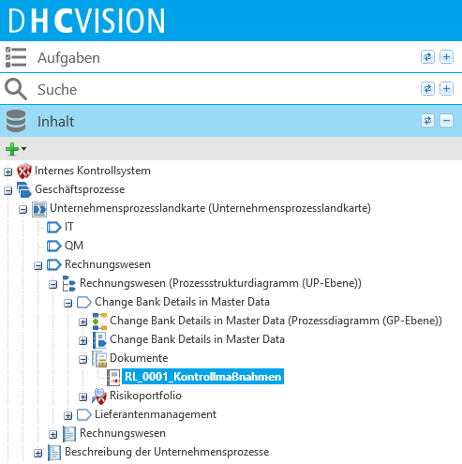
Fig. 4 Process-specific filing of documents
In order to be able to link documents to Master data or other documents, the attributes "References, IT applications, relevant companies or areas of validity" must be maintained via the document properties. More information on the attributes and document properties is provided in the following chapter "Create and Editor" section.

Create and edit
In order to be able to use all the advantages of electronic document management, the documents must be created in DHC VISION and their properties described. New documents are created in the system by Attachment of a new information object, with selection of the corresponding document type. One or more document templates can be defined for each document type, which can be selected when creating new objects. It is also possible to create a pure object cover. External files or documents can then be uploaded to this, or new documents can be generated based on the standard MS Office formats (Excel, Word, PowerPoint, etc.).
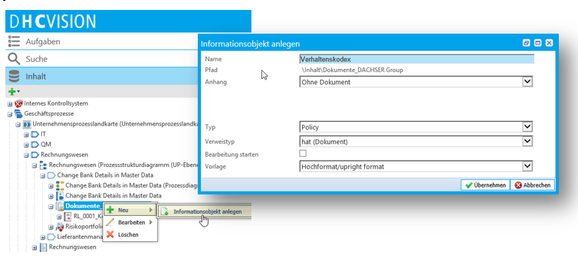
Fig. 5 Attachment and selection of a document type and its template
With the Attachment of new document objects in the system, the document type abbreviation and a cross-client, consecutive, 4-digit number for each type are included in the name by default. For example, the name of a directive is composed as follows:
RL_0001_Example guideline
<abbreviation>_<number per type, cross-client>_<title>
The document abbreviation and the assignment of the consecutive number can be adapted to different requirements. The type abbreviations for the most common document types are listed below:
Document type | Type abbreviation
Policy | PO
Guideline | RL
Procedural instruction | VA
Work instruction | AA
Operating instructions | BA
Form | FB

The document abbreviations are not language-independent, i.e. they cannot be translated and are therefore the same for all languages.
Attachment of an object opens the properties editing of the document. Here, both standardized and customer-specific metadata can be maintained, either automatically or by the user. Attributes and metadata are grouped according to their purpose and thematized in so-called "categories". The following graphic shows an example of the "Master data" category for a document, with the associated maintainable attributes.
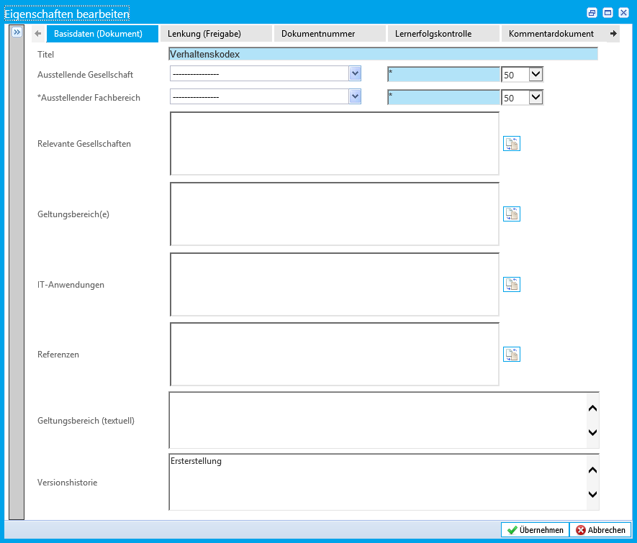
Fig. 6 Maintaining the metadata of a document
The content is then edited. DHC VISION supports editing with the help of an implemented editing client, which opens the document in the corresponding local Office component based on the existing source format. By using defined templates, certain metadata of the document can be automatically printed in the document with the help of integrated TAG technology (e.g. version, status, Scope(s), etc.).
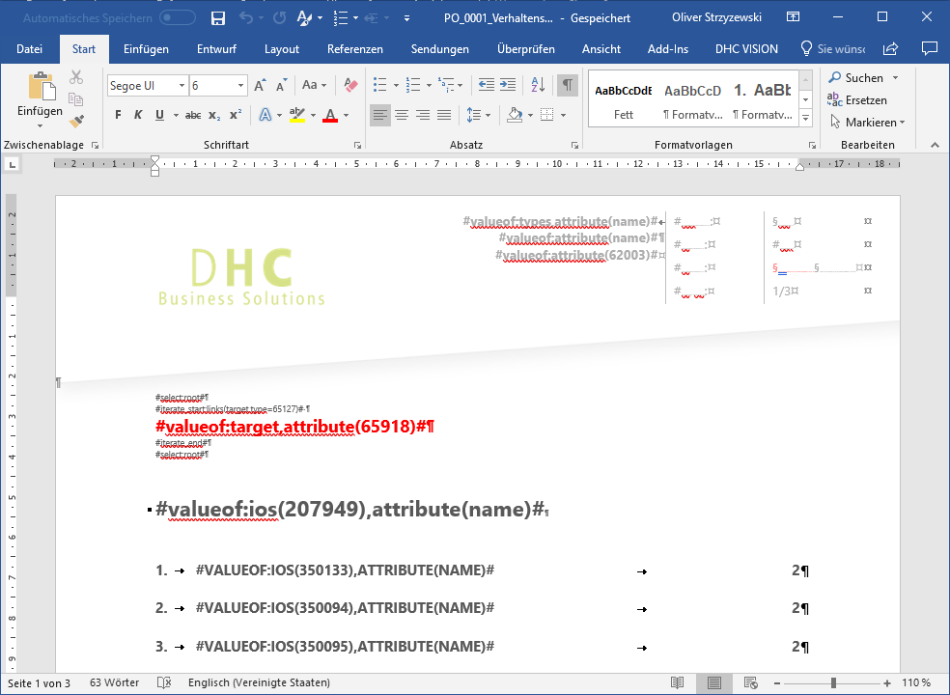
Fig. 7 Content editing of a template-based document in MS Word with display of the TAG technique
Once the document has been saved, it is automatically and system-supported converted to PDF and the current version is displayed on the web.
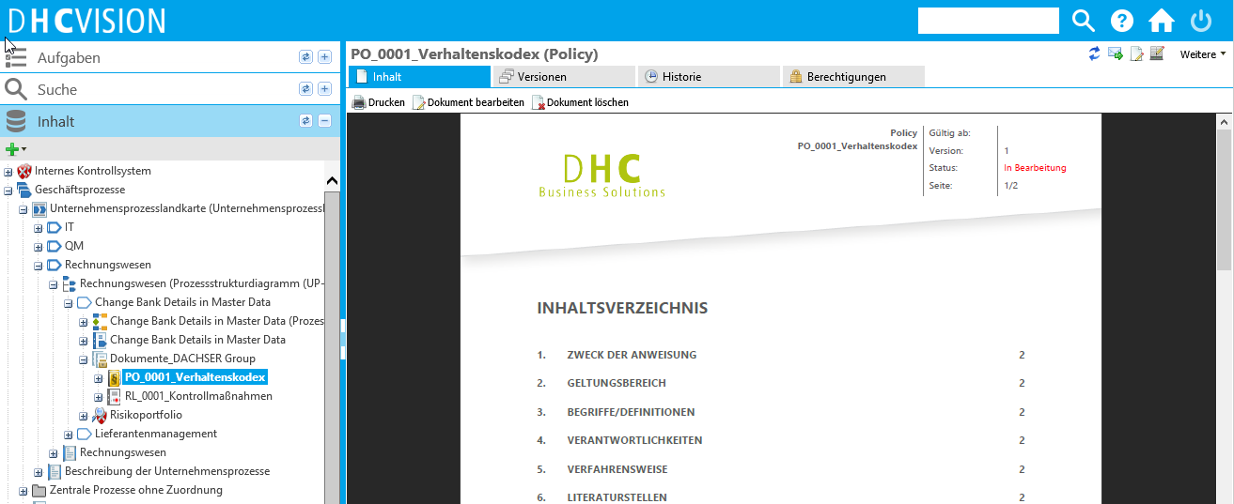
Fig. 8 Displaying the converted document as a PDF on the web
Subsequent changes to the content or properties are possible at any time. Due to the versioning and the associated status network of the documents, it should be noted that changes to released documents result in the creation of a new editing version (for more information, see chapter "Versioning and revision").
The assignment of authorizations and the assignment of participants in the release process is carried out via property editing in the "Control (release)" category:
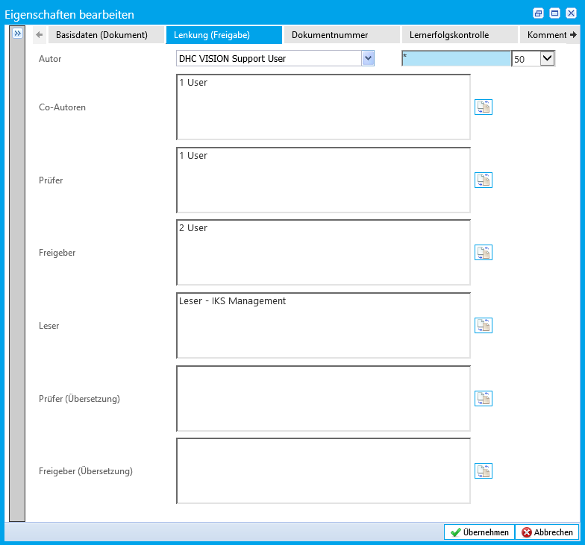
Fig. 9 Authorization assignment and allocation of WF participants in the document properties
Group and person-related authorizations are assigned in this category. Authorizations for readers are assigned via a user group assignment in the "Reader" attribute. For the other attributes (author, co-author, reviewer, releaser (incl. translation)), personal authorizations are assigned. Details on authorizations and roles can be found in the chapter "Authorizations".
In order to maintain the "dual control principle", the same person cannot be entered as author and reviewer.
To describe documents in more detail with additional information or relevant Equippments, the document can be supplemented with objects of the type "Additional info" or "Attachment".

Dealing with Attachments and Additional Information
Additional information and Equippments can be added to each document. The author decides which of the two document types is added to a document when Attachment of a new information object to the document.
Additional information
This is a document attachment that is not subject to the release cycle of the main document and does not have its own release cycle. Additional information is released and published directly via switches in the properties. Due to their lack of criticality, they can be deleted again directly. The creation, modification and deletion of additional information has no effect on the main document, i.e. in no use case is a new version of the associated document created. Examples of additional information: Brief instructions, photos and screenshots, other additional information that does not require checking and release in accordance with the "dual control principle".
Equippment
Attachments are controlled documents, i.e. they are automatically released with the release of the main document. Their content has an effect on the associated version of the main document, which means that they should be viewed critically. The creation, modification or archiving of Attachments therefore triggers a new version of the associated main document. Equippments are subject to their own versioning, but pass through all the statuses of the release process of the main document. Released Attachments cannot be deleted. They are marked for archiving and archived with the release of the next version of the main document (= complete revocation of rights, except for the archive group).

authorizations
Dedicated control of documents is achieved by assigning authorizations. By defining authorization groups in the system and assigning them specifically to documents, read and change rights can be assigned to a group of users/persons for each document.
Various roles are implemented in DHC VISION in order to provide individual users with the appropriate functions according to their area of application and at the same time to reduce the complexity of the overall system for the user. The following system roles (license roles in brackets) are available and described in more detail in the "Document management" solution:
Document reader (READER)
Readers can only view approved objects. For each object, you can decide again which reader may or may not view this object. In "Document Management", the system role (User Groups) "Reader - Document Management" is implemented as standard. All users in this group can view the documents and all dependent objects, such as Attachments. The users in this group can access the documents directly via the reader dashboard.
Users in these groups can take note of documents. Acknowledgements are documented and clearly summarized for authors or other key roles of the document. Additional subgroups can be assigned to the reader groups, e.g. location-specific User Groups.
Document author (AUTHOR)
If users are assigned to the "Authors" User Groups by the technical administration, they are offered in the author or co-author selection list for the respective document. When assigned, each author receives read and write permissions on the document itself and all details, such as attachments, additional information and Change proposals.
The Creator of a document is automatically confirmed in the "Author" field. However, this default value can be changed at any time and the authorizations passed on as a result. In addition to the actual author of a document, additional personal change rights can also be assigned via the "Co-authors" attribute. Co-authors have no relevance within the release workflow. Only the registered author signs the creation of the document in the first step of the workflow (additional information on workflow in the "Release").
The following objects can also be created as authors:
- All document types such as policies, guidelines, procedural instructions, work instructions, etc.
- Change proposals for documents
Document checker (AUTHOR)
A reviewer basically checks the content of a document according to technical and formal aspects. As both requirements exceed the capabilities of a single reviewer, two reviewers are often used in the review step. In this case, one reviewer confirms the technical check and the other the formal check. If users are assigned to the "Reviewer" User Groups by the technical administration, they are offered in the reviewer selection list for the respective document. When assigned, each reviewer receives read and write permissions on the document itself and on all details, such as attachments, additional information and Change proposals.
The following objects can be created as reviewers:
- Change proposals for documents
Document approver (AUTHOR)
A releaser is responsible for the document itself and its content. He decides whether a document is distributed to readers in this form and must be acted upon in accordance with the requirements in the document. If users are assigned to the "releaser" user group by the technical administration, they are offered in the releaser's selection list on the respective document. When assigned, each releaser receives read and write permissions on the document itself and all details, such as attachments, additional information and Change proposals.
The following objects can be created as releasers:
- Change proposals for documents
Translator (AUTHOR)
A translator can translate all released content of the DHC VISION system into another language. They cannot create new objects independently.

release
After document creation, attribute and document content maintenance, as well as the definition of document control, the approval process can be initiated. Processing is workflow-supported in the system. The 3-step release process, consisting of the steps "Create - Review - Release", is started by one of the co-authors or by the author themselves.
In the first workflow step of "Create", only the registered author signs and not the entire co-author team. For the "Review" and subsequent "Release", the reviewers and releasers maintained in the attributes are assigned. In order to maintain the "dual control principle", the same person cannot be entered as author and reviewer.
The following diagram provides an overview of the approval process:
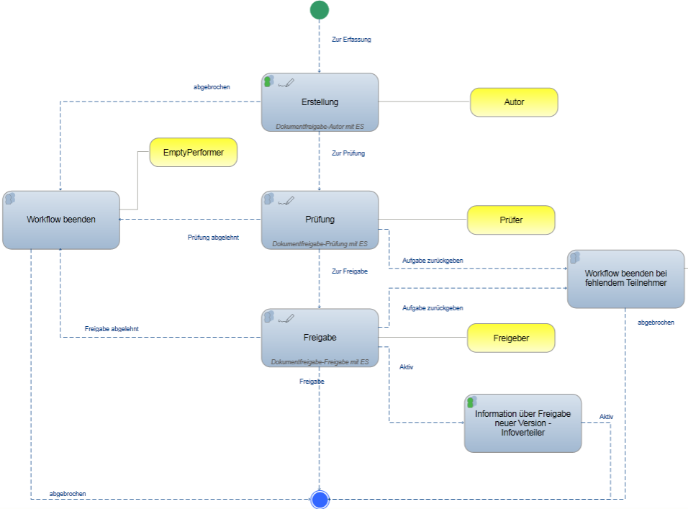
Fig. 10 "Document release with signature" process flow
One or more users can be entered for the check and release. For the check, all assigned participants must have completed their task positively so that the release can be triggered. For the release, it is sufficient if only one of the assigned users completes their task positively to finally release the document. In the event of a rejection during review or release with multiple users, the workflow is canceled for all subsequent participants immediately after the first rejection. Throughout the workflow process, the system informs the users involved of the status and existence of workflow tasks by means of e-mail notifications.
All workflow participants complete their tasks with an electronic signature. The signatures of the individual participants are documented in the system for each released version and can be printed as document content.
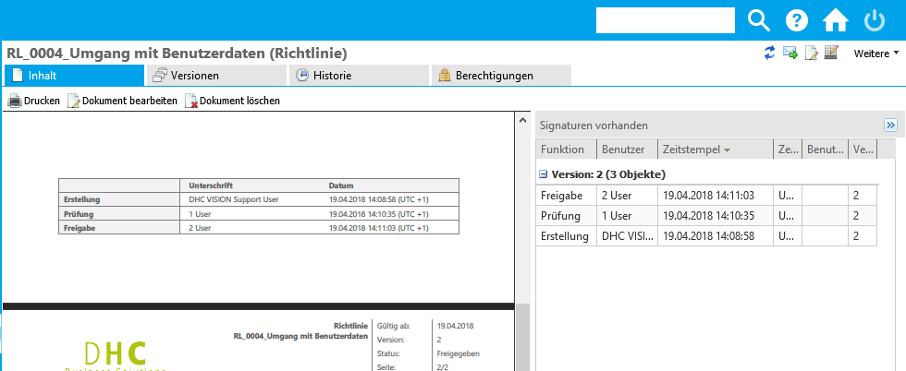
Fig. 11 Documentation of signatures in DHC VISION and in the document
After release, the document is automatically published and is therefore visible to the readers addressed.

Versioning and revision
If a valid and released document is revised, a new version is automatically created in the editing status. All data from the previous version is retained, but can be adapted. If Attachments to the new version are no longer relevant, they can be archived. The actual archiving then takes place after the release of the current editing version.
The following changes trigger a new document version:
- Changes to the document content
- Changes to attributes that generate content versions
- Changes to or archiving of existing Attachments
- Change of reference due to Creator of new Attachments
- Change proposals that are planned to amend the document
Change proposals for existing documents can also be managed in DHC VISION. The handling of Change proposals is described below.

Change proposals
All employees who have author rights in the system can create Change proposals for a document without affecting the content or version history of the document. A Change proposal clearly belongs to a document and is displayed in the document. The function for creating Change proposals is activated from the release or "Validation" of the first version of a document. If the document is already being revised, Change proposals can also be printed in the document for information purposes.
When a Change proposal is created, the author of the underlying document is informed by e-mail. If the Change proposal is scheduled for implementation, this creates a new version of the document in which the Note about an existing Change proposal can be printed.
The author documents the editing of the assigned Change proposals directly in the Change proposal. As a result, the Creator of the proposal receives an e-mail notification. Completed Change proposals are no longer displayed in the document.
Change proposals are created and managed in the Cockpit for a document in the "Change proposals" folder of the same name.
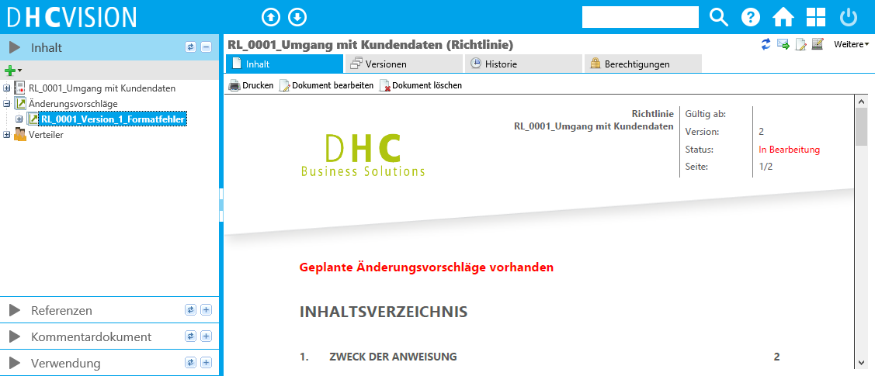
Fig. 12 Management and display of Change proposals in the cockpit of a document

Extend validity, suspension & reactivation
Documents that are managed in versions are subject to a life cycle. This means that the documents must be reviewed for validity after a certain period of time. During this check, a decision must be made as to whether the document is still valid in its current version, whether it needs to be revised or whether it is invalid and needs to be invalidated. In the case of "invalidation", documents are not deleted but archived for a defined period of time. A special case of archived documents is reactivation, in which archived documents are reactivated. The following chapters provide details on the three processes of extending validity, "overriding" and reactivation.

Process for "extending validity "
The period for which a check of the extended validity is necessary can be defined for each document type. A period of 3 years is set for the document types in the DHC VISION standard. The count starts from the release of a document and is updated for each newly released version (= "Valid from" date + period of extended validity). The calculation of "Valid from" and the "Period of extended validity" results in the "Valid until" date.
If a document reaches the period 30 days before the validity expires (= "valid until" date), a request for validity extension is created by the system. The request for validity extension is linked to the document to be checked and must be processed with workflow support. Two processes are available for processing:
Process 1: Extend validity by releasers with information to authors, co-authors and reviewers
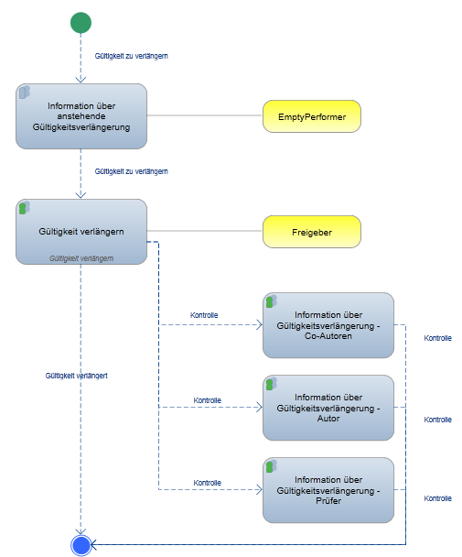
Fig. 13 Process for the GüV by releasers
The check is carried out by the releaser currently entered on the document. Authors, co-authors and reviewers only receive an information e-mail about a pending extension of validity and when the validity is extended.
Process 2: Extend validity by author, reviewer and releaser with information to authors, co-authors and reviewers
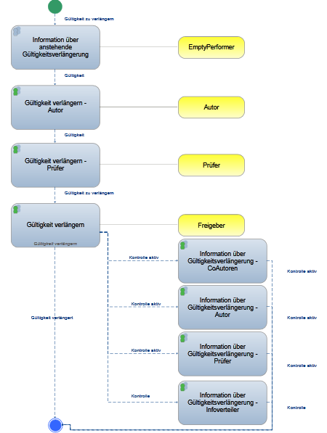
Fig. 14 GüV process with author, reviewer and releaser
The check for extended validity is carried out by all users of the document involved in the release process. The author, co-authors and reviewers also receive an info email when the validity is extended after release by the author.
By declaring the additional validity, the request for validity extension is deleted. The document remains valid in its current version. The validity, i.e. the "Valid until" date, is updated by the default value of 3 years. If there are Attachments to the document, these are also released and have the same validity as the main document.
If the document needs to be revised, a new version is created by the author and the document is updated. The pending request for validity extension and the associated WF process are disregarded by the participants. With the release of the new version of the revised document, the process for validity extension is automatically terminated and the request for validity extension is deleted.
If, when checking the validity extension, it is determined that the document has no additional validity and must be withdrawn from circulation, a request for "Override" can be created for the document. The process for AKS is described below.

Process for "overriding "
Released documents that have no additional validity and for this reason may no longer be available to users in the system must be invalidated. This involves declaring the documents and their attachments (if any) invalid and archiving them. Archiving is not a physical deletion, but merely the withdrawal of authorizations for the document. With the exception of a specific user group, the archive group, all authorizations are revoked at user group and person level. Users in the "Archive" group still have read access to the archived documents.
The archive duration can be defined for each document type. A period of 10 years is set for the document types in the DHC VISION standard. After the archive period has expired, the documents are also physically deleted.
To invalidate documents, users with write access can create a request for AKS for a selected document in the system. After Attachment of the request for AKS, the workflow for processing the request is started automatically. Two processes are available for "Override":
Process 1: "Override" by releasers with information to authors, co-authors and reviewers
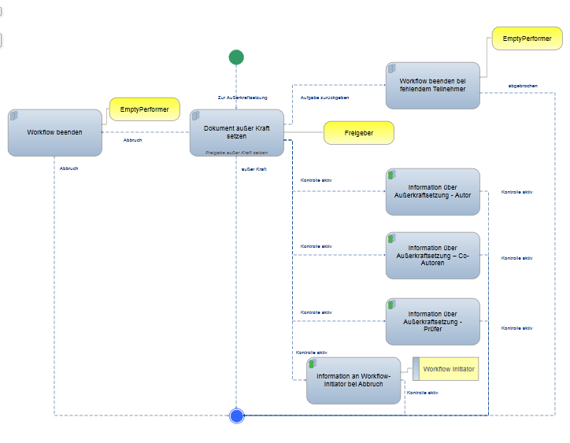
Fig. 15 Process for AKS by releasers
The AKS is carried out by the releaser currently entered on the document. Authors, co-authors and reviewers only receive an information email about the declaration of "Override".
Process 2: Override by applicant (=initiator), reviewer and releaser
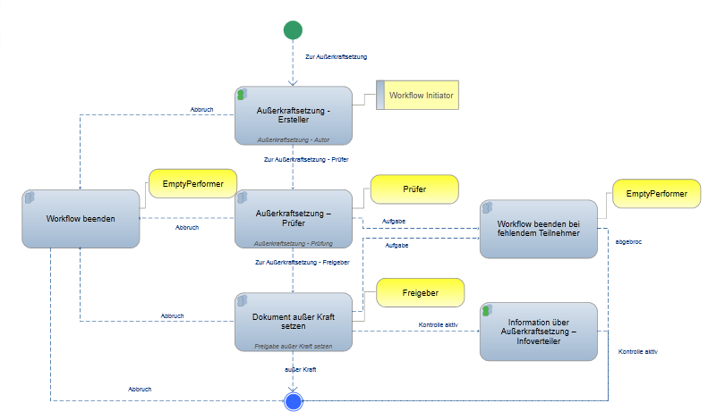
Fig. 16 Process for "override" with Creator (request), reviewer, releaser
The check for AKS is carried out in 3 steps. In the first step, the Creator of the request checks the request and the document. In the next two steps, the review and subsequent approval of the AKS is carried out by the reviewers and releasers maintained on the document.
After the declaration of "Invalid", the request for "Invalid" is not deleted for documentation purposes. The last valid and approved version of the document is given the status "Invalid". Existing edited versions are deleted. The archive duration runs from the time of the "Override". All rights (except for the archive group) are revoked.
If the "suspension" has been declared on the basis of the triennial validity extension check, the current validity extension process is terminated and the request for validity extension is deleted.
During the archiving period, it may be necessary in rare cases to reactivate previously invalidated documents and their Attachments. The reactivation process is used for this purpose.

Process for reactivation
Reactivation is used to re-validate invalidated documents. To do this, a request for reactivation is created in the folder provided for this purpose and the corresponding document is selected for reactivation. Only the "Business Admin group" is permitted to create requests for reactivation. The workflow is then started automatically.
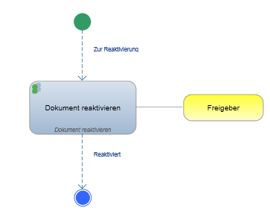
Fig. 17 Process for reactivation with initiator
The Creator of the request for reactivation (=initiator) is also the Editor of the workflow step. Once the reactivation has been confirmed, a new version of the document is created in the process. The metadata and properties maintained at the time of the AKS are retained in the new version upon reactivation. The authorizations are set according to the maintained attributes "reader, author, co-author, reviewer and releaser (incl. translation)". The User Groups and persons on the Distribution list are also confirmed from the "Invalidated" version ("Distribution list" see chapter "Distribution"). Finally, the Equippments archived with the document are also reactivated. This restores the original status, except for the version number and the status. The document can then be released in accordance with the defined release process.

Distribution
Distribution lists can be maintained for each document. Distribution is maintained by assigning User Groups or persons who are automatically informed about the release of the corresponding document. A distinction is made between two types of Distribution in the system:
- Distribution by e-mail
- Distribution for acknowledgement
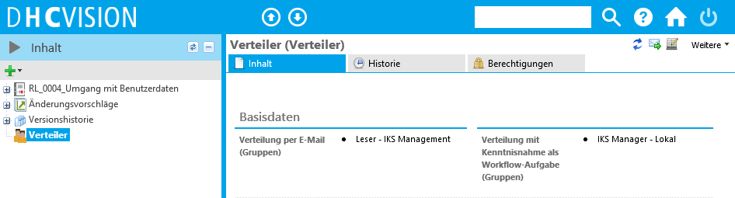
Fig. 18 Maintaining the Distribution list in the cockpit for the document
All User Groups and persons assigned to the Distribution automatically receive read authorization for the corresponding documents to which they have been assigned.
The two types of distribution will now be discussed in more detail.

Distribution by e-mail
With Distribution by e-mail, the directly assigned users and the users of the assigned User Groups are informed by e-mail notification when a new document version is released. No additional actions are required. A subsequent change to the "Distribution by info" attribute only has an effect on the existing User Groups and persons in relation to the email notification when the next version is released.

Distribution for acknowledgement
If a document's Distribution list has been maintained for acknowledgement prior to release, the persons entered and the users of the assigned User Groups are automatically requested by e-mail to actively confirm acknowledgement upon release. The hyperlink in the e-mail gives each recipient direct access to the relevant document. The acknowledgement is workflow-supported without a signature.
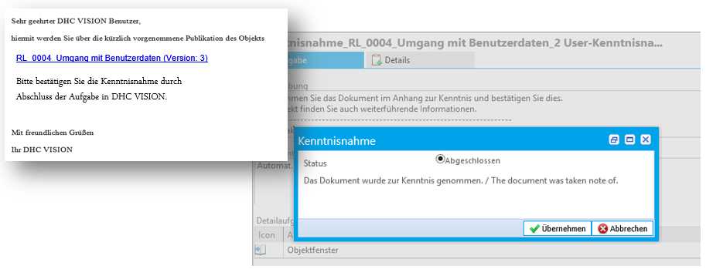
Fig. 19 E-mail notification and confirmation of the workflow task
The author team of the document receives an overview of all acknowledgements that have not yet been confirmed, as well as a notification as soon as all persons maintained in the Distribution have confirmed acknowledgement of the current version.
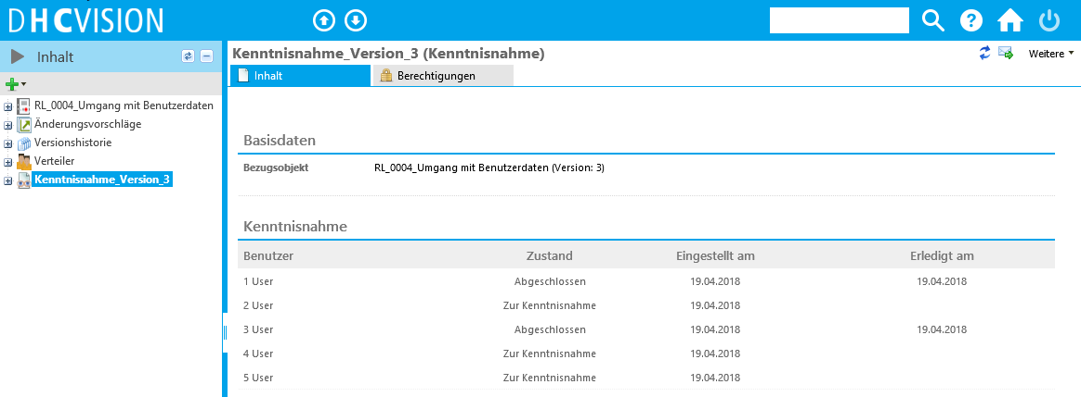
Fig. 20 Proof of confirmed acknowledgements
A subsequent change to the "Distribution for acknowledgement" attribute also only has an effect on the existing User Groups and persons with regard to the distribution of the workflow task when the next version is released.
In addition to the stored functions of distribution by email or for acknowledgement, the maintenance of the distribution list also plays a central role for the distribution lists in the dashboard. More details in the following chapter.

Dashboard and evaluations
By defining the distribution groups in the distribution list per document, the user and role-specific dashboards are also filled with the necessary information. This means that for all users who are included in a group assigned to the Distribution, the corresponding document is assigned in the dashboard.
Furthermore, role-specific evaluation reports and searches are available for the documents in the system. Different selection parameters and selection criteria are available for each report. These influence the evaluation results and filter the results lists according to the settings made. This enables a targeted evaluation and search function according to specific objects and criteria. Role-specific dashboards and evaluation options are described below.

Dashboard reader
All documents relevant to the user are listed in the "Document list" dashboard. (Prerequisite: The user is in one of the User Groups maintained on the Distribution list or directly in the Distribution list). When a document is selected from the list, detailed information such as existing Attachments and additional information, referenced documents and language versions are displayed in the footer. The display of the content of the additional information is authorization-dependent. Deeper navigation is possible via the additional information. This gives readers direct access to the documents and document-dependent details that are relevant to them.
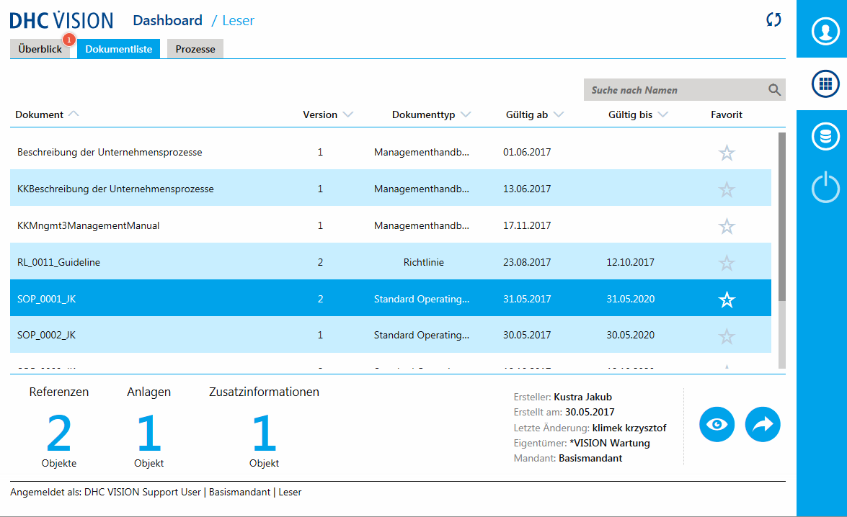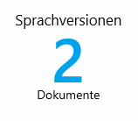
Fig. 21 Reader dashboard "Document list"

Reader evaluations
The following report is implemented for the Reader role:
Status report: Documents & Instruction
The report provides an evaluation of instructions stored in the system with additional information depending on the selected parameters.

Author evaluations
The following reports are implemented for the Reader role:
Search for documents & instructions (author version)
The report provides an evaluation of the documents saved in the system in the editing status (author version), with additional information depending on the selected parameters.
Status report: Documents & Instruction
The standard report provides an evaluation of documents stored in the system (with revision cycle), with additional information depending on the selected parameters. The status is displayed using a traffic light system. From 2 months before "valid until" the traffic light turns yellow, from one month before it turns red.
Status report: Documents & Instruction (current status)
The standard report "Document monitoring (current status)" provides an evaluation of documents stored in the system, with additional information depending on the selected parameters. Here you can search for the current status in order to determine which documents currently have which workflow status. There is a traffic light system for documents in the workflow, which is green if less than 5 days have passed since the last status change, yellow if less than 10 days have passed and red if more than 10 days have passed.
Status report: for acknowledgement
The report lists all acknowledgements, depending on the status.

Translation
The translation function in DHC VISION allows a language-dependent display of released documents. The translation can only be carried out for content and documents whose original language version is in the "Released" state. The translated version must be checked and released with workflow support, just like the original. Only once the language version has been released is the document visible to authorized readers in the corresponding login language. Before translation, the document is visible in the original language.
The approval process for the translation is as follows:
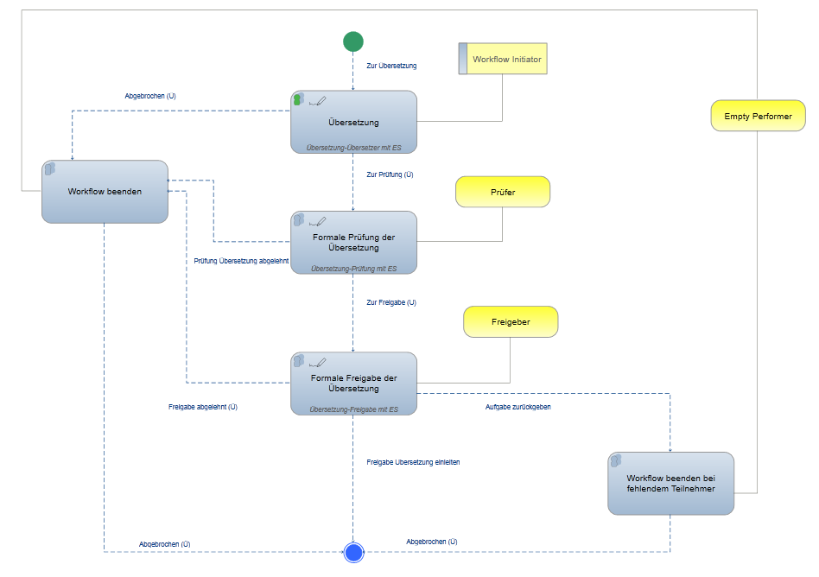
Fig. 22 Approval process for translated documents
The assignment of participants for checking and releasing the translation is carried out in the properties dialog of the document, analogous to the assignment of the release process with signature (see: Chapter "Authorizations").

Multi-client system
For each document in a multi-client system, you can specify in which clients the corresponding document is visible or not.
However, a document cannot be changed in a client. If you want to make a local addition to a document in a client, you must create a new document in the client, describe the change or extension there and create a reference to the original document. The extended local document must be released using the processes described above.

Management of process organization/management of business processes
The business process management solution (PM for short) provides tools and methods for modeling, communicating, measuring and continuously improving processes and the process landscape. The seamless integration and paperless management of the necessary manuals and process documents is carried out using a variety of functionalities from the document management system (DMS for short). Templates can be created, process documents and manuals can be parameterized and generated. Workflows and electronic signatures are used for the secure and traceable control and release of process documents. To ensure compliance with quality and compliance guidelines, it is possible to document risks and corresponding controls and measures in a process-oriented manner. Norms can also be documented and assigned to processes, organizational units or other documents, resulting in an overview matrix. Potential for improvement, suggestions for correction and measures can be created and processed for the continuous improvement of processes and content as well as the active involvement of employees.
Holistic business process management is characterized by the linking of an organizational structure with a process organization established in the company. The aim is to assign competencies and tasks to sub-units of the company (organizational units, jobs and roles). The management of these organizational units for the ICS is described in chapter "Management of the organizational structure". In the following sections, only the process organization and the associated DHC VISION processes (=workflows) are described.

Process pyramid and its levels
To describe the process organization, DHC VISION offers a best practice pyramid, according to which the processes are detailed and hierarchized over five levels.
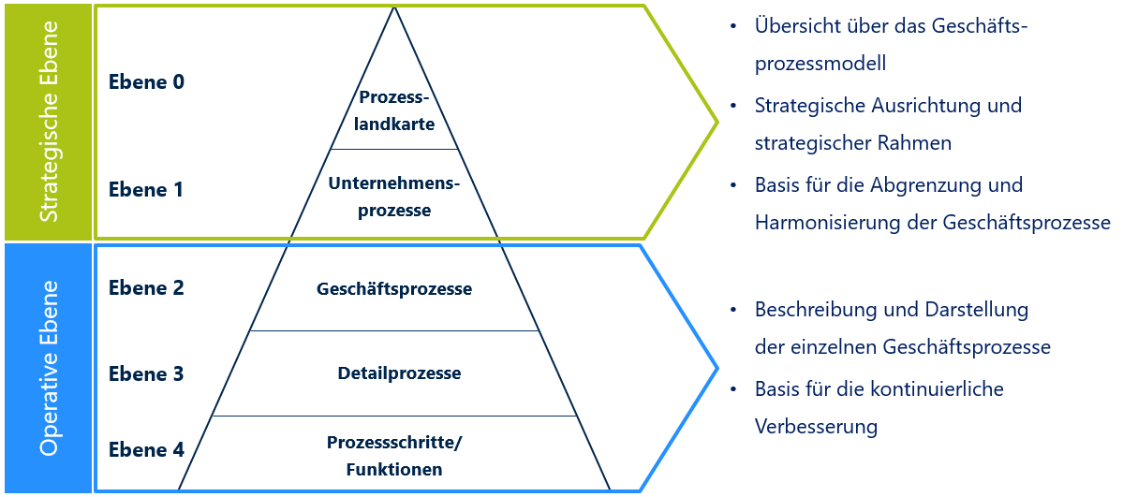
Fig. 23 Process pyramid with 5 levels
These are linked to each other through cross-references (=interfaces), allowing processes and process flows to be harmonized and standardized. The classification of the processes in the level model also improves the consistency and comprehensibility of the processes. In addition, the dependencies between the processes at the different levels of detail become transparent. The easily recognizable dependencies and cross-references promote acceptance among readers and form an ideal basis for effective optimizations.
The individual levels of the process pyramid are described below.
Level 0: Company or company process map (UPLK)
The corporate process map represents the corporate processes required to achieve an objective or purpose, such as procurement, production, accounting and sales. The corporate processes of the level are specified in core, support and management processes.
Level 1: Corporate process
Level 1 contains the structure and characteristics of corporate processes according to various criteria. Corporate processes can be mapped using process structure diagrams or as a value chain diagram corresponding to a value-adding process. The central type for describing corporate processes are business processes. These can be structured into business process groups, business processes and business process variants.
Level 2: Business process
At level 2, the content of the business processes developed at level 1 is described. These can be described verbally and/or graphically using various methods such as process diagrams. The best practice method provides for description using process diagrams. The process template with IT applications and machinery/equipment can be selected as the model template or without. The business processes are described in the process diagram using detailed processes.
Level 3: Detailed process
Each activity in a business process corresponds to a detailed process. The graphical description can be provided by an EPC, a BPMN or a process diagram. Here too, the best practice method uses the process diagram. As at level 2, there are also two templates available for process modeling with the process diagram (IT-supported or manual). The process flow at detailed process level is described by process steps
Level 4: Process step
Each detailed process consists of individual process steps or activities. For IT processes, these are data input, transaction and data output; for manual activities, a description of the respective activity to be performed. The process step is the last level of the process description and cannot be structured in more detail. The description at process step level is provided by supplementary documents such as checklists, forms and, if necessary, work instructions.

Create and edit
The application of the best-practice process pyramid allows DHC VISION to automatically create the navigation bar. To do this, the system interprets the relationships between the different objects in the models and displays them in the form of a "tree". This is a structure, not a hierarchy.
The automatically generated tree structure looks as follows in the delivery status:
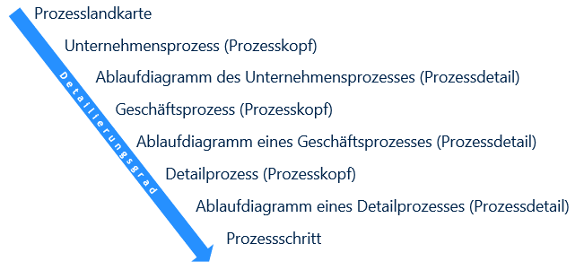
Fig. 24 Structure of the navigation tree
This means that the redundant maintenance of a filing structure for processes is omitted.
If it is not possible or not desired to classify the existing customer processes in the level structure of the process pyramid, the processes can also be stored in a flat process list. However, the decisive factor here is also the type of process (corporate process, business process or detailed process) that is to be created. Attachment of the processes is then carried out manually by creating new information objects in the "Process list" folder in the Business processes view. The process header is created and described first. Below this, the process model is created to represent the process flow. When the process model is created, the process description is also created in the system. In a later step, the processes can be transferred from the flat list to the modeled structure.
As already mentioned, the automatic process structure is generated by interpreting the models, i.e. the central tool in process management is modeling. This is done using MS-VISIO and is described in chapter "Modeling of business processes".
Depending on the level, different information can be created for a process. A process always consists of a process header and various process details. The process header contains, for example, the process name, a process description, the person responsible for the process, the process manager and a process team. Process details describe the process in more detail and can be, for example: process description, process models and documents. The process models contain the "process heads" of the respective lower level (hierarchization) and the "process heads" of the respective same level (horizontal interfaces). When a process model is created, regardless of the model type, the process description for the process is automatically created. This contains the most important information about the process, such as the process description, responsible persons, R-A-C-I matrix and the process flow. The process description is the central control element for the release of processes. How the release of processes is carried out is described in chapter "Release " is summarized.

Modeling of business processes
In DHC VISION, Microsoft Office Visio is integrated as a modeling front end and has been expanded to include intelligent database support. Every object created with Visio is stored in the database and can be reused in additional Visio models. This prevents the creation of data redundancies and simplifies process harmonization.
Various process models with different templates, symbols and modeling methods are available for each process level. The following graphic provides an overview of the process models that can be used for each level:
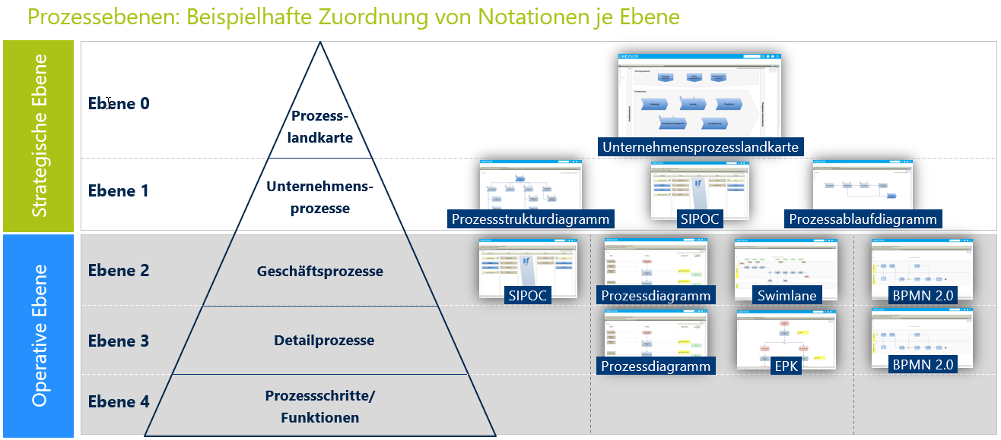
Fig. 25 Assignment of existing notations per level
To edit a model, the document editing function is started on the process model. In VISIO, objects are modeled using drag & drop, i.e. by placing the existing symbols on the drawing sheet. The name serves as a unique identifier. Naming automatically creates a database object of the selected type. If the object already exists in the database, it can be selected and created using the DHC VISION add-in function of the database search. This method is preferred as it prevents errors and redundancies. If several objects have been created on the drawing sheet, they are placed in a logical sequence or structure using edges/connectors. The method for connecting different objects/symbols is specified by DHC. This avoids "uncontrolled growth" in the models and ensures standardization of the processes and their sequence. The methodology varies between the existing model types, as each process model type has different symbols and therefore different linking options. The following figure shows an example of process modeling of a process flow at GP level in VISIO:
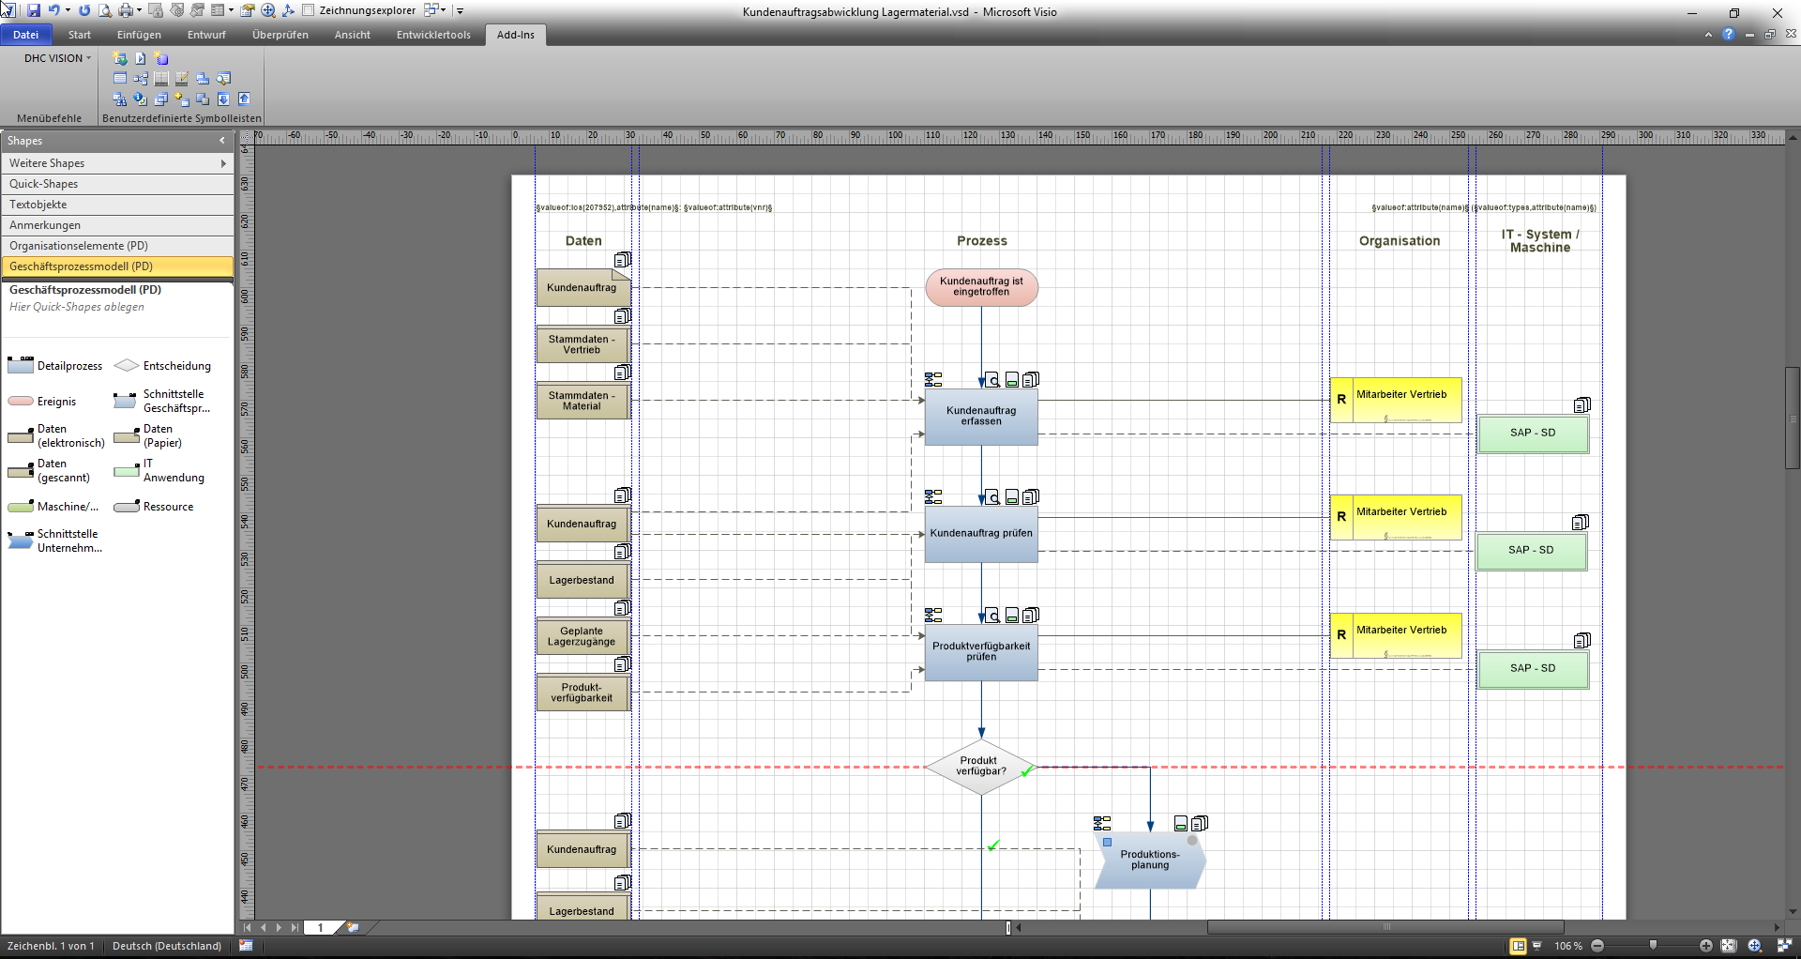
Fig. 26 Process modeling in MS VISIO
From a technical perspective, the detailed process steps are arranged in a sequence in a business process flow model. Decisions and events within the process can be used to create complex process sequences. For each process step, IT applications can be defined that either support this step or execute it fully automatically. This is an important aspect in relation to an ICS system, as automated IT controls can be directly related to the business process. Furthermore, for each process step, it is possible to define which organizational unit is responsible for carrying out this step (Responsible), has overall responsibility (Accountable), is involved (Consultant) or/and distributes information (Informed). This R-A-C-I methodology creates a close link between the process organization and the organizational structure. Furthermore, data can be created for each process step that is required as input for the process step or which output the process step must deliver in the form of data. This assignment of input and output data allows risks in the process to be better defined and evaluated later on, as risks often arise when handling the data.

authorizations
Dedicated control of processes and their process documents is achieved by assigning authorizations. By defining authorization groups in the system and assigning them specifically to processes and process documents, read and change rights can be assigned to a group of users/persons.
Various roles are implemented in DHC VISION in order to provide individual users with the appropriate functions according to their area of application and at the same time to reduce the complexity of the overall system for the user. The following system roles are available in the process management solution (license roles in brackets), whereby the assignment of authorizations for processes and their process documents must be differentiated:
Process reader (LESER)
Readers can only view approved objects. For each object, you can decide again which reader may or may not view this object. In "Process Management", the system role (User Groups) "Reader - Process Management" is implemented as standard. All users in this group can view released processes, organizational units and Norm. They also have read access to the documents assigned to the processes and organizational units. Users in this group can access the processes and documents directly via the reader dashboard. Users in the "Reader - Process Management" group can take note of processes and documents and document the acknowledgement. Additional subgroups can be assigned to these groups, e.g. location-specific User Groups.
Process owner (AUTHOR)
Process owners are responsible for the strategic management of an end-to-end process. They are therefore responsible for the goal-oriented design, execution and control of the respective process. The focus of their actions is on the target orientation of their own process, the interactions with other processes and the selection of sustainable key figures. Furthermore, the process owner is fundamentally responsible for the release of the process.
If users are assigned to the "Process owners" user group by the technical administration, they are also offered in the selection list of process owners for the respective process. When assigned, process owners receive read and write permissions to the process itself, as well as to all details, such as process models or risks. The process owner is also proposed as a releaser for the process in the release workflow.
The following objects can be created with the "Process owner" role:
On a corporate process:
- Value chain, process structure diagram and all objects contained therein
- Document container
- Risks
On a business process:
- Process diagram (GP level) and all objects contained therein
- Document container
- Risks
Process Manager (AUTHOR)
A process manager supports the process owner and coordinates tasks and activities relating to the process. He or she should have the necessary authority to optimize the process if required and to manage the process consistently in order to ensure an optimal work result.
Users who are assigned to the "Process manager" user group by the technical administration are offered in the process manager's selection list for the respective process. When assigned, the process manager receives read and write permissions to the process itself with all details, such as the process models. The process manager is also proposed as a reviewer for the process in the release workflow.
The following objects can be created with the "Process manager" role:
On a corporate process:
- Value chain, process structure diagram and all objects contained therein
- Document container
- Risks
On a business process:
- Process diagram (GP level) and all objects contained therein
- Document container
- Risks
Process team (AUTHOR)
This is a group of process stakeholders and process management specialists who constantly measure the actual process performance and take immediate countermeasures if deviations from the PLAN are detected. This means that these employees not only have an overview of their respective sub-tasks, but also of the best possible functioning of the entire process. The exact distribution of tasks and resource/quantity planning are executed here together with the process manager. Users who are assigned to the "Process team" user group by the technical administration are offered in the process team selection list for the respective process. When assigned, each individual process team member receives read and write permissions to the process itself with all details, such as the process models. They are also proposed as co-authors for the process in the release document.
The following objects can be created as a member of a process team:
On a corporate process:
- Value chain, process structure diagram and all objects contained therein
- Document container
- Risks
On a business process:
- Process diagram (GP level) and all objects contained therein
- Document container
- Risks
Process Modeler (AUTHOR)
This is a position or role whose core task is to be able to document processes in one or more notations. Users who are assigned to the "Process Modeler" user group by the technical administration can model the process models at the "Business Process" and "Detailed Process" level:
- Process diagram (DP level)
The following objects can be created as process modelers:
- Process diagram (DP level) and all objects contained therein
- Document container
Document author/process author (AUTHOR)
The process author is the Creator of a process. This is equivalent to the "Author" role in the DMS and is therefore proposed as the author of the corresponding process document. However, this default value can be changed at any time and the authorizations can be passed on without affecting the Creator of the process.
If users are assigned to the "Authors" user group by the technical administration, they are offered in the author or co-author selection list for the respective process document. When assigned, each author receives read and write authorizations on the process document itself and all details, such as attachments, additional information and Change proposals.
The following objects can also be created as authors:
- All document types such as policies, guidelines, procedural instructions, work instructions, etc.
- Change proposals for documents
Document Reviewer/Process Auditor (AUTHOR)
A reviewer basically checks the content of a document according to technical and formal aspects. As both requirements exceed the capabilities of a single reviewer, two reviewers are often used in the review step. In this case, one reviewer confirms the technical check and the other the formal check. If users are assigned to the "Reviewer" User Groups by the technical administration, they are offered in the reviewer selection list for the respective document. When assigned, each reviewer receives read and write permissions on the document itself and on all details, such as attachments, additional information and Change proposals. If the review is a process (document type: process instruction), the process manager of the process is suggested as the reviewer.
The following objects can be created as reviewers:
- Change proposals for process documents
Document approver/process approver (AUTHOR)
A releaser is responsible for the document itself and its content. He decides whether a document is distributed to readers in this form and must be acted upon in accordance with the requirements in the document. If users are assigned to the "releaser" user group by the technical administration, they are offered in the releaser's selection list on the respective document. When assigned, each releaser receives read and write permissions on the document itself and all details, such as attachments, additional information and Change proposals. If the release is a process, the person responsible for the process is suggested as the releaser.
Translator (AUTHOR)
A translator can translate all contents of the DHC VISION system into another language. It cannot create new objects independently.
Business Process Administrator (AUTHOR)
The Business Administrator is a specialist "super user" who can execute the functions of all roles. They are responsible for the structure and consistency of the overall system. Business administrators also have some additional special functions that are not available to the other roles, such as canceling workflows in which they are not involved.

Release
Processes are released via the process descriptions associated with the process. The "Management manual chapter" type is available for the corporate process map and corporate processes. The "Process instruction" document type is used for operational processes, such as business processes and detailed processes.
The release is analogous to the document types in the document management system and is therefore not specified in more detail (see chapter "Release (DMS)").
With the release of the process description, the following objects of the process are also released and published:
- Process head
- Process model(s)
- Process headers of the next level processes and interfaces used in the model
The release of each individual process at each level follows the same principle. With the release, the processes and their detailed descriptions are activated and visible to the readers (depending on the set read authorizations for the process).

Versioning and revision
If a valid and released process is revised/changed, a new version is automatically created in the editing status. Depending on which object in the dependency network of the process the change is executed on, this has an effect on other objects:
Changes to the process header create a new version of:
- Process head
- Process model (only for attributes that have an effect on the representation in the model)
- Process instruction or management manual chapter
Changes to the process model generate a new version of:
- Process model
- Process instruction or management manual chapter
Changes to the process instruction/management manual chapter creates a new version of:
- Process instruction or management manual chapter
All data from the previous version, except for the change made, is retained after the new version has been created and can be adapted. The versioning of the process instruction/management manual chapter is carried out in the same way as the other document types in the DMS (see chapter "Versioning and revision (DMS)"), also with regard to Attachments.

Extend validity, suspension & reactivation
Processes are subject to a life cycle and are managed in versions. This means that the processes and their process descriptions must be checked for validity after a certain period of time. During this check, a decision must be made as to whether the current version of the process and process document is still valid, whether it needs to be revised or whether it is invalid and must therefore be invalidated. In the case of "suspension", processes and their documents are not deleted but archived for a defined period of time. Reactivation is a special case for archived processes and process documents. In this case, archived processes are reactivated. In contrast to document management, "decommissioning" and "reactivation" in process management must be carried out with an accompanying detailed analysis and only when the effects are absolutely clear, as there is a high degree of cross-references, interfaces and dependencies to other processes in process management.
The following chapters provide details on the three processes of extending validity, "overriding" and reactivation.

Process for extending validity
Extend validity is carried out in the same way as for the DMS and is not specified in more detail here (see chapter "Process for "Extending validity" in Policies & Guidelines Management).
As the process document serves as the central control element in process management, it is used to control the extended validity. The extended validity is explained for the process document, process header and process model.

Process for "override"
The "Override" process is similar to the DMS and is not specified in more detail here (see chapter "Process for "Overriding" in Policies & Guidelines Management).
Overriding" takes place via the process document. When the "invalidation" is declared, the process document itself, the process header and the process model (with the exception of the process headers of the next level or interfaces) are invalidated.

Process for reactivation
Reactivation is carried out in the same way as DMS and is not specified in more detail here (see chapter "Process for reactivation" in Policies & guidelines management).
During reactivation, the process document itself, the process header and the process model are reactivated and set to a new processing version. The release takes place via the regular release process of the process document.

Distribution
As in document management, processes are distributed via the distribution object at the respective process instruction/management manual chapter (see chapter "Distribution"). When the process instruction is distributed, the processes are distributed in the same step, i.e. the associated process header and the process model are attached to each process instruction. Distribution of processes therefore has an effect on the document list and the process list in the dashboard. More on this in the following sections.

Dashboard and evaluations
By defining the distribution groups in the distribution object, the user- and role-specific dashboards are filled with the necessary information. This means that the corresponding document and process is assigned in the dashboard for all users who are included in a group assigned to the distribution object or who are assigned directly in the distribution object. Different dashboards and evaluation options are available for each role.
Furthermore, role-specific evaluation reports and searches are available for the processes in the system. Different selection parameters and selection criteria are available for each report. These influence the evaluation results and filter the results lists according to the settings made. This enables a targeted evaluation and search function according to specific objects and criteria. Role-specific dashboards and evaluation options are described below.

Dashboard reader
Both a document list and a process list are available to the reader in process management.
Document list
All process documents relevant to the user are listed in the "Document list" dashboard. (Prerequisite: User is in one of the User Groups maintained on the Distribution). When a document is selected from the list, detailed information such as existing Attachments and additional information, referenced documents and language versions are displayed in the footer. The display of additional information is authorization-dependent. Deeper navigation is possible via the additional information. This gives readers direct access to the documents and document-dependent details that are relevant to them.
Fig. 27 Reader dashboard "Document list"
Process list
All processes relevant to the user are listed in the "Process list" dashboard. The processes displayed here correspond to the distributed process documents from the document list, as the distribution takes place via the process document. When a process is selected from the list, detailed information such as the process model, upstream and downstream processes and documents relating to the process are displayed in the footer. The display of additional information is authorization-dependent. Deeper navigation is possible via the additional information. This gives readers direct access to the processes and process-related documents relevant to them.
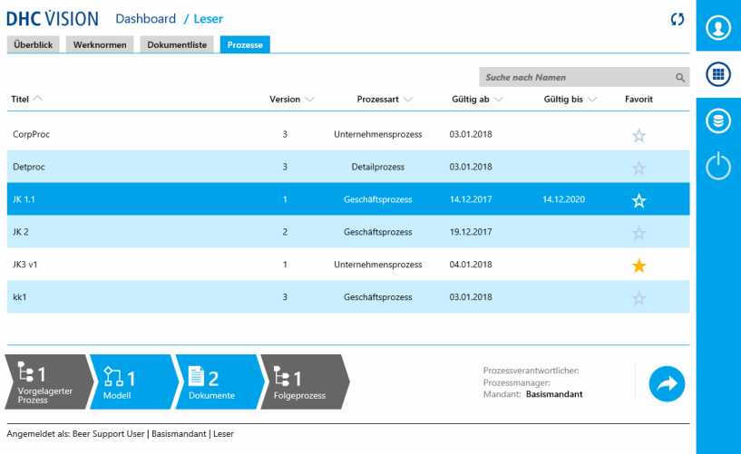
Fig. 28 Reader dashboard "Process list"

Reader evaluations
The following report is implemented for the Reader role:
Search for processes
The report can be used to evaluate processes at all levels of the process pyramid by name (with wildcards), process owner, process manager, Creator, creation date and additional criteria. The results list can be used to navigate directly to the relevant process.

Author/Business Admin evaluations
The following report is implemented for the Author or Business Admin role:
Search for processes (author version)
The report can be used to evaluate processes at all levels of the process pyramid in the editing state (author version) by name (with wildcards), process owner, process manager, Creator, creation date and additional criteria. The results list can be used to navigate directly to the relevant process.

Translation
The translation function in DHC VISION allows a language-dependent display of released processes and their process description. The translation can only be carried out for content (e.g. processes) and documents whose original language version is in the "Released" state.
In process management, the process header, the process model and the associated process description, including the attributes used, must be translated. DHC VISION supports the user in translating the attributes by means of a translation dialog. The translation of the model content, i.e. the process objects, is carried out in VISIO. The attribute designations and text modules used in the standard are automatically translated for the process description. The default translation language is German or English, depending on which was defined as the initial maintenance language. Process description texts that have been maintained in terms of content are translated in the MS Word application.
After translation, the objects must be released. The release is carried out in the same way as the release of the original language version via a release workflow on the process document. The review and release of the translated version is not usually executed by the same people in the release workflow of the original language version. For this reason, reviewers and releasers for the translation are attributes to be maintained separately in the "Control (release)" category on the main document. When the translation of the process document is released, the process header, the process model and the process document itself are released and published for the authorized readers in the corresponding logon language.
The approval process for the translation is as follows:
Fig. 29 Approval process for translated documents

Multi-client system
For each process, you can specify in which clients the corresponding process is visible or not.
In a multi-client system, there can be both centrally defined and local processes. Processes specified and released centrally or from a higher-level client initially appear in the derived mandates. This also applies to the language versions. At local level or in a derived client, the central processes can be adapted locally and/or local processes can be added, depending on the authorizations. A local variant of the original process is created when a local process is adapted or "enhanced".
In a derived client, a pronounced process can lead to
- Additional process models can be created or the centrally defined process flow for this client can be "deleted".
- Additional documents can be created.
- additional risks are recorded or centrally defined risks for this client are "deleted".
The local variants are also released via the processes described above. A process can only be "overridden" in the "base client" of the process and applies to all process variants.

Management of the organizational structure
The organizational structure of a company can be mapped using Company units and organizational units.

Create and edit
Company units and organizational units are created separately by type in the "Master data" view by creating new information objects in the respective object folder.
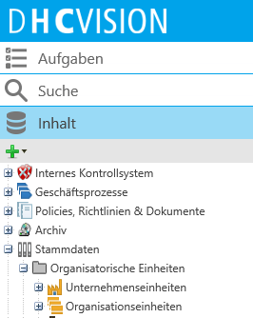
Fig. 30 Filing structure of the organizational units
Different metadata is available to describe the organizational units. This is illustrated using the "organizational unit" type as an example:
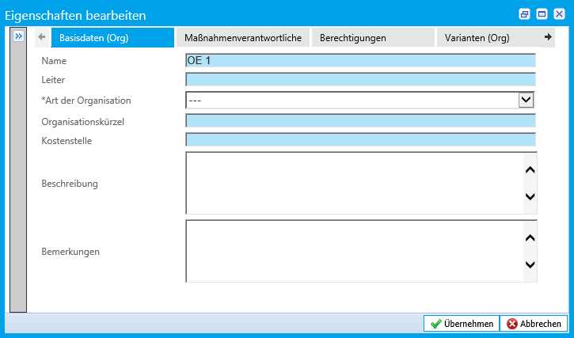
Fig. 31 Metadata of an organizational unit

authorizations
Authorizations are assigned via reader and author groups directly on the object.

Versioning and revision
Organizational units are not versioned and therefore do not need to be released. After Attachment in the Master data, they can be linked to individual processes in process models via the R-A-C-I logic. A revision has a direct effect and is immediately visible to everyone.

Translation
Organizational units can be translated. During translation, the name and metadata are translated. The translation is released directly so that translated organizational units can be viewed directly by the reader.

Multi-client system
In a derived client, a distinct organizational unit can be
- additional risks are recorded or centrally defined risks for this client are "deleted".

Management of IT applications
IT applications are of particular importance in ICS management, as controls are partly executed automatically by IT systems. By managing IT systems as Master data, these can be linked to various process steps in processes. This makes it possible to identify whether IT applications are involved in processes with control execution. Documents can also be linked to IT applications by maintaining the "IT application" attribute in the document properties.

Create and edit
IT applications are managed in the "Master data" view in the "IT applications" structure element. Metadata can be created for an IT application.
IT applications can also be assigned documents from policy and guideline management.

authorizations
Authorizations are assigned via reader and author groups directly on the object.

Versioning and revision
IT applications are not versioned and are therefore not subject to a release process. A revision has a direct impact and is immediately visible to everyone.

Translation
IT applications can be translated. During translation, the name and metadata are translated. The translation is released directly so that translated IT applications can be viewed directly by the reader.

Multi-client system
In a derived client, the following can be assigned to an IT application
- additional risks are recorded or centrally defined risks for this client are "deleted".
- Additional documents can be created.

Management of risks and controls
Risks that must be considered as part of ICS management can arise in the organizational structure, the process organization and in the IT applications. It is therefore necessary for these to be considered comprehensively and transparently at all three levels. The dovetailing and definition of the detailed dependencies of the 3 levels takes place via the process organization (see "Modeling of business processes"). The risks must be evaluated (gross evaluation) and, based on this, the additional handling of the risk (risk treatment) must be determined. If a decision is made to minimize risk, controls must then be defined, implemented, activated and executing. These controls should reduce the risk values (gross values) and lead to an improved evaluation (net evaluation).

Definition and evaluation of risks
Risks are managed in several steps. First, risks must be identified, created and defined. The risk is assigned to a process, an organizational unit or an IT application according to its level. In the definition, the risk is described and the causes and effects are formulated. In the next step, the risks are evaluated on a qualitative and quantitative level. Mathematical calculations can be used to calculate the extent of damage if a risk occurs. The results help with the decision on the complete risk treatment. The details of the steps are described in the following sections.

Create and edit
The creation of risks is identical at the different levels, the object of the risks is different. In DHC VISION, the risk object for the management level is the organizational unit, for the process level it is the process and for the IT level it is the IT application.
For the Attachment of risks, the corresponding organizational unit, the corresponding process or the corresponding IT application is selected and a risk is defined by creating a new information object. The following metadata can be created for a risk:
Attribute | Format | Description
Name | Character string (255) | Name of the risk
Risk field | Selection box | Classification of the risk, e.g. process risk, information risk, ...
Risk description | Character string | Description of the risk in detail
Assumptions | Character string | List or description of the assumptions that led to the creation of the risk.
Causes | Character string | List or description of the causes that are decisive for the risk.
Effects | Character string | Description of the impact in text form if the risk is not subject to additional evaluation.
Risk identifier | Character string | The person who initially defined the risk. He subsequently serves as an additional contact person.

Furthermore, additional documents can be created for risks that contain additional in-depth information on the corresponding risk.
All risks for a risk object are automatically summarized in a risk portfolio. This creates a risk list for each risky object.
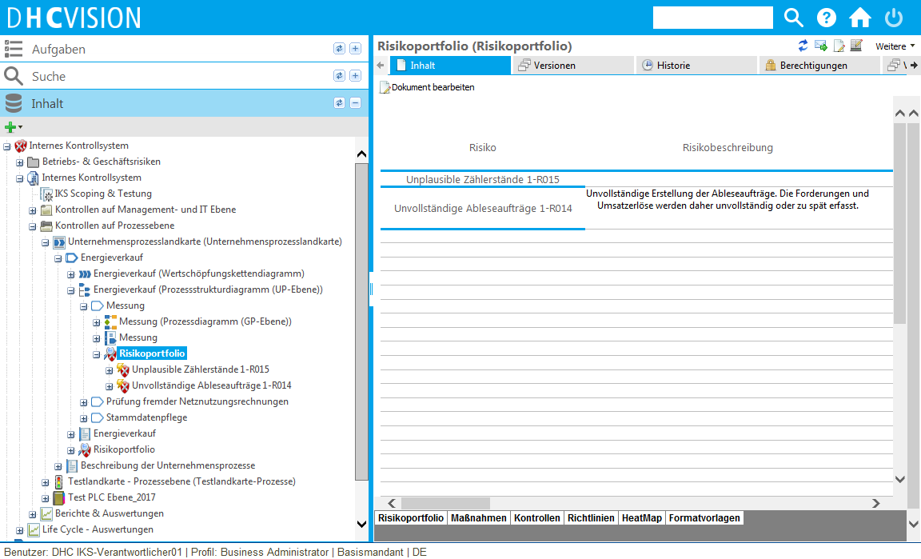
Fig. 32 Risk portfolio with risk list

Evaluation of risks and risk treatment
Once a risk has been identified, it should be evaluated in the next step. The following assessment techniques are stored in DHC VISION:
- Qualitative Evaluation
- Quantitative Evaluation
Attribute | Format | Description
Quantitative valuation methodology
Amount of loss (T€) | Number | Amount of loss in € value if the risk materializes
Probability of occurrence | Number (0-100) | Percentage probability that the risk will occur under the defined assumptions.
Risk treatment | Selection box | Definition of the additional handling of the risk. Possible values are  - Avoid  - Transfer  - Reduce (by defining controls)  - Share  - Accept
Net loss amount (€ thousand) | Number | Loss amount of the residual risk in € value
Net probability of occurrence | Number (0-100) | Percentage probability of occurrence of the residual risk
Qualitative evaluation methodology
Amount of damage | Selection box | Possible values for defining the amount of damage are  - Very low  - Low  - Medium  - High  - Very high
Probability of occurrence | Selection box | Possible values for defining the probability of occurrence are  - Very low  - Low  - Medium  - High  - Very high
Risk treatment | Selection box | Definition of the additional handling of the risk. Possible values are  - Avoid  - Transfer  - Reduce (by defining controls)  - Share  - Accept
Net loss amount | Selection box | Possible values for defining the amount of damage are  - Very low  - Low  - Medium  - High  - Very high
Net probability of occurrence | Selection box | Possible values for defining the probability of occurrence are  - Very low  - Low  - Medium  - High  - Very high

When evaluating risks, a distinction is made between evaluation before controls (gross value) and evaluation after controls (net value). Evaluation before controls (gross value) means that the risk value is determined without risk treatment measures, i.e. the initial value. Evaluation after controls (net value) takes into account the defined controls, assuming that the controls are effective. This net value is also referred to as the residual risk value.
In the qualitative evaluation, the expected loss value is calculated from the product of the possible probability of occurrence ([1]: Very low, [2]: Low, [3]: Medium, [4]: High, [5]: Very high) and the possible amount of loss ([1]: Very low, [2]: Low, [3]: Medium, [4]: High, [5]: Very high).
In the quantitative evaluation, the expected loss value is calculated from the product of the possible probability of occurrence (as a value between 1 and 100) and the possible amount of loss (as a value in thousands of euros).
Using configurable conversion formulas, it is possible in DHC VISION to convert quantitative evaluations into qualitative evaluations.
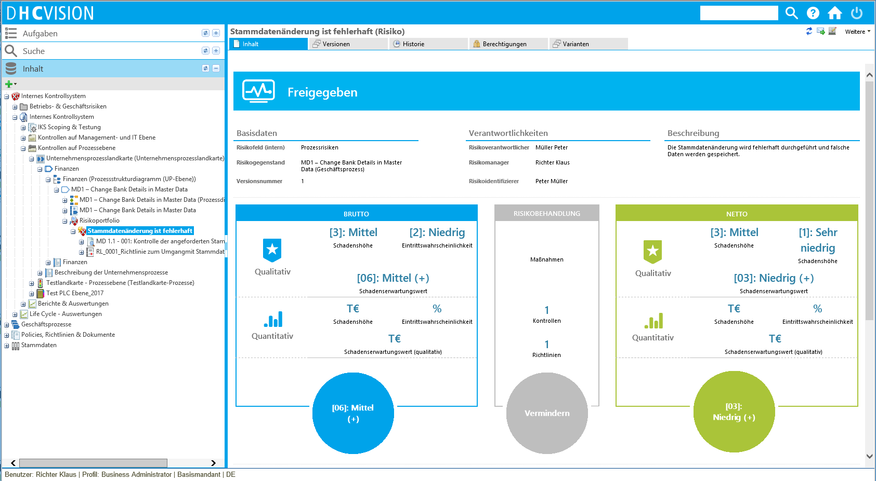
Fig. 33 Risk assessment
In order to achieve the expected loss value of a risk from gross to net, risk treatment measures must be implemented. Corresponding controls must be defined in the ICS environment.
The evaluated risks for a risk object can be viewed in a heat map display in the risk portfolio. The risk movement can be observed through the visual gross-net comparison.
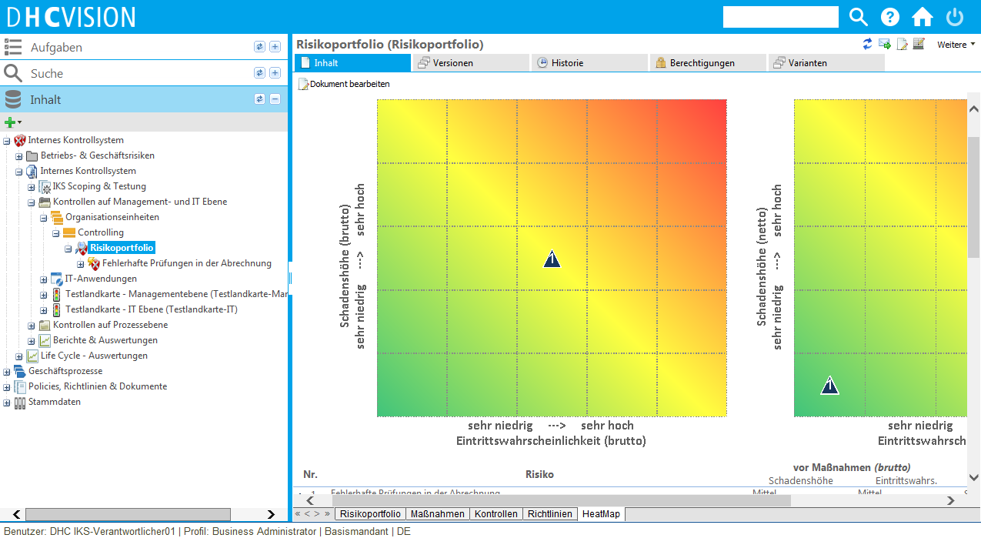
Fig. 34 Risk portfolio and representation of the heat map

authorizations
The authorizations of a risk are automatically controlled via the higher-level object, the risk object. In this way, a risk in a process receives the authorizations of the process.

Definition of controls
As described above, controls depend on the risks for which they are defined to minimize risk. As risks can be identified for the organizational structure, the process organization and for the IT applications, the corresponding controls are assigned to these levels, the control levels.

Control levels
DHC VISION supports 3 control levels:
Controls at management level
Controls at management level (known as company level controls or entity level controls) are primarily management control activities that are documented at company level, at subsidiaries or at the respective business unit. These do not necessarily relate to a specific business process, but are of great importance for the business processes as a whole and form the basis for assessing the entire ICS. Furthermore, management controls can be used to regularly review process controls. The respective management is responsible for the implementation of these controls. For this reason, management controls are maintained at organizational units in DHC VISION.
Controls at process level
Controls at business process level are documented together with the process flow. Depending on the occurrence of risks, controls can be executed at all levels of the process pyramid. The controls defined for a process can then be assigned to the corresponding process steps in an existing process flow.
Controls at IT level
The high importance of and dependence on information technology (IT) make controls over the essential systems essential. The reliability of automated data processing depends on various supporting IT components, such as networks, databases and operating systems. IT controls essentially describe controls that are executed automatically by IT systems. They are useful to define, among other things, when controls are executed by the same IT application in different processes.

Create and edit
In order to achieve the net expected loss values of a risk, controls must be defined. To do this, a new information object of the type "Control" is created for the risk. The following metadata can be created for a control:
Attribute | Format | Description
Name | Character string (255) | Name of the control
Key control | Selection field | Possible values are:  - Yes  - No  If it is a key control, this can have an impact on the subsequent testing of the controls. If controls are tested for a process and a key control is not effective, the entire process can be considered non-compliant with the ICS. All additional controls in this process no longer need to be tested.
Mode of action | Selection field | Possible values are:  - Preventive  - Detective
Control frequency | Selection field | Possible values are:  - Daily  - Weekly  - Monthly  - Quarterly  - Annually  - On request
Type of implementation | Selection field | Possible values are:  - Manual  - Automatic (in an IT application)
Control objective description | Character string | Objectives to be achieved with this control
Control description | Character string | Description of the tasks to be carried out by the control executor during the execution of the control.
Evidence required | Character string | Description or list of the evidence that must be provided in order for the inspection to be defined as successful or unsuccessful.
Control characteristics | Selection field | Possible values are:  - Centrally defined  - Locally defined  If a control is defined centrally, it first of all applies to all locations and Company units of the company. If it is defined locally, it only applies to a specific Company unit.
Control effective since | Date | For migration purposes, the date from which this control has already been successfully implemented in the company can be created here.
Transaction code/Service ID | Character string | If it is an IT control, the exact service of the IT application in which the control is executed can be defined here.
Control level | Selection field | Possible values are:  - Management level  - Process level  - IT level
Assignment to process steps | Selection field | If the control is a control at process level, it can be assigned to one or more individual process steps in the process flow if there is a process flow. Existing controls are then displayed graphically in the process model at the process steps.

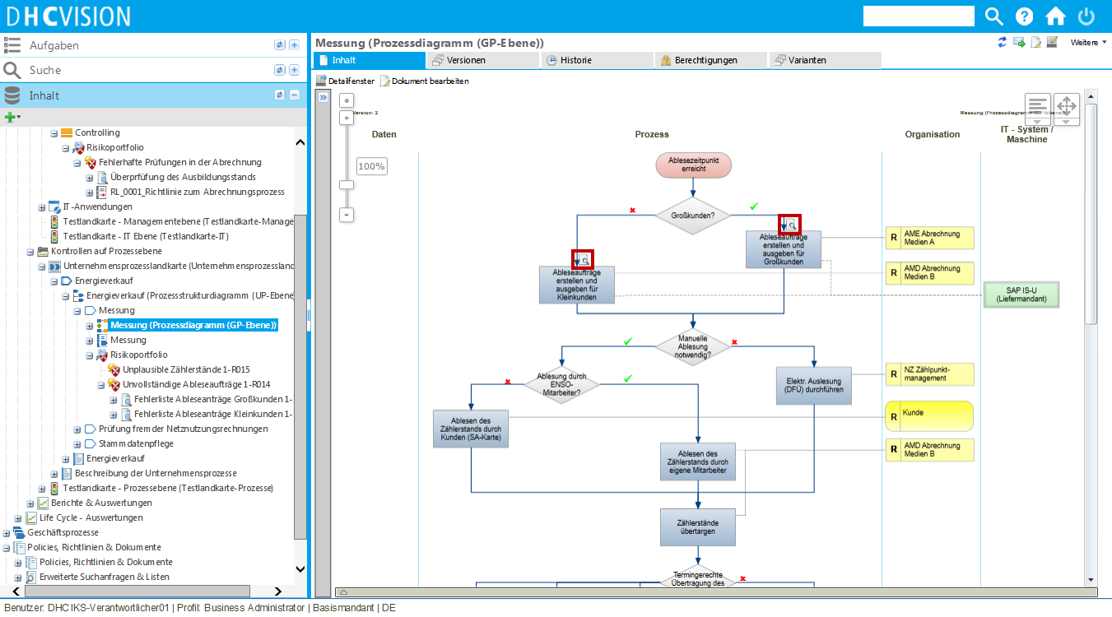
Fig. 35 Representation of assigned process controls in the process diagram
Furthermore, additional documents can be created for controls, which contain additional detailed information on the corresponding control.
Templates for the control records can be stored for the controls. These templates can be Excel lists with status fields, for example, in which the individual activities during the inspection are listed and must be processed via the status field. These templates are later instantiated for each inspection execution order so that the person carrying out the inspection can fill them in when processing the inspection.

authorizations
Author/Co-Authors (AUTHOR)
If users are assigned to the "Authors" User Groups by the technical administration, they are offered in the selection list of the author or co-author of the respective control. When assigned, each of the authors receives read and write authorizations on the control itself and all details, such as the attachments.
The Creator of a control is automatically confirmed in the "Author" field. However, this default value can be changed at any time and the authorizations passed on as a result. In addition to the actual author of a control, additional personal change rights can also be assigned via the "Co-authors" attribute. Co-authors have no relevance within the release workflow.
Reviewer (AUTHOR)
A reviewer basically checks the content of a control according to technical and formal aspects. As both requirements exceed the capabilities of a single reviewer, several reviewers can be used in the review step. In this case, one reviewer confirms the technical check and the other the formal check. If users are assigned to the "Reviewer" User Groups by the technical administration, they are offered in the selection list of the reviewer at the respective check. When assigned, each reviewer receives read and write permissions on the check itself and on all details, such as the attachments.
Releaser (AUTHOR)
A releaser is responsible for the control. He decides whether a control is to be distributed in this form to those responsible for the control. If users are assigned to the "releaser" user group by the technical administration, they are offered in the releaser's selection list for the respective control. When assigned, each releaser receives read and write permissions on the control itself and all details, such as the attachments.

Release of risks and controls
Risks and controls are in the status in progress when they are created and are initially not valid. To make risks and controls visible to all authorizations, they must be released or activated.

Release of risks
The release of risks for a risk object, i.e. organizational unit, process or IT application, takes place via the risk portfolio or via the release of the risk object directly. Release via the risk portfolio can take place directly (without the dual control principle) or via a workflow (with the dual control principle).
The following is a brief outline of the workflow for release using the dual control principle.
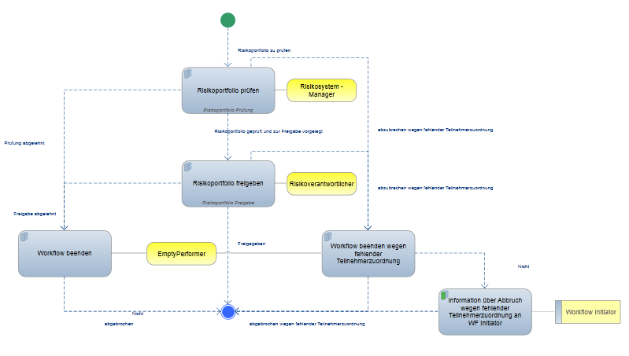
Fig. 36 WF process for the release of risks contained in the risk portfolio

Release of controls
During the release, the control design is reviewed and released. In DHC VISION, the check and release of the control design is workflow-supported. The following process is available for this purpose:
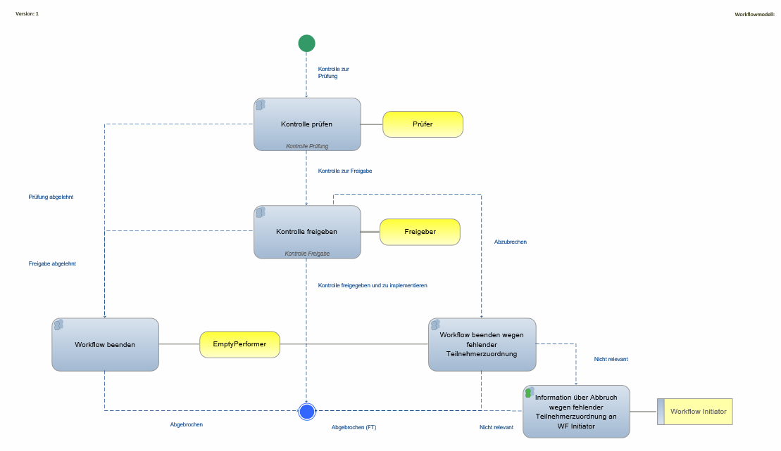
Fig. 37 "2-step" release with reviewer and releaser
Reviewers and releasers are defined at the Control in the "Control" category. Several reviewers and releasers can be entered. All registered reviewers must confirm the inspection. For the release, confirmation by a releaser is sufficient for the inspection to be released.
Once the design has been released, the control must be activated or implemented. The control can only be executed after activation. The time for activating the control is defined as part of the release.

Activation of controls
In order for the checks to be executed and documented with system support, they must be activated in the system. Only after activation are the controls created as workflow tasks according to their control cycle and can be executed. This activation phase serves to implement the control in the company. The control is activated automatically on the activation date defined in the release.
The activation step is triggered by the release of the control. An email is sent to all defined control owners asking them to implement the control. The implementation of the control itself is an organizational process in which the person responsible for the control names his control executors and trains them accordingly in the execution of the control. The control is activated implicitly at the end when the person responsible for the control stores the control executors in the system.

Versioning and revision of risks and controls
Controls and risks are managed in DHC VISION in versions and are subject to a life cycle. Changes to released risks and controls automatically lead to new versions. These versions "in progress" are initially not valid and must be released or activated. Only then is the corresponding version visible again to all authorizations.

Dashboard and evaluations
The evaluation options available in ICS Management for each role are described below. Role-specific dashboards for the ICS are currently in the design and development phase and are therefore not yet included in the current scope of delivery.

IKS Manager evaluations
Risk control matrix
The 3 reports on the risk control matrix (management level, process level, IT level) list the coverage of the respective objects (organizational units, processes, IT applications) with risks and corresponding controls.
Status of the checks carried out
The report uses extensive selection criteria to list all current inspections. A traffic light system allows you to see directly whether control executions have not been carried out and whether they are already overdue.
Status of control responsibility
The report uses extensive selection criteria to list all controls for which the responsible person is responsible. You can view the current status of each control.

Evaluations by the person responsible for control
My control responsibility
The report uses extensive selection criteria to list all the controls for which I am responsible person. You can view the current status of each control.
Status of the checks carried out
The report lists all current inspections using extensive selection criteria. A traffic light system allows you to see directly whether control executions have not been carried out and whether they are already overdue.

Evaluations of control executors
My inspections
The report uses extensive selection criteria to list all my current inspections. A traffic light system allows you to see directly whether control executions have not yet been carried out and whether they are overdue.

Translation of risks and controls
The translation function in DHC VISION allows a language-dependent display of released risks and controls. The translation can only be carried out for content (e.g. risks and controls) and documents whose original language version is in the "Released" state.
In risk and control management, only the used and manually maintained attributes are translated. DHC VISION supports the user with the translation by means of a translation dialog. By default, German or English is available as the translation language, depending on which was defined as the initial maintenance language.
For versioned objects, such as risks and controls, the translation is released without a workflow. This requires direct release via the translation dialog. The content is only visible to readers in the translated language once the translation has been released directly.

Multi-client system

Risks in the multi-client system
For a risk object (organizational unit, process, IT application), you can define whether risks can be changed on a client-specific basis. New risks can be added to a client and transparent risks can be deleted. However, transparent risks cannot be changed in the client. The release of new risks is carried out using the processes described above for the respective client.

Controls in the multi-client system
For each control in a multi-client system, you can specify whether the control is relevant in the client or not. If it is not relevant, it is not displayed, i.e. it is invisible.
You can also specify for each control whether the control may be adjusted in the client or not. If it is adjusted, the client-specific values are superimposed on the original data. The client-specific modified controls must be released and activated using the processes described above.
In a multi-client system, the respective control managers and control executors are defined for each control for each client. The processes for activating and executing a control run separately for each client as described above.

Implementation phase
In the execution phase, the controls are carried out by the relevant control executors with system support. Inspection results and evidence can be created for each inspection.

Execution of controls
The execution of controls is workflow-supported. The workflow tasks are started automatically according to the defined control cycle and distributed to the person responsible for carrying out the control for completion. Controls can also be started manually under certain circumstances.
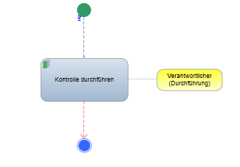
Fig. 38 Process for the execution of the control
The person responsible for execution receives a workflow task in which they can carry out the check, document it and store the corresponding evidence.
To complete the control execution, he must complete the workflow task.
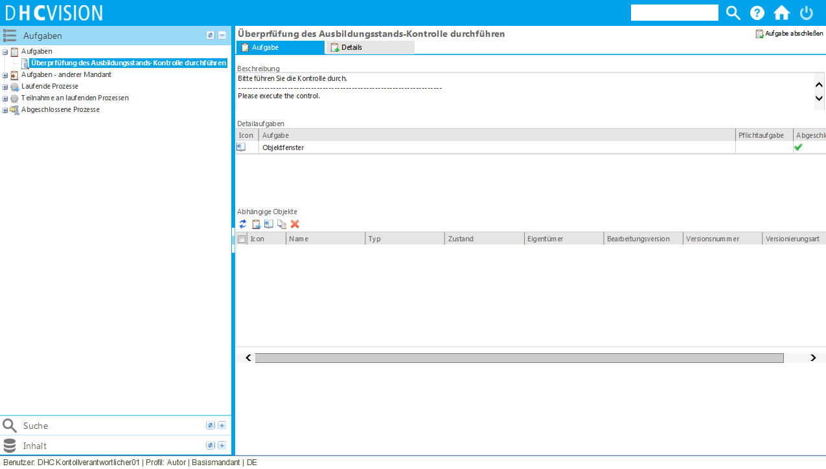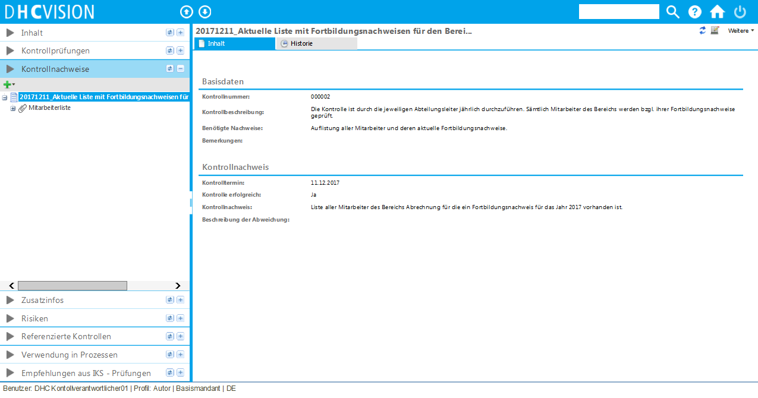
Fig. 39 Workflow task for carrying out checks

Test phase
The effectiveness and design of the company's controls must be reviewed as part of an end-of-year audit. The audit can be carried out both internally and by external reviewers (e.g. auditors). The result is recorded in the annual report. The controls are tested in 3 successive phases:
- Scoping phase
- Test phase
- Year-end report
In the scoping phase, the control test scope is defined at control level. The aim of this phase is to avoid having to execute a 100% full-scope test every time. Scoping is intended to reduce the testing effort without negatively affecting the quality of the test results. It is therefore important that appropriate scoping mechanisms are developed and documented in advance.
In the test phase, the control tests are then carried out for the controls defined as relevant in the scoping. These test results are summarized in the annual report.

Definition of test maps
In order to be able to test controls in relation to year-end testing, all relevant objects (organizational units, business processes and IT applications) must first be identified. This identification is carried out using test maps.
The person responsible for the ICS can use the test maps to gain an overview of the control objects available in the company. The test maps are also used to track ongoing control tests. Test maps can be maintained for all three control levels (management, process and IT level).
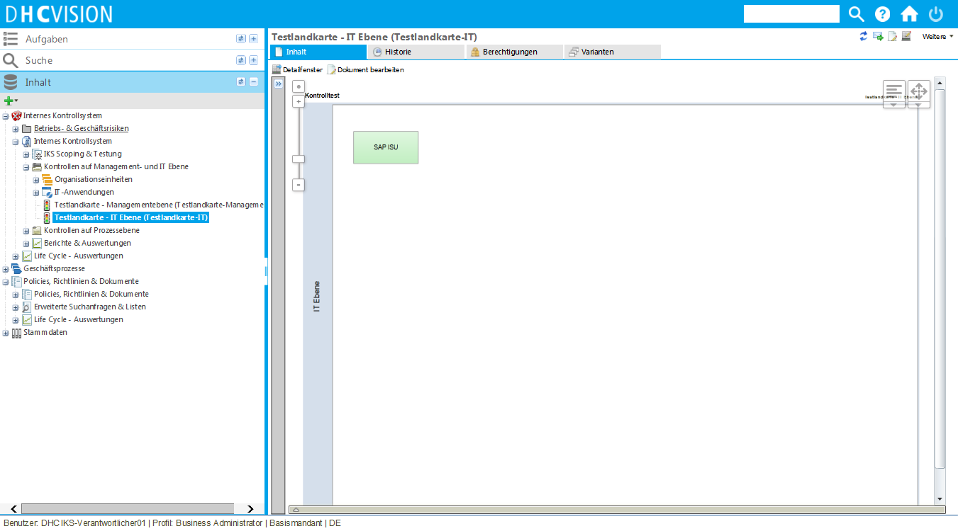
Fig. 40 Example of a test map of the IT control level
A test map is modeled using MS Visio. Existing organizational units, IT applications and processes in the system can be reused in the modelling via the DB search of the DHC VISION add-ins.
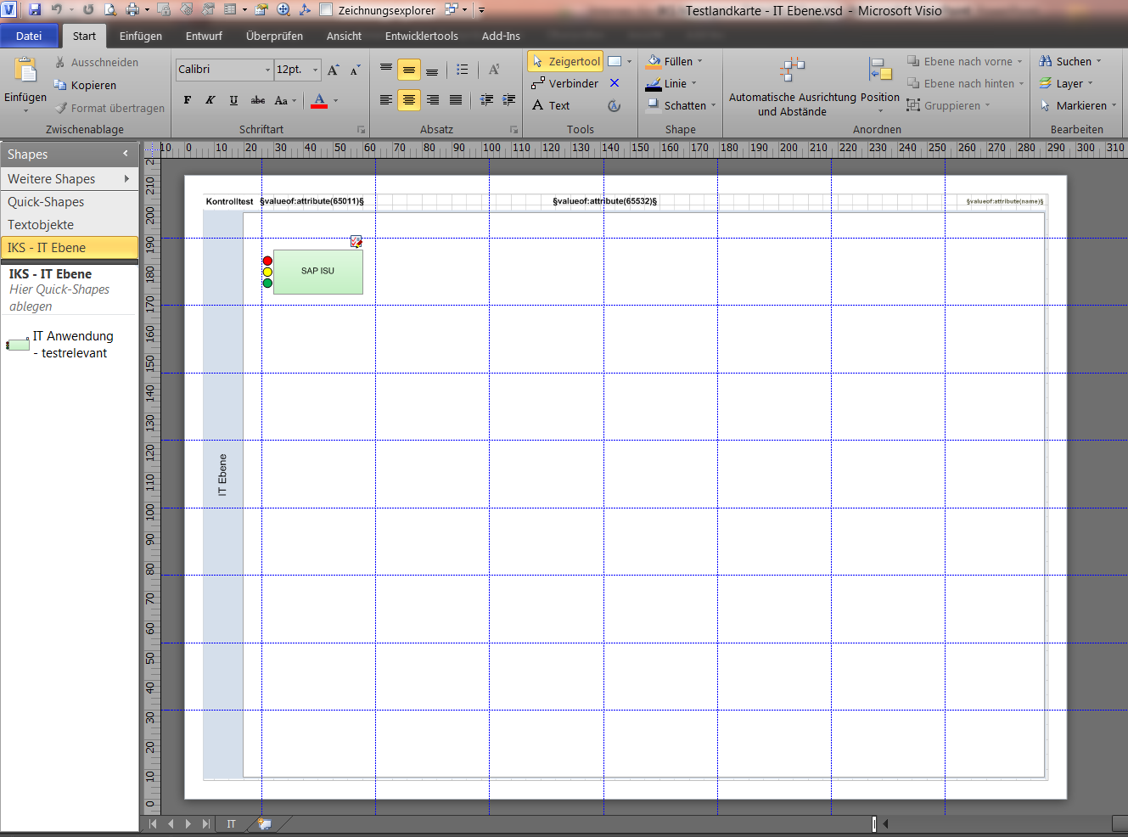
Fig. 41 Modeling the test maps using MS Visio

Scoping
In the scoping phase, the scope of the checks to be tested is defined. The system automatically reads all the controls for the objects defined on the respective test maps. A separate scoping table is generated for each control level. Using the generated table, the scope can be checked and, if necessary, adjusted by setting or removing controls from the test scope within the MS Excel integration.
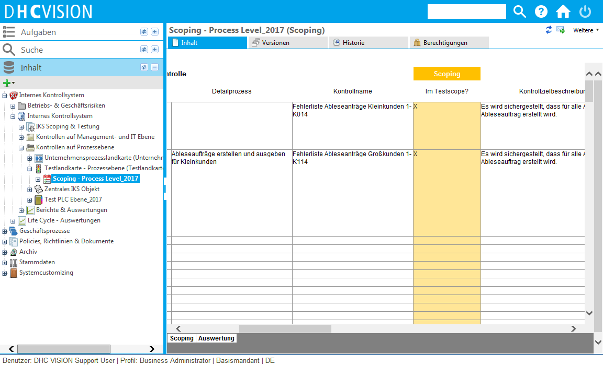
Fig. 42 Representation of the scoping objects and table
The scoping phase is started and ended by editing the properties of the "ICS scoping and testing" object. Scoping is restarted for each year and each control level.
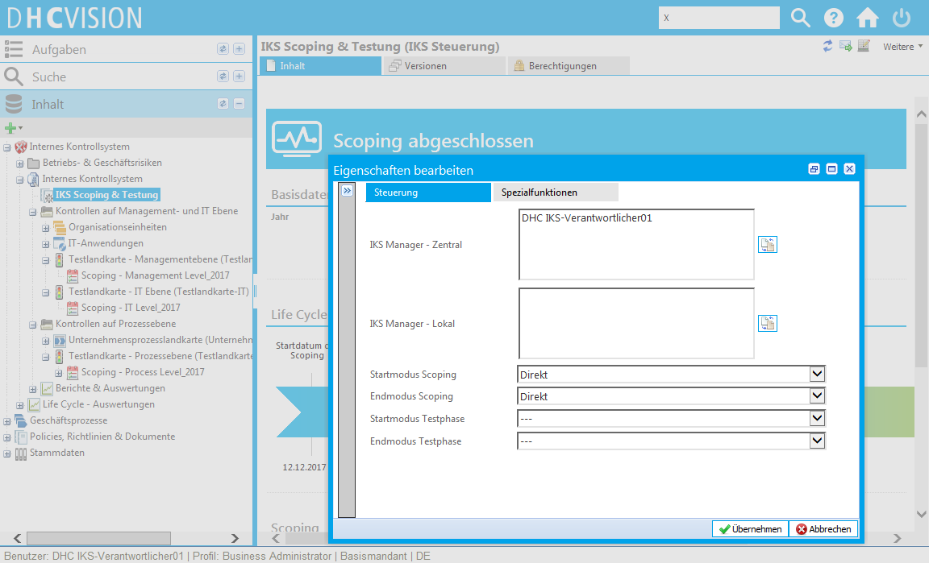
Fig. 43 Properties dialog for starting and ending scoping

Testing
Once the scoping phase is complete, the test phase begins. As in the scoping phase, the test phase is controlled via the property processing of the "ICS scoping and testing" object. When testing is started, the system creates a test report for each control level. The test report summarizes the results of the control tests. Testing can be carried out by both internal and external testers (= auditors).
In a first step, an internal tester can be defined for each control test to be carried out. The individual testers are defined via the test report. Once the testers have been defined, the workflows for the execution of the internal tests can be started for these control tests . For each control test, the respective tester receives an email asking them to execute the test. Once they have executed the test, they must complete the workflow task.
No workflow is started for the control tests for which no explicit tester is stored. The test can be executed explicitly for these.

Internal testing
A control test object is generated for each control that was defined as relevant for testing in scoping. A test protocol is also created for each control test object. The control tester opens the test protocol and evaluates the relevant control according to design and efficiency. To evaluate the control by design, he must check whether the control still exists and whether the design of the control still corresponds to the control objective description. He documents the results of his design test in the test log and can also make recommendations for improving the control design. These recommendations can later be viewed by the person responsible for the control and the control can be adjusted accordingly if necessary.
In a second step, the tester must then check the efficiency of the inspection. To do this, the system proposes a number of random samples to the tester according to the risk classification and inspection frequency. The tester notes each sample with the individual test result in the test log. At the end of the random sample test, the tester decides whether the control is efficient or not. If the tester has improvements to the control efficiency, he can note these in the test protocol. These recommendations can later be viewed by the person responsible for the inspection and the inspection can be adjusted accordingly if necessary.

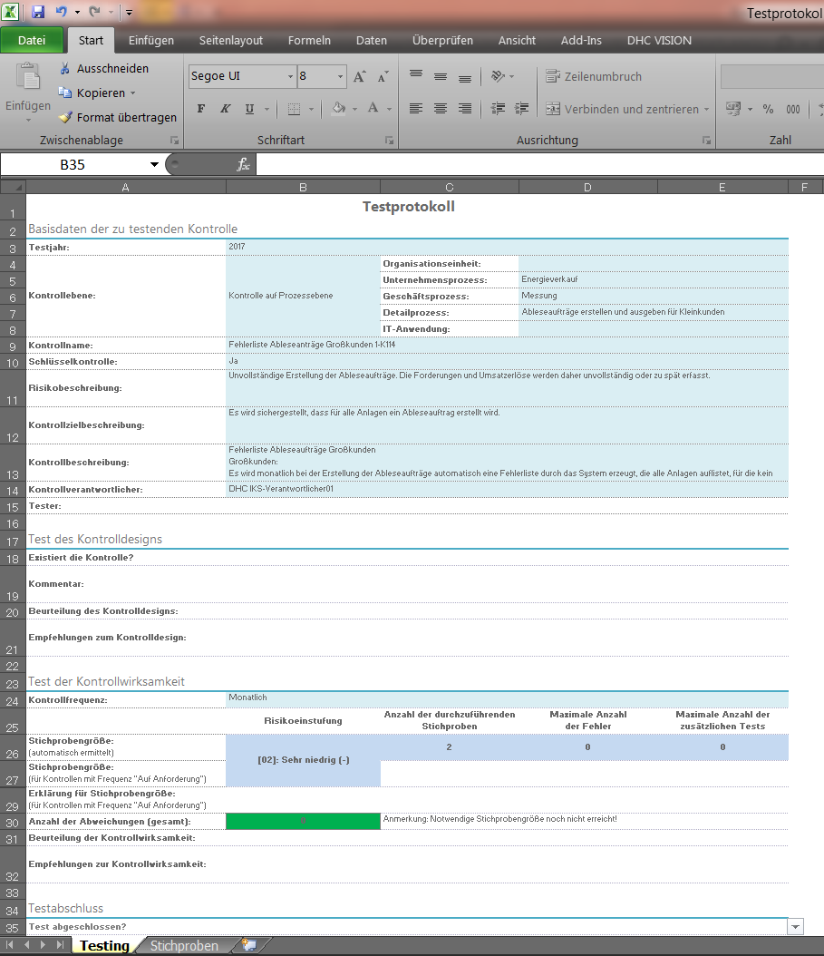
Fig. 44 Maintaining the test log by internal testers in Excel

External testing
A separate test report is provided for the test results from the external test. This can be loaded from DHC VISION using the check-out function and provided to the auditors in Excel format for processing. Once the report has been processed, it is checked back into DHC VISION.
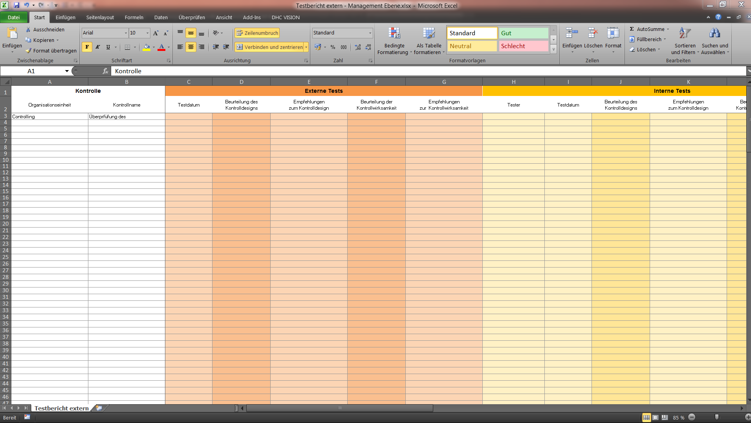
Fig. 45 Editing the external report in MS Excel
An overview of the progress of ongoing tests is possible via the test map. Results that have already been created are also graphically displayed here using a traffic light scheme.
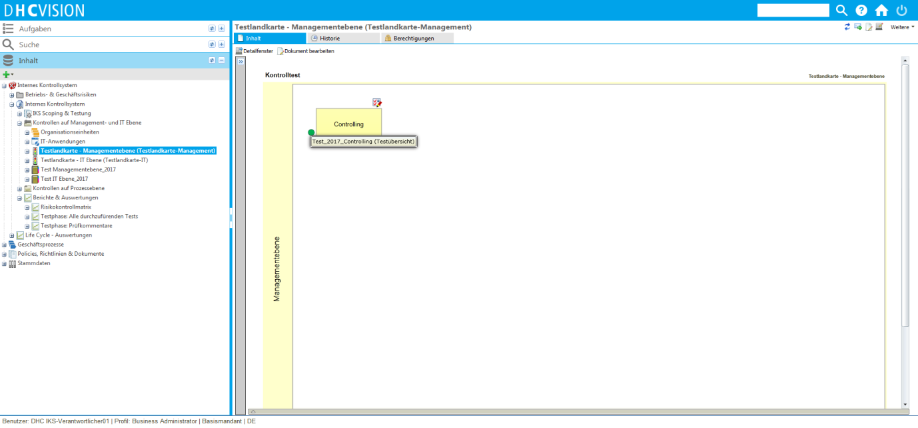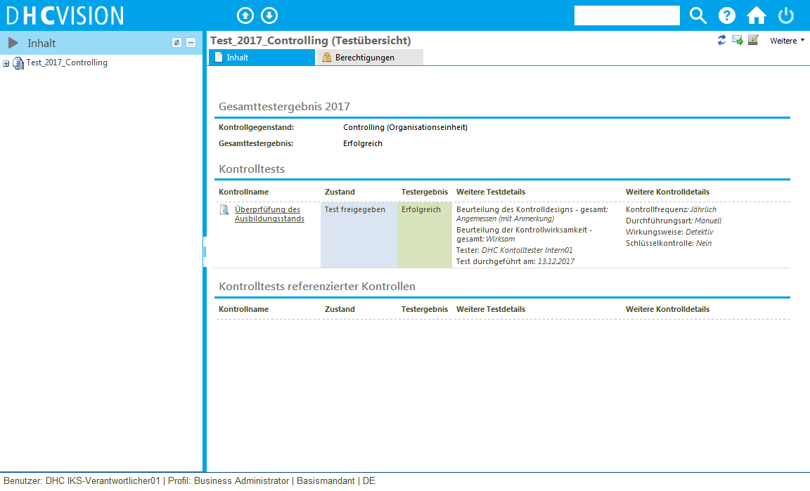
Fig. 46 Presentation of the comprehensive test report

Creator of the annual report
The results from internal and external testing are summarized in a comprehensive test report and can be adjusted again in their overall assessment. The test phase is concluded again via the ICS control object. Closure can only take place once all defined control tests have been completed. Once testing is complete, a new scoping and test phase can be initiated.
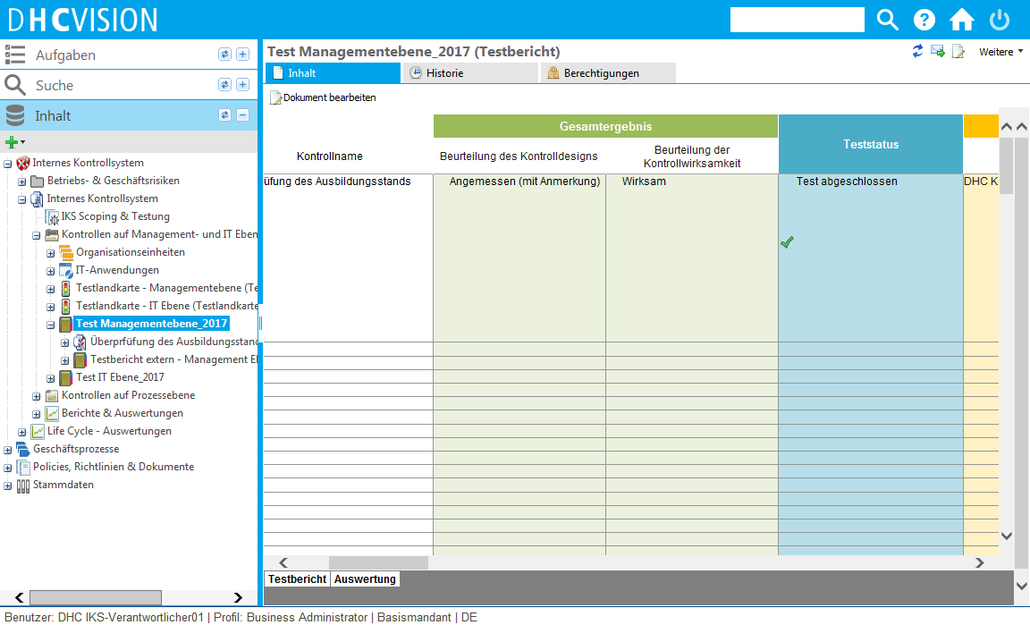
Fig. 47 Presentation of the comprehensive test report

Test phase in the multi-client concept
For each client, you can specify whether a client is relevant for testing or not. If a client is identified as relevant for testing, the test process runs as described above.
If a client is defined as not relevant for testing, scoping and testing cannot be started.

Roles in the internal control system
The following table lists and describes the specialist roles of ICS management.
Professional roles | Description
reader | Readers can only view approved objects. For each object, you can decide again which reader may or may not view this object.  Users in these groups can take note of processes and documents and document their acknowledgement with a signature. Additional subgroups can be assigned to these groups, e.g. location-specific User Groups.
Process owner | Process owners are responsible for the strategic management of an end-to-end process. They are therefore responsible for the goal-oriented design, execution and control of the respective process. The focus of their actions is on the target orientation of their own process, the interactions with other processes and the selection of sustainable key figures. Furthermore, the process owner is fundamentally responsible for the release of the process.  If users are assigned to the "Process owners" user group by the technical administration, they are also offered in the selection list of process owners for the respective process. When assigned, process owners receive read and write permissions to the process itself as well as all details such as process models or risks. The process owner is also proposed as a releaser for the process in the release workflow.
Process manager | A process manager supports the process owner and coordinates tasks and activities relating to the process. They should have the necessary authority to optimize the process if required and to manage the process consistently in order to ensure the delivery of an optimal work result.  Users who are assigned to the "Process manager" user group by the technical administration are offered in the process manager's selection list for the respective process. When assigned, the process manager receives read and write permissions to the process itself with all details, such as the process models. The process manager is also proposed as a reviewer for the process in the release workflow.
Process team | This is a group of process stakeholders and process management specialists who constantly measure the actual process performance and take immediate countermeasures if deviations from the PLAN are detected. This means that these employees not only have an overview of their respective sub-tasks, but also of the best possible functioning of the entire process. The exact distribution of tasks and resource/quantity planning are executed here together with the process manager.  Users who are assigned to the "Process team" user group by the technical administration are offered in the selection list of the process team for the respective process. When assigned, each individual process team member receives read and write permissions to the process itself with all details, such as the process models. They are also proposed as co-authors for the process in the approval workflow.
Process modeler | This is a position or role whose core task is to be able to document processes in a notation.  Users who are assigned to the "Process modeler" user group by the technical administration can model the process models at the "Business process" and "Detailed process" level.
Author | If users are assigned to the "Authors" User Groups by the technical administration, they are offered in the author or co-author selection list for the respective document. When assigned, each author receives read and write permissions on the document itself and all details, such as attachments, additional information and Change proposals.
reviewer | A reviewer basically checks the content of a document according to technical and formal aspects. As both requirements exceed the capabilities of a single reviewer, two reviewers are often used in the review step. In this case, one reviewer confirms the technical review and the other the formal review.  If users are assigned to the "Reviewer" user group by the technical administration, they are offered in the reviewer's selection list for the respective document. When assigned, each reviewer receives read and write permissions on the document itself and on all details, such as attachments, additional information and Change proposals.  If the check is a process (document type: process instruction), the process manager of the process is suggested as the reviewer.
releaser | A releaser is responsible for the document itself and its content. He decides whether a document is distributed to readers in this form and must be acted upon in accordance with the requirements in the document. If users are assigned to the "releaser" user group by the technical administration, they are offered in the releaser's selection list on the respective document. When assigned, each releaser receives read and write permissions on the document itself and all details, such as attachments, additional information and Change proposals.  If the release is a process, the person responsible for the process is proposed as the releaser.
Risk officer | The person responsible for risk is responsible for risk identification, evaluation of a risk and additional implementation. At the same time, they are responsible for efficient risk reporting to management. If users are assigned to the "risk owner" user group by the technical administration, they are offered in the risk owner's selection list for the respective risk. Upon assignment, the risk owner receives read and write permissions on the risk itself and all details, such as any controls.  If it is a process risk, the person responsible for the process is proposed as the risk owner.
Risk manager | The risk manager supports the person responsible for risk in creating and evaluating risks as well as handling risks via measures and controls.  If users are assigned to the "Risk manager" user group by the technical administration, they are offered in the risk manager's selection list for the respective risk. When assigned, the risk manager receives read and write authorizations on the risk itself and all details, such as any measures. If it is a process risk, the process manager of the process is suggested as the risk manager.
Control manager | The person responsible for controls is responsible for the documentation and correctness of their controls.  If users are assigned to the "Control managers" User Groups by the technical administration, they will be offered in the selection list of control managers in the control execution of the control.
Control executor | The control executor executes manually defined controls operationally according to their frequency and documents this with control evidence.  If users are assigned to the user group "Control executor" by the technical administration, they are offered in the selection list of those responsible for control execution.
Internal tester | The internal testers test the controls defined as relevant by the scoping and check them for design and effectiveness. They make recommendations to those responsible for processes and controls, which they must take into account in the next update phase.
External testers | The external testers check the design and effectiveness of relevant controls. They make recommendations to the process and control managers, which they must take into account in the next update phase.
Business Administrator / Central ICS Manager | The Business Administrator is a specialist "super user" who can execute the functions of all roles. He is responsible for the structure and consistency of the overall system. He is mainly responsible for Master data and data maintenance in the central client, but also has authorizations in the local clients across the entire client concept. The existing User Groups "Business Admin - ICS Management" is used for the Business Administrators. Business administrators must have a corresponding login profile for access at local level (alternatively, they can be assigned to the "ICS Manager (local)" group).
Local ICS Manager | The local ICS manager is the local person responsible for the ICS in the local clients. As the "local key user", they manage the local control responsibility and the transaction data in the system.  A local ICS manager group must be defined for each client. This must then be assigned to the "Main group - Local ICS managers".
Translator | A translator can translate all contents of the DHC VISION system into another language. It cannot create new objects independently.
Reviewer (translation) | A reviewer (translation) checks the correctness of the translation with reference to the original.  If users are assigned to the user group "Reviewer (translation)" by the technical administration, they are offered in the selection list of the reviewer (translation) on the respective document.
Releaser (translation) | A releaser (translator) confirms and is responsible for the accuracy of the translation with reference to the original.  If users are assigned to the "Releaser (translation)" user group by the technical administration, they are offered in the releaser (translation) selection list for the respective document.

The ICS process in a complex corporate structure
In a complex corporate structure, the ICS process described above can take different forms. The exact characteristics always depend on the detailed corporate structure.
The following questions need to be answered:
- Is the company one legal entity or does it consist of several legal entities?
- Will the processes, organizational units, IT applications, risks and controls be specified exclusively centrally or should local characteristics also be possible in the individual legal entities or locations?
- Are executions carried out at the individual locations or also at the central level or in the legal entities?
- Are the annual control tests executed in the individual legal entities or also at central level?
In DHC VISION, complex company structures can be mapped using clients. The client definition in DHC VISION is as follows:
- On the one hand, a DHC VISION client ensures a completed data unit vis-à-vis the clients at the same level. On the other hand, a DHC VISION client creates data transparency with its child clients, so that the child clients can generally view all the content of the parent client.
- Client hierarchies can be created in DHC VISION. The hierarchy levels are freely definable.
- Each DHC VISION client has exactly one parent client (except for the root client(s)).
- Each DHC VISION client has an original language in which the content in this client is created and edited.
- Translation languages can be added to each client, into which the contents of the client can be translated.

The client is therefore the highest level of order in DHC VISION and represents a data-related and organizationally completed unit in the system. The client therefore structures the use of the system.
In a multi-client-capable system, a distinction must be made between client-dependent and cross-client data and objects. Client-dependent data and objects are data, data presentations, processes and configurations that can be regulated individually for each client.
Cross-client data, processes and objects are used for the general and client-independent configuration of the system and are equally valid for all derived clients in a hierarchically structured client system.
In relation to an internal control system, a client can contain the following transaction data and configuration settings:
- Policies, guidelines and documents
- Processes/organizational units/IT applications
- Risks
- Controls
- Control feedthroughs
- Control tests
DHC VISION is delivered with a comprehensive client structure implemented. This delivery status is represented as follows:
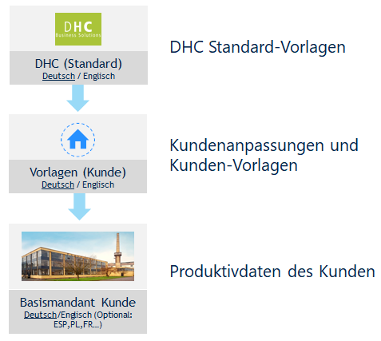
Fig. 49 Client structure in the DHCV delivery status
The principle corresponds to a hierarchical structure of predecessor and successor. The top client is represented by the "DHC (standard)". This contains the standard configurations, processes and templates of DHC VISION. Derived from this, and one level below, is the "Template (customer) client". Due to the hierarchy and the predecessor-successor relationship, the default settings are passed on from the top client to the clients below it. Consequently, the "Basic client customer" at the last level also has the settings of the two clients above it.
Customer-specific adjustments that deviate from the standard configuration and standard processes are made on the "Templates (customer)" client, so that the customer-specific settings apply to all subsequent or derived clients, in addition to the "untouched" standard settings.
The standard client model in DHC VISION can be extended both horizontally and vertically from the base client level. This is made possible by defining the predecessor client when creating new clients. This allows both client concepts of a client-dependent or cross-client data structure to be mapped.
The two forms of a client concept are then described and illustrated in detail.

Client concept for client-dependent data and processes
In a separate client system, in which client-dependent data and processes are used for each client, there is no upstream "central client" (with the exception of "templates (customer)") that specifies the data structures and processes. The clients, which work independently of each other, are located in parallel on one level.
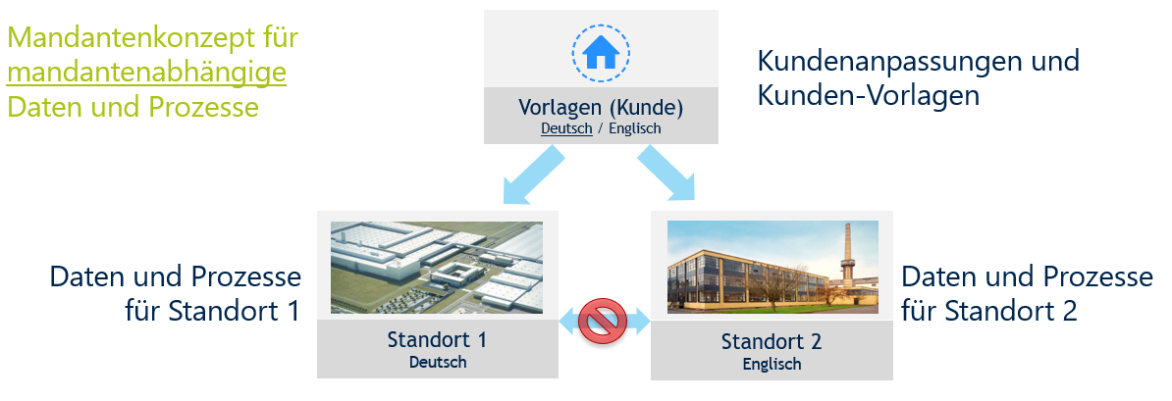
Fig. 50 Example structure for client-dependent data and process management

Client concept for cross-client data and processes
In a client system in which overarching data and processes are specified for derived clients, there must be an upstream "central client" that manages the centrally defined and standardized data structures and processes. The information is passed on to lower-level clients in accordance with the hierarchical structure.
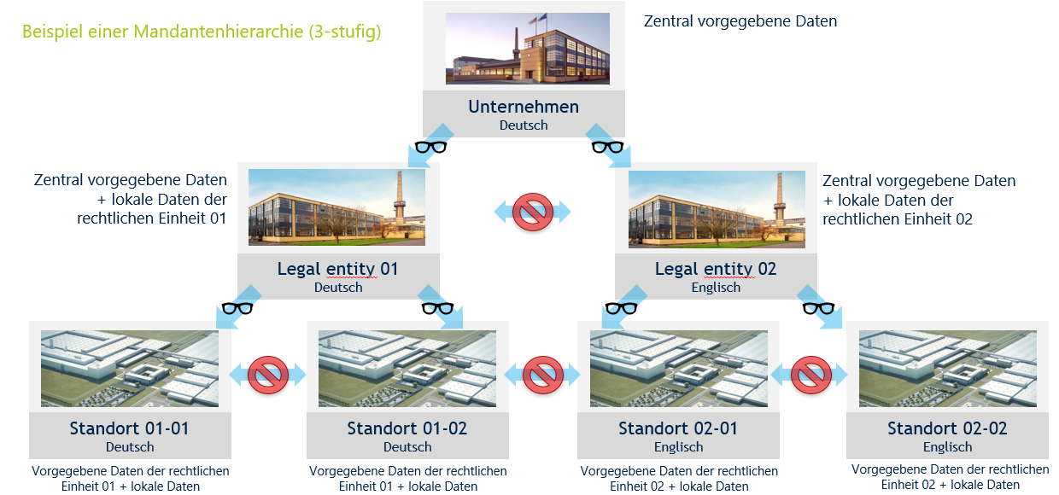
Fig. 51 Example structure for cross-client data and process management
Depending on the requirements or the internal circumstances with regard to centrally and locally available data and processes, mixed forms of the two client concepts can occur from a certain level.

Multilingualism of clients
In accordance with internationalization, several or different languages can be managed for each client in DHC VISION. Each client is assigned a language key as the original language (=initial language). Created information is coded with this language key. As long as there is no translated version of the original language, the information is displayed in the original language. This looks as follows for a multi-client concept:
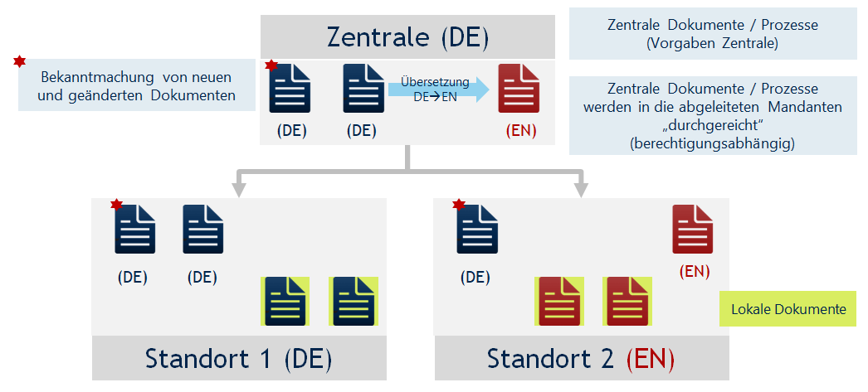
Fig. 52 Example structure for cross-client data and process management
English and German are included in the standard scope of delivery of the software. However, additional languages can be created as language keys. Corresponding translations for the newly created languages must be implemented additionally.
When using language, a distinction is made between surface language and content language.

Surface language
The interface language is the displayed language of the software application and includes the translation of the functions, resources and interface notifications. It is controlled by the language setting of the browser used and is therefore also referred to as the browser language. As already described, only the German and English languages are implemented in the DHC VISION standard. If a language other than German is selected in the browser, the user interface in DHC VISION always appears in English.
Example: Select browser language FR (=French) Display DHCV in EN (=English)
A technical extension of the interface language is possible.
It is easy to switch between interface languages when logging into the system. Here you can easily switch between the available interface languages. However, the selected setting only applies to the currently open session. The default value is set via the language setting in the browser.
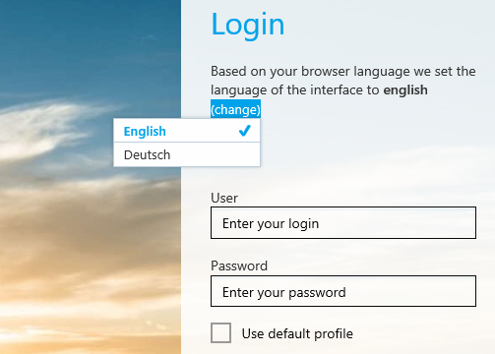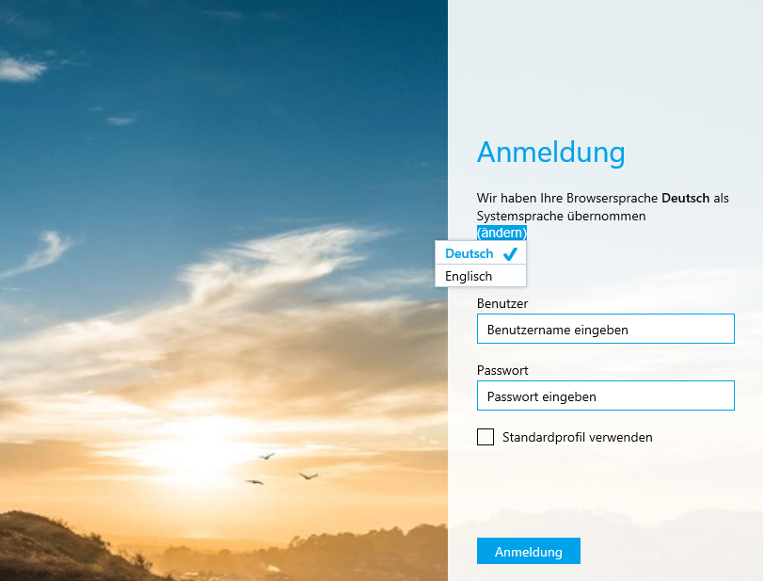
Fig. 53 Changing the interface language when logging into the system

Content language
The content language is the language and language setting that the user can select when logging into the system to display the created information, content and data (e.g. created documents, processes and information objects). Several content languages can be assigned to a client. To display the selected content language, the content must be translated into the corresponding language. Otherwise, the information is displayed in the initial language of the client in which the object was created. For versioned objects, it should also be noted that topicality takes precedence over language. This means that the most recently released objects/documents for which there is no other language version (translation) are always displayed in the latest initial language version, even if a language version exists for the previous version.

Fig. 54 Selecting the content language when logging into the system

Master data
The Master data relevant for ICS management in DHC VISION are:
- Keywords
- Reference catalog for controls
Master data is maintained by the Business Admin group. The handling of ICS-relevant Master data is described below.

Keyword management
Keywords are used to index certain topics or subject areas. By assigning them to documents, the documents are categorized according to specific topics, which also improves the search results.
Like all Master data, Keywords are created and managed in the "Keywords" structure element in the Master data view. A release is not required. The assignment to the document is made via the document properties in the "Keywords" attribute of the same name.

Management of reference catalogs for controls
As the person responsible for the ICS, it is possible to create control catalogs with corresponding categorization in groups under the "Master data" view in DHC VISION. Reference controls can be managed below the control groups. These serve as templates for the Attachment and maintenance of new controls, which hardly differ in terms of their properties. Upon Attachment of a control with the name "." and the reference to a reference control, the properties of the reference control are confirmed. The properties of the newly created object can then be adjusted without affecting the reference object.
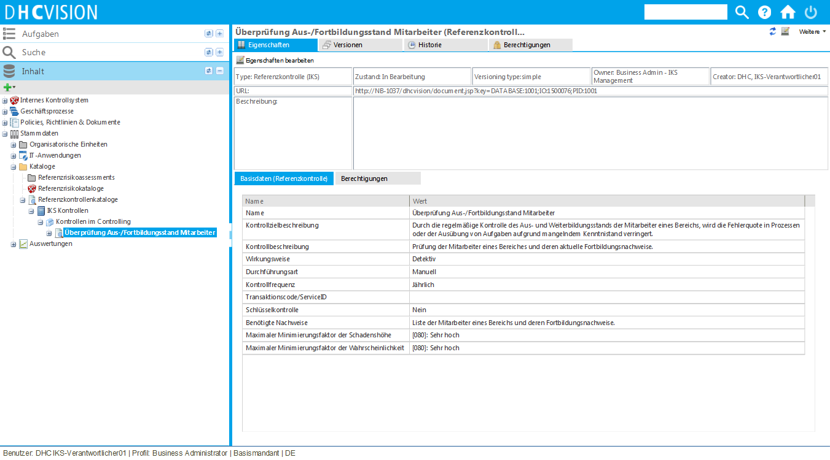
Fig. 48 Example of maintaining reference checks

Metadata of the most important ICS objects

corporate process
Attribute | Description
Master data
Name | Name of the corporate process
Type of corporate process | - Management process  - Core process  - Support process
Description | Brief description of the process so that the process can be categorized within the company.
Localization | - Central process: A central process is specified as a mandatory standard process for the entire company and may not be adapted in the legal entities or locations.  - Central process, adapted locally: A central process is proposed as a standard process for the entire company and can be adapted in the legal entities or locations if necessary.  - Local process (default): The process is only relevant for the legal entity or this location.
Remarks
Corporate process outsourced | - Yes: The process is outsourced to a supplier or another company and has interfaces with internal processes. Otherwise, the process is to be regarded as a black box.  - No (default)
authorizations
Process owner | See "Roles in the internal control system"
Process manager | See "Roles in the internal control system"
Process team | See "Roles in the internal control system"
reader | See "Roles in the internal control system"

Business process
Attribute | Description
Master data
Name | Name of the business process
Type of business process | - Main process/business process group  - Business process (default)  - Business process variant
Description | Brief description of the process so that the process can be categorized within the company.
Localization | - Central process: A central process is specified as a mandatory standard process for the entire company and may not be adapted in the legal entities or locations.  - Central process, adapted locally: A central process is proposed as a standard process for the entire company and can be adapted in the legal entities or locations if necessary.  - Local process (default): The process is only relevant for the legal entity or this location.
Remarks
Business process outsourced | - Yes: The process is outsourced to a supplier or another company and has interfaces with internal processes. Otherwise, the process is considered a black box.  - No (default)
authorizations
Process owner | See "Roles in the internal control system"
Process manager | See "Roles in the internal control system"
Process team | See "Roles in the internal control system"
reader | See "Roles in the internal control system"

Detailed process
Attribute | Description
Master data
Name | Name of the detailed process
Type of detailed process | - Manual (default)  - IT-supported
Description | Brief description of the process so that the process can be categorized within the company.
Localization | - Central process: A central process is specified as a mandatory standard process for the entire company and may not be adapted in the legal entities or locations.  - Central process, adapted locally: A central process is proposed as a standard process for the entire company and can be adapted in the legal entities or locations if necessary.  - Local process (default): The process is only relevant for the legal entity or this location.
Remarks
authorizations
reader | The groups listed here receive read rights to the process
Authors | The groups listed here receive write access to the process

organizational unit
Attribute | Description
Master data
Name | Name of the organizational unit
Head of | Person in charge of the organizational unit
Type of organization | - Main department  - Department  - Range
Organization code | Reference to the corresponding SAP field
Cost center
Description
authorizations
reader | The groups listed here receive read rights to the process
Authors | The groups listed here receive write access to the process

IT application
Attribute | Description
Master data
Name | Name of the IT application
Type of application | - IT application group  - IT application  - IT module  - IT service
Description
Operating status | - In development  - In qualification  - In operation  - Out of service
responsible person
Employment type | - Purchased  - Developed in-house  - Developed externally  - Leased  - Freeware
Manufacturer
Degree of utilization | - High  - Medium  - Low
Personal access data | - Yes  - No
Criticality | - Uncritical  - Critical  - Highly critical
Version
Current version | - Yes  - No
Remarks
authorizations
reader | The groups listed here receive read rights to the process
Authors | The groups listed here receive write access to the process

Document (policy/guideline/...)
Attribute | Description
Master data
Title | Title of the document. The title is the last part of the name
issuing company | Company unit selection box.
issuing department | Selection box of organizational units.  The document is automatically stored in the corresponding document folder at the organizational unit.
Relevant companies | Company unit selection box.  The document is relevant for these companies.
Scope(s) | Selection box of organizational units.  The documents are relevant for these organizational units. The issuing department is automatically included in the list.  The document is automatically filed in the corresponding document folder at the organizational units.
NormS | Selection box from Norm and Norm chapters.  The assignment links the document to the Norm and is automatically displayed in the "Norm view".
References | Selection box from Instruction.  The assignment gives the document a reference to the selected documents. These references can be viewed directly in the document cockpit. This allows documents to be related to each other.
Keywords | Keyword selection box.  Additional groupings of documents can be made dynamically by assigning Keywords.
IT applications | Selection box for IT applications.  The document is relevant for these IT applications. The document is automatically stored in the corresponding document folder in the IT application.
Machinery/Attachments | Selection box of machinery/Attachments.  The document is relevant for this machinery/attachment. The document is automatically stored in the corresponding document folder on the machinery/attachment.
Products/Materials | Selection box of products/materials.  The document is relevant for this product/material. The document is automatically stored in the corresponding document folder for the product/material.
Scope(s) (textual) | Character string (multiline)  Text field in which the Scope(s) can be created textually if the organizational units are not managed in the system (Scope field).
Version history | Version history entry in which it is recorded which changes have been made with reference to the previous version.
Control (release)
Author | Selection box of authors (users from the User Groups "Authors").  During assignment, each author receives read and write permissions on the document itself and all details, such as attachments, additional information and Change proposals.
Co-authors | Selection box for co-authors (users from the "Authors" User Groups).  During assignment, each author receives read and write permissions on the document itself and all details, such as attachments, additional information and Change proposals.
reviewer | Reviewer selection box (user from the "Reviewer" User Groups).  During assignment, each reviewer receives read and write permissions on the document itself and on all details, such as the attachments, additional information and Change proposals. The system ensures that the author and reviewer cannot be the same person.
releaser | Selection box for releasers (users from the "Releasers" User Groups).  During assignment, each releaser receives read and write permissions on the document itself and on all details, such as attachments, additional information and Change proposals.
reader | Selection box for reader groups
Reviewer (translation) | Selection box for the reviewer of the translation (user from the User Groups "Reviewer - Translation").  A reviewer (translation) checks the correctness of the translation with reference to the original.
Releaser (translation) | Selection box of the reviewer of the translation (user from the User Groups "Releaser - Translation").  A releaser (translator) confirms and is responsible for the accuracy of the translation with reference to the original.

Risk
Attribute | Description
Master data
Risk name | Name of the risk, is synchronized with the name of the information object
*Risk field (internal) | 12-level range for classifying the risk. The attribute value can be pre-assigned if the risk has been created for specific data objects. Example: Risk for the process Process risk
Risk description | Multi-line textual description of the risk
Assumptions | Multi-line textual description of the assumptions underlying the description & evaluation of the risk
Causes | Multi-line textual description of the causes that lead to the risk
Effects | Multi-line textual description of the impact that the occurrence of the risk would have
*Risk identifier | Textual entry of the risk identifier
Evaluation & control
Amount of damage (qualitative) | Possible values for defining the amount of damage (gross) are  Very low - Low - Medium - High - Very high
Probability of occurrence (qualitative) | Possible values for defining the probability of occurrence (gross) are  Very low - Low - Medium - High - Very high
Risk treatment | Definition of the additional handling of the risk. Possible values are  Avoid - Transfer - Reduce (by defining controls) - Share - Accept
Net loss amount (qualitative) | Possible values for defining the amount of loss (net) are:  Very low - Low - Medium - High - Very high
Net probability of occurrence (qualitative) | Possible values for defining the probability of occurrence (net) are  Very low - Low - Medium - High - Very high
authorizations
Risk officer | Selection of the user who is responsible person for the risk. The assigned user receives change rights for the object. A risk responsible person is responsible for risk identification, risk assessment and additional implementation and for efficient risk reporting to management.  In the case of process risks, the person responsible for the process is initially confirmed.  All persons in the "Risk owners" User Groups are assigned to the selection.
Risk manager | Selection of the user who is responsible for the operational management of the risk. The assigned user receives change rights for the object. The risk manager supports the risk owner in risk identification, risk assessment and risk handling via measures and controls.  In the case of process risks, the process manager of the process is initially confirmed.  All persons in the "Risk Manager" User Groups are assigned to the selection.
reader | The groups listed here receive read rights
Authors | The groups listed here receive write access
Documents
Document type | Selection of the document types set in the system whose documents are to be assigned to the risk.  As a rule, the risks are assigned guidelines or policies that describe how the risk is to be handled or through which the risk is to be reduced.
Documents to be assigned | Documents can be assigned to the risk according to the selected document type. Only released documents are listed. The documents assigned here are then displayed in the object cockpit of the risk in the "Guidelines & documents" accordion or when drilling down into the risk.
Documents to be removed | This field can be used to remove assigned documents from the risk.

Control
Attribute | Description
Master data
Name | Name of the risk, is synchronized with the name of the information object
Key control | Two-stage range that indicates whether this is a key control (Yes/No).  Key controls are critical controls in the ICS. If a control designated as a key control fails, the controls based on/subsequent to the key control are to be considered ineffective.
Mode of action | Two-stage range indicating whether the check is preventive or detective  Preventive controls are used to prevent the occurrence of errors or omissions. Post-detection controls (detective) are used for the timely detection and correction of errors, fraud or omissions.
Control frequency | Six-stage range that indicates the frequency of control execution:  daily - weekly - monthly - quarterly - annually - on request
Type of implementation | Three-stage range indicating whether the check is executed manually or automatically (in an IT application)
*Control target description | Multi-line textual description of the objective being pursued with the control
Control description | Multi-line textual description of the inspection procedure
Evidence required | Multi-line textual list of the evidence that must be provided as part of the inspection process
Control characteristic | Two-level range that specifies whether the control is defined centrally or locally (= multi-client system)
Control effective since | Date field with calendar function, in which the date of implementation and effective setting of the control can be documented
Transaction code/ServiceID | Single-line entry of a transaction code or a ServiceID linked to the control
Control level | Three-level range indicating the level at which the control was defined and is executed:  - Process level  - Management level  - IT level
Reference control catalog | If the transfer of information from an existing reference check is planned, the reference check catalog in which the reference check is contained is selected here.
Reference control group | Selection of the reference check group that is assigned to the reference check catalog selected above and in which the reference check is contained.
Reference check | Selection of the reference control that is assigned to the reference control group selected above.  After completing attribute editing with "Confirm", all attributes are confirmed by the selected reference control.  Please note: Attribute values that have already been maintained will be overwritten.
Control
Author | The person who is responsible for the Attachment and editing of the control is preset as the author. The person entered is granted read and write access to the object
Co-authors | Additional users can be entered as co-authors, who should have read and write access to the control in addition to the author. To select the users, they must be assigned to the "Co-authors" user group.
reviewer | The users who are eligible to check the design of a control are entered as reviewers. This can also be several reviewers. The check must be carried out by all reviewers. For process controls, the field is pre-assigned with the defined process manager of the process. To select the users, they must be assigned to the "Reviewer" User Groups.
releaser | The users who are eligible for the release of the control are entered as releasers. This can also be several releasers. It is sufficient for the release if one of the releasers has confirmed the release. For process controls, the field is pre-assigned with the defined process owner of the process. To select the users, they must be assigned to the "Releaser" User Groups.
Activation
Control activated from | Date field with calendar function in which the date of activation of the control can be specified. Activation takes place automatically on this date if the control previously had the status "Released for implementation".
Assignment
Detailed processes, process steps, activities | Selection of detailed processes or process steps where the control is actually executed. The control is linked to these objects and displayed in process diagrams.  All detailed processes and process steps that are part of the business process in which the control is effective can be selected.

List of abbreviations
Abbreviation | Description
AKS | Override
BPMN | Business Process Model and Notation
DMS | Document management system
DP | Detailed process
EPK | Event-driven process chain
GP | Business process
GPM | Business process management
GüV | extend validity
IKS | Internal control system
P&R management | Policies & guidelines management
PDCA | Plan-Do-Act-Check
PM | Process management
PQM | Process & Quality Management
PS | Process step
REAK | Reactivation
WF | Workflow

