|  |  |  |  |  |  |
| --- | --- | --- | --- | --- | --- |
|  | **Shipping and Production Cost** | | | |  |
|  | **Warehouse 1** | **Warehouse 2** | **Warehouse 3** | **Warehouse 4** | **Capacity** |
| **Plant A** | 622 | 614 | 630 | 0 | 100 |
| **Plant B** | 641 | 645 | 649 | 0 | 120 |
| **Demand** | 80 | 60 | 70 | Dummy = 10 | 100+120 = 220 |

1. **Heart Start Problem:**

Here I have created Dummy Variable Warehouse 4 to match both supply and Demand

Network Diagram:

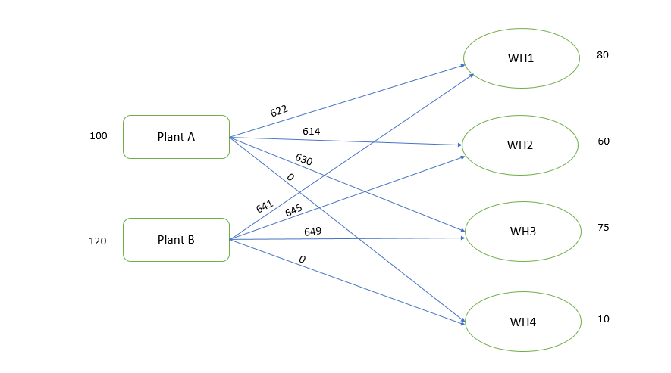

**Formulation:**

Let, Z represent total shipping and production cost

* Xij represents the total shipping and production cost from Plant i to Warehouse j
* Choose values of 8 decision variables Xij to minimize Z

Minimize Z = 622X11  + 614X12 + 630X13 + 0X14 + 641X21 + 645X22 + 649X23 + 0X24

Subject to the constraints,

X11  + X12 + X13 + X14 = 100

X21 + X22 + X23 + X24 = 120

X11 + X21 = 80

X12 + X22 = 60

X13 + X23 = 70

X14 + X24 = 10

And Xij >= 0

2. **Oil Distribution:**

**Capacity:**

Well 1 has a capacity of 93 thousand barrels per day (TBD),

Well 2 can produce 88 TBD, and

Well 3 can produce 95 TBD

A total of 93 + 88 + 95 = 276 TBD

**Demand:**

Here the requirement = R1 + R2 + R3 + R4 + R5 = 30 + 57 + 48 + 91 + 48 = 274

Capacity is not matching the demand

Therefore, a Dummy variable for requirement is created with value 2

**Network Diagram:**

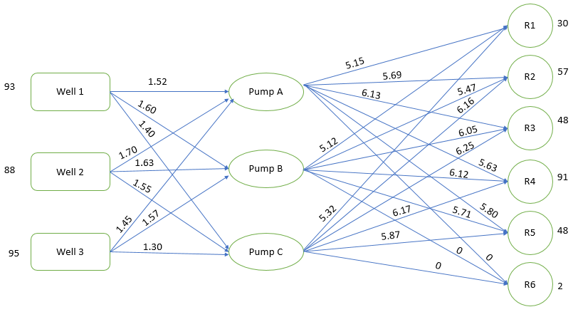

**Formulation:**

Let Z be the minimum cost of providing oil to the refineries

* WiPj represents the cost of providing from Well to Pump
* PjRk represents the cost of providing from pump to refinery

**Minimum Cost Z** =

1.52W1P1 + 1.60 W1P2 + 1.40 W1P3+ 1.70 W2P1 + 1.63 W2P2 + 1.55W2P3 + 1.45 W3P1 + 1.57 W3P2 + 1.30 W3P3+ 5.15P1R1 + 5.69P1R2 + 6.13P1R3 + 5.63P1R4 + 5.80P1R5 + 0P1R6 + 5.12P2R1 + 5.47P2R2 + 6.05P2R3+ 6.12P2R4 + 5.71P2R5 + 0P2R6 + 5.32P3R1 + 6.16P3R2 + 6.25P3R3 + 6.17P3R4 + 5.87P3R5 + 0P3R6;

**Subject to constraints:**

W1P1 + W1P2 + W1P3 = 93

W2P1 + W2P2 + W2P3 = 88

W3P1 + W3P2 + W3P3 = 95

P1R1 + P2R1 + P3R1 = 30

P1R2 + P2R2 + P3R2 = 57

P1R3 + P2R3 + P3R3 = 48

P1R4 + P2R4 + P3R4 = 91

P1R5 + P2R5 + P3R5 = 48

P1R6 + P2R6 + P3R6 =2

Constraints from Pump to Refinery:

W1P1 + W2P1 + W3P1 = P1R1 + P1R2 + P1R3 + P1R4 + P1R5 + P1R6

W1P2 + W2P2 + W3P2 = P2R1 + P2R2 +P2R3 + P2R4 + P2R5 + P2R6

W1P3 + W2P3 + W3P3 = P3R1 + P3R2 + P3R3 +P3R4 +P3R5 + P3R6

WiPj >=0 and PjRk >=0