**(Computer Center Staffing)** You are the Director of the Computer Center for Gaillard College and responsible for scheduling the staffing of the center. It is open from 8 am until midnight. You have monitored the usage of the center at various times of the day and determined that the following numbers of computer consultants are required.

|  |  |
| --- | --- |
| Time of day | Minimum number of consultants required to be on duty |
| 8 am–noon | 4 |
| Noon–4 pm | 8 |
| 4 am–8 pm | 10 |
| 8 am–midnight | 6 |

Two types of computer consultants can be hired: full-time and part-time. The full-time consultants work for eight consecutive hours in any of the following shifts: morning (8 am – 4 pm), afternoon (noon – 8 pm), and evening (4 pm – midnight). Full-time consult- ants are paid $14 per hour.

Part-time consultants can be hired to work any of the four shifts listed in the table. Part-time consultants are paid $12 per hour. An additional requirement is that during every time period, at least one full-time consultant must be on duty for every part-time consultant on duty.

1. Determine a minimum-cost staffing plan for the center. In your solution, how many consultants will be paid to work full time and how many will be paid to work part time? What is the minimum cost?

Let us consider:

Fi = No. of consultants who start their shift full time in a day (i.e., 8 hours) (i = 1, 2, 3)

Pj = No. of consultants who start their shift part time in a day (i.e., 4 hours) (j= 1, 2, 3, 4)

Full time consultants are paid $14 per hour, Therefore per day = 14*8 = $112

Part time consultants are paid $12 per hour, therefore per day = 12*4 = $48

**Minimize cost staffing plan** for center be Z

Z = 112(P1 + P2 + P3) + 48(F1 + F2 + F3 +F4)

Subject to,

|  |  |
| --- | --- |
| F1 + P1 ≥ 4 | Time 1 |
| F1 + F2 + P2 ≥ 8 | Time 2 |
| F2 + F3 + P3 ≥ 10 | Time 3 |
| F3 + P4 ≥ 6 | Time 4 |

And, Pi ≥ 0, Fi ≥ 0

Here, one full time consultant must be on duty for every part time consultant

Let us assume in Time 1, F1 + P1 = 4

As per above condition F1 = P1 So F1 = P1 = 2

In Time 2, F1 + F2 + P2 = 8

Here F1+F2 should be equal to P2, So F2 = 2, P2 = 4

In Time 3, F2 + F3 + P3 = 10

Here F2+F3 should be equal to P3, so F3 =3, P3 = 5

In Time 4, F3 + P4 = 6, So P4 = 3

So F1+F2+F3=7, P1+P2+P3+P4= 14

Therefore,

No. of full-time consultants = 7

No. of part time consultants = 14

1. After thinking about this problem for a while, you have decided to recognize meal breaks explicitly in the scheduling of full-time consultants. In particular, full-time consultants are entitled to a one-hour lunch break during their eight-hour shift. In addition, employment rules specify that the lunch break can start after three hours of work or after four hours of work, but those are the only alternatives. Part-time consultants do not receive a meal break. Under these conditions, find a minimum-cost staffing plan. What is the minimum cost?

Here one hour is taken as lunch break for all full-time consultants

Therefore, Minimum cost staffing plan :

Z = 14(8-1)(P1+P2+P3) + 48(F1+F2+F3)

Z= 98(P1+P2+P3) + 48(F1+F2+F3)

Back Savers is a company that produces backpacks primarily for students. They are considering offering some combination of two different models—the Collegiate and the Mini. Both are made out of the same rip-resistant nylon fabric. Back Savers has a long-term contract with a supplier of the nylon and receives a 5000 square-foot shipment of the material each week. Each Collegiate requires 3 square feet while each Mini requires 2 square feet. The sales forecasts indicate that at most 1000 Collegiates and 1200 Minis can be sold per week. Each Collegiate requires 45 minutes of labor to produce and generates a unit profit of $32. Each Mini requires 40 minutes of labor and generates a unit profit of $24. Back Savers has 35 laborers that each provides 40 hours of labor per week. Management wishes to know what quantity of each type of backpack to produce per week. Solve this problem graphically

**Nylon:**

3C+2M ≤ 5000

Let us consider, 3C+2M = 5000

C= 0, then M = 2500

M=0, then C = 1666.67

**Labor:**

(3/4)C + (2/3)M ≤ 1400

Let us consider, (3/4)C + (2/3)M = 1400

C=0, then M = 2100

M=0, then C = 1866.67

And **Sales Forecast**: C ≤ 1000

M ≤ 1200

To Solve the problem graphically, I am considering Collegiate on X-Axis and Minis on Y- Axis

The following lines to be plotted on the graph:

* 1. 3C + 2M = 5000
  2. (3/4)C + (2/3)M = 1400
  3. C=1000
  4. M= 1200

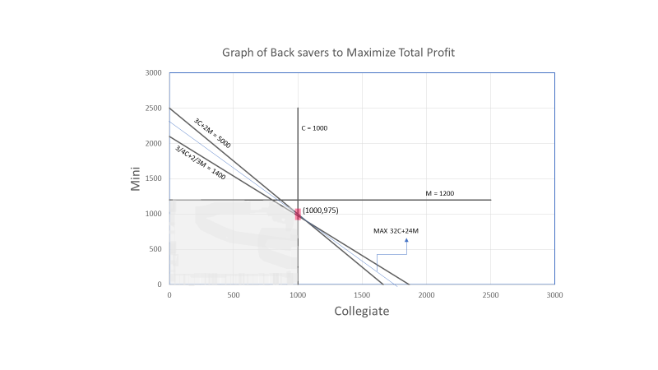

After solving the problem graphically,

The optimal Solution for the problem is C=1000 and M = 975 (974.4) which is common intersection point.

Maximum Profit = 32C + 24M = 55400

**(Weigelt Production)** The Weigelt Corporation has three branch plants with excess production capacity. Fortunately, the corporation has a new product ready to begin production, and all three plants have this capability, so some of the excess capacity can be used in this way. This product can be made in three sizes--large, medium, and small--that yield a net unit profit of $420, $360, and $300, respectively. Plants 1, 2, and 3 have the excess capacity to produce 750, 900, and 450 units per day of this product, respectively, regardless of the size or combination of sizes involved.  
 The amount of available in-process storage space also imposes a limitation on the production rates of the new product. Plants 1, 2, and 3 have 13,000, 12,000, and 5,000 square feet, respectively, of in-process storage space available for a day's production of this product. Each unit of the large, medium, and small sizes produced per day requires 20, 15, and 12 square feet, respectively.  
 Sales forecasts indicate that if available, 900, 1,200, and 750 units of the large, medium, and small sizes, respectively, would be sold per day.  
 At each plant, some employees will need to be laid off unless most of the plant’s excess production capacity can be used to produce the new product. To avoid layoffs if possible, management has decided that the plants should use the same percentage of their excess capacity to produce the new product.  
 Management wishes to know how much of each of the sizes should be produced by each of the plants to maximize profit.

* **Define the decision variables**

Let,

P1L – No. of Large Size units produced per day by Plant 1

P2L – No. of Large size units produced per day by Plant 2

P3L – No. of Large size units produced per day by plant 3

P1M – No. of medium size units produced per day by Plant 1

P2M – No. of medium size units produced per day by plant 2

P3M – No. of medium size units produced per day by plant 3

P1S – No. of small size units produced per day by Plant 1

P2S – No. of small size units produced per day by plant 2

P3S – No. of small size units produced per day by plant 3

Let N be the Total Net profit per day

* **Formulate a linear programming model for this problem.**

Management wishes to know how much of each of the sizes should be produced by each of the plants to maximize profit.

**Maximize N** = 420P1L + 360P1M + 300P1S + 420P2L + 360P2M + 300P2S + 420P3L + 360P3M +300P3S

**Constraints:**

**Capacity:**

Plant 1 have the excess capacity to produce 750 units per day

Therefore,

P1L + P1M + P1S ≤ 750

Plant 2 have the excess capacity to produce 900 units per day

Therefore,

P2L + P2M + P2S ≤ 900

Plant 3 have the excess capacity to produce 450 units per day

Therefore,

P3L + P3M + P3S ≤ 450

**Storage Space:**

Plant 1, 2 and 3 have 13000, 12000, 5000 square feet of in-process storage space and,

Each unit of large, medium, small produced per day requires 20, 15 and 12 square feet

Therefore,

20P1L + 15P1M + 12P1S ≤ 13000

20P2L + 15P2M + 12P2S ≤ 12000

20P3L + 15P3M + 12P3S ≤ 5000

**Sales forecasts:**

Sales forecasts indicate that if available, 900, 1,200, and 750 units of the large, medium, and small sizes, respectively, would be sold per day

Therefore,

P1L + P2L + P3L ≤ 900

P1M + P2M + P3M ≤ 1200

P1S + P2S + P3S ≤ 750

P1L ≥ 0, P2L ≥ 0, P3L ≥ 0

P1M ≥ 0, P2M ≥ 0, P3M ≥ 0

P1S ≥ 0, P2S ≥ 0, P3S ≥ 0