Lightbox Anywhere User Guide
Introduction
In an article or in a product page, there are usually many images and these images’ size is configured to suit with the article’s layout. Therefore, images will not be displayed with its original size and it may cause difficulty in viewing a number of images.
With Lightbox Anywhere plugin, the problem will be solved easily.
Lightbox Anywhere is a plugin content taking picture from articles or description and displaying them in its full size in a lightbox. All images of article or description will be displayed in lightbox whenever you click on any image. Lightbox Anywhere shows images in different beautiful lightbox styles, can be used for different components: com_content, com_k2 và com_virtuemart.

Features:

- Easy to configure.
- Lightbox Anywhere shows images with full size in different beautiful lightboxes when image is clicked.
- Able to add plugin in specific article, category, section in com_content.
- Able to add plugin in each item or category of com_k2.
- Support using plugin with com_content, com_k2 and com_virtuemart.
- Support many attractive lightbox types: lightboxjs, Evolution and facybox JS.

Installation
Please follow these steps to install Lightbox Anywhere Plugin to your Joomla 1.7 and Joomla 2.5 site.
* Preparing step:
- Extract the downloaded package to your computer.
- Choose exactly version that matches your Joomla version (Joomla 1.7 or Joomla 2.5)
* Install module (for Joomla 1.7, if you are using Joomla 2.5 version, it is the same): Use all files in folder Joomla 1.7
- Go to your site administrator section;
- Select "Extensions"->"Install/Uninstall".
- In "Upload Package File" block, please install all extensions bellow:
+ Installation/ plg_content_lightbox_anywhere 1.0.0 j1.7.zip (this is a required extension, it is Lightbox Anywhere plugin core).
+ plg_system_js_loadjquery v1.3.
- Go to "Extensions"->"Plugin Manager"->"System - jQuery Library" then.
+ Enable plugin then "Save"
- Please do all the steps above for Joomla 2.5.

Configuration and setup default content:
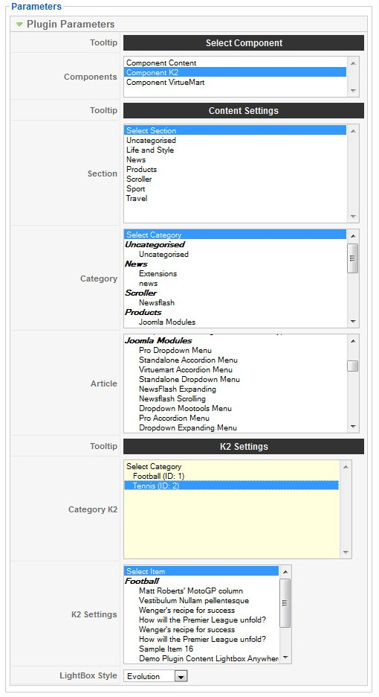
Figure 1
Setting configuration for module:
- Component: select plugin used with component: com_content, com_k2 and com_virtuemart.(you have installed components use plugins and you would like to show plugin on them then select below. You can use Ctrl-click to select more than one item. Default: none).
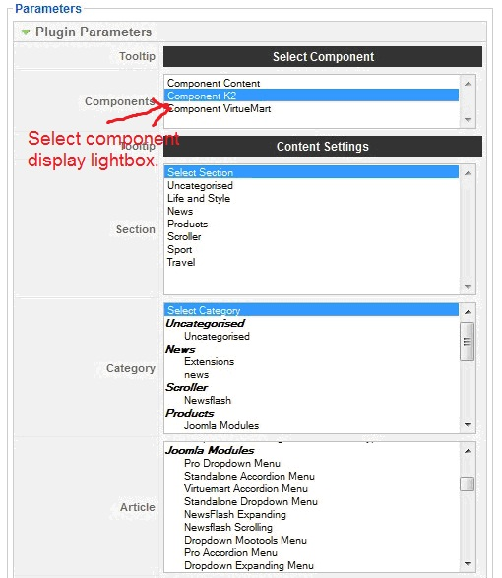

- Section, category, and article: select articles in section, category or specific article using plugin Lightbox Anywhere. With 3 options:
  - You can only choose one option among 3 options.
  - If choose uncategorized in section then category with sectionid = 0 will be selected and if choose uncategorized in category then articles with catid = 0 will be selected.
- Similarly, with Category K2 and Item K2: first, if you want plugin to be used in articles of component K2, you’ll have to choose com_k2 trong in Component, then select each item or item in category allowed to use plugin.
- Lightbox Style: select displaying types for plugin. There are 3 types:

+ Mootools - Slimbox :
+ jQuery - Evolution.
+jQuery - Fancybox.
If Lightbox style: jQuery - Fancybox or jQuery – Evolution, enable plugin "System - jQuery Library".

FRONT END
- There are 3 ways to display slideshow in lightbox:
  - Evolution:

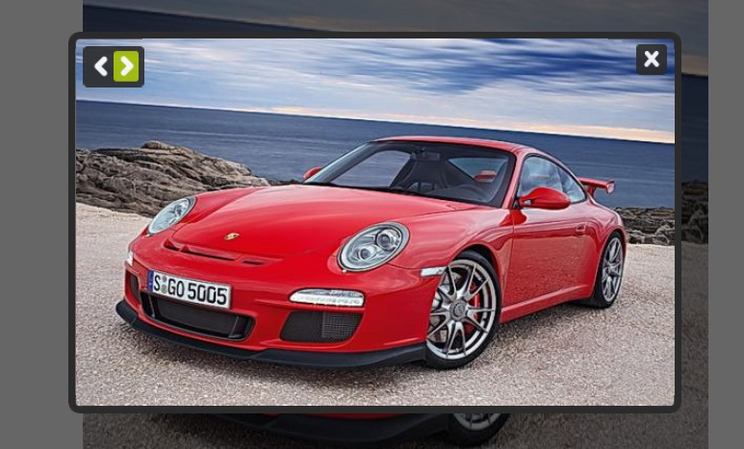
Figure 2
  - Fancybox JS:


Figure 3
  - Lightbox JS:

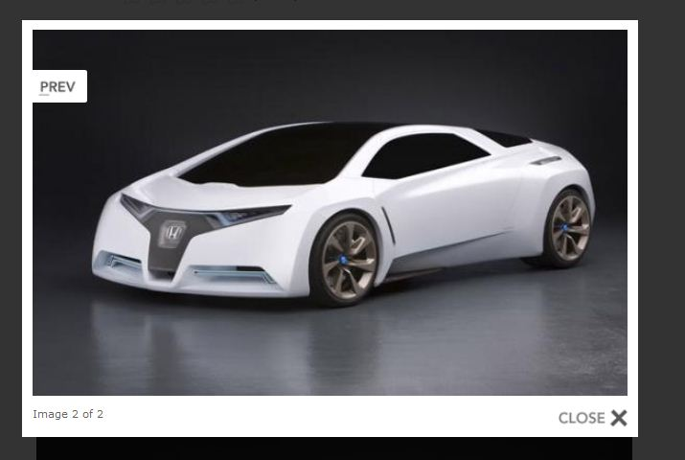
Figure 4

