EUROPEAN RESEARCH COUNCIL
Starting Grant 2026 — Part B: Scientific Proposal

TE-TUMOR
Transposable Elements as Sensors and Drivers
of Epigenetic Instability in Cancer

Principal Investigator | Dr. Abdou Akkouche
Host Institution | GReD (Génétique, Reproduction et Développement), CNRS / Université Clermont Auvergne, France
ERC Panel | LS3 — Cellular, Developmental and Regenerative Biology
Duration | 60 months (5 years)
Requested Budget | €1,500,000
Proposed Start Date | January 2027

Table of Contents
1. Extended Synopsis
2. Introduction and Scientific Background
2.1 Transposable elements: parasites turned genome architects
2.2 Polycomb group proteins: master epigenetic silencers
2.3 The PI's foundational work: E(z) and dual histone marks
2.4 TEs in cancer: emerging evidence and open questions
2.5 Drosophila as a model for epigenetic tumorigenesis
3. Critical Gaps in Knowledge
4. Central Hypothesis
5. Objectives and Specific Aims
Aim 1: Polycomb-mediated TE control in somatic tissues
Aim 2: RNAi–Polycomb cooperation in TE defense
Aim 3: Tumor-state-dependent TE activation and consequences
6. Preliminary Data
6.1 TABOR activation in Polycomb-deficient tumors
6.2 RNA-seq: selective TE deregulation
7. Methodology and Work Packages
8. Timeline and Milestones
9. Translation to Human Cancer
10. Budget Justification
11. Risk Management and Contingencies
12. Expected Impact and Output
13. Principal Investigator — Track Record
14. References

1. Extended Synopsis
Epigenetic deregulation is a hallmark of cancer, yet how it reshapes genome activity beyond classical gene expression remains poorly understood. Transposable elements (TEs), which constitute ~45% of the human genome and ~30% of the Drosophila genome, are normally kept silent by epigenetic mechanisms including DNA methylation, histone modifications, and Polycomb repression [1]. However, TE activation is frequently observed in tumors, where it has been linked to genome instability, innate immune signaling, and tumor evolution [2,3].
Despite these observations, fundamental questions remain unanswered: How do oncogenic epigenetic states unlock TE activity? In which tumor cell populations does this occur? And does TE activation contribute to tumor progression or merely accompany it?
TE-TUMOR proposes a paradigm shift: rather than treating TEs as passive byproducts of epigenetic chaos, we hypothesize that TEs act as dynamic sensors and potential drivers of epigenetic instability in cancer. Our preliminary data provide compelling support: loss of Polycomb repression in the Drosophila eye epithelium induces tumors accompanied by robust, clonal activation of the LTR retrotransposon TABOR — upregulated 173-fold (log2FC = +7.43, padj ≈ 0) — in 100% of tumors. Strikingly, TABOR activation correlates with tumor size and is suppressed when the tumor program is blocked, suggesting that TE activation depends on the tumor cell state, not merely on Polycomb loss.
This project will: (1) define how Polycomb repression controls TEs in somatic tissues; (2) determine whether RNA interference cooperates with Polycomb to buffer TE activation; (3) uncover how tumor-specific cell states unlock TE expression and characterize its cellular consequences; and (4) translate findings to human cancer by mining TCGA and single-cell datasets for TE signatures in Polycomb-mutant tumors.

2. Introduction and Scientific Background

2.1 Transposable elements: parasites turned genome architects
Transposable elements are mobile DNA sequences that propagate within genomes through copy-paste (retrotransposons) or cut-paste (DNA transposons) mechanisms. Far from being "junk DNA," TEs have profoundly shaped genome evolution by contributing regulatory sequences, novel genes, and structural variation [4]. In humans, TEs account for approximately 45% of genomic DNA, with LINE-1, Alu, and endogenous retroviruses (ERVs) being the most abundant families [5]. In Drosophila melanogaster, TEs represent ~30% of the genome, with LTR retrotransposons (including gypsy, copia, and TABOR families) being particularly prevalent [6].
While TEs drive genome evolution over long timescales, their acute mobilization is dangerous: new insertions can disrupt genes, trigger chromosomal rearrangements, and generate double-stranded DNA breaks [7]. In animal gonads, the piRNA pathway provides a dedicated defense system against TEs [8]. In somatic tissues, however, TE silencing relies primarily on chromatin-based mechanisms and, in Drosophila, the endo-siRNA pathway [9].

2.2 Polycomb group proteins: master epigenetic silencers
Polycomb group (PcG) proteins form two principal complexes — PRC1 and PRC2 — that cooperate to establish and maintain transcriptional silencing [10]. PRC2, containing the catalytic subunit E(z)/EZH2, tri-methylates histone H3 at lysine 27 (H3K27me3), creating a repressive chromatin mark recognized by PRC1 [11]. PRC1, containing Polyhomeotic (Ph) and Posterior sex combs (Psc/BMI1), monoubiquitylates H2AK119 and compacts chromatin [12].
PcG proteins are among the most frequently mutated chromatin regulators in human cancer. EZH2 is mutated or overexpressed in lymphoma, melanoma, prostate, bladder, and endometrial cancers [13]. BMI1 (Psc homolog) is overexpressed in breast, colorectal, lung, and brain cancers [14]. PHC1/2/3 (Ph homologs) are altered in leukemia and medulloblastoma [15]. Loss of Polycomb function drives tumorigenesis through deregulation of developmental genes (Hox, Wnt, Notch pathways), but its impact on transposable element expression in somatic tissues has never been systematically investigated.

2.3 The PI's foundational work: E(z) controls chromatin targeting via dual histone marks
The PI recently demonstrated that E(z) — the Drosophila homolog of EZH2 — plays a critical role in directing the heterochromatin protein Rhino to piRNA source loci via a novel dual-mark recognition mechanism (H3K9me3 + H3K27me3) [16]. This work established that E(z)-dependent H3K27me3 is not merely a silencing mark but a specificity determinant for chromatin protein binding. Importantly, it placed the PI at the unique intersection of Polycomb biology and transposable element regulation — the precise junction that TE-TUMOR now exploits in the cancer context.

2.4 TEs in cancer: emerging evidence and open questions
TE activation in cancer has emerged as a topic of intense interest. In human tumors, LINE-1 retrotransposons can mobilize and cause somatic insertions that contribute to tumor evolution [17,18]. Endogenous retroviruses (ERVs) are reactivated in many cancers and can trigger innate immune responses through production of double-stranded RNA (dsRNA) — a phenomenon termed "viral mimicry" that can sensitize tumors to immune checkpoint blockade [19,20].
Epigenetic drugs (DNA methyltransferase inhibitors and EZH2 inhibitors) are known to reactivate TEs [21], and the EZH2 inhibitor tazemetostat is now FDA-approved for epithelioid sarcoma [22]. However, whether TE activation contributes to the therapeutic efficacy or represents a dangerous side effect remains unknown.
In Drosophila, the powerful genetic toolkit allows precise dissection of cause and consequence at single-cell resolution within intact tissues — a capability that is impossible to achieve in human tumors. The conservation of core epigenetic machinery (E(z)/EZH2, Ph/PHC, Psc/BMI1, Ago2/AGO2) ensures that mechanistic insights from Drosophila can be directly translated to human cancer biology.

2.5 Drosophila as a model for epigenetic tumorigenesis
The Drosophila eye imaginal disc provides an ideal model for studying Polycomb-driven tumorigenesis. Loss of PRC1 components (Ph, Psc) in the eye disc leads to neoplastic transformation, tumor growth, and metastasis [23,24]. These tumors exhibit hallmarks of human cancer: uncontrolled proliferation, loss of cell polarity, invasion, and activation of conserved oncogenic pathways (JAK-STAT, Zfh1/ZEB) [25]. The short generation time (10 days), powerful genetic tools (Gal4-UAS, FLP-FRT clonal analysis), and accessibility of intact tissues for imaging make this system uniquely suited for the proposed experiments.

3. Critical Gaps in Knowledge
Despite significant advances in both TE biology and cancer epigenetics, four fundamental questions remain unanswered:
Gap 1 — Polycomb control of TEs in somatic tissues is unexplored.
While Polycomb's role in regulating developmental genes is well established, its contribution to TE silencing in somatic (non-gonadal) tissues has never been systematically studied [1]. The piRNA pathway operates primarily in gonads; how TEs are controlled in somatic tissues where Polycomb is a dominant silencer remains a major open question. Existing TE-cancer studies focus almost exclusively on DNA methylation [19], leaving the Polycomb–TE axis entirely unexplored.
Gap 2 — TE activation selectivity is unexplained.
When epigenetic silencing is disrupted, not all TEs respond equally — some activate, some are further repressed, and most remain unchanged. Our preliminary RNA-seq data illustrate this strikingly: 6 TEs are upregulated and 14 are downregulated upon Polycomb loss. No current model explains this selectivity. Understanding which defense systems control which TEs — and whether they cooperate or act independently — is critical for predicting TE behavior in cancer.
Gap 3 — The link between tumor cell state and TE activation is unknown.
TE activation in cancer is treated as a passive consequence of global epigenetic collapse [2]. No study has asked whether TE activation depends on the specific tumor cell state rather than on epigenetic loss alone. Our observation that TABOR activation is suppressed when the tumor program is blocked — even though Polycomb remains absent — challenges this view and suggests a fundamentally different model.
Gap 4 — Cellular consequences of TE activation in tumors are unmapped.
While TE activation has been correlated with genome instability and immune signaling at the population level [3], no study has mapped TE activation at single-cell resolution within intact tumors and correlated it with cellular stress markers (DNA damage, dsRNA, apoptosis, proliferation). Bulk approaches average signal across millions of cells, obscuring the critical question: are TE-active cells the ones that are dividing, dying, or both?
TE-TUMOR addresses all four gaps simultaneously. By combining genetic models of Polycomb-driven tumorigenesis with single-cell imaging of TE expression and cellular stress markers, we will determine how Polycomb loss, tumor cell identity, and TE activation are mechanistically connected — and establish whether TEs are passive markers or active contributors to tumor biology.

4. Central Hypothesis
Epigenetic tumor states created by the loss of chromatin repressors such as Polycomb unlock transposable element expression in specific tumor cell populations, where TE activation may contribute to genome instability, cellular stress responses, and tumor heterogeneity.
This hypothesis makes three testable predictions:
- Prediction 1: Polycomb complexes directly silence a defined subset of TEs in somatic tissues, and this silencing cooperates with the siRNA pathway.
- Prediction 2: TE activation in tumors depends on the establishment of a specific tumor cell state (defined by JAK-STAT/Zfh1 signaling), not merely on Polycomb loss.
- Prediction 3: TE-active tumor cells exhibit elevated markers of genome instability (γH2Av), antiviral response (dsRNA/J2), and altered cell fate (proliferation or apoptosis).

5. Objectives and Specific Aims

Aim 1 — Define how Polycomb repression controls TEs in somatic tissues (Months 1–30)
Rationale: PcG complexes are major chromatin repressors, but their role in TE regulation in somatic tissues remains poorly understood. Our preliminary data show that loss of Polyhomeotic (PRC1) induces selective TE deregulation (6 up, 14 down), suggesting Polycomb contributes to TE control but cooperates with additional mechanisms.
Tasks:
- T1.1: Generate PRC1 (Ph, Psc) and PRC2 (E(z), Su(z)12) knockdowns in eye imaginal discs using Ey-Gal4
- T1.2: Perform strand-specific, ribo-depleted RNA-seq (3 biological replicates per genotype) to identify all deregulated TEs
- T1.3: Validate top TE candidates by RT-qPCR and single-molecule RNA-FISH
- T1.4: Perform H3K27me3 and H3K9me3 CUT&RUN in wild-type and mutant eye discs to map chromatin state at TEs
- T1.5: Bioinformatic integration: correlate TE expression changes with chromatin mark loss/gain
Methods: Strand-specific RNA-seq, CUT&RUN, RT-qPCR, RNA-FISH (smFISH), DESeq2, Drosophila genetics.
Expected result: Complete map of Polycomb-dependent vs. independent TEs in somatic tissue. Identification of which TE families are directly silenced by H3K27me3 vs. controlled by other mechanisms.
Deliverable: Publication (target: Genes & Development or EMBO Journal).

Aim 2 — Test whether RNA interference cooperates with Polycomb to buffer TE activation (Months 9–36)
Rationale: In Drosophila somatic tissues, the endo-siRNA pathway (Ago2-dependent) is a major TE defense mechanism [9]. We hypothesize that RNAi acts as a compensatory buffer when Polycomb silencing is compromised — explaining why only a subset of TEs escape in Polycomb mutants.
Tasks:
- T2.1: Profile small RNA populations (siRNAs, miRNAs) in eye discs by small RNA-seq (oxidized + non-oxidized)
- T2.2: Identify TE-targeting endo-siRNAs and map their genomic origins
- T2.3: Generate Polycomb + Ago2 double mutant clones (Ph⁻; Ago2⁻) using FLP-FRT mosaic analysis
- T2.4: Compare TE activation profiles: single vs. double mutants (RNA-seq + RNA-FISH)
- T2.5: Test whether combined loss enhances tumorigenesis and/or genome instability (γH2Av staining)
Methods: Small RNA-seq, FLP-FRT clonal analysis, Ago2 mutants, combinatorial genetics, γH2Av immunostaining.
Expected result: If RNAi buffers TE activation, double mutants will show synergistic TE derepression far exceeding either single mutant. This would establish the first layered defense model for somatic TE control.
Deliverable: Publication (target: Molecular Cell or EMBO Journal).

Aim 3 — Determine how tumor cell states unlock TE activation and characterize its cellular consequences (Months 12–48)
Rationale: Our preliminary data reveal that TABOR activation depends on the tumor state (Zfh1/Stat92E program), not merely on Polycomb loss. This aim will mechanistically dissect this link and map the cellular consequences of TE activation at single-cell resolution within intact tumors.
Tasks:
- T3.1: Characterize TABOR activation dynamics across tumor developmental stages (early clones → late tumors)
- T3.2: Test tumor-state dependency: Zfh1 RNAi, Stat92E RNAi, and Stat92E dominant-negative in Polycomb-deficient background
- T3.3: Combine TE RNA-FISH (TABOR, BLASTOPIA, DM1731) with immunostaining for: γH2Av (DNA damage), J2 antibody (dsRNA), PH3 (proliferation), Dcp1 (apoptosis)
- T3.4: Quantitative single-cell image analysis: co-expression scoring, spatial correlation mapping
- T3.5: Functional tests: TE-directed RNAi (knockdown of TABOR/BLASTOPIA in tumors) to test whether TE silencing modifies tumor behavior
Methods: Multiplex RNA-FISH, γH2Av/J2/PH3/Dcp1 immunostaining, confocal microscopy, single-cell quantification (CellProfiler/QuPath), TE-directed RNAi.
Expected result: First single-cell spatial map of TE activation correlated with stress markers in tumors. Determination of whether TE-active cells are preferentially dying, dividing, or stressed.
Deliverable: High-impact publication (target: Nature, Science, or Cell).

6. Preliminary Data
We present two key datasets that establish the feasibility and novelty of TE-TUMOR.

6.1 TABOR is massively activated in Polycomb-deficient tumors
Using the Ey-Gal4 driver to knock down Psc and Su(z)2 in the eye imaginal disc, we observe robust tumor formation accompanied by striking TABOR activation detected by RNA-FISH. Red signal (TABOR RNA) is specifically enriched in tumor tissue and absent from adjacent wild-type regions.
Figure 1: TABOR RNA-FISH in Ey>Psc, Su(z)2 KD eye disc tumors
Blue = DAPI (nuclei) · Red = TABOR RNA-FISH · Genotype: Ey-Gal4 > UAS-Psc RNAi, UAS-Su(z)2 RNAi
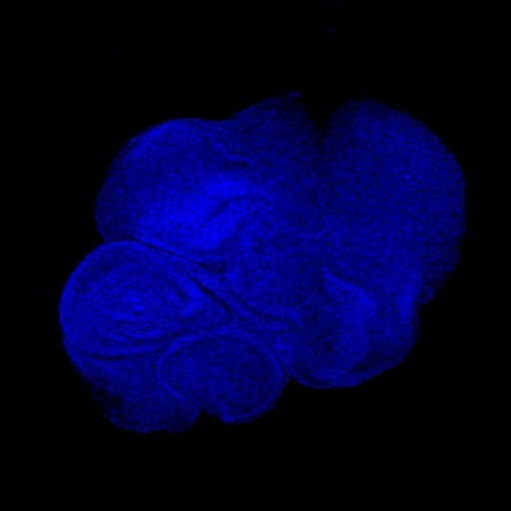  DAPI (nuclei) | 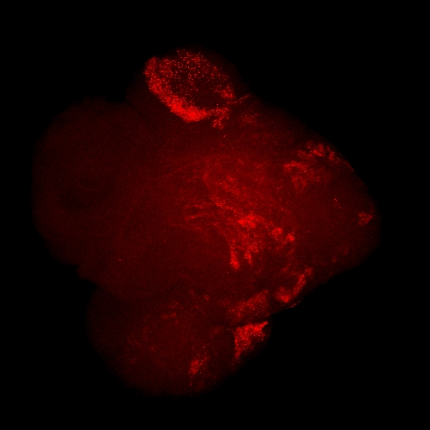  TABOR RNA (red channel) | 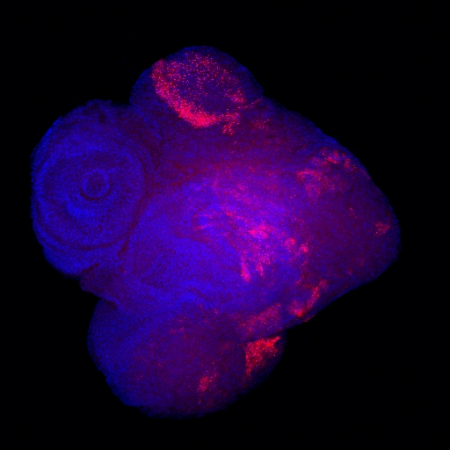  Merge (DAPI + TABOR)
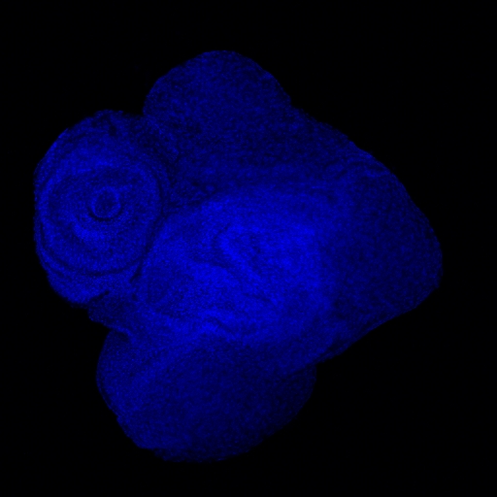  Sample 2 — DAPI | 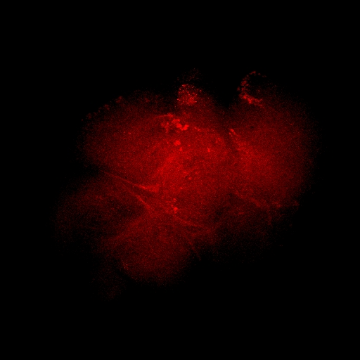  Sample 2 — TABOR | 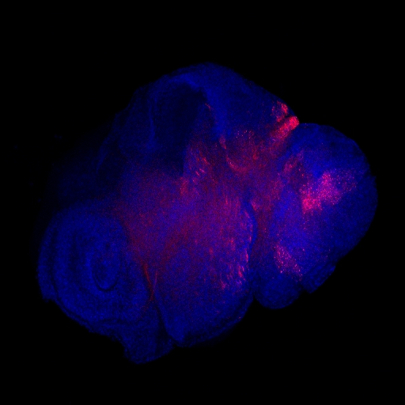  Sample 2 — Merge

6.2 RNA-seq reveals selective TE deregulation upon Polyhomeotic loss
Differential expression analysis (DESeq2) comparing Ph knockdown to control eye discs reveals 1,414 significantly deregulated features (padj < 0.05), including 1,394 genes and 20 transposable elements. Critically, TE responses are selective: 6 are upregulated and 14 are downregulated, arguing against non-specific epigenetic collapse.
Table 1: Significantly deregulated TEs upon Ph knockdown
TEs upregulated:
TE Family | log2FC | Fold Change | padj
TABOR | +7.43 | ×173 | ≈ 0
DM1731 | +4.07 | ×17 | ≈ 0
MDG1 | +2.77 | ×7 | < 1e-10
BLASTOPIA | +2.60 | ×6 | < 1e-10
TRANSPAC | +2.51 | ×6 | < 1e-10
GTWIN | +2.21 | ×5 | < 1e-10

TEs downregulated (top 7 shown):
TE Family | log2FC | Fold Change | padj
ZAM | -6.16 | ÷72 | < 1e-10
HETA | -3.87 | ÷15 | < 1e-10
TAHRE | -3.77 | ÷14 | < 1e-10
TART_B1 | -3.70 | ÷13 | < 1e-10
TC1-2_DM | -3.53 | ÷12 | < 1e-10
HOBO | -3.07 | ÷8 | < 1e-10
ROO | -2.25 | ÷5 | < 1e-10

Key interpretation: The selectivity of TE response (LTR retrotransposons up, telomeric elements HETA/TAHRE/TART down) demonstrates that Polycomb loss does not cause non-specific chromatin decompaction. Instead, different TE families are controlled by different — and potentially layered — silencing mechanisms. TABOR's extreme upregulation (log2FC = +7.43, the highest of any feature) and its correlation with tumor state make it an ideal molecular sensor for investigating the link between epigenetic tumor identity and TE activation.

7. Methodology and Work Packages

7.1 Model system
All experiments use the Drosophila melanogaster eye imaginal disc system. Polycomb mutations are introduced using the Ey-Gal4 driver (eye-specific expression) combined with UAS-RNAi constructs. Clonal analysis uses the FLP-FRT system for mosaic tissue generation. Temporal control is achieved using Gal80ts temperature-sensitive repression.

7.2 Key technologies
- Transcriptomics: Strand-specific, ribo-depleted RNA-seq with TE-aware quantification (TEtranscripts/SQuIRE [26])
- Chromatin profiling: CUT&RUN for H3K27me3, H3K9me3, H2AK119ub — low-input, high-resolution [27]
- Small RNA-seq: Oxidized (NaIO4) and non-oxidized libraries to distinguish siRNAs from piRNAs
- Single-molecule RNA-FISH: Stellaris probes for individual TEs + HCR-FISH for signal amplification
- Multiplexed imaging: RNA-FISH combined with immunofluorescence (γH2Av, J2, PH3, Dcp1) on same tissue
- Image analysis: Custom CellProfiler/QuPath pipelines for single-cell co-expression scoring

7.3 Work package summary
WP | Title | Months | Personnel | Key output
WP1 | Polycomb & TE control | 1–30 | Postdoc + PI | TE atlas + Publication 1
WP2 | RNAi–Polycomb cooperation | 9–36 | PhD + PI | Defense model + Pub 2
WP3 | Tumor states & TE consequences | 12–48 | Postdoc + PhD | SC map + Pub 3 (flagship)
WP4 | Human cancer translation | 33–60 | Engineer + PI | TCGA analysis + Pub 4
WP5 | Integration & framework | 39–60 | PI + full team | Review + follow-up grant

8. Timeline and Milestones
Table 3: Gantt chart overview
Work Package | Year 1 | Year 2 | Year 3 | Year 4 | Year 5
WP1: Polycomb & TEs | ████████ | ████████
WP2: RNAi cooperation | ████ | ████████ | ████
WP3: Tumor & TE |  | ████████ | ████████ | ████████
WP4: Human translation |  |  | ████ | ████████ | ████████
WP5: Synthesis |  |  |  | ████ | ████████

Key milestones:
- M12: Complete TE expression atlas for all Polycomb genotypes (WP1)
- M18: Small RNA landscape characterized; Ago2 double mutants generated (WP2)
- M24: First publication submitted — Polycomb-TE control (WP1)
- M30: Tumor-state dependency of TABOR confirmed or refuted (WP3) — Go/no-go decision point
- M36: Single-cell TE–stress co-expression map complete (WP3)
- M42: Human TCGA analysis completed (WP4)
- M48: Flagship publication submitted (WP3)
- M54: Human validation data compiled (WP4)
- M60: Synthesis review + follow-up grant submitted (WP5)

9. Translation to Human Cancer

9.1 Conservation of molecular machinery
The core molecular components investigated in TE-TUMOR are deeply conserved between Drosophila and humans:
Drosophila | Human ortholog | Cancer relevance
E(z) | EZH2 | Mutated in lymphoma, melanoma, prostate, bladder. FDA-approved inhibitor (tazemetostat).
Polyhomeotic (Ph) | PHC1/2/3 | Altered in leukemia, medulloblastoma, osteosarcoma.
Psc | BMI1 | Overexpressed in breast, colorectal, lung, brain cancers. Cancer stem cell marker.
Ago2 / endo-siRNAs | AGO2 / DICER1 | DICER1 mutations in ovarian/thyroid cancers. RNAi deregulated broadly.
Stat92E / Zfh1 | STAT3 / ZEB1 | Major oncogenic drivers. ZEB1 drives EMT; STAT3 constitutively active.

9.2 Planned human data analysis (WP4)
- Mine TCGA datasets (n > 10,000 tumors) for TE expression patterns in EZH2/BMI1/PHC-mutant vs. wild-type tumors
- Analyze published single-cell RNA-seq atlases for cell-state-specific TE activation signatures
- Correlate TE activation with innate immune signatures (interferon response genes, dsRNA sensing)
- Cross-reference with patient survival data to assess prognostic value
- Establish clinical collaborations for validation (Centre Jean Perrin, Clermont-Ferrand)

9.3 Clinical implications
EZH2 inhibitors and TE activation: Tazemetostat (FDA-approved) and other EZH2 inhibitors are expected to reactivate specific TEs. Our framework predicts which TEs will respond and in which cell types. This could be therapeutically exploited through viral mimicry (TE-driven immune activation sensitizing tumors to checkpoint immunotherapy [19]), or represent a risk if TE activation drives genome instability. Understanding this is critical for the ~15 ongoing EZH2 inhibitor clinical trials.

10. Budget Justification
Category | Amount (€) | % of total | Details
Personnel | 700,000 | 47% | 1 Postdoc (60 mo) + 1 PhD student (36 mo) + 1 Research engineer (24 mo, bioinformatics)
Consumables & Sequencing | 450,000 | 30% | RNA-seq (24 libs), CUT&RUN (18 libs), small RNA-seq (12 libs), FISH probes, antibodies, fly genetics
Equipment & Travel | 200,000 | 13% | Confocal access, computational cluster, conferences (EMBO, Keystone, Gordon), collaborator visits
Overhead & Other | 150,000 | 10% | Host institution overhead, publication costs, open access, data management
TOTAL | 1,500,000 | 100%

11. Risk Management and Contingencies
Risk level | Risk | Mitigation strategy
HIGH | TE signals too weak for single-cell FISH in tumors | TABOR shows 173× upregulation — among the strongest possible signals. We use HCR-FISH for amplification. If needed, shift to smFISH with branched DNA amplification. Drosophila tissues are thin and accessible.
MEDIUM | Polycomb + Ago2 double mutants lethal | FLP-FRT clonal analysis generates mutant patches in wild-type tissue. Temporal control via Gal80ts. Alternative: partial RNAi knockdown titration series.
MEDIUM | TABOR tumor-state dependency not confirmed | M30 go/no-go decision. If not confirmed, pivot to DM1731 or BLASTOPIA (also upregulated). A negative result still yields a publication defining TE–tumor-state independence.
MEDIUM | Human TE patterns diverge from fly predictions | Divergence is scientifically interesting — reveals lineage-specific TE control. Fly model provides stand-alone mechanistic value. WP4 is designed as validation, not foundation.
LOW | Recruitment delays | GReD has strong PhD programs (École Doctorale SVSAE) and international postdoc networks. Timeline includes 3-month buffer.
LOW | Sequencing bottlenecks | On-site GenomAuvergne platform. Backup: commercial providers (Novogene, BGI) with <4 week turnaround.

12. Expected Impact and Output

12.1 Scientific impact
TE-TUMOR will establish a new conceptual framework: transposable elements as dynamic sensors and potential drivers of epigenetic instability in cancer. This reframes TEs from passive genome residents to active participants in tumor biology. By linking Polycomb dysfunction, tumor cell identity, and TE activation at single-cell resolution, this project will provide the first mechanistic understanding of why specific TEs wake up in specific tumor states.

12.2 Publication plan
Timeline | Paper | Target journal
Year 2 | Polycomb controls TEs in somatic tissues | Genes & Development / EMBO Journal
Year 3 | Polycomb–RNAi layered defense against TEs | Molecular Cell / EMBO Journal
Year 4 | Tumor-state-dependent TE activation (flagship) | Nature / Science / Cell
Year 5 | TE signatures in human Polycomb-mutant cancers | Nature Cancer / Cancer Discovery
Year 5 | Perspective: TEs as sensors of epigenetic instability | Nature Reviews Cancer / Nat Rev Genetics

12.3 Training and open science
- Training: 1 PhD thesis + 2–3 Master's internships. International conference presentations.
- Open science: All sequencing data deposited in GEO/SRA upon publication. Analysis pipelines on GitHub. Preprints on bioRxiv.
- Outreach: Science communication through institutional channels and public science festivals.

The case for funding, in three sentences:
1. We have discovered that TE activation in tumors is tied to the tumor cell state itself — not random epigenetic collapse. No one else has reported this.
2. The PI has published proof (Nature Struct. Mol. Biol., 2025) that the exact Polycomb enzyme at the center of this project controls chromatin targeting via a novel dual-mark code, establishing unique expertise and credibility.
3. This project will create a paradigm shift — with direct translational relevance through EZH2 therapeutics, viral mimicry immunotherapy, and TE-based cancer biomarkers.

13. Principal Investigator — Track Record
Dr. Abdou Akkouche
Researcher, GReD (Génétique, Reproduction et Développement), CNRS / Université Clermont Auvergne, France

Key publication
Akkouche, A. et al. Binding of heterochromatin protein Rhino to a subset of piRNA clusters depends on a combination of two histone marks. Nature Struct. Mol. Biol. 32, 1517–1527 (2025). DOI: 10.1038/s41594-025-01584-8

Competitive advantages
- Unique expertise: One of very few researchers combining deep Polycomb mechanistic knowledge with TE biology expertise
- Published foundation: The Nature Struct. Mol. Biol. paper directly establishes E(z) as a TE regulator — the exact premise of TE-TUMOR
- Preliminary data: TABOR discovery provides strong, unpublished preliminary data that no competing group possesses
- Institutional support: GReD provides state-of-the-art imaging, genomics (GenomAuvergne), and fly facilities

14. References
[1] Slotkin, R. K. & Martienssen, R. Transposable elements and the epigenetic regulation of the genome. Nat. Rev. Genet. 8, 272–285 (2007).
[2] Burns, K. H. Transposable elements in cancer. Nat. Rev. Cancer 17, 415–424 (2017).
[3] Jang, H. S. et al. Transposable elements drive widespread expression of oncogenes in human cancers. Nat. Genet. 51, 611–617 (2019).
[4] Bourque, G. et al. Ten things you should know about transposable elements. Genome Biol. 19, 199 (2018).
[5] Lander, E. S. et al. Initial sequencing and analysis of the human genome. Nature 409, 860–921 (2001).
[6] Kaminker, J. S. et al. The transposable elements of the Drosophila melanogaster euchromatin. Genome Biol. 3, RESEARCH0084 (2002).
[7] Hancks, D. C. & Kazazian, H. H. Roles for retrotransposon insertions in human disease. Mob. DNA 7, 9 (2016).
[8] Czech, B. et al. piRNA-guided genome defense: from biogenesis to silencing. Annu. Rev. Genet. 52, 131–157 (2018).
[9] Chung, W.-J. et al. Endogenous RNA interference provides a somatic defense against Drosophila transposons. Curr. Biol. 18, 795–802 (2008).
[10] Schuettengruber, B. et al. Genome regulation by Polycomb and Trithorax: 70 years and counting. Cell 171, 34–57 (2017).
[11] Margueron, R. & Reinberg, D. The Polycomb complex PRC2 and its mark in life. Nature 469, 343–349 (2011).
[12] Francis, N. J. et al. Chromatin compaction by a Polycomb group protein complex. Science 306, 1574–1577 (2004).
[13] Kim, K. H. & Roberts, C. W. M. Targeting EZH2 in cancer. Nat. Med. 22, 128–134 (2016).
[14] Sahasrabuddhe, A. A. BMI1: a biomarker of hematologic malignancies. Biomark. Cancer 8, 65–75 (2016).
[15] Awad, S. et al. Mutation in PHC1 implicates chromatin remodeling in primary microcephaly pathogenesis. Hum. Mol. Genet. 22, 2200–2213 (2013).
[16] Akkouche, A. et al. Binding of heterochromatin protein Rhino to a subset of piRNA clusters depends on a combination of two histone marks. Nat. Struct. Mol. Biol. 32, 1517–1527 (2025).
[17] Tubio, J. M. C. et al. Extensive transduction of nonrepetitive DNA mediated by L1 retrotransposition in cancer genomes. Science 345, 1251343 (2014).
[18] Rodriguez-Martin, B. et al. Pan-cancer analysis of whole genomes identifies driver rearrangements promoted by LINE-1 retrotransposition. Nat. Genet. 52, 306–319 (2020).
[19] Roulois, D. et al. DNA-demethylating agents target colorectal cancer cells by inducing viral mimicry by endogenous transcripts. Cell 162, 961–973 (2015).
[20] Chiappinelli, K. B. et al. Inhibiting DNA methylation causes an interferon response in cancer via dsRNA including endogenous retroviruses. Cell 162, 974–986 (2015).
[21] Topper, M. J. et al. Epigenetic therapy ties MYC depletion to reversing immune evasion and treating lung cancer. Cell 171, 1284–1300 (2017).
[22] Gounder, M. et al. Tazemetostat in advanced epithelioid sarcoma with loss of INI1/SMARCB1. Lancet Oncol. 21, 1423–1432 (2020).
[23] Martinez, A.-M. et al. Polyhomeotic has a tumor suppressor activity mediated by repression of Notch signaling. Nat. Genet. 41, 1076–1082 (2009).
[24] Classen, A.-K. et al. A tumor suppressor activity of Drosophila Polycomb genes mediated by JAK-STAT signaling. Nat. Genet. 41, 1150–1155 (2009).
[25] Rossi, F. et al. An in vivo genetic screen in Drosophila identifies the orthologue of human cancer/testis gene SPO11/MEIOB as a novel tumor suppressor. PLoS Genet. 17, e1009875 (2021).
[26] Jin, Y. et al. TEtranscripts: a package for including transposable elements in differential expression analysis of RNA-seq datasets. Bioinformatics 31, 3593–3599 (2015).
[27] Skene, P. J. & Henikoff, S. An efficient targeted nuclease strategy for high-resolution mapping of DNA binding sites. eLife 6, e21856 (2017).

