***Easy Groceries***

***Admin User Manual***

When the customer clicks on **Admin** **Login**

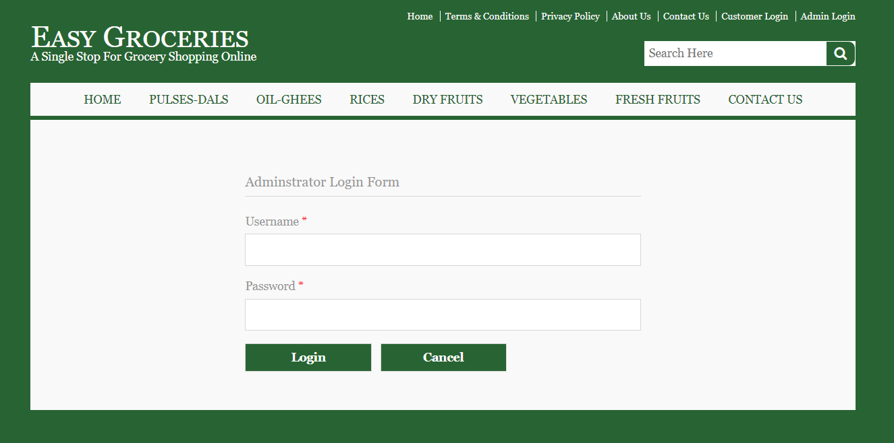

After logging in this is how the **Home Page** of the Customer Looks. He can traverse from here to other pages.

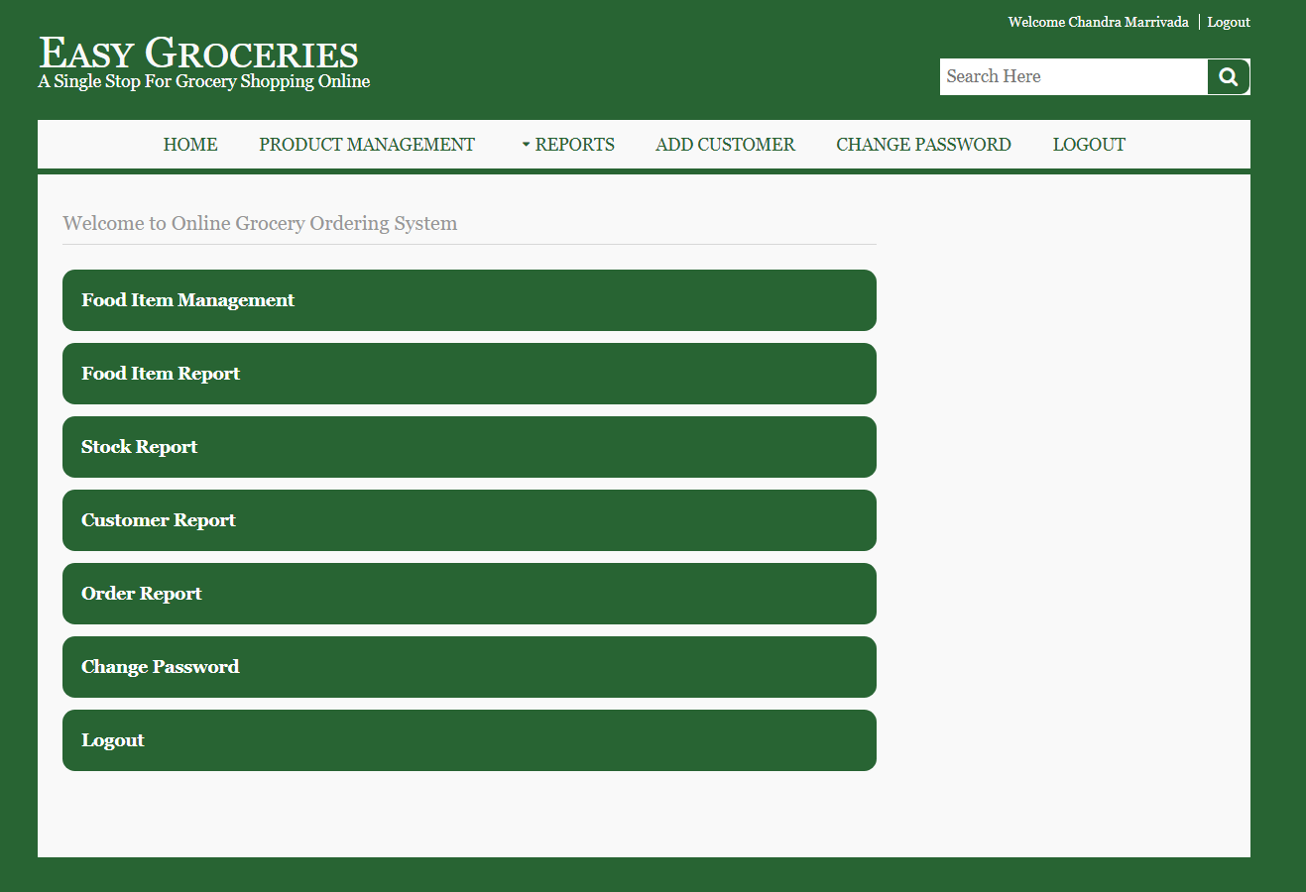

The **Product Management Tab** helps in adding new products available. He can also add **Number of Products** available in Stock.

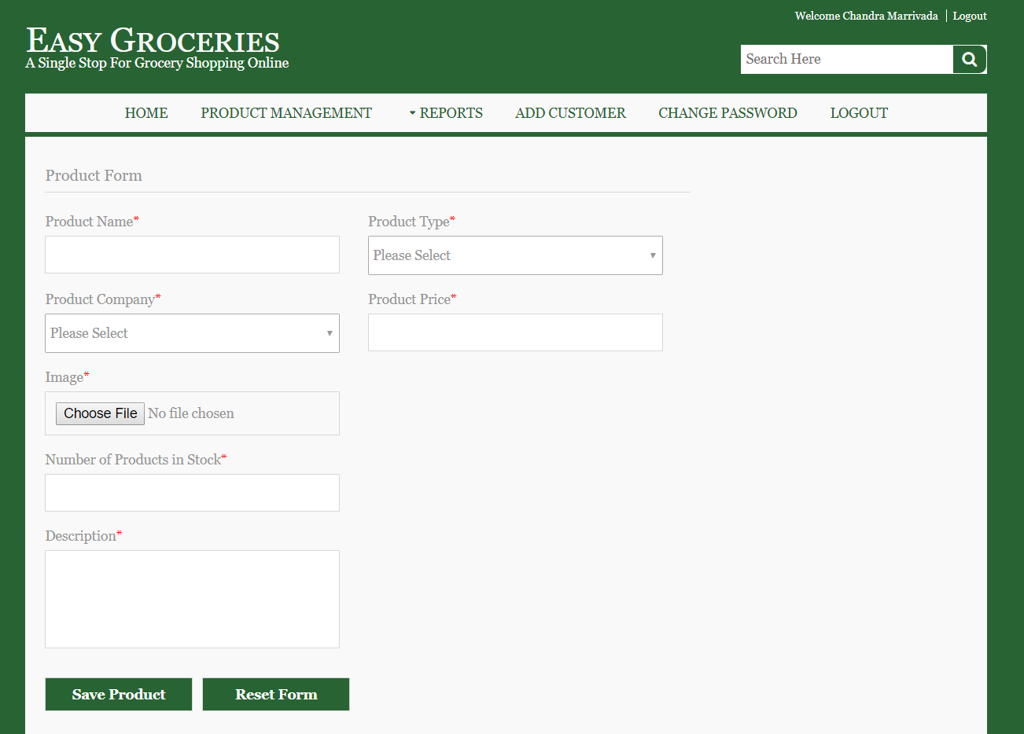

He finds Product Details under **Reports 🡪 Product Reports**

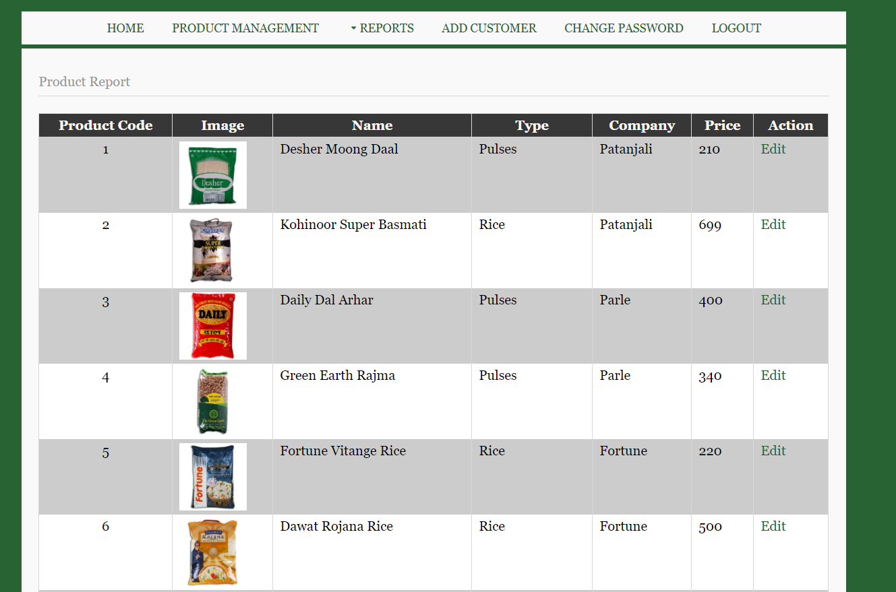

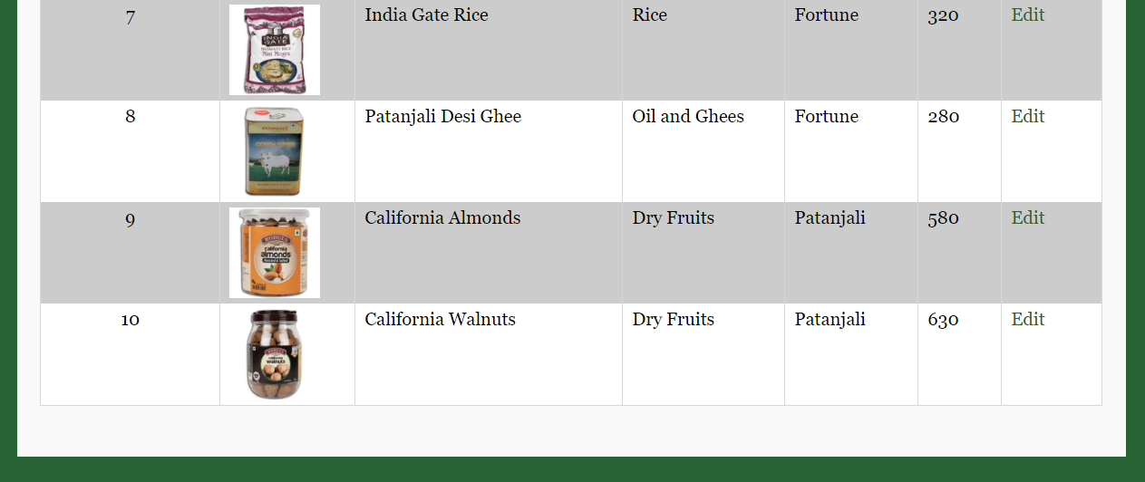

He finds Stock Details under **Reports 🡪 Stock Reports**

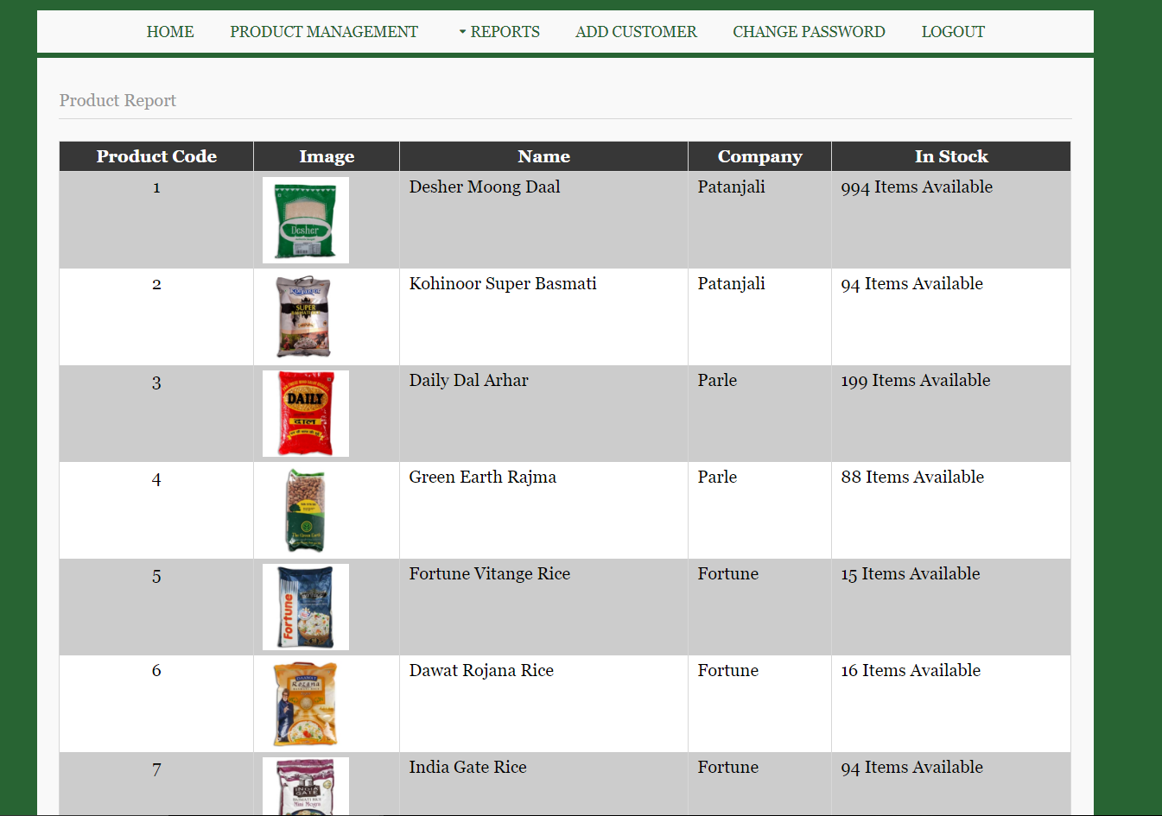

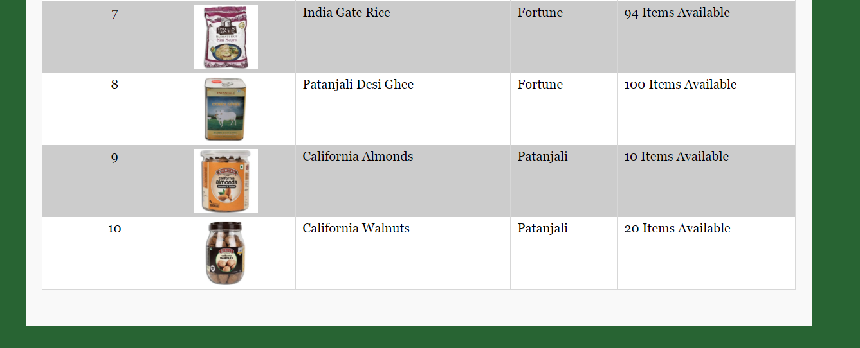

He finds Customer Details under **Reports 🡪 Customer Reports**

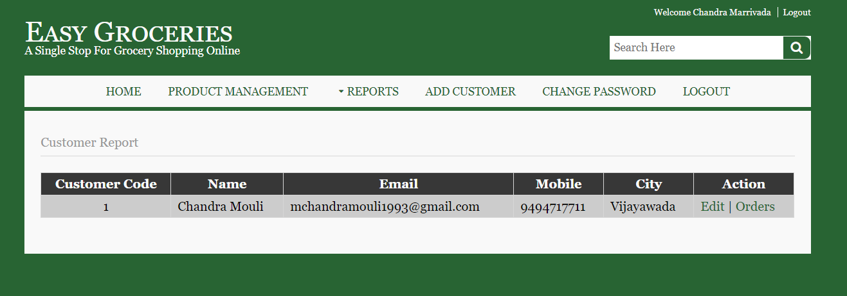

He finds Order Details under **Reports 🡪 Order Reports**

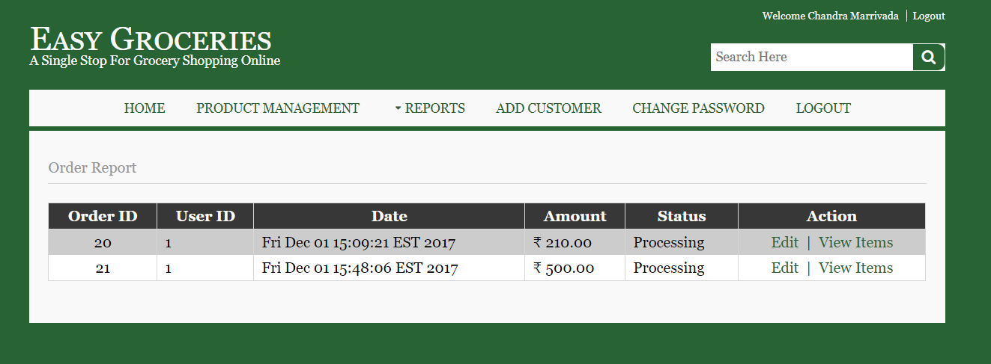

And be able to edit the **Orders** and change its **Order Status** if necessary

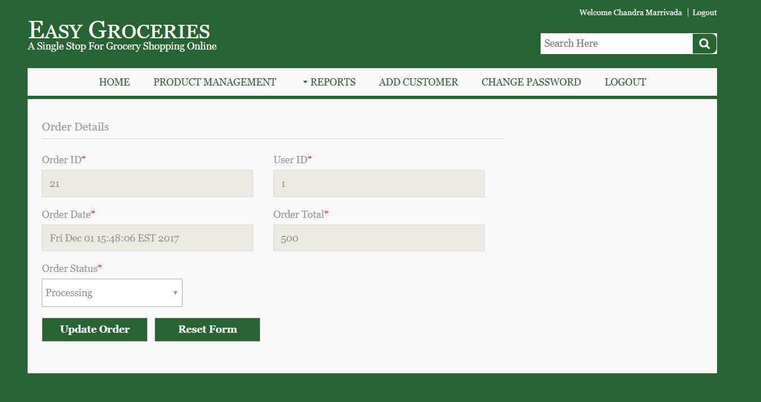

The **Admin** can also **Change his Password** if he feels any threats.

