***Easy Groceries***

***Customer User Manual***

Every person will be able to see the **Home Screen**, traverse through the **List - Product Items** and will be able to add them to the cart. But if he wants to continue, he needs to **Login.**

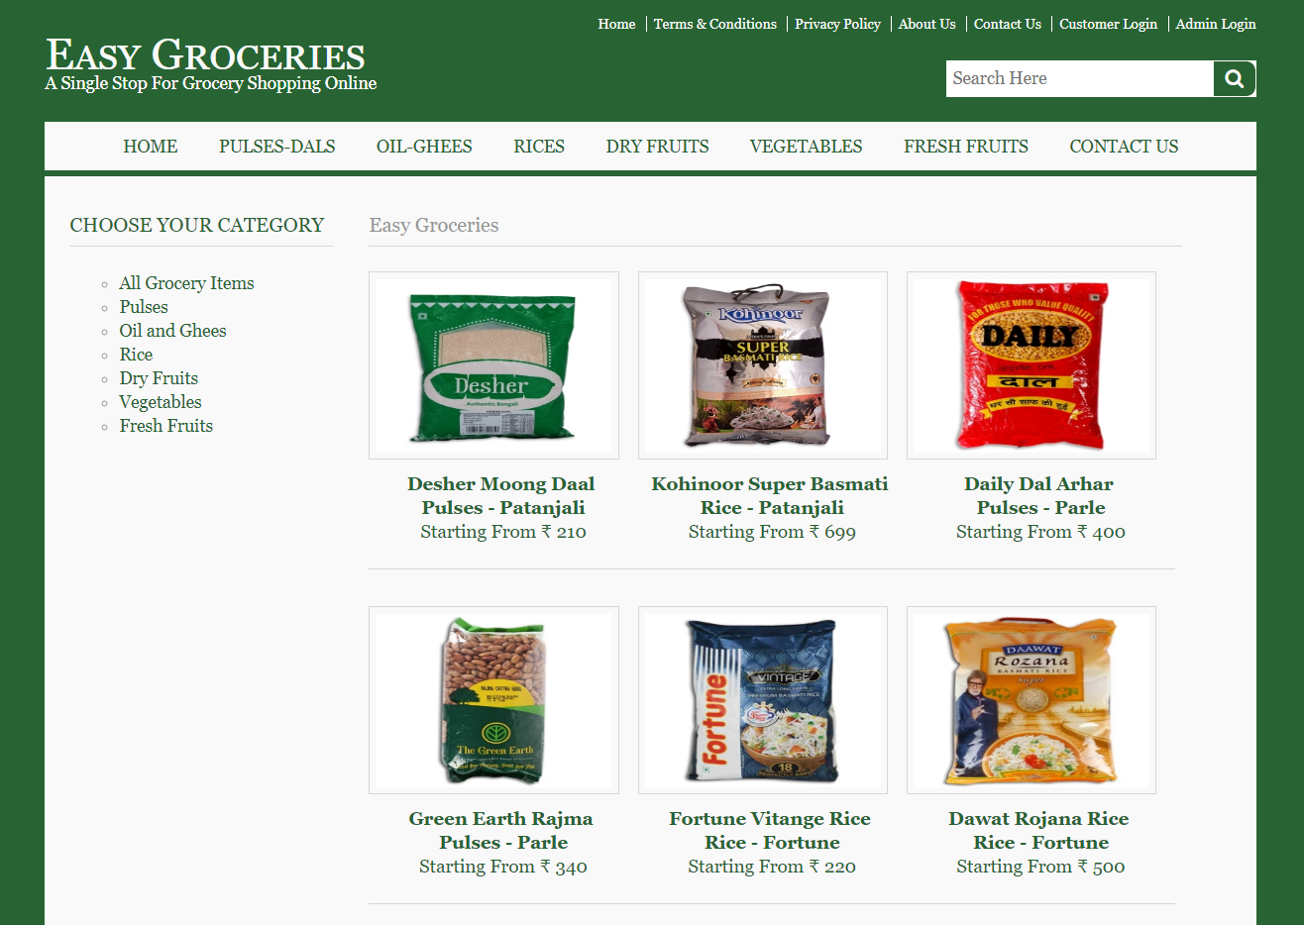

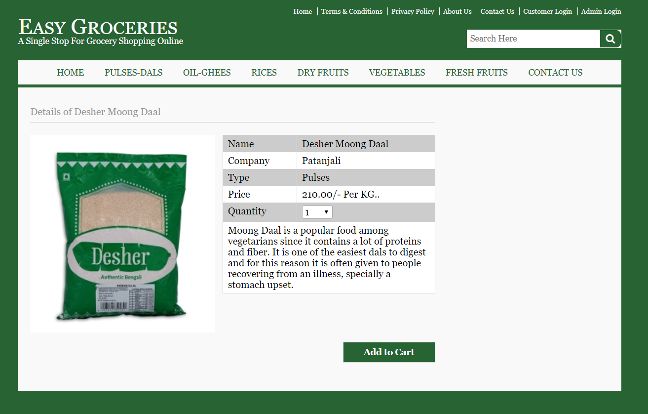

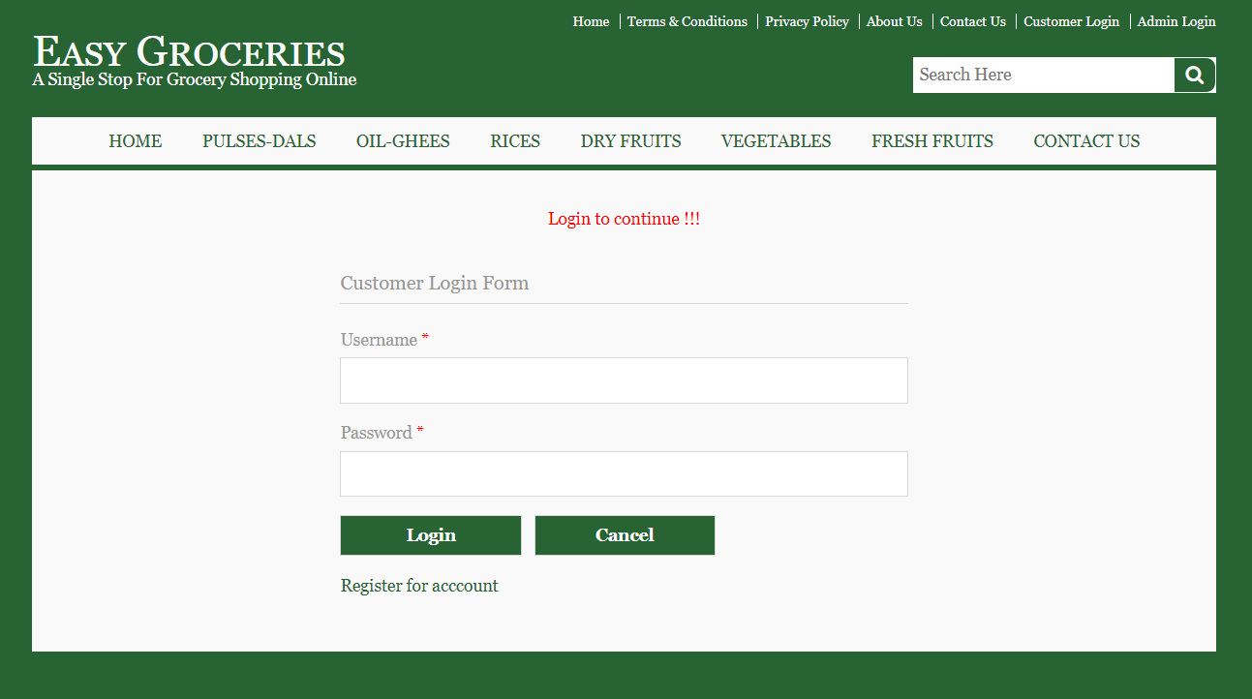

Before Logging in we suggest you read the **Terms & Conditions**, **Privacy Policy** so that every customer will know the Terms of the site and about customers Privacy.

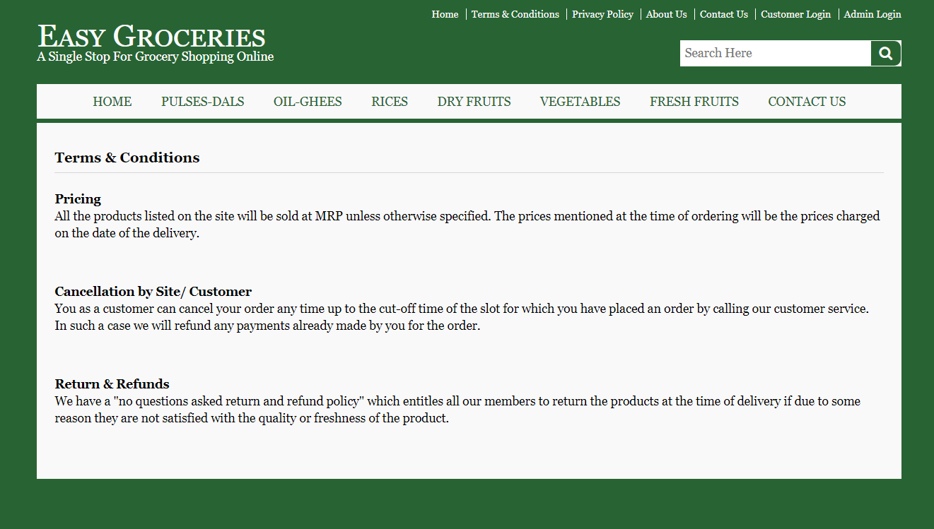

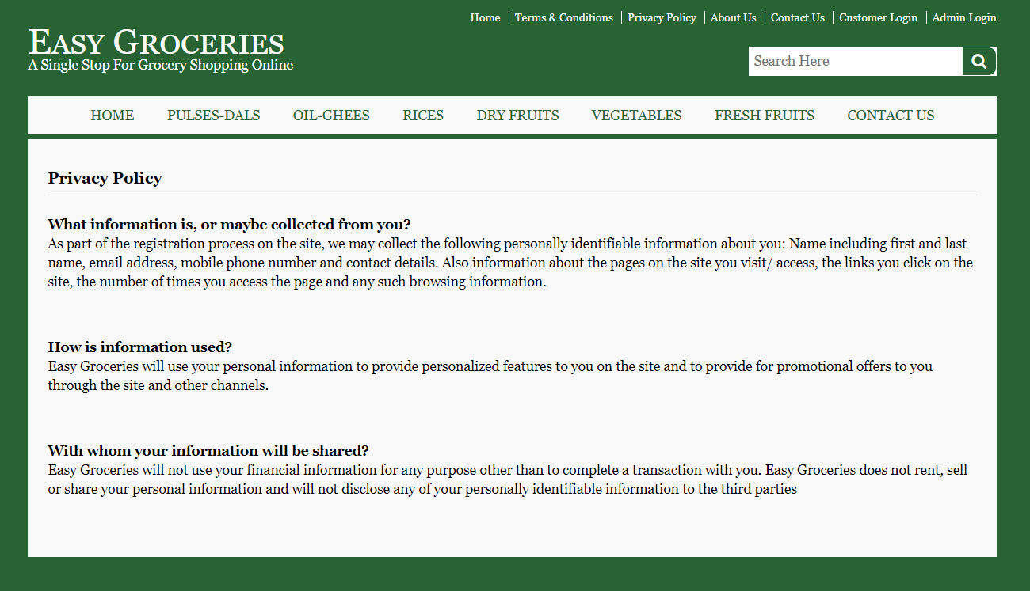

When the customer clicks on **Customer** **Login**

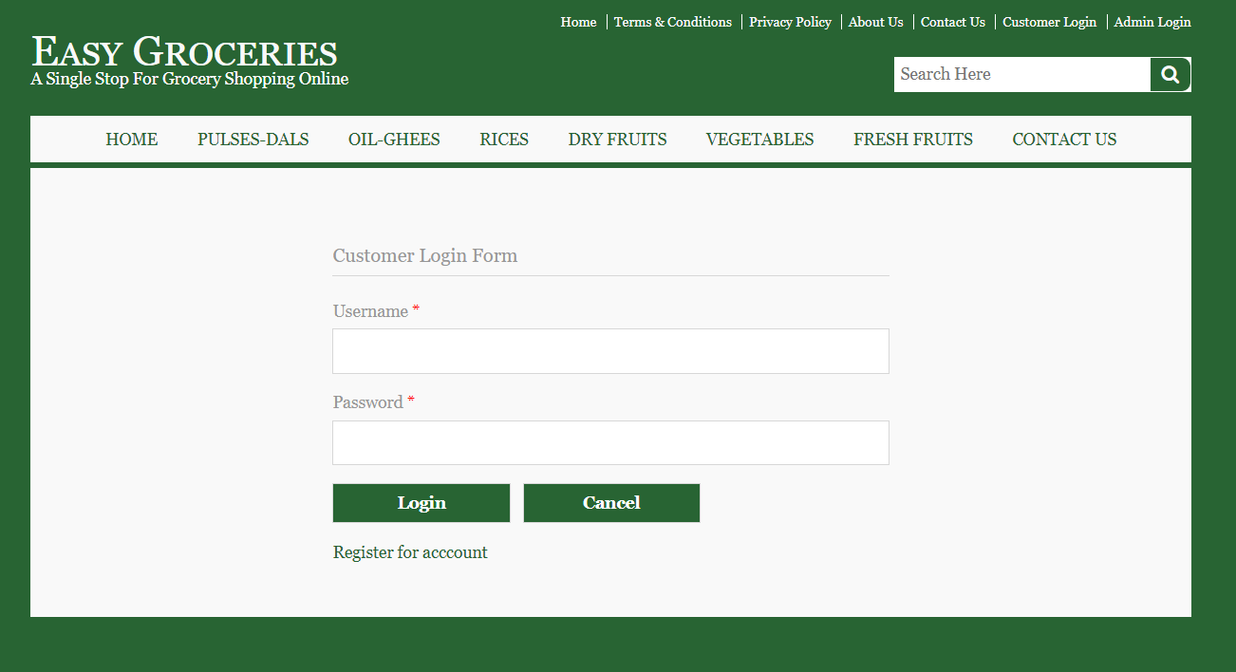

If he has an account in this site, he can directly login using the login form otherwise he needs to register using **Register for Account** link.

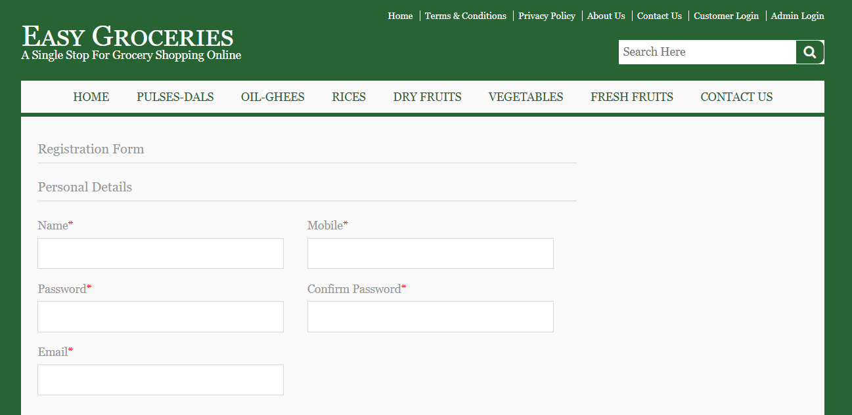

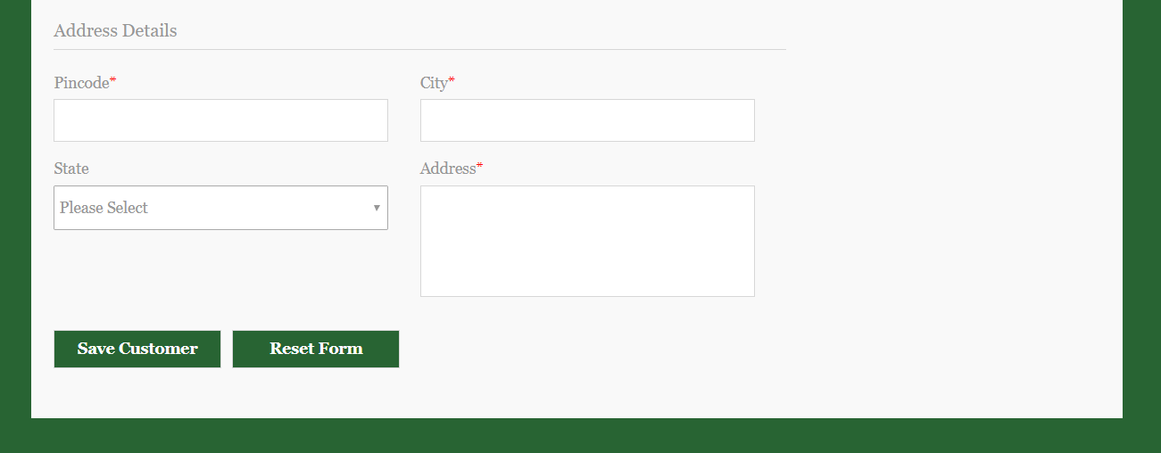

If there is any mistake, he can **Reset** the form.

After logging in this is how the **Home Page** of the Customer Looks. He can traverse from here to other pages.

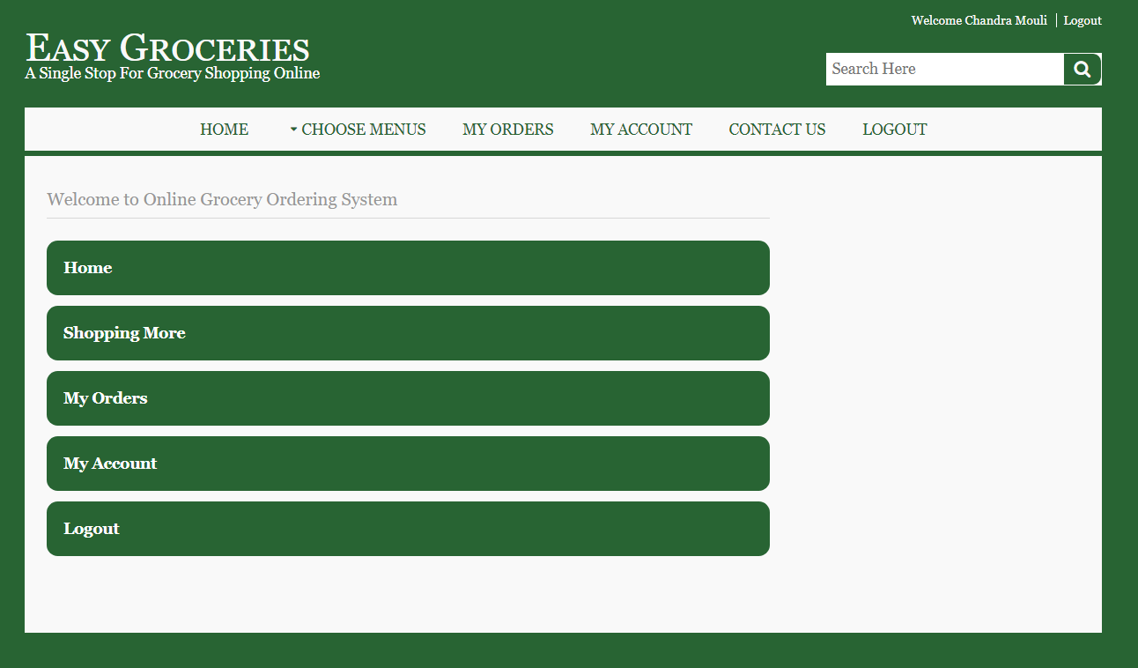

He will find all the products under Home Button in the Header Navigation Bar.

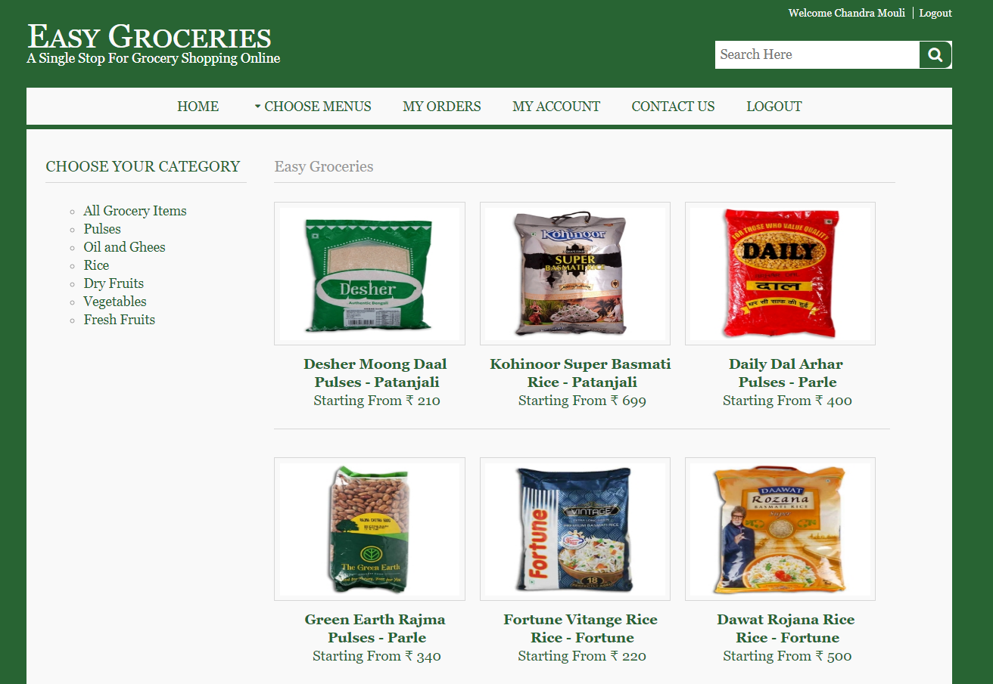

This List-Product helps him in adding the desired **quantity** of products to cart.

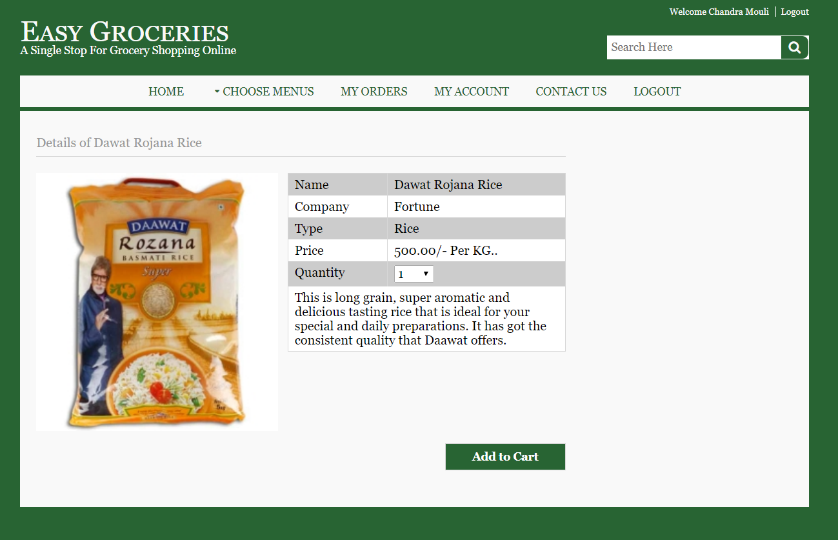

He can use the **Action button** to **delete** the product from the cart and proceed to checkout.

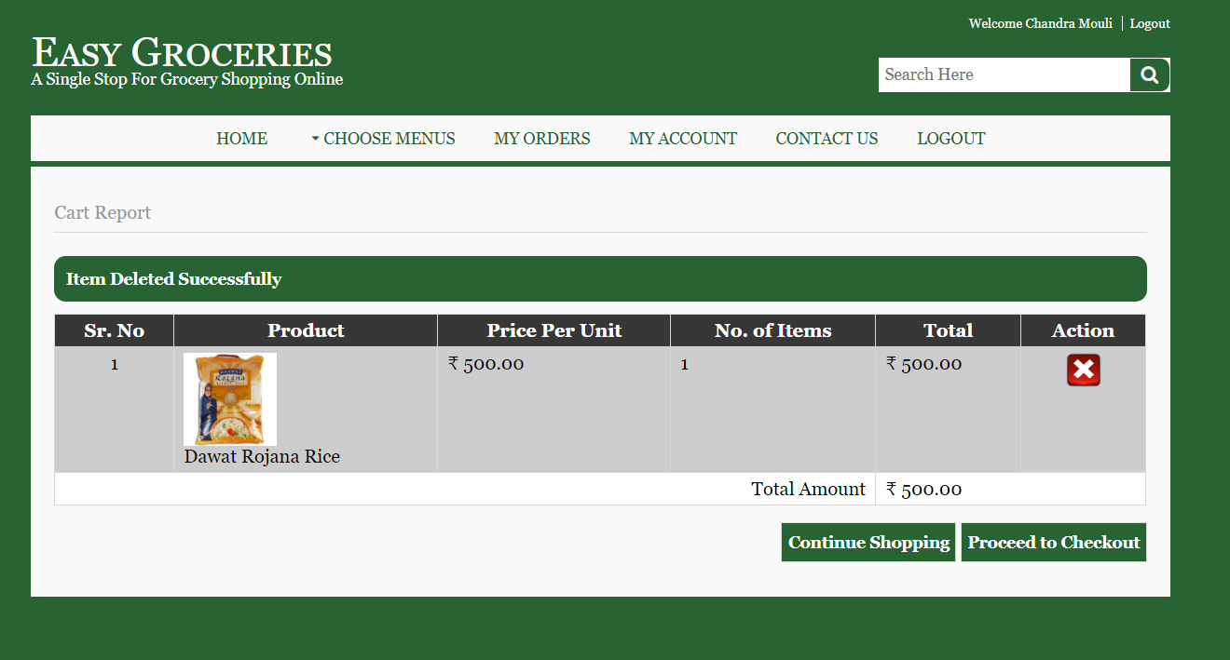

Once he decided the product which he wants to buy, and after checking out, it asks to provide the **Shipping Address** to where the product must be delivered.

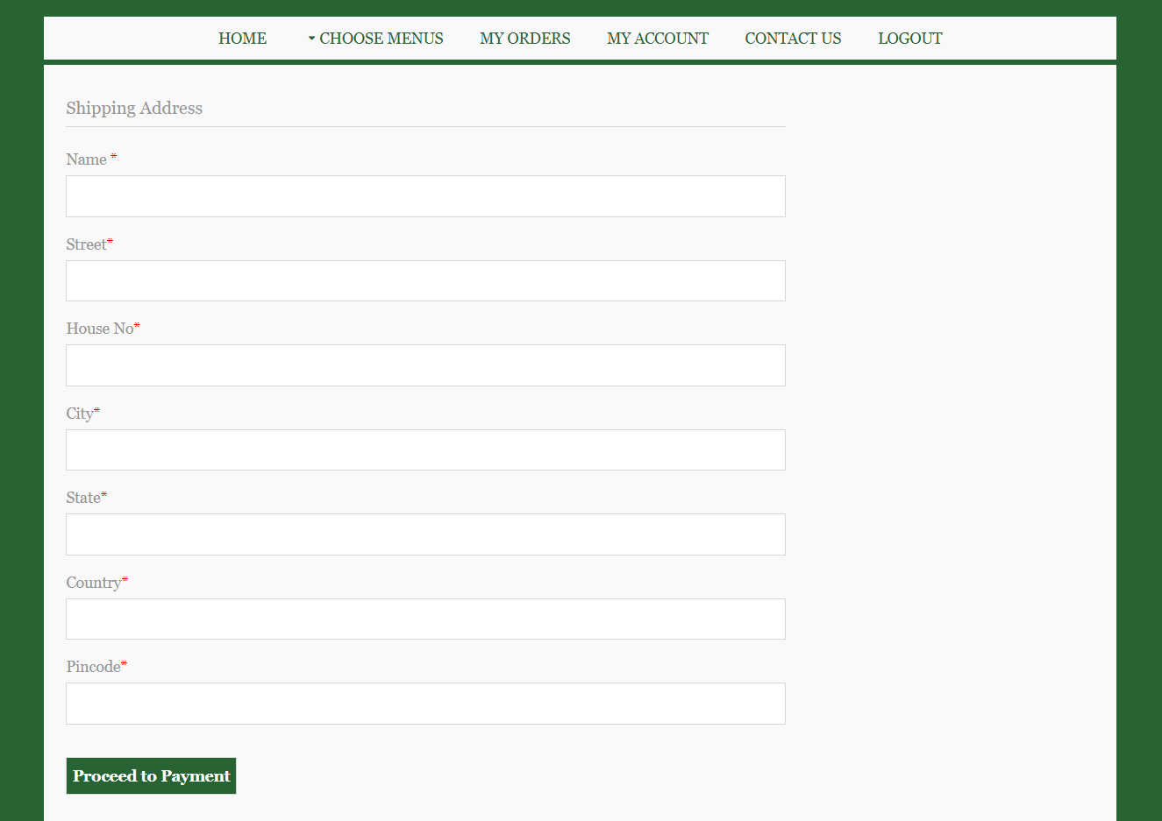

The **Payment** can be done online.

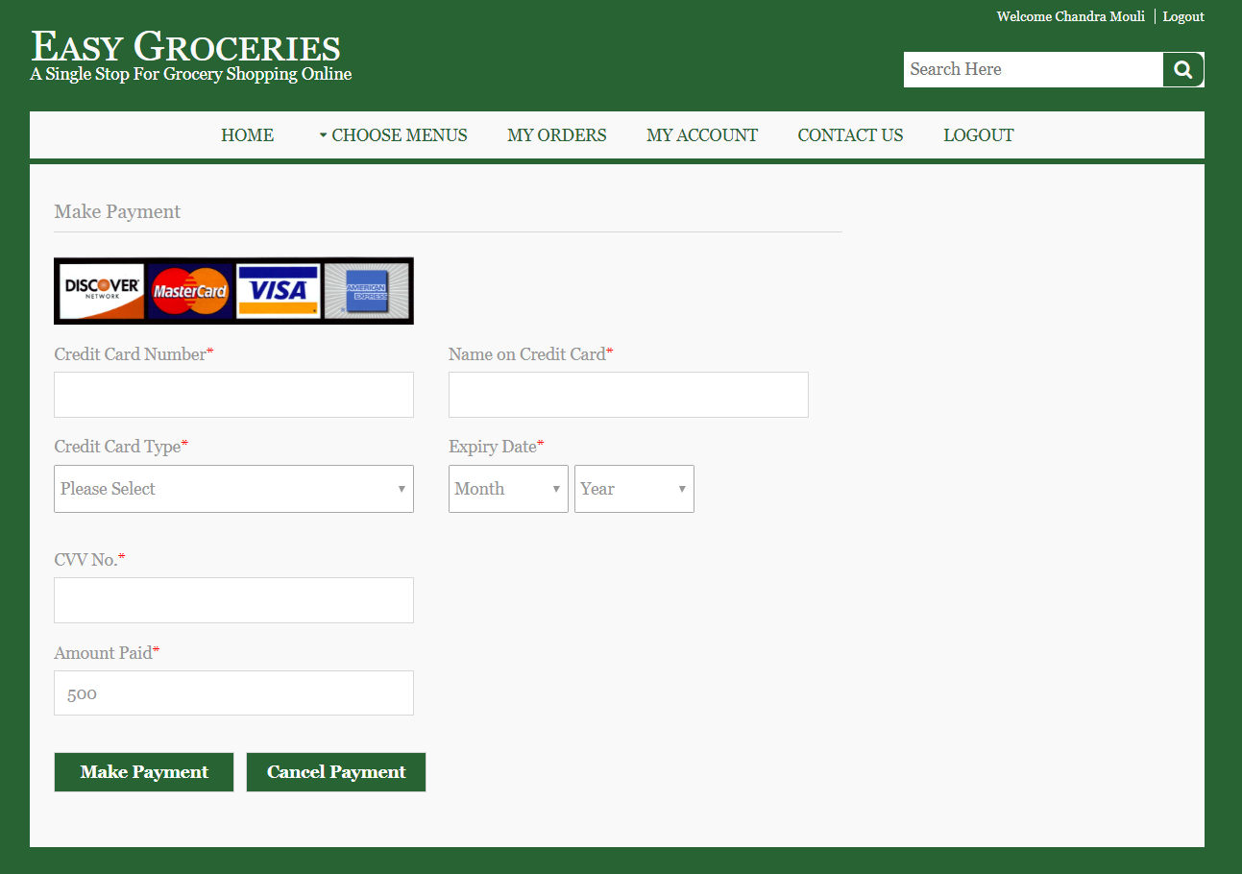

After the payment, he gets the **Order Confirmation.**

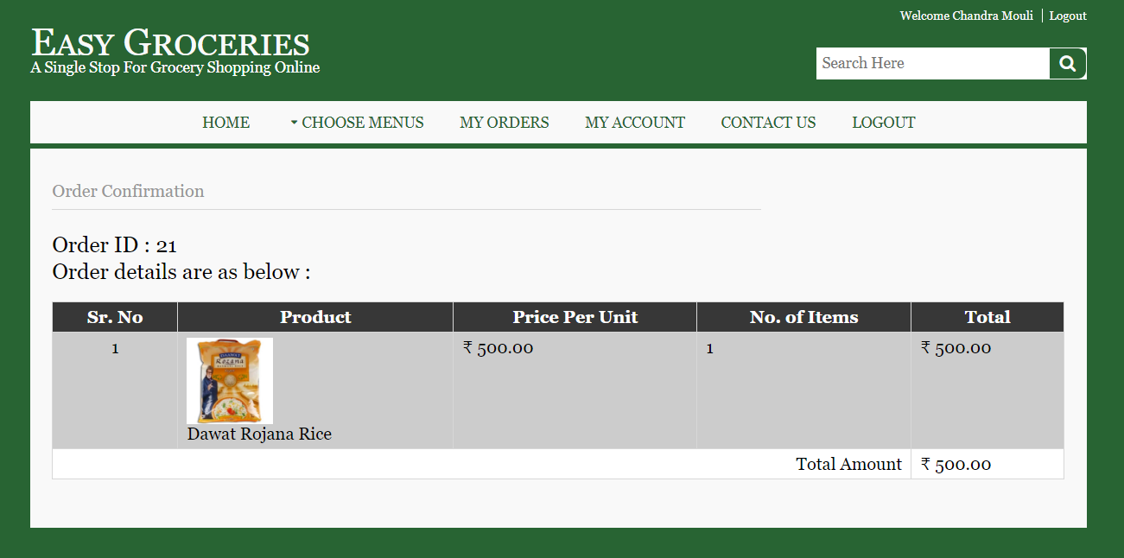

He can check his orders in **MyOrders** tab from Header Navigation Bar.

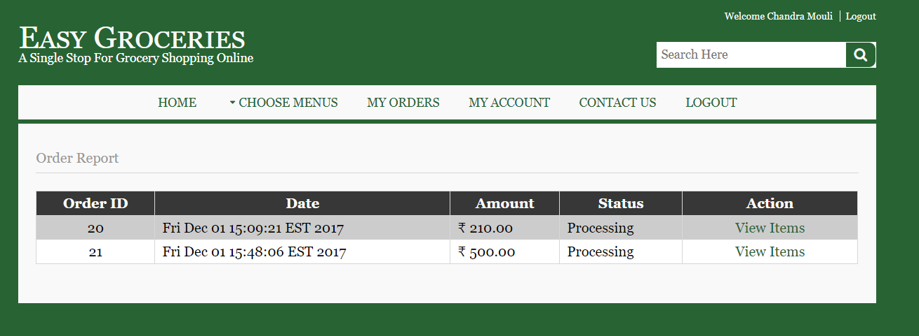

And see in detail of how many items he ordered through View Items under Action.

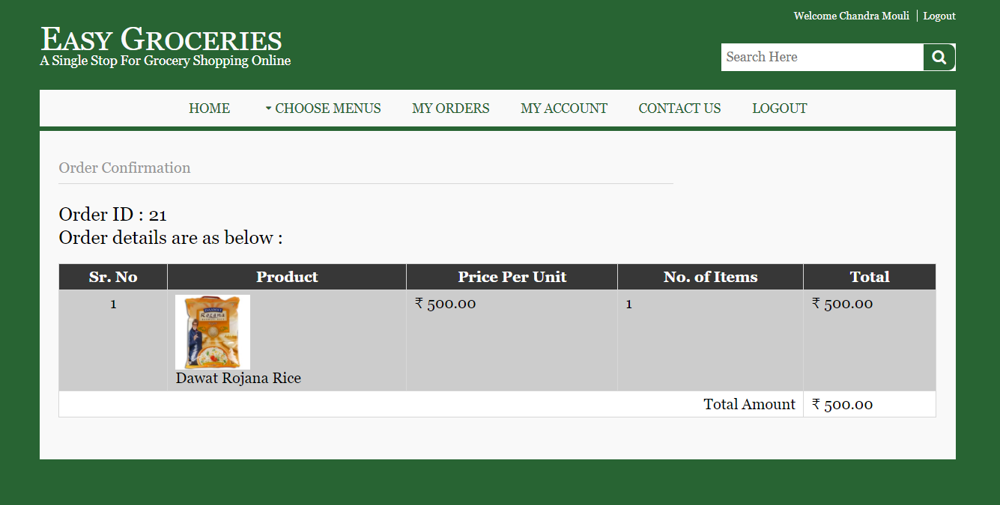

One done, he can logout successfully using the **Logout** button.

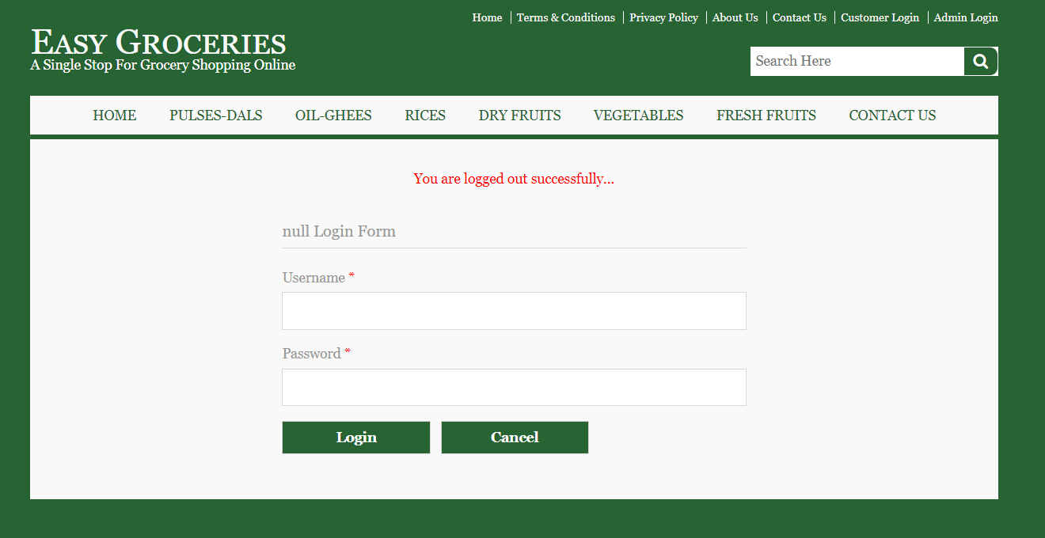

If he has any doubts, he can fill the form in the **Contact Us** column.

