**Final Project**

Ming Chang

IC115 T01: Web Design & Development I

Professor Nick Kolobutin

December 12, 2021

**Final Project**

* GitHub link(s)

1. repository link: https://github.com/mchangdev/mingchang.github.io
2. website link:

* Functions/features/pages descriptions
* Technologies/skills applied
* Novelty and any other specialties worth mentioning
* Development procedure
* A zipped file including HTML/CSS code and other associated files
* Web Project Topic Selection

The theme of my website is about programming techniques. The name of the site is My Repository of Skills. There are several reasons for creating this site. First of all, I would like to redescribe the programming knowledge I learned through the Internet or work in my own language. I think classifying and expressing information in a reasonable way can deepen my impression and make my thinking clearer. The second is in case you forget some technical details over time. By checking my website, I can quickly recall relevant skills and knowledge, and avoid wasting time and energy searching for information again. Finally my website provides technical solutions for those who need them. When someone has a technical problem like mine, it will improve the efficiency with which visitors acquire skills and solutions if they can find relevant technical knowledge and solutions on my site.

My goal for the site is to be able to categorize information and update articles regularly. Because the technologies involved may include HTML/CSS, JavaScript, databases, and some common front-end frameworks, it is important to categorize the information. This is not only convenient for me to view the information myself, but also for visitors to browse the corresponding page according to their needs. Technology is dynamic, and I wanted the site to be positioned to reflect current technology trends and relatively hot development-related topics.

My target audience should be those who have a certain background in software development, such as those who are interested in software development, students of computer related majors and those who have a background in software development.

The problem I want to solve on my website is to provide a platform for my technical growth, which can not only facilitate my own review and review, but also provide relevant articles for those who need to learn. If someone finds something wrong with my article, it will help me improve my ability.

My site is text-based, with some images to supplement the content. Links to videos from other sites will also be provided if needed.

My site has a similar structure to the following two sites:

https://developers.weixin.qq.com/miniprogram/en/dev/framework/

http://blueskykong.com/

http://www.ityouknow.com/

* Web Project Planning Analysis

My site consists of seven pages, each working title is Home, Recent, Popular Articles, HTML/CSS, JavaScript, Cloud Server and About. Through the navigation bar on the home page, you can directly open each page and browse. Each page has links to its home page and sub-pages, and you can jump between the seven pages as needed.

My website information sources are mainly from the following websites:

https://intl.cloud.tencent.com/document/product

https://www.csdn.net/

https://www.runoob.com/

https://developers.weixin.qq.com/miniprogram/en/dev/framework/

My schedule:

|  |  |
| --- | --- |
| Time | Task |
| October 25 | Determine the main color and logo of your site |
| November 8 | Make a preliminary layout of the home page |
| November 15 | Complete the layout of the sub-pages |
| November 22 | Optimize and adjust the page layout |
| November 29th | Fill home page with real content |
| December 6 | Populate the child pages except the home page with real data |
| December 13 | Optimize website details and wait for release |

* Web Project Site Map

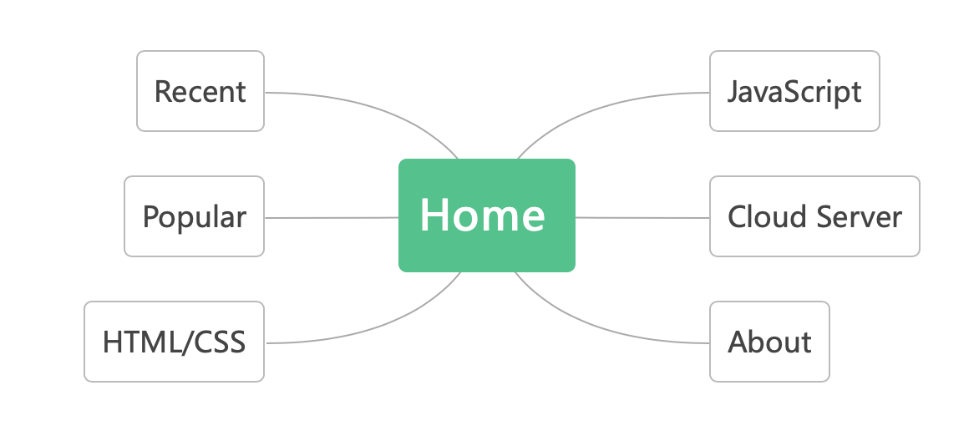

* Web Project Page Layout Design

Home page

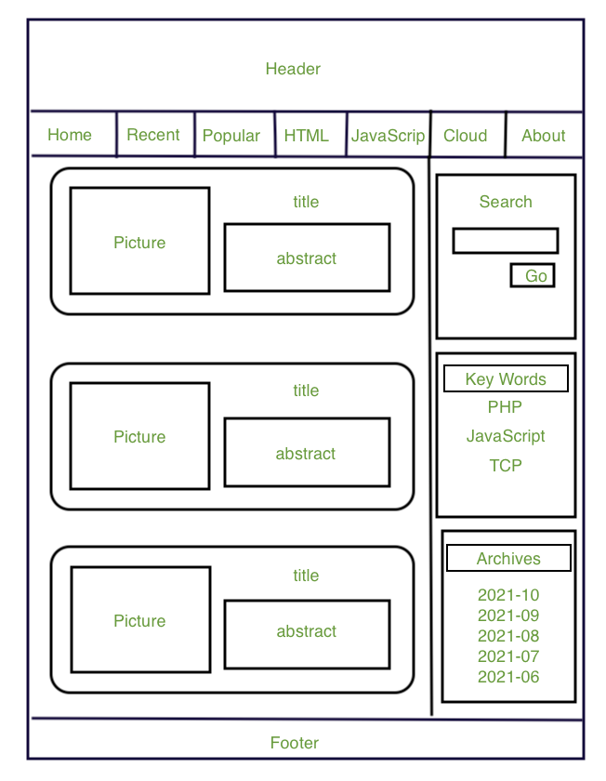

Content page

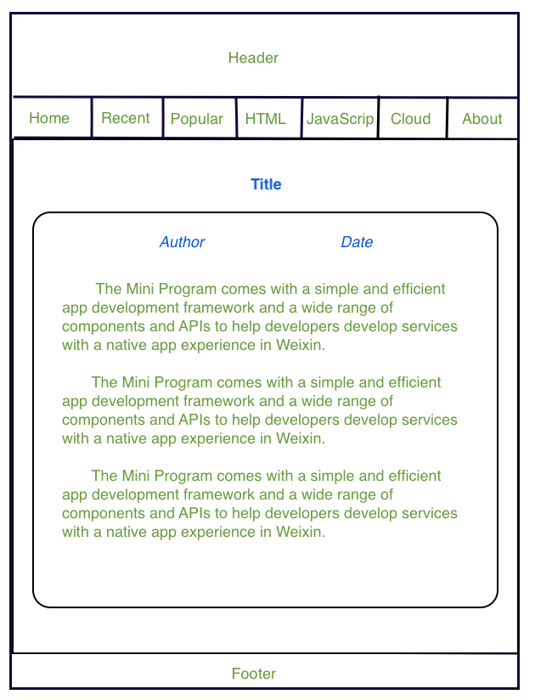

Continue working on your web site project. You will push/publish your web files to GitHub using the method described in this lab manual. You will provide the link(s) in your project **document**, e.g.,

repository link: https://github.com/qxpang/qxpang.github.io

website link: qxpang.github.io;

What to be submitted by the due date (Dec. 18)?

**a. A Word or pdf document**

i. Include the **GitHub link**(s) into the document (from the links your code and site are accessible; will be instructed in the next week)

ii. Functions/features/pages descriptions

iii. Technologies/skills applied

iv. Novelty and any other specialties worth mentioning

v. Development procedure

vi. etc.

b. A **zipped file** including HTML/CSS code and other associated files (in case GitHub is not accessible)

4. Where to submit?

BB -> IC 115 -> Assessments -> Project

5. The project evaluation will be performed mainly from the following aspects: documentation writing/organization (clarity, easiness to read, formatting, etc.), richness of features implemented in the website, technologies/skills applied in the website development, novelty, amount of coding, etc.. You document should well explain the implemented features, techniques applied, and so on.