ShapeBase 0.1 Alpha
(Draft)

Introduction
ShapeBase is a small set of programs to explore molecular shape and volume. The programs are based on the theory of quasi-random Monte Carlo integration, where both volume and shape are approximated via quasi-random point generation and sampling.

One can sample via a grid to find the volume of a shape. Form a grid in a known volume that encompasses the shape in question. The number of grid points inside the shape over the total number of grid points is the fraction of the known volume that represents an approximation of the shape’s volume. However the error in using a grid to approximate the shape volume is related to the dimension: that is, it is exponential in the dimension, and thus, the higher the dimension, far more grid points are needed to reduce the error. It has been shown that by using random sampled points, rather than grid points, removes the exponential dimension term. Thus, the error becomes simply linear in the number of points. This approximation method is the classical Monte Carlo integration (Metropolis). The mean and the variance of the error converge linearly with repeated sampling of points.

Pseudo random numbers are used to generate points in a space to integrate over volumes. It was later found that quasi-random sampled points reduce the error at an even faster rate in relatively low dimensions, so that even fewer points can be used to obtain the same error as pseudo random points. This is known as quasi-Monte Carlo integration and is used in numerous fields, most notably finance.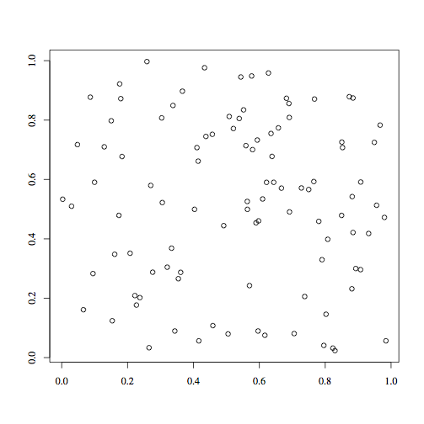
Figure 1: A sample of 100 pseudo randomly generated points on the unit square.

In figure 1, note the clumping and small void regions. These are an artifact of sampling a uniform random distribution and not a property of the pseudo random number generation (providing the pseudo random number generator is a good one, such as the one used to generate these points, and passes numerous statistical measures). In figure 2, the points are generated using the Hammersley quasi-random sequence. Note how the points have a “random” feel, ungrid-like, and they are largely uniformly spread about the square. (Note they may have an occasional lattice-like structure, a result of number theoretic properties of the sequence generator.)

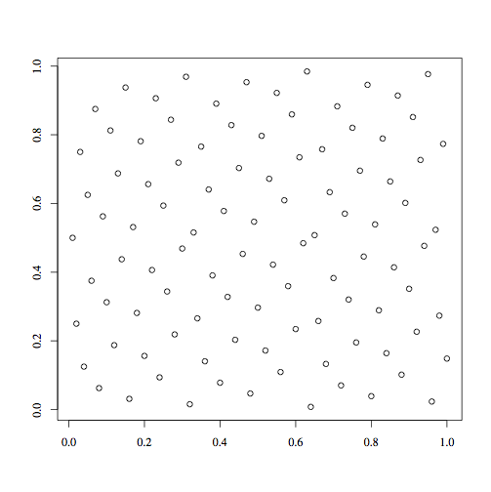
Figure 2. A sample of 100 quasi-random sequence generated points on the unit square.

Quasi-random points have a feature, "low discrepancy." Discrepancy is a measure of a point set that quantifies the relative variance of the nearest neighbor distances between points. If the discrepancy is low, the points are more uniformly spread about. Pseudo random points have higher discrepancy than quasi-random points. Low discrepancy is one such factor that contributes to increasing the convergence of the error.

Machine methods for generating quasi-random sampled points with low discrepancy have been developed over the years. The Hammersley sequence is one such quasi-random number generator with low discrepancy properties, and the sequences necessary to generate 3D points is very simple and fast. Approximating the volume of a molecule in 3 dimensions is ideal for quasi-random Monte Carlo integration – it is both fast and simple. Hammersley points need only be generated once. Finding the right number and density for a given problem may take some experimentation however, but once those have been found, all instances of the problem can use the same points repeatedly. For example, one might want to treat a fragment database differently than a natural products database, as the relative sizes of these types of compounds differ considerably on average.

ShapeBase thus contains a method for approximating molecular volumes using the quasi-random Monte Carlo integration. However, another step is needed to compare shapes, and that is a fixed reference frame of points. With a fixed set of quasi-random points, two different conformations can be compared by aligning the conformations, then finding the points in common inside each versus the points outside of each. Points then represent queries in the form of "0" for not contained within a molecule, and "1” represents a point inside the molecule. The indicator function results of the quasi-random points, and their inclusion or exclusion within the shape, then corresponds to a fixed length bit string.

Alignment requires orientation along major axes and there are 4 basic orientations for a 3D object. Thus, 4 fingerprints for each conformation are generated that correspond to the 4 orientations along the major axes, and 4 comparisons (whether, Tanimoto, Cosine, Tversky, etc.) are made between any two conformations fingerprint sets. The maximum similarity is thus the approximate shape similarity between the two conformations. Note, that all 4 choose 2 comparisons can be made to find the maximum similarity, however, this is typically almost no different that comparing 1 configuration of one conformation with the 4 configurations of the other conformation. This is due to the fact that if there are sufficient points in the sampling, the variance of the error small for the maximum similarity. This factor can produce asymmetric matrices though the measures are symmetric. The percent asymmetry for such matrices is very small, typically less than 1%. It is much smaller than can be found other shape methods (see, Asymmetry ACS presentation, ACS COMP, San Francisco 2006).

Note that if one aligns shape B to shape A that is fixed, this approximation may differ from the approximation that results from aligning shape A to shape B that is fixed. If the conformations are from the same compound, the approximations should match but possibly for some minor error due to precision (cf. Procrustes Analysis). However, given conformations from different compounds, there is bound to be more significant differences in the approximations. NXN shape (dis)similarity matrices of N conformations from different compounds are bound to be asymmetric as a result. When the percent asymmetry of a matrix is small, averaging (i,j), (j,i) elements can be used to convert the asymmetric matrix to symmetric form for use in cluster or similarity analysis (MXN matrices can be treated similarly).

The number of points that sample the space should be large enough to obtain reasonable approximations of the volume such that shape comparisons are also reasonable. For example, the number should guarantee that all atoms are sampled by a reasonable number of points. Rather than approximate the volume of a conformation in a cube, to reduce the number of points and maintain the density of the points, a sphere or ellipsoid is used (roughly a half or a third of the points in the cube respectively). A sphere is used to find the principal coordinate orientation, since the original conformation orientation may be arbitrary and not fit along the major axes of a scalene ellipsoid, but once the orientation along principal axes is found a scalene ellipsoid can be used to further reduce the number of points and maintain the necessary density of sample points. It is important to find the maximum extent from the origin of atom point sets in the set of conformations. Preliminary sampling suggests that most small molecules < 500 MW are contained with a radius of 11 Angstroms, and that conformations will fit within a near spheroidal ellipsoid.

ShapeBase Tools:

There are 6 programs in ShapeBase.

The first is a program to generate quasi-random points in 3 dimensions. The program is called HammersleySpheroid. It generates points inside an ellipsoid of a given radius and parameters, a, b, c., necessary to produce a scalene ellipsoid. A sphere is a special case where a = b = c = 1.0. The radius is in angstroms, e.g., where the radius = 10.0, and a = b = c = 1.0, creates a sphere with a radius of 10 angstroms centered at the origin, and a volume of (4/3)*pi*r^3, or roughly 4189 cubic angstroms. Most small molecules can be centered and encompassed by such a sphere. If the database is large and contains large or long compounds (e.g., lipiphilic compounds), the user may wish to generate a larger sphere or ellipsoid with a long axis to make sure all centered molecules fit within the ellipsoid. The number of points needs to be increased respectively to cover all of the molecules since each molecule typically only represents a small percentage of the volume in the sphere or ellipsoid. The program presently takes a size parameter for the number of points, but the number of points returned are those within a sphere or ellipsoid that is contained within a cube with sides of double the radius input. This makes for an annoying "by hand" testing to get a set of points that is divisible evenly by 64, the typical word length of most modern machines now. All of the programs are general, such that any number of points will suffice, but for efficiency, keeping the number of points as some factor of 64 is advisable. The default point files are, happily, factors of 64. There is a relatively simple way to generate the points within a sphere or ellipsoid such that the number of points can be determined directly. We hope to implement this method and see if there are any significant differences in the sampling.

There are several files that contain default spheres and ellipsoids of specific sizes and number of points, so that the user may never wish to explore the use of HammersleySpheroid.

The second program is ShapeVolume. This program takes a sphere of Hammersley points and a set of conformations and returns an approximation of the volume, given a space filling parameter that increases the size of the of the atom spheres, by a constant factor (e.g, "1.3"). This approximation is relative to the specific Hammersley sphere and number of points in that sphere. As long as these inputs stays fixed all additional molecules can be compared.

Volumes are returned in units of "angstroms", but as of yet there has been no attempt to approximate the actual volume in terms of absolute scale (under your favorite model of molecular shape) -- again, the volumes are meant to be a relative measure. So for example, it may be that the volumes returned by the program are off by a factor of 3, but would nevertheless correlate with the actual volumes. No comparison has been made however to determine the correlation coefficient. This is an interesting area of exploration (what number and density of sampling points is necessary to get within reasonable correlation of some so-called “absolute” volumes, and, to approximate the volumes on such an absolute scale).

The third program is AlignMonte. This program takes as input a set of conformations, the first of which is the reference conformation. The remaining conformations are aligned to the reference conformation. It also contains a parameter for space filling, the same as for ShapeVolume. Alignment uses shape fingerprints as explained below, but the fingerprints are generated and used internally, and are not output. Shape alignment also uses common methods found in the imaging literature, and could be further refined.

The fourth program is ShapeFingerprinter. This program takes as input a set of conformations and two points files, a sphere and an ellipsoid file, and the space filling parameter. As long as the sphere, ellipsoid, and space filling parameters are kept the same, the fingerprints are comparable and of the same fixed length. Arriving at a fixed set of input points and parameter is up to the user, though a reasonable default set is included in the distribution.

The fifth program is ShapeFPMeasures. This program takes a shape fingerprint file and generates a similarity matrix (for either shape similarity searching or shape clustering matrix modes). The shape similarities are the standard bit string measures such as Tanimoto, Tversky, etc. The fingerprints are typically long (e.g., 8192 bits X 4), and they contain the natural discrete ties in proximity problem of all such bit string fingerprints, though somewhat ameliorated by their significant length. However, they do not suffer from some numerical inconsistencies that other shape similarity methods exhibit (e.g., where the shape tanimoto Tani(A,A) can be fractionally greater than 1!). ShapeFPMeasures output is consistent with the Mesa GroupBase Module’s input for SimilarityOutput and Clustering and parallel Clustering programs.

The last program is ShapeRadius. Given a set of conformations, this program outputs the maximum radius from all mean centered conformation atom point sets plus the maximum atom radius. Running this program on set or sets of conformations gives the user a way to create a sphere size sufficient to cover all conformations. Maximum x, y, z atom points along principal components are also returned such that ellipsoid dimensions can also be calculated.

ShapeBase is not meant to take the place of more refined shape methods and is largely distinct from such methods. Rather, it is designed for fast filtering of gross properties of shape and volume for large data sets. Similarly, shape alignment returns a Tanimoto value, such that a large set of conformations can be aligned to a single conformation for gross filtering. As CPU and RAM grow and become more accessible, the method’s greater accuracy can be obtained by simply increasing the number of sampling points. Storing such large fingerprints on disk or in RAM is an area still under exploration and will be needed to perform shape similarity studies on a large scale.

There are some simple tricks employed such that not all Euclidean distances are calculated to find whether a point lies inside or outside the molecule. These tricks represent a constant time speed-up and make the generation of fingerprints or the approximation of volume faster than it would be otherwise. The current distribution considers atoms as having certain radii in angstroms, but in principle any function of the shape of a molecule can be used, providing there is a method for determining whether a sampling point lies in or out of that shape function. The functions used may however slow the process considerably.

Improvements:
- HammersleySpheroid in principle should transform the dimension Hammersley sequences to spherical coordinates. This would allow the user to specify exactly the number of points desired, rather than having the reduced set of points found in a sphere over that of the input number used to generate the points in a cube from which the spherical points are drawn.
- Alignment only explores the 4 configurations along the major axes. A further refinement would be to rotate about axes a specified number of units to find any local minimum off the major axis that has a greater similarity. This will slow the process considerably however, as for each unit about the axis will need a corresponding fingerprint. It is not clear that there is an added benefit if the alignment procedure is slowed such that it is no longer competitive with other methods in speed.
- Since the number of points inside a molecule is such a small fraction of the number of points in the reference ellipsoid (less than 10%), the fingerprints can be compressed via indexing, such that they take up less storage. This would require substantial refactoring of the MeasuresShapeFP program however in both IO and measures comparison.
- Explore other molecular shape functions.

References:

A Fast Method of Molecular Shape Comparison: A Simple Application of a Gaussian Description of Molecular Shape;
J. A. Grant, M. A. Gallardo, B. T. Pickup
Journal of computational chemistry, Vol. 17, No. 14. (1996), pp. 1653-1666.

A Shape Descriptor Based on the Line Scan Transform;
M. Cannon and T. Warnock;
Los Alamos National Laboratory technical Report LA-UR-04-5865, 2004.

Small Molecule Shape-Fingerprints;
J. A. Haigh, B. T. Pickup, J. A. Grant, and A. Nicholls,
J. Chem. Inf. Model., 2005, 45 (3), pp 673–684

Normalization and alignment of 3D objects based on bilateral symmetry planes;
T. Jefry and W. K. Leow;
Lecture notes in computer science, ISSN 0302-9743
Advances in multimedia modeling : ( Part I-II : 13th International multimedia modeling conference, MMM 2007, Singapore, January 9-12, 2007 : proceedings)
International Multimedia Modeling Conference No13, Singapore , SINGAPOUR (2007), vol. 4352 (2), pp. 74-85[Note(s) : 797, 743 p., ] [Document : 12 p.] (22 ref.) ISBN 978-3-540-69421-2 ; 3-540-69421-8 ; 978-3-540-69428-1 ; 3-540-69428-5

Quasi-Monte Carlo Integration;
Morokoff, W.J. and Caflisch, R.E;
J. Comput. Phys., No. 2, p. 218—230, vol. 122,1995

Monte Carlo methods for solving multivariable problems ;
Hammersley, J; Proceedings of the New York Academy of Science,
p. 844—874, vol. 86, 1960

Computational Investigations of Low-Discrepancy Sequences;
Kocis, L. and Whiten, W, ACM Transactions on Mathematical Software,
No.2, p. 266—294, vol. 23, 1997

