**Technical Documentation – Deploy Execute Single Schema Workflow**

1. Workflow – Deploys and executes the Oracle Schema Changes to an Environment.

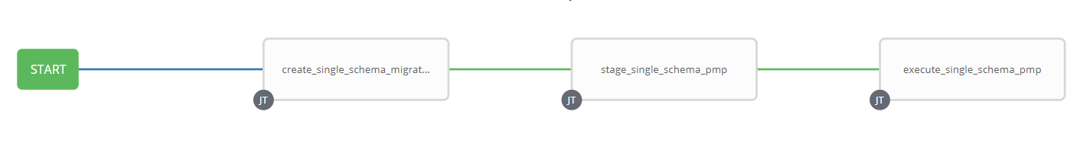

1. Survey – User Supplied Variables

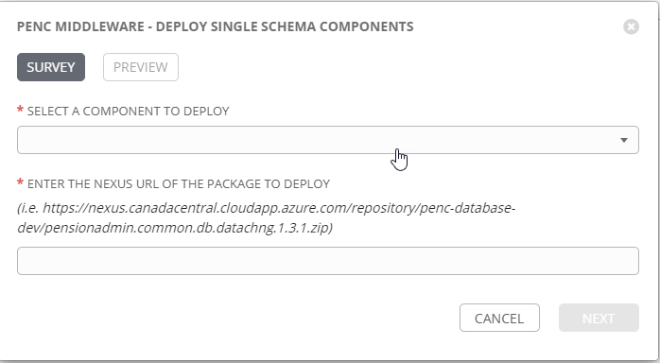

|  |  |  |  |
| --- | --- | --- | --- |
| **Survey Extra Variables** | **Prompt** | **Type** | **Description and Usage** |
| Component | Select a component to deploy | Multiple Choice Single Pick | The component to deploy – this includes the environments to deploy the component to.  pensionadmin.calculator.db.pnfxmmbr.devl  pensionadmin.calculator.db.pnfxmmbr.dev3  pensionadmin.calculator.db.pnfxmmbr.rdev  …  pensionadmin.training.db.trngmstr.trng |
| Package | Enter the Nexus URL of the package to deploy | Text | The url to the tar or zip file in the Nexus Repository. |

EXTRA VARIABLES – at Workflow Level

|  |  |  |
| --- | --- | --- |
| **Extra Variables** | **Value** | **Description and Usage** |
| pmp_url | https://acisbcp.penc.local:7272 | The url to the Password Manager Pro Application – Used to obtain the Oracle Schema Passwords |
| pmp_Nexus_Resource | TEST_NEXUS | The resource within PMP that holds the Nexus Resource |
| pmp_Nexus_User | admin | The Nexus User ID to use to export the package from Nexus |
| migration_log_url | http://dardanos1bcp.penc.local:7005/ords/devops/test2/log/record2/new/ | The URL for APEX/ORDS that houses the migration_log table. |

1. Jobs Used by the workflow - http://owl.penc.local:18080/svn/deploy_automation/trunk/Ansible_PlayBooks/Harness

| **Job Template** | **Ansible Playbook** | **Credential / host** | **Project** | **Description and Usage** |
| --- | --- | --- | --- | --- |
| create_single_schema_migration | create_single_schema_migration.yml | pencmw – pdeploy1bcp | Harness | Creates Variables/Artifacts for use within the workflows, based on the User supplied survey results.  DeploymentLogDir: >-  /codemove_common/dp_automation/tmp/deploymentlog/pensionadmin.common.db.datachng.devl/20220810_094607  ENV: DEVL  Schema: DATACHNG  StageDir: >-  /codemove_common/dp_automation/tmp/stage/pensionadmin.common.db.datachng.devl/20220810_094607  component_type: db  date_time: '20220810_094607'  main_component: pensionadmin  stage_server: diagoras1bcp  sub_component: common  tower_hostname: pdeploy1bcp.penc.local |
| stage_single_schema_pmp | stage_single_schema_pmp.yml | codemove on {{stage_server}} – diagoras1bcp | Harness | {{StageDir}} and {{DeploymentLogDir}} |
| execute_single_schema_pmp | execute_single_schema_pmp.yml | pencmw on pdeploy1bcp or pdevops1bcp  PMP_ANSIBLE_AUTH_TOKEN – for pmp access | Harness | Obtains the password for the NEXUS User from PMP.  Copies the zip/tar file from Nexus with the {{package}} url to the {{StageDir}}  Expands the zip/tar file to {{DeploymentLogDir}}  Removes the {{StageDir}}  Searchs for the migrate.sql file as it can be in either the ‘full’ or ‘incr’ folder  Obtains the password for the Oracle Schema from PMP.  Executes the migrate.sql file against the appropriate environment.  Updates the migration_log table in APEX/ORDS via the {{migration_log_url}}. |