**Technical Documentation – Deploy_PENFAX_PENCALC**

1. Workflow – Deploys PENFAX Artifacts to an Business Servers, Online and BATCH Environments.

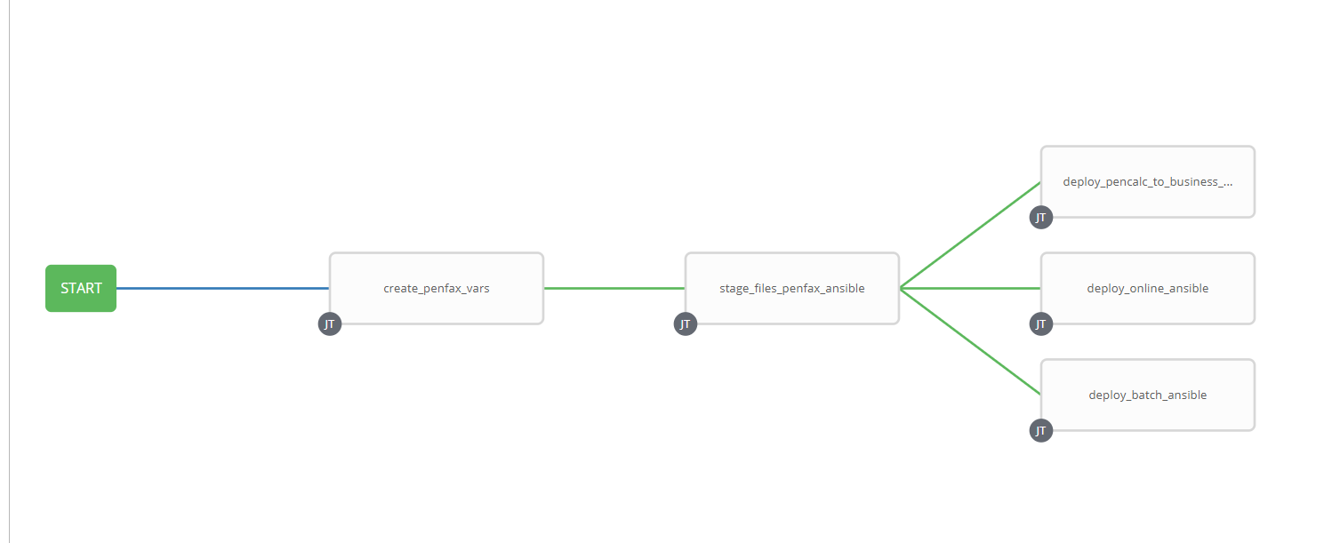

1. Survey – User Supplied Variables

|  |  |  |  |
| --- | --- | --- | --- |
| **Survey Extra Variables** | **Prompt** | **Type** | **Description and Usage** |
| FFV | Fixed For Value | Text | The fixed for value for the deployment – must be for the format ###.###.###.### (i.e. 58.0.12.0). Numbers only with a maximum of 3 digits and there must be 4 sets separated with a ‘.’. Used to create staging and deployments directories. Used by all job templates in the workflow |
| STAGE | Stage PENFAX Artifacts | Multiple Choice Single Pick | True or false – Copies the MSC Artifacts from the MOS Build Releases Directory to the Staging folder. |
| ReleaseDir | Build Directory | Text | The /pencmw_common/MOS/releases/ subdirectory that contains the MSC artifacts |
| PENCALC | Deploy PENCALC to Business Servers | Multiple Choice Single Pick | false, DEV, TEST, MAINT, PROD – Select the Business Server Environment to deploy PENCALC to. Leave it false if it is NOT to be deployed |
| Online_Batch | Deploy to Online and/or Batch | Multiple Choice Single Pick | false, Both Online and Batch, Online, Batch – Select if Online, Batch or Both are to have PENFAX deployed. Leave it false if it is NOT to be deployed |
| ENV | Deploy to Which Environment | Multiple Choice Single Pick | The Environment to Deploy to: DEV3, DEVL, RDEV, TST1, TST2, TST3, TRNG, TRNM, MUAT, IPASP. Only a single environment can be deployed to per workflow execution |

1. Jobs Used by the workflow

| **Job Template** | **Ansible Playbook** | **Project** | **Description and Usage** |
| --- | --- | --- | --- |
| create_penfax_vars | create_penfax_vars_ansible.yml | PENFAX Deployments | DeploymentLogDir: /codemove_common/dp_automation/deployments/005.000/005.000.003.000/PENFAX  StageDir: /codemove_common/dp_automation/stage/005.000/005.000.003.000/PENFAX  batch_dir: /home/jcs/jcsdev3  date_time: '20200526_1318'  deployment_batch_host: diagoras1bcp  deployment_online_host: none  jcsOwner: jcsdev3.devel  online_compile_dir: /export_home/codemove/compile/ipas12c/dev3/penfax  online_runtime_dir: /opt/ipas_app_dev/dev3/penfax  pencalc_hosts: none  stage_server: diagoras1bcp |
| Stage_files_penfax_ansible | deploy_msc_ansible.yml | PENFAX Deployments |  |
| Deploy_pencalc_to_business_servers_ansible |  | PENFAX Deployments |  |
| Deploy_online_ansible |  | PENFAX Deployments |  |
| Deploy_batch_ansible |  | PENFAX Deployments |  |