To gain Access to run the Digital Services Deployment into DEV (dbusserv3bcp/dbusserv4bcp) and TEST (tbusserv3bcp/tbusserv4bcp), login Ansible Tower with your Active Directory IDIR Crendentials using this url: You have to use Chrome or Firefox to use Ansible Tower – Internet Explorer will NOT WORK. <https://pdeploy1bcp.penc.local/#/templates?template_search=page_size:20;order_by:name;type:workflow_job_template,job_template>.

Once you have logged in contact Mike Charchuk and he will add your IDIR Account to the Ansible Tower group that has access to run the workflow.

Once you have been granted access log in again with the above URL and you will have this screen:

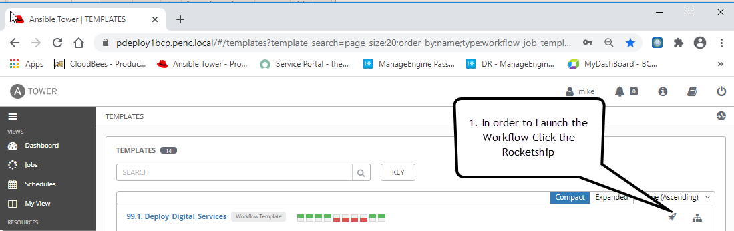

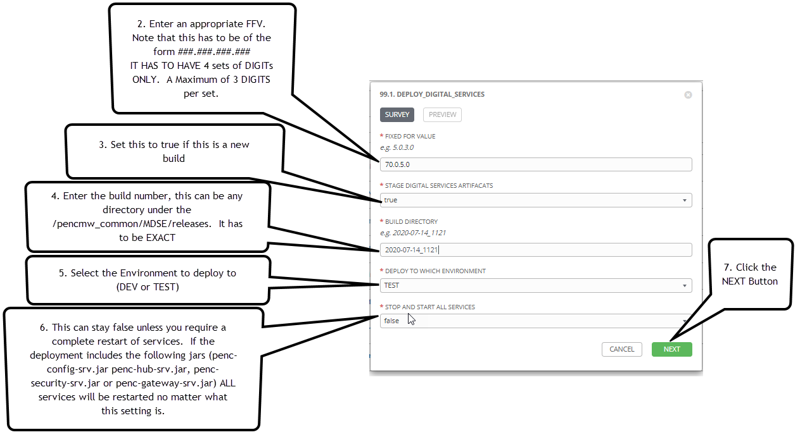

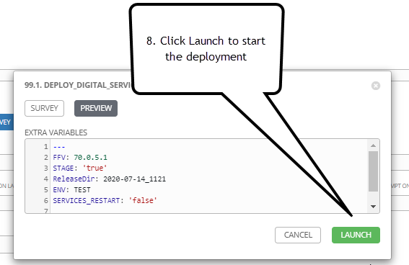

For a successful Deployment the Workflow will be all GREEN

