Architecture Write-Up
Agentic PR Review & Release Notes Pipeline — Capstone Project

Workflow Overview
This system automates a real engineering workflow: reviewing a pull request for bugs, security issues, and silently breaking changes, then drafting a release note. It targets an engineering manager or tech lead who bottlenecks on manual review. The pipeline combines three specialized LLM agents (a planner, a reviewer, and a release-manager), one deterministic scoring step, MCP-backed persistent storage and retrieval, and a hard human checkpoint for any risky change. Full acceptance criteria, failure modes, and delivery-path details are in the project PRD.
Delivery path: job-seeker / no-deployment. The pipeline runs against real, merged pull requests from two public repositories (chalk/chalk and date-fns/date-fns) rather than live production traffic. A small set of these real PRs were modified to include one intentional, documented bug each, forming a ground-truth set used throughout evaluation.

System Architecture
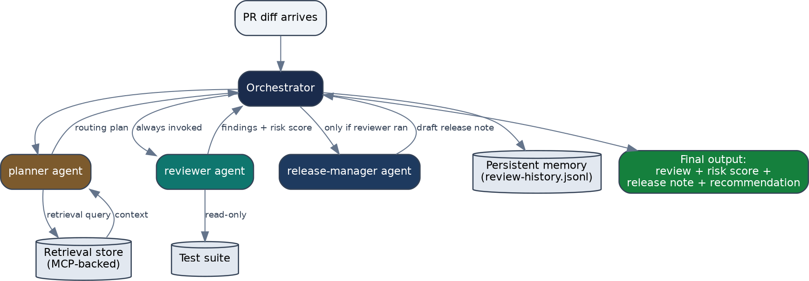
Figure 1: Orchestration flow. Colored nodes are LLM agents; cylinders are persistent/external data stores.

The orchestrator is the only component with authority to declare a run complete. It always invokes the planner first; the planner must always hand off to the reviewer (this is a structural rule, not a suggestion — see Section 6); the
release-manager only runs after the reviewer has produced findings, and reads those findings to decide how to frame its note.

Agent Roles

Agent | Purpose | Key Constraint
planner | Parses the diff, retrieves relevant prior context via the retrieval store, produces a routing plan. | No review or write authority — routing only. Cannot skip invoking the reviewer.

Agent | Purpose | Key Constraint
reviewer | Reads the diff and produces grounded findings (file, line, issue, severity). | Read-only. No git write/merge, no secrets, no network beyond MCP tools.
release-manager | Drafts a one-line release note from the diff and the reviewer's findings. | Draft-only. Must not imply safety for a change the reviewer flagged as high/critical severity.
Two supporting skills are shared across agents rather than duplicated: diff-parsing (used by both planner and reviewer, so both parse diffs identically) and risk-scoring (used by the reviewer; see Section 4 — this one was converted from an agent-invoked skill to deterministic code).

Deterministic vs. Agent Steps
Not every step in this pipeline is an LLM call. A full agent-vs-deterministic-vs-human classification of every pipeline step is documented separately (decision matrix); the most consequential conversion is summarized here.

Risk-scoring: converted from agent reasoning to code
The mapping from a reviewer's findings (a list of severities) to an overall recommendation was originally designed as a skill the reviewer agent would apply via its own reasoning on every call. On inspection, the mapping rules were fully specified with no genuine ambiguity left (e.g., any critical finding → escalate to a human) — so it was rewritten as a pure Python function.

Metric | Before (LLM reasoning, estimated) | After (deterministic code, measured)
Latency | Typical LLM call range (not directly timed in this project) | 0.0011 ms/call
Cost per call | Non-zero (API tokens) | $0
Consistency | Not guaranteed run-to-run | Guaranteed — 9/9 rule-branch tests pass every run
This conversion directly targets a measured weakness: in the pre-agent human baseline, reviewers scored 1 out of 2 on stating severity/recommended action consistently, across every seeded-bug case tested. Full reasoning, three rejected alternatives (each with cited evidence), and open risks are documented in ADR-001.

Human Checkpoints
No agent in this pipeline has git write, merge, or credential access — full stop. Beyond that hard boundary, the deterministic risk-scoring rules force specific situations to a human:
  - Any critical or high severity finding → escalate_to_human, never auto-approved.
  - A calibration log entry (a change to routing, prompts, or tool grants made because of eval evidence) requires human promotion from a proposals file — no agent can write directly to the calibration log.
  - If the reviewer's LLM call is unavailable (timeout, missing credentials, retries exhausted), the orchestrator fails
closed: it escalates to a human rather than silently approving the change.

MCP Boundaries & Role-to-Tool Access
Two local MCP servers back this pipeline, communicating over stdio JSON-RPC. Both independently enforce a
role-based tool allow-list on every call — this is not just a config file the orchestrator is expected to respect; each server checks the caller's declared role itself and rejects unauthorized calls with a specific error.

Role | pr-review-storage | pr-review-retrieval | Git write / Secrets
orchestrator | get_review_history, put_review_record, get_calibration_log | search_context, index_stats | None
planner | get_review_history, get_calibration_log | search_context, index_stats | None
reviewer | get_review_history, get_calibration_log | search_context, index_stats | None
release-manager | None | None | None
This table is the single source of truth, cross-referenced against three places: the orchestration diagram's routing rules, each MCP server's own TOOL_GRANTS dict, and a CI policy test (Section 9) that fails the build if any of these three drift apart.

Storage & Retrieval

Persistent storage
Review history and a calibration log are stored as append-only JSON Lines files, schema-validated on every write — malformed records are rejected, not silently stored, so the audit trail stays trustworthy. Full diffs and secrets are explicitly never stored in memory; only summaries.

Retrieval
The retrieval server indexes every PR diff at the per-changed-file level using TF-IDF, with an explicit relevance floor: a query that doesn't clear the threshold returns an empty result rather than a fabricated weak match. A 6-query
ground-truth retrieval test (5 positive, 1 negative/false-positive check) was run against the real server: 4/6 hit, with one honest miss (a conceptual query with no lexical overlap — the relevance floor correctly returned nothing) and one confirmed false positive (logged as a calibration proposal for a stricter relevance threshold).

CI/CD Integration
A GitHub Actions workflow runs on any pull request touching agents, skills, MCP servers, evals, or governance docs — the exact file categories the project requires eval-gated merges for. Four jobs run:
  - Policy checks — asserts the real TOOL_GRANTS code matches the documented governance policy, and functionally verifies a denied role really gets denied.
  - Eval checks — runs deterministic checks (schema validity, grounding, seeded-bug detection, false-positive control) against sample reviewer output.
  - Deterministic conversion check — runs the risk-scoring self-test (all 9 rule branches).
  - Retrieval self-test — informational, tracks the 4/6 ground-truth hit rate as a regression baseline.

Governance Enforcement: A Real Drill
Rather than only assert that governance is enforced, a real permission was deliberately revoked in the storage server's code (removing the reviewer's calibration-log read access) to test whether the safety net actually catches drift.

Stage | Result
Before | 5/5 policy tests pass
During (permission revoked) | 4/5 pass — test_storage_grants_match_policy fails with an exact, specific diff between actual and expected TOOL_GRANTS
Downstream check | A live call to the affected tool from the reviewer role confirmed real breakage: PermissionError, not a silent failure
After rollback | 5/5 policy tests pass again; the live tool call confirmed working again
This is real, captured test output, not a hypothetical — full transcript in the tool-evolution drill report.

Reliability & Cost Controls

Control | Verification
Per-call timeout (30s) | Code-level guarantee on both LLM and MCP subprocess calls
Retry with backoff (2 retries) | Implemented in the LLM call path; each attempt logged
Fail-closed fallback | Directly tested: pipeline runs with no API key present correctly returned escalated_fallback rather than a fabricated review, after the planner's real MCP call succeeded first
Max-iteration guard (5) | Code-level guarantee against runaway loops
Per-call / per-workflow token budgets | Directly tested: both budget types correctly raised BudgetExceededError when exceeded

Known Limitations
  - Full end-to-end runs with automated LLM API calls require a live API key not configured in the development environment used for this write-up; the pipeline's control flow, deterministic steps, and MCP integration are proven independent of that key, and the reviewer's judgment step was validated directly (Claude performing the review reasoning in-session) against the full holdout set.
  - Retrieval is lexical (TF-IDF), not semantic — it cannot match conceptual queries with no vocabulary overlap to relevant content, a known and documented limitation.
  - Ground-truth and holdout sets are small (single digits of PRs) — sufficient to catch obvious silent failures, not a statistically rigorous benchmark.

