Global Sales and Financial Performance Dashboard
Student Name: | M. Cheathana
Roll No: | E25FA005
Course: | B.Com (FinTech & AI), 2nd Year
Tool Used: | Microsoft Power BI Desktop
Project Title: | Global Sales and Financial Performance Interactive Dashboard

1. Introduction
The Global Sales and Financial Performance Dashboard is an interactive Business Intelligence solution developed using Microsoft Power BI Desktop. The primary goal of this project is to convert complex, multi-dimensional transactional data into high-level strategic visual insights for executive decision-makers. By organizing key metrics such as profit, sales volume, category distribution, regional contribution, and product-level totals, this report provides a holistic view of overall business health and operating efficiency.
The dashboard features cross-filtering capabilities, enabling dynamic drill-downs across various dimensions including region, category, employee performance, and temporal trends.
2. Objectives
The core objectives of this dashboard project are:
- KPI Tracking: Monitor critical financial and operational key performance indicators (KPIs) such as Total Sales, Total Profit, Average Sales, and Total Quantity Sold.
- Regional & Category Analysis: Evaluate performance across operational regions (Central, South, West, North, East) and product categories (Clothing, Accessories, Kitchen, Electronics, Outdoors, Furniture).
- Salesforce Performance Monitoring: Assess individual profitability metrics across sales employees (e.g., Khaled Hassan, Omar El Sayed).
- Cost Dynamics: Track overall cost trends (Sum of TotalCost) across monthly intervals.
- Granular Product Breakdown: Maintain detailed visibility into individual products (ProductName), sales amounts, transaction quantities, and profit margins via structured tables.
- Dynamic Interactivity: Implement slicers for Category, Region, and Year to enable user-driven ad-hoc data analysis.
3. Dataset Description
The underlying dataset aggregates sales transactions across multiple categories, store locations, regions, and sales agents. The primary schema includes the following data fields:
- Category: Product classification (e.g., Clothing, Accessories, Kitchen, Electronics, Outdoors, Furniture).
- Region: Geographic market segments (Central, South, West, North, East).
- EmployeeName: Sales representatives responsible for generating transactions.
- ProductName: Specific SKU/product identification code (e.g., ACC-CAS-002, ACC-CAS-055).
- MonthName / Year: Temporal markers for time-series trend evaluations.
- Total Sales / Price / Cost / Profit / Quantity: Numeric variables representing financial performance metrics.
4. Data Preparation
Before visualizations were constructed, data cleansing and transformation procedures were executed in Power Query Editor:
1. Data Type Verification: Ensured all numerical values (Total Sales, Total Profit, Quantity, Total Cost) were appropriately set to Fixed Decimal or Integer types.
2. Date Hierarchy Modeling: Normalized month names and years into standard temporal formats to maintain correct chronological order in line charts.
3. Null & Outlier Handling: Audited missing field values and handled inconsistencies across categorical fields (Category, Region, EmployeeName).
4. Data Modeling: Set up relationships between tables to enable seamless multi-directional filtering across visual elements.
5. DAX Measures Used
To drive the KPI cards and visual computations, the following Data Analysis Expressions (DAX) were defined:
Measure Name | DAX Formula | Result / Output
Average Sales | AVERAGE(Sales[SalesAmount]) | 706.36
Total Profit | SUM(Sales[Profit]) | $25.12M ($2,51,16,018.03)
Total Sales | SUM(Sales[SalesAmount]) | $70.64M ($7,06,35,711.87)
Total Quantity | SUM(Sales[Quantity]) | 300K (300,006 units)

6. Dashboard Components
6.1 KPI Cards (Top Banner)
Four high-level metrics are positioned at the top left to give immediate executive context:
- Average Sales: 706.36
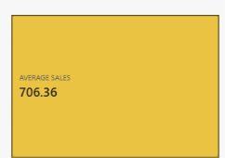
- Total Profit: $25.12M
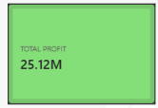
- Total Sales: $70.64M
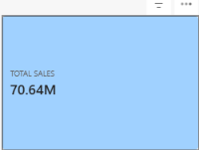
- Total Quantity: 300K

6.2 Horizontal Bar Chart – Total Profit by EmployeeName
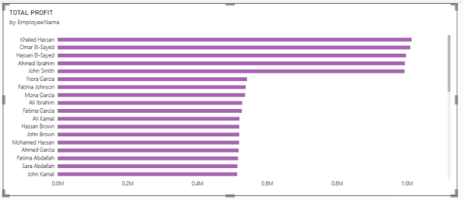
Compares total generated profit across individual sales representatives. High performers including Khaled Hassan, Omar El Sayed, Hassan El Sayed, Ahmed Ibrahim, and John Smith lead performance with profitability figures around or above $1.0M.
6.3 Donut Chart – Total Sales by Region
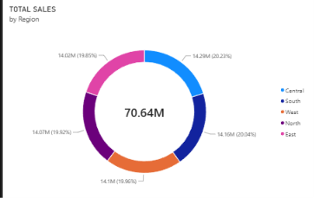
Displays revenue distribution across geographical divisions:
- Central: 20.23% ($14.29M)
- South: 20.04% ($14.16M)
- West: 19.96% ($14.10M)
- North: 19.92% ($14.07M)
- East: 19.85% ($14.02M)
6.4 Line Chart – Sum of TotalCost by MonthName
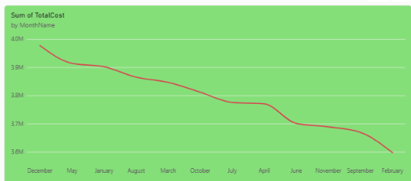
Tracks total operational costs chronologically across months. The visual demonstrates a downward cost trajectory starting near $4.0M in December/May down to approximately $3.6M toward February.
6.5 Clustered Column Chart – Total Sales by Category
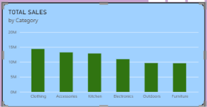
Ranks revenue performance across core retail product categories:
1. Clothing (Highest contributor ~ $13.5M+)
2. Accessories
3. Kitchen
4. Electronics
5. Outdoors
6. Furniture
6.6 Detail Summary Table
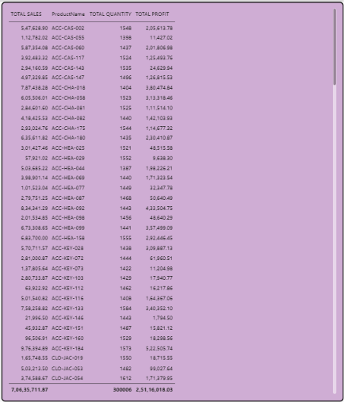
Lists itemized SKU-level performance metrics, including ProductName, TOTAL SALES, TOTAL QUANTITY, and TOTAL PROFIT. Totals summarize to $70,635,711.87 in Sales, 300,006 Units, and $2,51,16,018.03 in Net Profit.
7. Slicers Used
To enable ad-hoc exploration, three dynamic slicers are integrated into the right control pane:
• Category Dropdown Slicer:


Filters the entire report by specific merchandise categories (e.g., Electronics, Clothing, Kitchen).
• Region Dropdown Slicer:

Restricts visual data to selected geographic zones (Central, South, West, North, East).
• Year Range Slider:

Limits analyses temporally across the date boundaries (2018 to 2024).
8. Key Findings
1. Balanced Regional Distribution: Revenue is evenly distributed across all 5 sales regions, with each contributing roughly 20% (~$14.0M to $14.29M) of the total $70.64M sales volume.
2. Top Category Performer: Clothing is the highest-grossing category, followed closely by Accessories and Kitchen products.
3. Employee Profitability: Sales leadership is driven by top performers like Khaled Hassan and Omar El Sayed, who both exceed $1.0M in generated net profit.
4. Cost Efficiency Over Time: Total cost trends display a steady downward trajectory across consecutive monthly cycles, indicating improved cost control or reduced purchase volume toward year-end periods.
5. High Overall Profit Margin: Net profit stands at $25.12M against $70.64M total sales, reflecting an overall profit margin of approximately 35.56%.

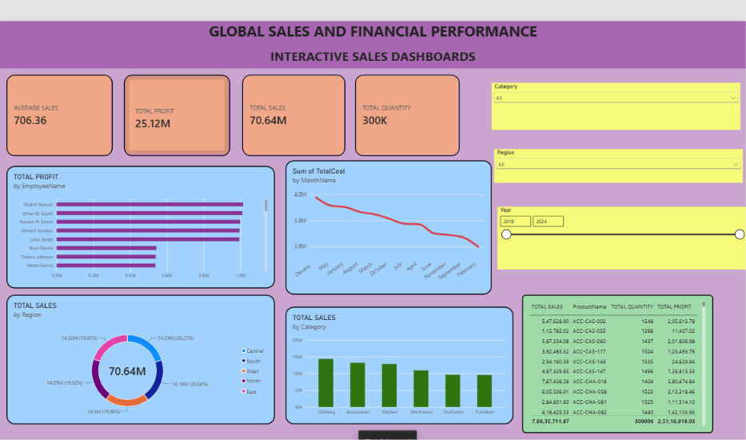
9. Conclusion
The Global Sales and Financial Performance Dashboard successfully transforms raw organizational sales data into an intuitive, interactive analytical report. By combining high-level KPI cards, regional donut charts, temporal line graphs, and category bar charts, the report enables business executives to immediately evaluate high-performing segments and track cost dynamics. The implementation of DAX measures and interactive slicers ensures flexible, real-time reporting tailored to strategic management needs.

