Tap Space Bar And Win

Version 1.0

Contents

Overview 1

Gameplay 1

Story 1

Art Style & Reference 2

Environment 2

Modes 2

Levels 2

Premium Version 4

|  |  |  |  |
| --- | --- | --- | --- |
| Ver # | Date | Author | Change details |
| 1.0 | 8/31/2015 | Ming Chen | Wrote the first iteration of GDD |

# Overview

Tap Space Bar And Win is a simple but additive game. The purpose of building this game is to get familiar with Unreal Engine 4 and experience the whole game development cycle. Players will be impressed by how this small game can represent the nature of gaming.

**Reference Games**: None

# Gameplay

Players will see the title and authors of the game when enter. The space bar will show up and wait for players input. Only tapping space bar can win the game. Tapping all other keys will lose the game. Then the game will exit gracefully.

# Story

We don’t need a story.

Art Style & Reference

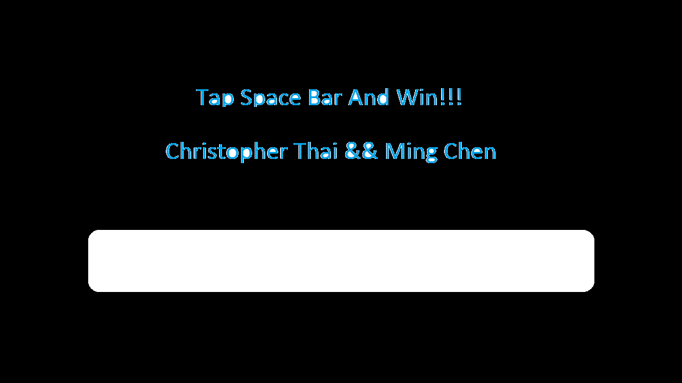

We will use the pure game art.

## Environment

The background should be dark or with starry night.

# Modes

Game mode is a key tapping mode, where players will tap space bar to win or lose.

# Levels

Only one level in this game. Tap space bar!

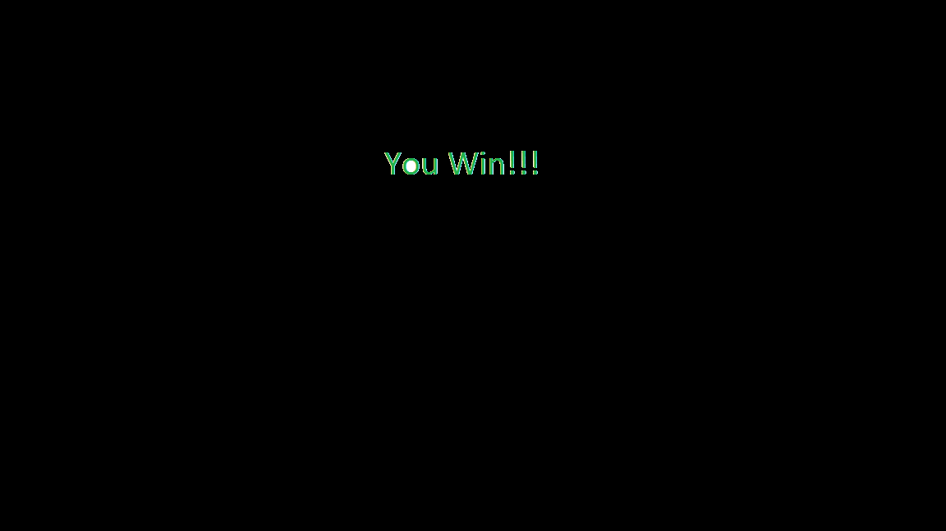

Or if players tap the wrong key, then…

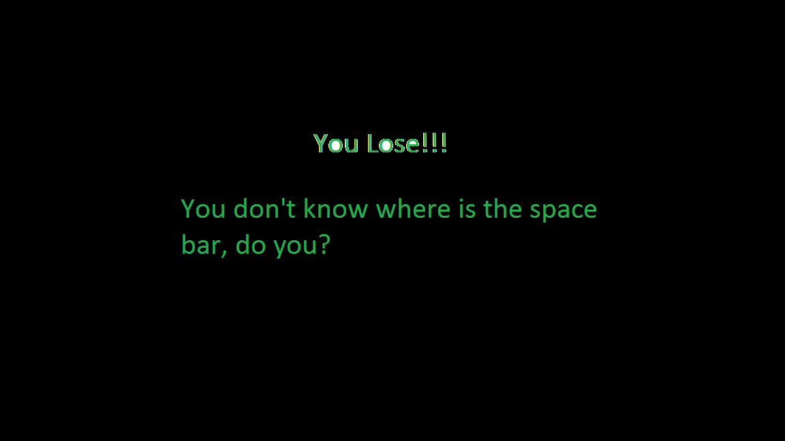

Then the game will exit…

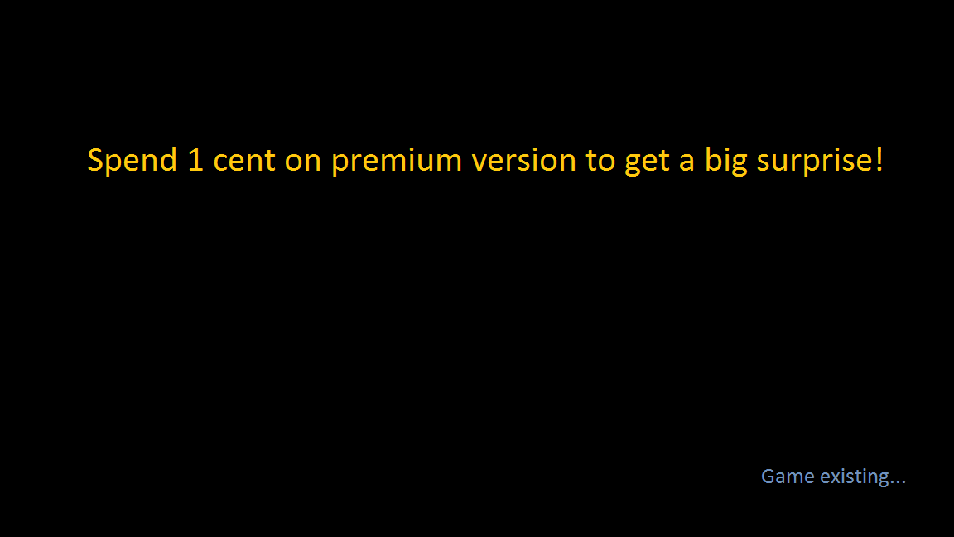

# Premium Version

Players can spend 1 cent to buy our premium version. Players will have the freedom to choose whether repeat the game of exit the game.

