### OBJECTIVE

Kubernetes Development with Machine Learning

### TERMS

Contracting: Near Philadelphia or Remote.

### TECHNOLOGIES

Go, Kubernetes, Docker, Python, NumPy, Pandas, Firebase, Django, R, MySQL, PostgreSQL, iOS (Swift), Linux, Nginx, Photoshop, InDesign.

**Google, AWS, DigitalOcean**

### EDUCATION

#### M.S. in Computer Science/Mathematics –

Villanova University

B.A. in Computer Science/Mathematics –

Rutgers University

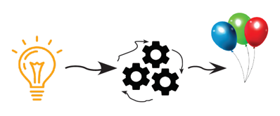

### Experience

#### Kubernetes • DEVELOPMENT • CWXSTAT • 2015+

Python/Go Restful API: Building systems to collect and analyze real time data, Pricing Applications, Video on Demand, and Machine Learning. Clients: NRG, Comcast, State and Local Government.

#### GO/Python • DevOps • FAA (CSC) • 2009 - 2015

TFMS Project: Built performance modeling systems (Go, Python, Pandas, NumPy, R, Oracle, Google Big Query, iOS). Built deployment and problem detection system.

#### SOFTWARE DEVELOPMENT• Data Analysis •VWR 2007 - 2009

Developed/designed custom pricing tools for price prediction, market analysis, and sales rep. performance.

#### Linux/DevOps • Fiberlink • 2006 - 2007

Automating VMware applications in a clustered environment. Oracle DBA and Linux.

#### DevOps: Thomas Jefferson University •2005 - 2006

Managing Postfix/Cyrus email system for 18,000 accounts. Created custom intelligent filters/programs for email processing and analysis.

#### Linux/DevOps • SilverStorm Tech • 2004 -2005

Fast paced startup. Managing complex system and supporting software development.

#### coding • University of Pennsylvania • 1999 - 2004

Constructed on-line video learning system (the first of its kind) – Also served as IT Director.

IT Director/Software Developer • AON • 1987 - 1999

Building Executive Compensation Products – Data Analysis.