Go to the link

https://www.python.org/downloads/release/python-341/
Find MSI installer on the bottom of the page
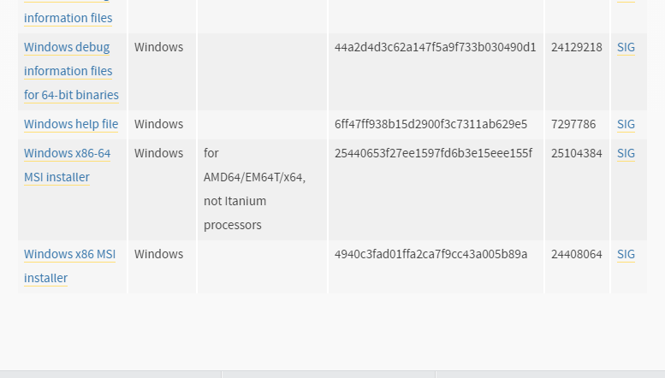
Click on MSI installer to download
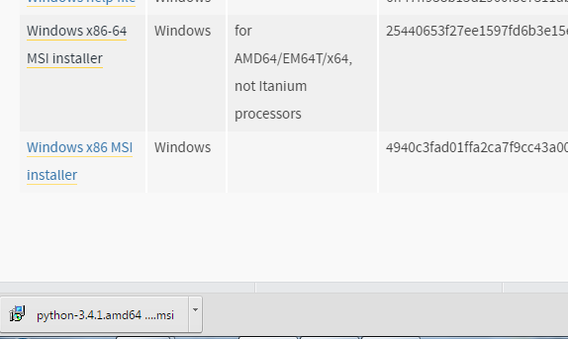
Click on downloaded file “python-3,4,1.amd64…..” to run installation
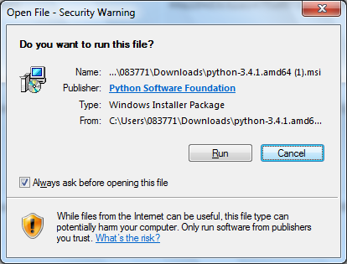
Continue with installation.

