ICS2O Programming Sep 4th, 2014

Writing Programs in IDLE's File Editor
Until now we have been typing instructions one at a time into the interactive shell. When we write programs though, we type in several instructions and have them run all at once. Let's write our first program!
The name of the program that provides the interactive shell is called IDLE, the Interactive DeveLopement Environment. IDLE also has another part called the file editor.
Click on the File menu at the top of the Python Shell window, and select New Window. A new blank window will appear for us to type our program in. This window is the file editor.
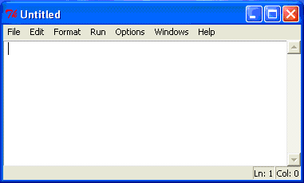
Figure 1: The file editor window
Hello World!
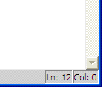
Figure 2: The bottom right of the file
editor window tells you where the cursor
is. The cursor is currently on line 12.

A tradition for programmers learning a new language is to make their first program display the text "Hello world!" on the screen. We'll create our own Hello World program now.
If you look at the bottom-right corner of the file editor window, it will tell you which line the cursor is currently on.
Enter the following text into the new file editor window. We call this text the program's source code because it contains the instructions that Python will follow to determine exactly how the program should behave.

# This program says hello.
print('Hello world!')
print('It is good to meet you')

Saving Your Program
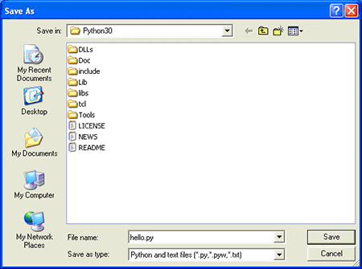
Figure 3: Saving the program.
Once you've entered your source code, save it so that you won't have to retype it each time we start IDLE. To do so, choose the File menu at the top of the File Editor window, and then click on Save As. The Save As window should open. Enter hello.py in the File Name box then press Save. (See Figure 3.)
You should save your programs every once in a while as you type them. That way, if the computer crashes or you accidentally exit from IDLE, only the typing you've done since your last save will be lost. Press Ctrl-S to save your file quickly, without using the mouse at all.

Opening The Programs You've Saved
To load a saved program, choose File > Open. Do that now, and in the window that appears choose hello.py and press the Open button. Your saved hello.py program should open in the File Editor window.
Now it's time to run our program. From the File menu, choose Run > Run Module or just press the F5 key on your keyboard. Your program should run in the shell window that appeared when you first started IDLE. Remember, you have to press F5 from the file editor's window, not the interactive shell's window.

