ICS2O1 Programming Sep 14th, 2016

Operators
+, -, *, /
// integer division
% Modulus – reminder
** to the power of

Order of Operations

BEDMAS
Brackets
Exponents
Multiplication Division (Modulus)
Addition Subtraction

Order of Operations
How would you type this into the computer?
4x + x² - 34
4 + x (3y²)

Go through logic of math notation first
everything above and below line is calculated first
in programming we will use brackets to say that
(4.0x + x² - 26) / (4 + x (3y²))

So, to put it all as one Python expression you would write
(4 * x + x**2 -34)/(4 + x*(3*y**2))

Some Bedmas examples
a) 2 + 7 / 2 → 5.5

b) 3.0 * 5 /2 → 7 .5

c) 2.0 + 7 / ( 3 // 4 ) → error statement. Can’t divide by 0

2) Delete any unnecessary brackets:
a) ( ( a * b ) / ( c * d ) ) a * b / ( c * d )

3) Write as a Python expression
a) x
+ 4 ( y – 3 )
2
x / 2 + 4 * ( y – 3 )

Group Problem
How can you use the symbols + - * % ()
together with the numerals 1 8 6 7 to get all 9 values
eg 1 // 8 + 6 // 7 => 0
1 // 8 – 6 + 7 => 1
1 % 8 – 6 + 7 => 2
1 + 8 - ( 6 % 7 ) => 3
- 1- 8 + 6 + 7 => 4
- 1 – ( 8 % 6 ) + 7 4
- 1 – (8 / 6 ) + 7 5
1 – ( 8 % 6 ) + 7 6
1 – ( 8 / 6 ) + 7 7
- 1 + ( 8 % 6 ) + 7 8
1 + ( 8 / 6 ) + 7 9
Math module

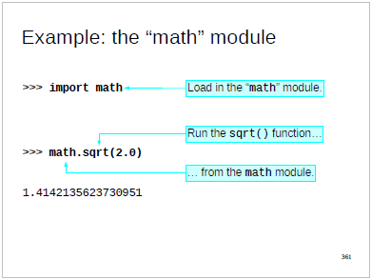

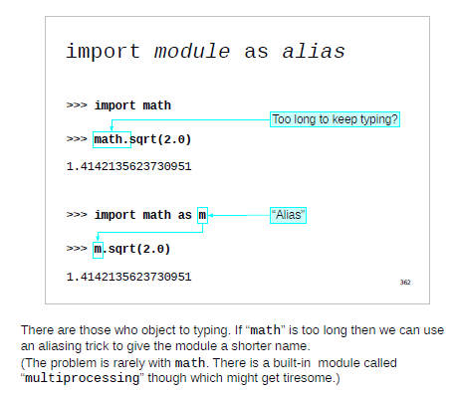
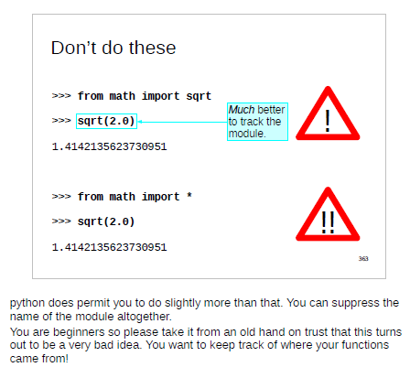
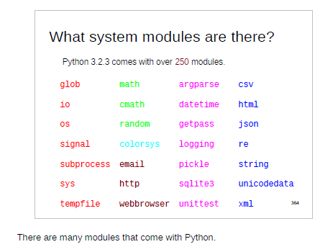

Math functions and constants:

math.pi The mathematical constant π = 3.141592..., to available precision.
x=2* math.pi*15
>>>math.pi
3.141592653589793

math.ceil(x) Return the ceiling of x, the smallest integer greater than or equal to x
math.ceil(3.5) → 4 math.ceil(-5.3)→-5
math.fabs(x) Return the absolute value of x.
math. fabs (3.5) → 3.5 math. fabs (-5.3)→5.3
math.factorial(x) Return x factorial. Raises ValueError if x is not integral or is negative.
math. factorial(3) → 6 math. factorial(4)→24
math.floor(x) Return the floor of x, the largest integer less than or equal to x.
math. floor (3.5) → 3 math. floor (-5.3)→-6
math.pow(x, y) Return x raised to the power y.
math. pow (2,3) → 8

math.sqrt(x) Return the square root of x.

math.cos(x) Return the cosine of x radians.
math.hypot(x, y) Return the Euclidean norm, sqrt(x*x + y*y). This is the length of the vector from the origin to point (x, y).
math.sin(x) Return the sine of x radians.
math.tan(x) Return the tangent of x radians.

math.degrees(x) Converts angle x from radians to degrees.
math.radians(x) Converts angle x from degrees to radians.

