ICS2O Programming

Selection

The if Statement
Notes at:
https://pythonroom.com/book/learn section: Branching

So far only worked with one kind of structure
Sequence structure. Everything follows in sequence
Input name
Input age
Processing
Output a sentence that gives name and age
But not everything can be handled by sequence. Sometimes you have to make decision
That go one way or another
You get below 50 you fail
You get 50 or above you pass
It follows a very simple flow (flow charting)
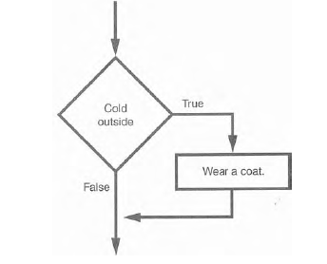

input/output

processing

decision structure

Computer logic
Programming follows computer logic
Processor can add, subtract binary numbers
They can make logical yes/no or true/false decisions

Boolean Logic
Part of Boolean Logic
named after 19th century mathematician George Boole
devised a form of logic (algebra) which dealt only two values True and False
which deals with True and False

Boolean Conditions
Determines whether a particular condition exists between two things
Most basic one is
= = is something equal (equivalent) to something else
!= is something not equal to something else

Different than the assignment statement
variable = value or string

Structure
Begins with an if, followed by a condition, then a colon
Then, indented, the tasks that will be executed if statement is true

Example
If string = = “password”:
print (“You can log on”)
if string != “password”:
print (“You can not log on”)

the condition returns a Boolean Value (True or False)

show them on computer by writing up program

Other conditions
> something is greater than something else
If number is less than 50 fail
< something is less than something else
If mark is greater than 49 pass
>=
<=

Example
Have user enter a mark
if it is 50 or greater the computer will say “You passed”
if it is less than 50 the computer will say you failed

mark=input(“Enter a mark”)
mark=int(mark)
if mark < 50:
print (“Sorry, you failed the course.”)

if mark >= 50:
print (“You passed.”)

