ICS2O Programming

Boolean Values
Explain difference between Boolean Conditions and Boolean Values
Only two values
True
False
Notice the capital letters. Notice that I am spelling it out but it is not in quotes –
because it is an actual value

Boolean Variables
Store the value in a variable
Show how Boolean conditions can be saved into Boolean variable

Give more examples of Boolean on screen
Show examples of creating True or False Boolean results
5> 3 True
5==5 True
5!=5 False
5<3 False

No quotes around Boolean
True not “True”

Concatenate a string and a Boolean
value = True
print “It is”, value - work
print “It is” + value - error statement

You can just put True or False into if statement
if True:
print(“true is always true”)

if else
passwordAttempt = “caer3881”
if password == “caer3881”:
print (“Congratulations. You have entered the right password”)
else:
print (“That is not the right password”)

Octoberfest program
Octoberfest program
Write a program that tells a user it is a good month for OctoberFest when they enter October and
you can’t have Octoberfest in a month that is not Octoberfest

Bullet Proofing Input
Show them the OctoberFest program
enter various dates
then show problems with abbreviated months and all lowercase months
bullet proof entering of month
use of upper and lower

Alpha Order
Numbers can be greater or lesser.
Can characters? Yes
so is “A” > “B”
B is greater because it comes later in the alphabet
then “Z” should be greater than “a”
no because “Z” is a capital and capital letters come first in alpha order
But how about these
“1” < “A”
“(“ <”A”
“{“>”A”
“[“>”A”
“[“<”a”
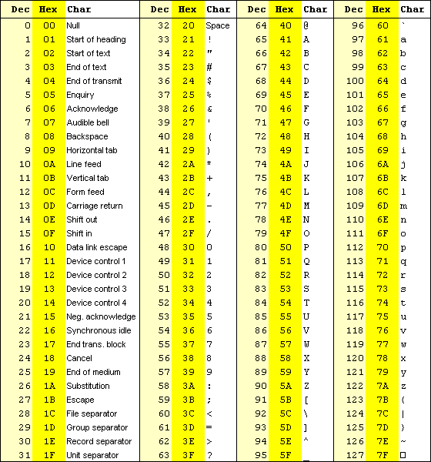
This takes us back to what I covered in the hardware section
Keeping track of characters is done by assigning each character an ascii code
Greater than or less than is based on their alpha order

What it is actually checking is their ascii order
Show ascii chart` saved as a graphic in Unit 2 folder

‘1’ → 49
‘(’ → 40
‘A’ → 65
‘Z’ → 90
’[‘ → 91
‘a’ → 97
‘z’ → 122
‘{‘ → 123

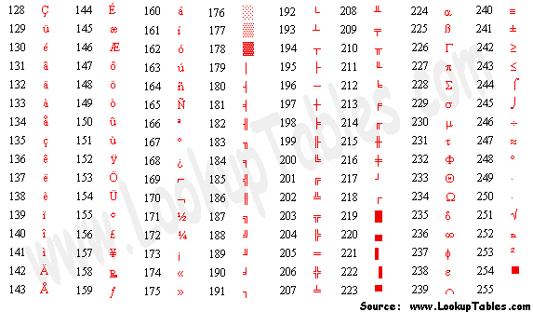

Are the following true
‘a’ > ‘A’ True
‘Z’ > ‘z’ False
‘9’ > ‘b’ True
“Daniel” > “Carter”

Extended ASCII
To convert back and forth between them
chr(ascii number)
ord(‘char’)

print( chr(201)) # prints É
print( chr(205) * 10 ) # prints ÍÍÍÍÍÍÍÍÍÍ

print( ord('|') ) # prints 124

print( ord('}') ) # prints 125

