Unit 3 – Repetition

Loops
while True:
print ("Python is the best programming language.")
# runs infinitely

while false:
print ("Mrs S is the best programming teacher")
# never print anything

Break out of Infinite loop
Infinite loops are logic errors
Don’t do it
To break out of an infinite loop
Control C

Conditional Loops
Examples

keepGoing='Y'
while keepGoing.upper() == 'Y':
print (“Python is the best programming language.”)
keepGoing=input(“Do you want to keep going? “)

Flow Chart

Do it as a flow chart and explain
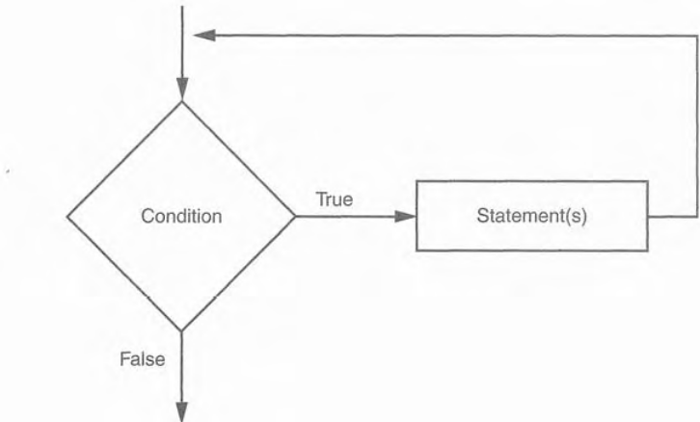
name=input("What is the name? [Hit enter to exit.]")
while name !="":
print('His name is', name)
name=input('What is the name? [Hit enter to exit.]')

cnt=1
while cnt<=1000:
print('Hello', cnt)
cnt=cnt+1
Print with no new line
Example 1:
print(1,end=' ')
print(1,end=' ')
print(1,end=' ')
print(1,end=' ')
print(1,end=' ')
print(1,end=' ')

Output:

1 1 1 1 1 1

Example 2:
cnt=5
while cnt<=10:
print(cnt, end=', ')
cnt=cnt+1
Output:
5, 6, 7, 8, 9, 10

