How to wear your Blue Service Dress uniform

You will wear your Blue Service Dress for special occasions and the first parade night every month for the Commanding Officer’s (CO’s) Parade.

This uniform is your dress uniform. It will be clean, starched and ironed. Boots will be highly polished. All badges will be sewn on properly. Details below.

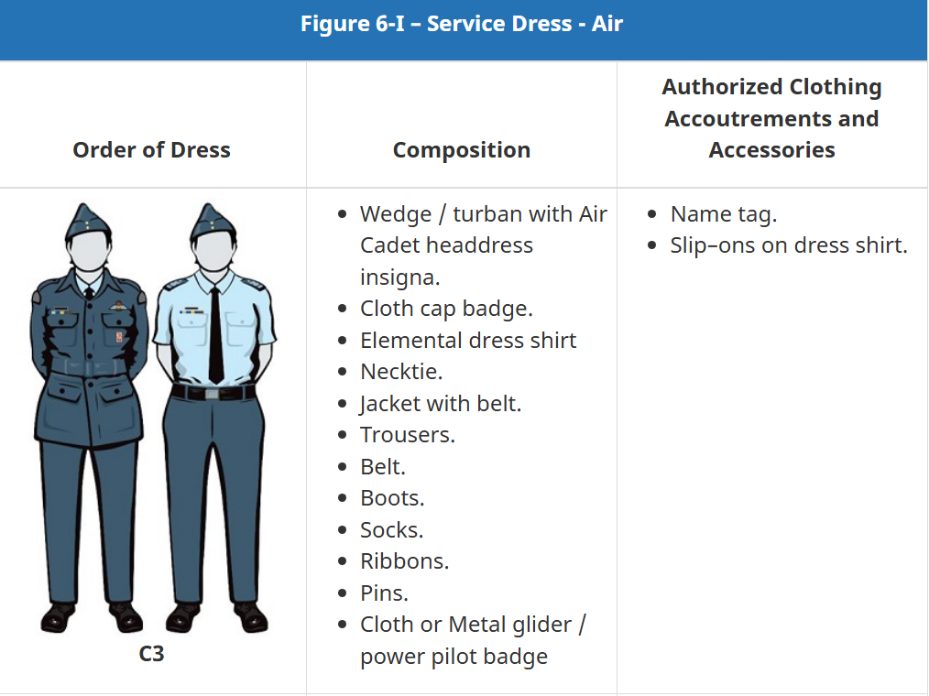

Wedge or Turban
- Wedge will be clean with the two silver buttons secured (it is common for the buttons to come loose, please fix them by sewing them in place with blue thread if needed)
- It is worn by centring the buttons on your eyes, tilting the cap badge towards the sky, and placing the wedge two fingers above your right eyebrow
- Hair – Regardless of gender and hairstyle hair will be pulled back off your face, no hair will be visible on forehead or cover your ears.
- Turban – Must wear issued turban with the issued metal cap badge pinned centred on your forehead by your hairline.
- Hijab – You will wear your issued hijab with your wedge worn the same way as indicated above.

Light Blue Dress Shirt and Tie
- Your shirt will be washed regularly and kept clean. Iron and starch shirt. A crease is pressed into the sleeve from the centre of the epaulette down to the cuff of the sleeve.
- The shirt is worn with all buttons done up. There are extra buttons inside the shirt to sew on if you lose one.
- Your shirt is worn with the rank slip-ons on each shoulder epaulette, and your name tag centred over your right pocket.
- Your shirt is worn with your issued black tie. The tie is tied in a windsor or preferred double-windsor knot. The bottom of the tie is just above your belt.

Blue Pants and Belt
- Your pants will be washed regularly and kept clean. Iron your pants. A crease down the centre of each leg front and back, from the waist band down through the cuff. Careful the iron is not too hot or you will make your pants shiny.
- Pant length – You will probably have to change the length of your pants when you get them and as you grow. The bottom of the pant leg is to be hemmed so they touch the boot eyelets which are second to the bottom of the laces. It is your responsibility to hem your pants – do not cut them.
- Black Web Belt – you will wear your issued web belt on your pants. Adjust your belt buckle to the length where the metal end tab rests with the metal buckle.

Tunic
- Your tunic (blue jacket) is the suit jacket portion of your uniform and is worn over your light blue dress shirt and tie. It will be washed often and kept free of wrinkles. There are no ironed in creases in your tunic.
- You will be given 385 Squadron identifying badges we call shoulder flashes. You will sew them at the top of each sleeve 2 cm from the shoulder seam. See diagram below.
- If you have been promoted, you must sew on your proper rank badges. See diagram below.
- Your name tag is worn centred over the right pocket.
- The blue tunic belt is worn with the tunic and can be removed when washed.

Boots and Socks
- You will wear the issued parade boots with this uniform. These are the shorter and harder boots. These boots will be highly polished and straight laced. See diagrams below and the watch the videos.
- You have been issued one pair of grey wool socks to wear with both pairs of your boots. If you prefer to wear black socks you may, but ensure they are in good condition, so you don’t get blisters.
- If your boots are too big or too small please see supply as quickly as you can so you don’t hurt yourself.
- You will need to get a polishing cloth and a tin of black shoe polish.

Extras
- Toque – If you have been issued a cadet toque you may wear it in place of your wedge during outdoor activities and going to and from the cadet unit. There may be exceptions to this like during an outdoor parade (Remembrance Day) so always bring your wedge with you.
- Parka – If you are Level 3 and up you may be issued a parka (winter coat). This may be worn with both Blue and FTU uniforms. As well as the issued toque and a pair of black gloves. Ensure you have moved your rank slip-ons onto your parka when wearing it.

Diagrams and links to videos

How to lace your parade boots https://www.youtube.com/watch?v=dRGHSQ0Kflw

How to polish your parade boots https://www.youtube.com/watch?v=x2X8OYNKnzw

How to iron your uniform https://youtu.be/LNZkFZiFnw8?si=zee72lbCDZr_ZKTq

Assorted dress standards https://www.youtube.com/watch?v=bvUqIBBrXOs

Tunic Badge Placement:

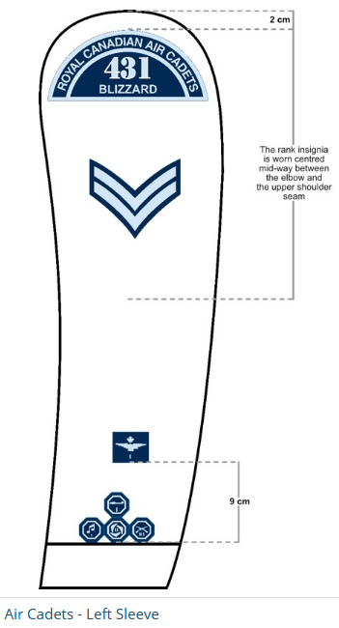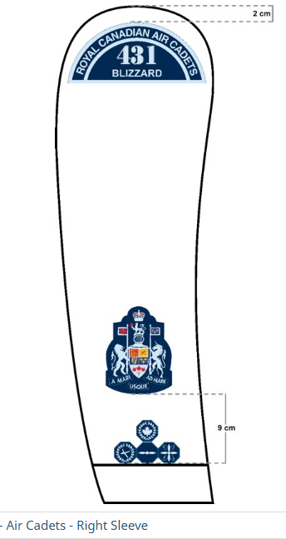

Straight lacing Parade Boots:



