How to wear your Field Training Uniform

You will wear your Field Training Uniform (FTU) for most of your training nights and extra activities.

This uniform is your daily wear uniform. Although it is easier to maintain than the Blue Service Dress uniform it will still be clean, and free of wrinkles. Boots will be blackened, and rank and name tag will be worn. Details below.

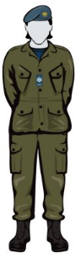
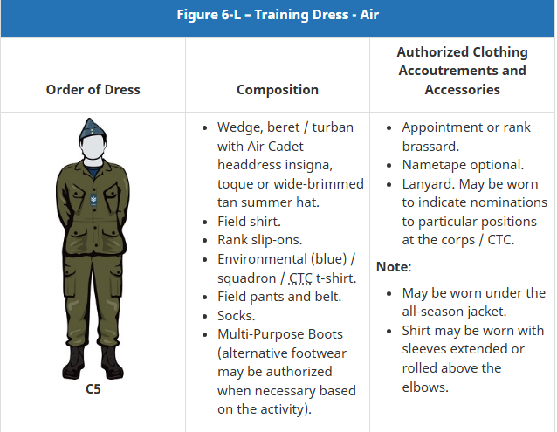

Beret or Turban
- Beret will be clean and formed. See video below.
- It is worn with the cap badge over your left eye, two fingers above your eyebrows. The beret does not fit like a ball cap and sits above the crown of your head.
- Hair – Regardless of gender and hairstyle hair will be pulled back off your face, no hair will be visible on forehead or cover your ears.
- Turban – Must wear issued turban with the issued metal cap badge pinned centred on your forehead by your hairline.
- Hijab – You will wear your issued hijab with your beret worn the same way as indicated above.
Blue T- Shirt
- You will wear the issued navy-blue t-shirt.

FTU Pants and Belt
- Your pants will be washed regularly and kept clean. Although you do not iron your pants, they must be free of wrinkles.
- Blousing Pants – Firstly you will fold and tuck the inner dust cuffs of your pants you’re your boots. Tighten your boot laces. Then using the strings in the cuffs of your pants you will tie your pants securely at the tops of your boots and neatly even out the cuffs. This will complete the process of blousing your pants.
- Black Web Belt – you will wear your issued web belt on your pants. Adjust your belt buckle to the length where the metal end tab rests with the metal buckle.

FTU Tunic
- Your green tunic will be washed often and kept free of wrinkles.
- One of your slip-ons will go on the epaulette centred on your chest.
- Your blue nametag will be worn above the right pocket similarly to your blue tunic.
- Your green tunic has two strings that must be tied and tucked neatly inside the tunic. One is at your waist and the second is at the bottom of the tunic. These are to help keep you clean and comfortable. These strings should not be visible to anyone.

Boots and Socks
- You will wear the issued multi-purpose boots with this uniform. These are the taller and softer boots. These boots will not be polished but they will be blacked and free of dirt and scuffs. These boots are cross laced. See diagrams below and the watch the videos.
- You have been issued one pair of grey wool socks to wear with both pairs of your boots. If you prefer to wear black socks you may, but ensure they are in good condition, so you don’t get blisters.
- If your boots are too big or too small, please see supply as quickly as you can so you don’t hurt yourself.
- You will need to get a polishing cloth and a tin of black shoe polish.

Extras
- Toque – If you have been issued a cadet toque you may wear it in place of your beret during outdoor activities and going to and from the cadet unit. There may be exceptions to this like during an outdoor parade so always bring your beret with you.
- Parka – If you are Level 3 and up you may be issued a parka (winter coat). This may be worn with both Blue and FTU uniforms. As well as the issued toque and a pair of black gloves. Ensure you have moved your rank slip-ons onto your parka when wearing it.

Diagrams and links to videos

How to form your beret https://www.youtube.com/watch?v=aid_Ha8Cpwg

How to lace your FTU boots https://www.youtube.com/watch?v=5lJ0P-QQrOc

How to wear your FTUs and blouse your pants. Please remember when watching these videos that you may need to adjust how you are blousing your uniform based on your uniform fit and body shape. We are all different and what works for one person doesn’t always work for the next person. Do what you can to achieve a similar look. https://www.youtube.com/watch?v=PV4Wn0CKQGo

