**Zadanie 1:** https://www.tinkercad.com/things/dlq3MMrqWrY/editel?sharecode=9SMhGBn7kndZw-AJJSnu1w5OIbnfsU7_kycAp6J5IKA

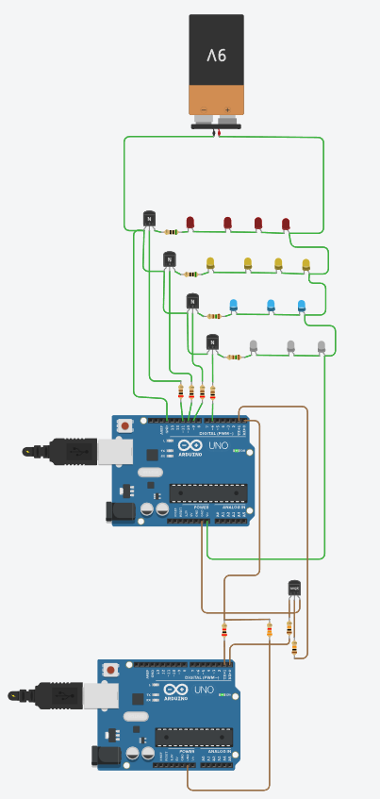

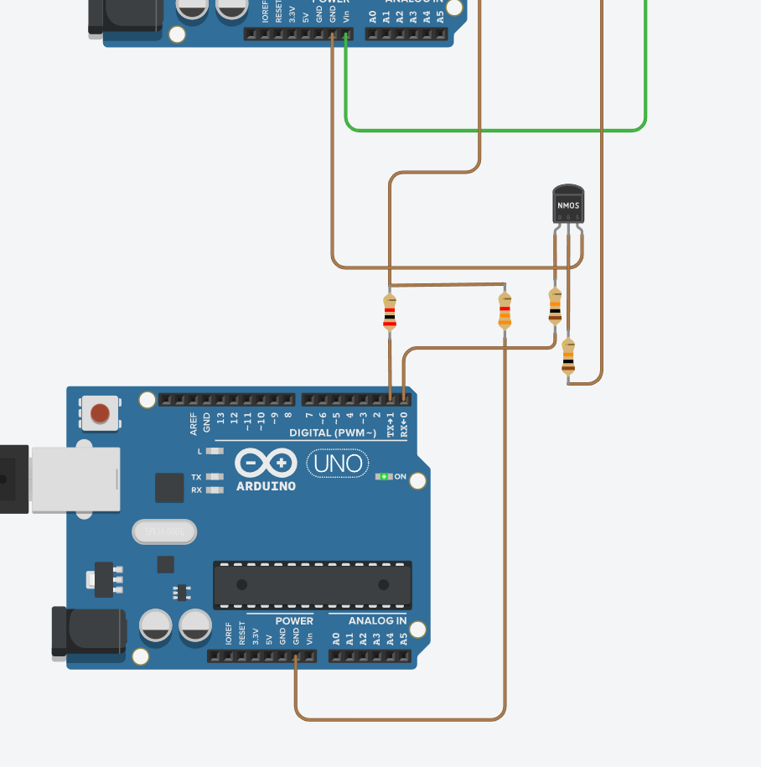

**Kod Master:**

// Master Arduino (5V)

const int red_pin = 11;

const int yellow_pin = 10;

const int blue_pin = 9;

const int white_pin = 6;

const int led_pins[] = {red_pin, yellow_pin, blue_pin, white_pin};

const float frequencies[] = {0.6, 1.0, 1.3, 2.5};

void setup() {

for (int i = 0; i < 4; i++) {

pinMode(led_pins[i], OUTPUT);

digitalWrite(led_pins[i], LOW);

}

Serial.begin(9600);

}

void loop() {

static bool state = false;

if (Serial.available() > 0) {

char cmd = Serial.read();

if (cmd == 't') {

state = !state;

Serial.write(state ? '1' : '0');

}

}

updateLEDs(state);

}

void updateLEDs(bool state) {

if (!state) {

for (int i = 0; i < 4; i++) {

unsigned long period = (unsigned long)(1000.0 / frequencies[i]);

if ((millis() % period) < (period / 2)) {

digitalWrite(led_pins[i], HIGH);

} else {

digitalWrite(led_pins[i], LOW);

}

}

} else {

unsigned long current_time = millis();

const unsigned long step_time = 1000;

int current_group = (current_time / step_time) % 4;

for (int i = 0; i < 4; i++) {

digitalWrite(led_pins[i], i == current_group ? HIGH : LOW);

}

}

}

**Kod Slave:**

// Slave Arduino (3.3V)

const int red_pin = 11;

const int yellow_pin = 10;

const int blue_pin = 9;

const int white_pin = 6;

const int led_pins[] = {red_pin, yellow_pin, blue_pin, white_pin};

const float frequencies[] = {0.6, 1.0, 1.3, 2.5};

void setup() {

for (int i = 0; i < 4; i++) {

pinMode(led_pins[i], OUTPUT);

digitalWrite(led_pins[i], LOW);

}

Serial.begin(9600);

}

void loop() {

static bool state = false;

if (Serial.available() > 0) {

char cmd = Serial.read();

if (cmd == '1') state = true;

else if (cmd == '0') state = false;

}

updateLEDs(state);

}

void updateLEDs(bool state) {

if (!state) {

for (int i = 0; i < 4; i++) {

unsigned long period = (unsigned long)(1000.0 / frequencies[i]);

if ((millis() % period) < (period / 2)) {

digitalWrite(led_pins[i], HIGH);

} else {

digitalWrite(led_pins[i], LOW);

}

}

} else {

unsigned long current_time = millis();

const unsigned long step_time = 1000;

int current_group = (current_time / step_time) % 4;

for (int i = 0; i < 4; i++) {

digitalWrite(led_pins[i], i == current_group ? HIGH : LOW);

}

}

}

**Dla linii TX – RX (5V -> 3.3V):**

TX z Arduino 5V (Master) powinien być połączony przez dzielnik napięcia do pinu RX Arduino 3.3V (Slave)

Vout = Vin * ( T2 / ( R1 + R2 ))

3.3V = 5V * ( R2 / ( R1 + R2 ))

Przyjmuje R1 = 2kOhm

Wiec R2 = 3.3kOhm

**Dla linii RX – TX (3.3V -> 5V):**

TX z Arduino 3.3V (Slave) powinien być połączony przez konwerter z MOSFET-em do pinu RX Arduino 5V (Master)

Source MOSFETa -> GND

Gate MOSFETa -> TX z Arduino 3.3V + rezystor podciągający 10kOhm do 3.3V

Drain MOSFETa -> RX Arduino 5V + rezystor podciągający 10kOhm do 5V

**Zadanie 2:** https://www.tinkercad.com/things/dlq3MMrqWrY/editel?sharecode=9SMhGBn7kndZw-AJJSnu1w5OIbnfsU7_kycAp6J5IKA

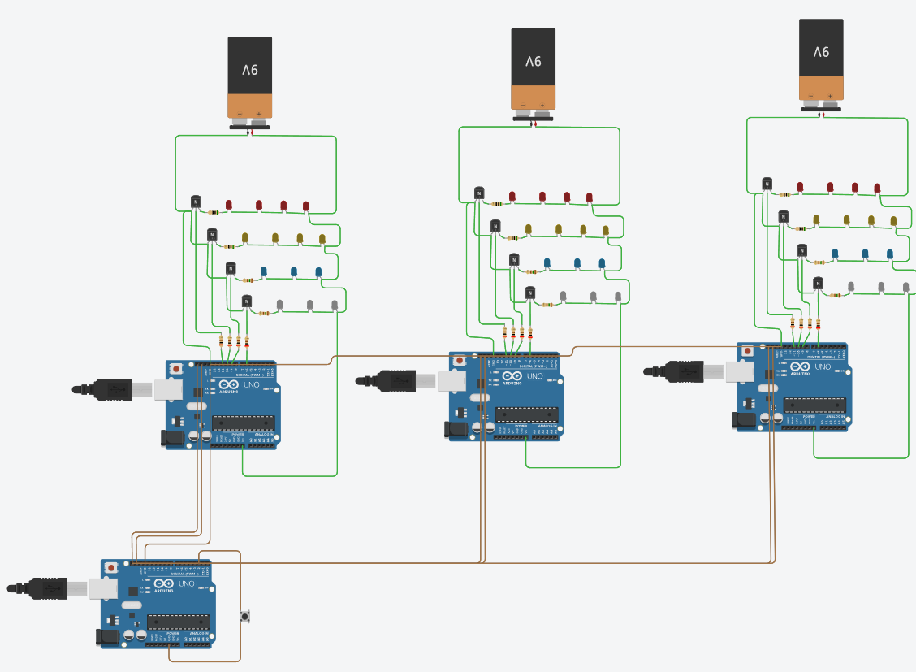

**Master:**

#include <Wire.h>

const int red_pin = 11;

const int yellow_pin = 10;

const int blue_pin = 9;

const int white_pin = 6;

const int button_pin = 2;

const int led_pins[] = {red_pin, yellow_pin, blue_pin, white_pin};

const float frequencies[] = {0.6, 1.0, 1.3, 2.5};

volatile bool state = false;

volatile unsigned long last_debounce_time = 0;

void interrupt_button() {

unsigned long current_time = millis();

if (current_time - last_debounce_time > 200) {

state = !state;

last_debounce_time = current_time;

}

}

void setup() {

for (int i = 0; i < 4; i++) {

pinMode(led_pins[i], OUTPUT);

digitalWrite(led_pins[i], LOW);

}

pinMode(button_pin, INPUT_PULLUP);

attachInterrupt(digitalPinToInterrupt(button_pin), interrupt_button, FALLING);

Wire.begin();

}

void loop() {

if (!state) {

for (int i = 0; i < 4; i++) {

unsigned long period = (unsigned long)(1000.0 / frequencies[i]);

if ((millis() % period) < (period / 2)) {

digitalWrite(led_pins[i], HIGH);

} else {

digitalWrite(led_pins[i], LOW);

}

}

} else {

unsigned long current_time = millis();

const unsigned long step_time = 1000;

int current_group = (current_time / step_time) % 4;

for (int i = 0; i < 4; i++) {

if (i == current_group) {

digitalWrite(led_pins[i], HIGH);

} else {

digi

**Slave 1:**

#include <Wire.h>

const int red_pin = 11;

const int yellow_pin = 10;

const int blue_pin = 9;

const int white_pin = 6;

const int led_pins[] = {red_pin, yellow_pin, blue_pin, white_pin};

volatile bool state = false;

void receiveData(int byteCount) {

while (Wire.available()) {

state = Wire.read();

}

}

void setup() {

for (int i = 0; i < 4; i++) {

pinMode(led_pins[i], OUTPUT);

digitalWrite(led_pins[i], LOW);

}

Wire.begin(8);

Wire.onReceive(receiveData);

void loop() {

if (state) {

for (int i = 0; i < 4; i++) {

digitalWrite(led_pins[i], HIGH);

}

} else {

for (int i = 0; i < 4; i++) {

digitalWrite(led_pins[i], LOW);

}

}

}

**Slave 2:**

#include <Wire.h>

const int red_pin = 11;

const int yellow_pin = 10;

const int blue_pin = 9;

const int white_pin = 6;

const int led_pins[] = {red_pin, yellow_pin, blue_pin, white_pin};

volatile bool state = false;

void receiveData(int byteCount) {

while (Wire.available()) {

state = Wire.read();

}

}

void setup() {

for (int i = 0; i < 4; i++) {

pinMode(led_pins[i], OUTPUT);

digitalWrite(led_pins[i], LOW);

}

Wire.begin(9);

Wire.onReceive(receiveData);

void loop() {

if (state) {

for (int i = 0; i < 4; i++) {

digitalWrite(led_pins[i], HIGH);

}

} else {

for (int i = 0; i < 4; i++) {

digitalWrite(led_pins[i], LOW);

}

}

}

**Slave 3:**

#include <Wire.h>

const int red_pin = 11;

const int yellow_pin = 10;

const int blue_pin = 9;

const int white_pin = 6;

const int led_pins[] = {red_pin, yellow_pin, blue_pin, white_pin};

volatile bool state = false;

void receiveData(int byteCount) {

while (Wire.available()) {

state = Wire.read();

}

}

void setup() {

for (int i = 0; i < 4; i++) {

pinMode(led_pins[i], OUTPUT);

digitalWrite(led_pins[i], LOW);

}

Wire.begin(10);

Wire.onReceive(receiveData);

void loop() {

if (state) {

for (int i = 0; i < 4; i++) {

digitalWrite(led_pins[i], HIGH);

}

} else {

for (int i = 0; i < 4; i++) {

digitalWrite(led_pins[i], LOW);

}

}

}