HS001 PR准备资料

Marketing Intro

1. Brand Name
Hypershell

2. Product Model
Ω Omega

4. Home Page
https://www.hypershell.cc （Official website, not the crowdfunding page）

5. Kickstarter Page
will be provided later

Product Intro

1. Function Overview
Hypershell all purpose exoskeleton is an entirely new category of powered exoskeleton product suitable for daily life, travel, work and other walking scenarios. It is the most advanced and coolest exoskeleton gear nowadays.
Hypershell Ω has significant advantages over other exoskeleton products, such as obvious boost effect, AAF(Automatic Adaptive Force) croe technology, adaptable to multiple postures and lightweight.
Using Hypershell exoskeleton can clearly experience exoskeleton boost. Just like you have the superpower you've been waiting for. This superpower can be equivalent to 30kg of weight loss at maximum output.
Therefore Hypershell can help users walk more easily, hiking farther, climbing higher mountains, running faster and carrying more. It also allows users to say goodbye to sore legs from shopping, museum, theme park or exhibitions. Meanwhile, Hypershell wearable exoskeleton robots could make walking less tiring for employees who need to walk a lot in the workplace, such as couriers, patrolmen, rangers, etc..It can also reduce the hassle of walking during the daily commute.
Hypershell can help you experience incredible superpowers in a variety of scenarios, such as hiking, traveling, photography, playing, shopping and commuting. It will bring you the coolest and most exciting new experience with walking or running, which has never been so light and agile.

2. Feature Description

2.1 Meet the Hyper Power you have been waiting for
Hypershell is an entirely new category of coolest exoskeleton. It unites state-of-the-art robotics, ergonomics and AI into an incredibly compact structure that gives you superpowers. Put your superpowers in your bag and transform into a superpower whenever you need it. Save you from tired travel, physical work, long trips and limited freedom.

2.2 Better Performance, Double Your Power
Feeling as light as a feather, the built-in robotic joint servo system brings amazing performance to Hypershell. Powered by intelligent algorithms and sensors, it follows muscle activity to deliver power, which means double the leg strength and less burden of movement. Hypershell gives you the strength to tackle almost any situation, whether you're on a long hike for sightseeing, intense manual labor, or traversing endless rainforests to challenge nature's peaks, the screamingly powerful Hypersehll has your back.

2.3 Hypershell thinks what you want
Driving your Hyper power is so easy, just take the first step and leave the rest to the data-driven AI-based engine. Hypershell knows and learns how you want to move in multiple situations, then calculates the optimal output without any delay, seamlessly adjusting speed from 0 to 10mph. Now forget about buttons and apps, just move the way you want to.

2.4 Stunning Compact, Ultra lightweight
Over 1,000 simulation iterations produced the optimal structural solution. Thanks to the all-alloy frame, Hypershell's weight and size have been compressed to an unprecedented level. The overall weight is equivalent to only 3 bottles of mineral water, so you won't feel the extra burden when you wear it for long periods of time. A special foldable structure inspired by eyeglasses makes Hypershell incredibly portable, taking up only 1/4 of the space in your backpack when folded.

2.5 All-day battery to keep you powered anywhere, anytime
Hypershell integrates automotive grade high-density batteries and energy recovery technology to achieve an ultra-long battery life of 35km for all-day, high-intensity use. Two hot-swappable batteries allow you to calmly handle multiple days of continuous use.

3. Function Details

3.1 Unprecedented Booster Experience
Precise prediction of power output with AAF(Automatic Adaptive Force) pixel-level force control accuracy*. 0.01s extremely fast response, enjoy a flexible and smooth experience. Supports 32N·m torque output, equivalent to offset 30kg of body weight**. No fear of walking, easier to travel.
*Force control accuracy up to 0.001N·m
**The reduction in energy consumption with the 32N·m maximum torque assist is the same as with the 30kg weight reduction

3.2 Real-time Posture Prediction
Recognize 9 different postures at 200 times per second. Using AI dynamic adaptive engine, smooth switching between various postures. Let you shuttle through various scenes at will, and go anywhere anytime.
9 postures: Walking, Running, Up Stairs, Down Stairs, Uphill, Downhill, Riding, Gravel road*, Standing

3.3 Fit You Better and Better
Through AI learning algorithms, automatically analyze sensor data, adjust control parameters, adapt to your walking habits, improve the experience and safety. Understanding then Matching.

3.4 5 Modes. Everything Is Just Right
There are beginner mode, power mode, follow mode, Hyper mode and refill mode for different needs. Always Under Control and Walk freely.

3.5 30 seconds Start A New Journey
Due to the quick release design and the application of quick release clips, the average wearing time is 30 seconds.

3.6 800W Motor Full of Energy
Using 800W high-efficiency motor, peak torque up to 32N·m, torque load up to 64, about 17 times more than the Tesla power unit. Let you stride forward.
*Tesla Model 3 power unit torque load is about 3.78

3.7 35km Range Goodbye to Anxiety
With a total of 200Wh high-capacity battery, 35km integrated range, no more charging anxiety.

3.8 BMS Manage Every Safety
12 BMS Protection Functions with 24-hour monitoring
Hardware protection: overcharge protection, over current protection, over discharge protection, over voltage protection, short-circuit protection, temperature protection
Software protection: battery balance adjustment, power calculation, automatic shutdown, timely warning, pre-charge protection, charge lockout

3.9 Alloy Skeleton Light and Strong
Using aircraft grade AM60B magnesium alloy. With one-piece die-casting molding and load-bearing fuselage, 15% weight reduction with more compact.

3.10 Ultra-light Weight Ultra-small Size
Net weight is only 1500g, equivalent to the weight of 3 small bottles of mineral water. Can be quickly folded, easy to carry and stored.

3.11 Ensure Safety and Security
12 layers of security all-round protection
12 protection functions: down to stop, sudden change of gait protection, anti-idling protection, low battery protection, over-limit protection, load limit, power-on safety self-test, beginner mode, IP54 protection, over-power alert, low battery alert, fault alarm

3.12 Performance Parameters Summary
- Full of Energy - 800W Motor - Efficient Electromechanical Control
- Ultra-light body - 1500g Weight - Light and Strong Alloy Akeleton
- No More Charging Anxiety - 35km Range - Efficient Design for Power Utilization
- Li-ion battery - 20Wh Battery - High-capacity Battery and Fast Charging Support
- Super Power - 32N·m Torque - Torque Load Is Up to 64
- 15km/h Speed - Keep Up with You Anytime
- 12 Safety Guarantees - BMS Manage Every Safety

3.13 Also App Assistance
Real-time control (speed adjustment, overall machine status, step record, mileage monitoring, assistance statistics, firmware upgrade)

4. Specification
- Dimensions: Length 510mm, Width 400mm, Height 50mm
- Net Weight: about 1500g
- Maximum step speed: about 15 km/h
- Motor rated power: 800W
- Integrated range: about 35km
- Operating temperature: -10℃ to 40℃
- Storage temperature: -20℃ to 50℃
- Protection level: IP54

User Manual
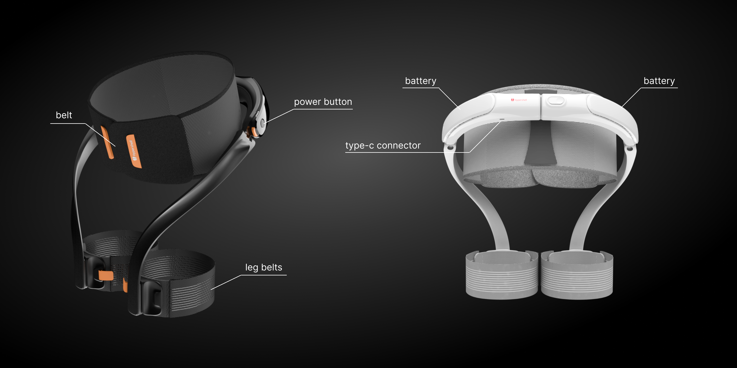

1. Wearing
1.1 Put the belt around the waist
1.2 Put the leg belts above the knee of each leg

2. Power On/Off
2.1 In the power off state, press and hold the power button for 3 seconds to turn it on
2.2 In the power on state, press and hold the power button for 3 seconds to turn it off

3. Function Switch
3.1 In the power on state, short press the power button to switch between modes

4. APP
4.1 Show remaining miles
4.2 Show remaining battery
4.3 Adjustment of output power
4.4 Mode switching
4.5 View current step count
4.6 View history record

5. Charging
5.1 Charging the product using type-c connector
5.2 Battery support hot-swappable replacement(one on each side)

Team Introduction
Hypershell started in 2018. In that year, our simulation research on the interaction of exoskeleton and human bodies showed a series of extraordinary possibilities. The data firmly revealed the unlimited potential of exoskeleton for human ability enhancement. Now we are a startup invested and incubated by Miracleplus (Y-Combinator China), Stood out from >10,000 global projects, and were selected with an ultra-low admission rate of <1%.
Hypershell is committed to continuously promoting human progress. Since our establishment in 2021, we have been innovating technologies and products in the field of exoskeleton to reshape people's lifestyles and enable technology to empower life.
All team members have more than 10 years of experience in the field of robotics, consumer products, and the electronic car industry. We have invented and produced more than 20+ hardware products and served more than 100,000 users in 30 different countries around the world.

