预热Ads
By Kelvin 1/14

1. 现有广告素材
ps：除了人群标签外重合度很高
人群标签 | 人群体量 | 正文 | 图片压字 | 标题 | 广告描述 | 效果预览
Hunitng + robotics + USA | 1140w | Boost your adventures to a new level with this Superlight Powered Exoskeleton. Walking Running Has Never Been So Light and Agile | Give you the power to defy gravity | Click to Get 50% Discount | Locking the Discount NOW! | 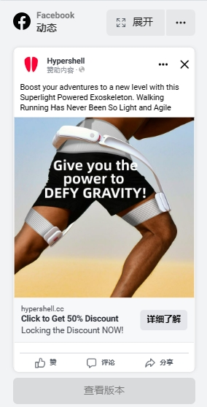
Backpacking + robotics  +USA | 3250w | Boost your adventures to a new level with this powered exoskeleton. Walking, Climbing, Running Has Never Been So Light and Agile. The power to DEFY GRAVITY! | Give you the power to defy gravity | Click to Get 50% Discount | Locking the Discount NOW! | 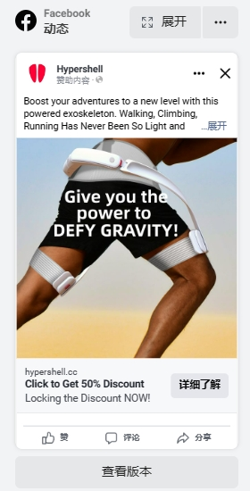
kickstarter+ 漫威+ USA | 1760w | Powered Exoskeleton is now become true! The power to DEFY GRAVITY! Walking, Climbing and Running Has Never Been So Light | Give you the power to defy gravity | Click to Get 50% Discount | Locking the Discount NOW!
生态旅游/探险 + robotics + kickstarter+ USA | 920w | Boost your adventures to a new level with this powered exoskeleton. Walking, Running Has Never Been So Light and Agile. | Give you the power to defy gravity | Click to Get 50% Discount | Locking the Discount NOW!
旅游常客/两周前旅行归来 + robotics + kickstarter+ USA | 900w | Meet the first powered Walking Booster for Traveler! The power to DEFY GRAVITY! Walking, climbing and running Has Never Been So Light. | Give you the power to defy gravity | Click to Get 50% Discount | Locking the Discount NOW! | 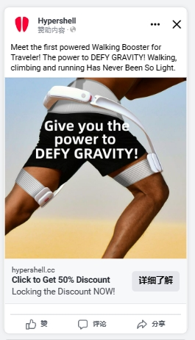
摄影师/户外摄影/自然摄影 + robotics + kickstarter+ USA |  | The first powered exoskeleton for photographer! Walking and running has never been so agile and light. Give you the power to unlock new map and shoot more. | Give you the power to defy gravity | Click to Get 50% Discount | Locking the Discount NOW! | 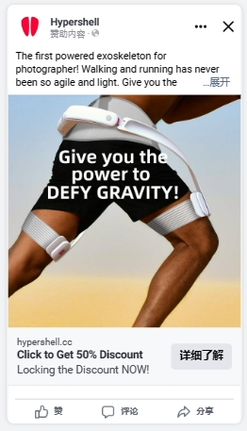
- 广告数据报告
ps：1月12-1月14之间的数据
广告组名称 | 成效 | 覆盖人数 | 展示次数 | 单次成效费用 | 花费金额 (USD) | 千次展示费用 (USD) | 成效获得率 | 点击量（全部） | 单次点击费用（全部） (USD) | 点击率（全部）
Photoer+kickstarter + double productivity | 57 | 4893 | 5142 | 1.360526 | 77.55 | 15.08168 | 1.108518 | 302 | 0.256788 | 5.873201
Travel+kickstarter + Defy gravity | 44 | 4970 | 5470 | 1.714318 | 75.43 | 13.789762 | 0.804388 | 367 | 0.205531 | 6.709324
Eco tour + KS + Defy gravity | 38 | 5241 | 5374 | 2.002895 | 76.11 | 14.162635 | 0.707108 | 366 | 0.207951 | 6.810569
Ironman +kickstarter + Defy gravity | 39 | 6267 | 6763 | 1.96 | 76.44 | 11.302676 | 0.576667 | 363 | 0.210579 | 5.36744
backpacking + Defy gravity | 45 | 5642 | 5797 | 1.686222 | 75.88 | 13.089529 | 0.776264 | 343 | 0.221224 | 5.916854
Hunting + Defy gravity | 50 | 5372 | 5732 | 1.534 | 76.7 | 13.381019 | 0.872296 | 362 | 0.211878 | 6.315422

2. 预热页数据
- 热力图
clarity.microsoft.com
使用的是google账户进行登录:
账号 it@hypershell.cc
密码 HumanBooster2022

3. 优化方向思路
- 地区
- 从单美国变更为包含以下国家
- USA, United Kingdom, Germany, France, Australia, Canada, Switzerland, Japan, Singapore, Netherlands
- 文案
- 素材
- 创意

Reference
- Ads图片素材figma库
- https://www.figma.com/file/qnkGx1t9XKTFcskl81wRcK/%E5%89%8D%E6%B5%8B%E5%B9%BF%E5%91%8A?node-id=0%3A1
- 文案素材库
- 极壳人都能写广告
- HS001 广告测试逻辑

