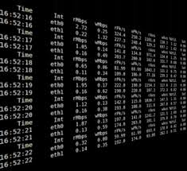

ELECTRONIC TELEPHONE DIRECTORY

AVL TREES APPLICATION ANALYSIS

AUTHOR : SIMPHIWE MCHUNU

AVL trees are data structures, that allow all operations that all other data structures allow to be operated on them. This is the BinarySearchTree with additional balance properties.

The problem that we encounter in most of our daily lives when it comes to searching for a particular
person’s details in the electronic telephone directory is that it takes more time to get the result whether the person that is being searched for exists in that particular telephone directory or not, even so suppose the person exists, the time it will take to output that person’s details will be long since we are dealing with large data set of about 10 000 entries. The best case is when the person is the first entry. The cause of this problem may be because the height of the subtrees are different, hence the tree becomes unbalanced. The duration of time for searching and deletion will be a bit long provided the tree is unbalanced. AVL trees tend to be one of the best solution in solving this predicament.

APPLICATION DESIGN

SEARCHAVL

public class SearchAVL extends AVLTree class that take Strings as datatype.
Within the SearchAVL class there are three methods namely, InsertToTree(), searchTree(), and main method.
InsertToTree() method is a static method of type AVLTree. It creates a new AVLTree that will allow operations such as insertion, search and deletion to occur. Exception handling is taken care of, such that it does not affect the functioning of the application in anyway. A new Scanner is created that reads the file. The method then checks if there are still elements to in the file by checking if the scanned file has the next line. Variables lineOne and fullname of type String are created and they store next line, and trancated last element of the next line respectively. LineOne stores the whole data item which consists of address, telephone number and fullname, seperated by “|”. The trancated
last element is the fullname which will be used as a key.
LineOne and fullname are inserted into the AVLTree by invoking an insert method under AVLTree class, which takes in two parameters of type String and insert them accordingly and return a balance
tree. File that was scanned is then closed. IOException is handled.

SearchTree() method is a static method of type void. The method also takes into consideration the exceptions that may arise. InsertToTree() is invoked and elements from a specified file, say testdata in the AVLTree data structure. A new file say queryfile is read by using Scanner.
The method checks if there are still names or elements in the queryfile and try to find or match the names in the queryfile with those in testdata. If they match, the whole details of that person is printed out. If the person is not in the AVLTree data structure, “Not found” is displayed on the screen. IOException and NoSuchElementException are handled under this method.

Main method is a static method of type void. The main method invokes searchTree() method or InsertToTree() method, depending on which operation is needed to be done on that instance. The function of the main method is to display the output on the screen for the user.

The SearchAVL application ensures that the data is loaded once, meaning no new tree or raher seperate trees are created whenever we insert and search.

When a 20 entry queryfile is used in searching for those particular entries, SearchAVL traverse through the whole testdata file of about 10 000 entries and try to match the names in queryfile with those in testdata file. If the element does not exist is prints out “Not found” otherwise, the person’s details are displayed on the screen. The output looks as follows:

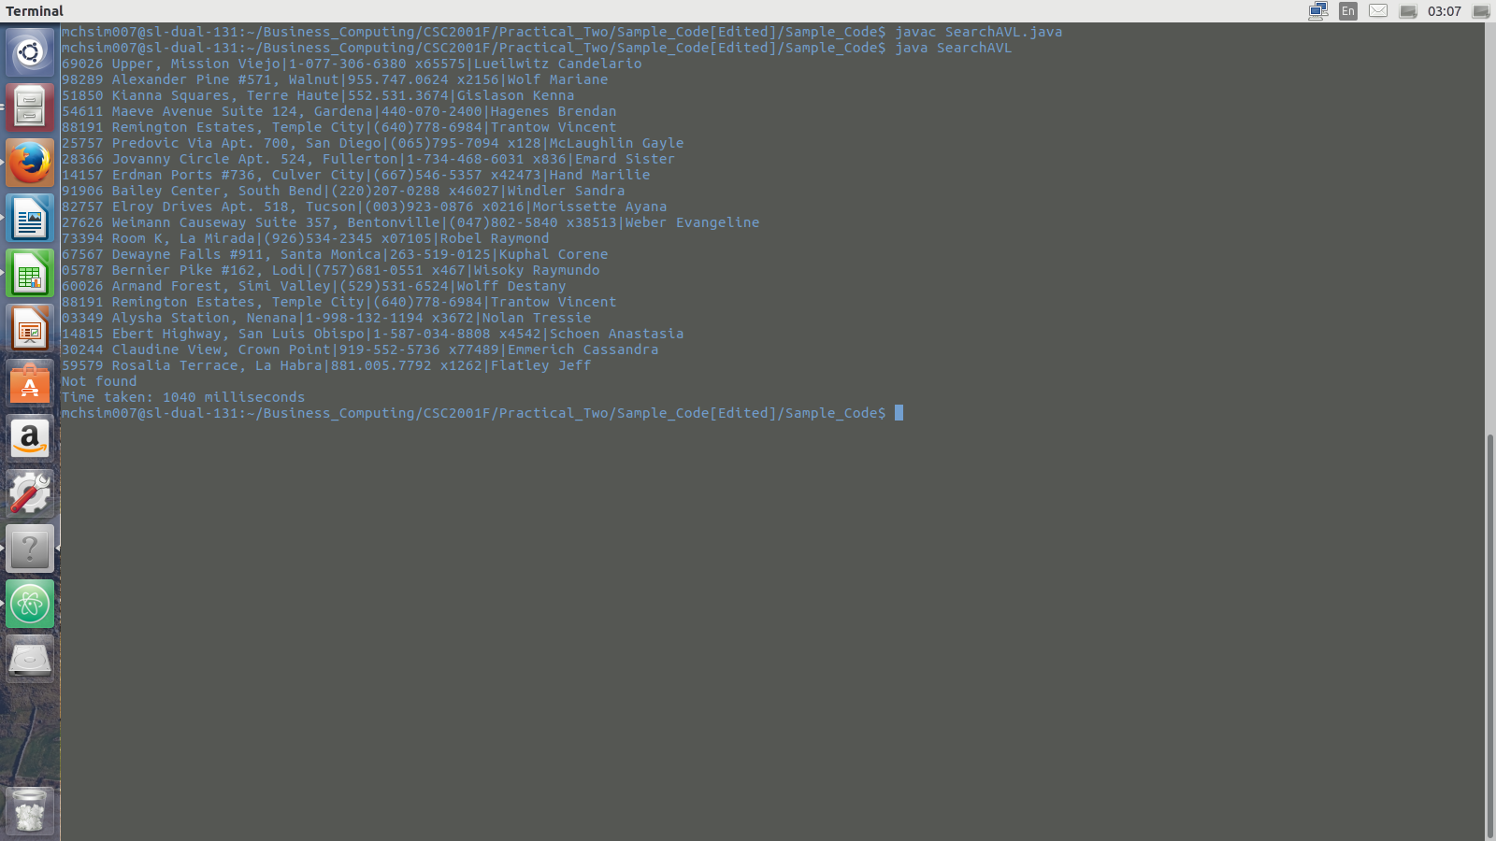

Experimental Design and Results

For the experiment I used different sets of entries namely 20, 50, 300, 5000 , 8000 and 10 000 entries that were used to perfom insertion, search and deletion operation on the AVLTree, and BinarySearchTree data structures. I only used the 20 names in the queryfile and observed what the results are in terms of duration for each operation as the Tree data structures grew.

The following results were obtained:

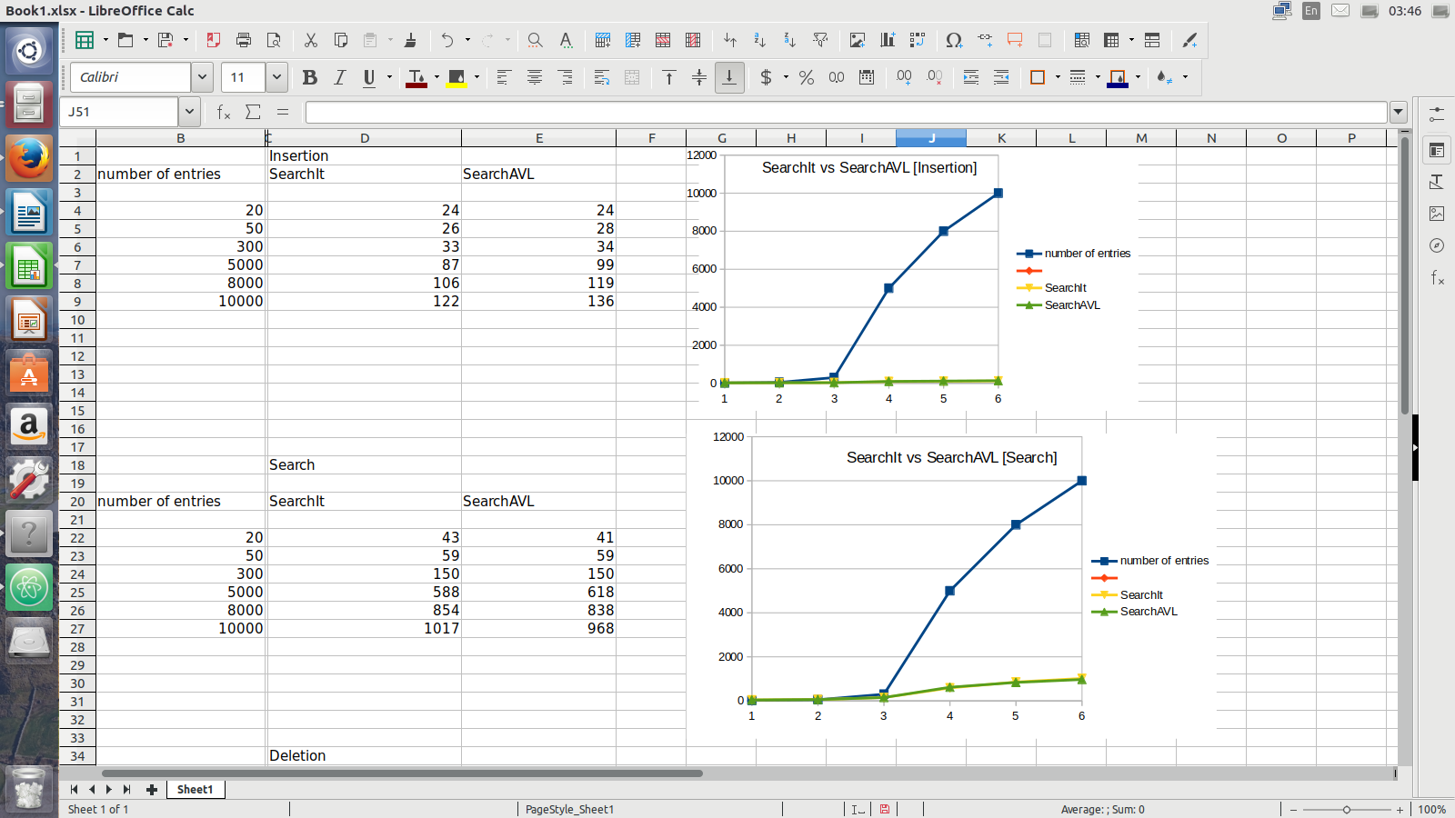

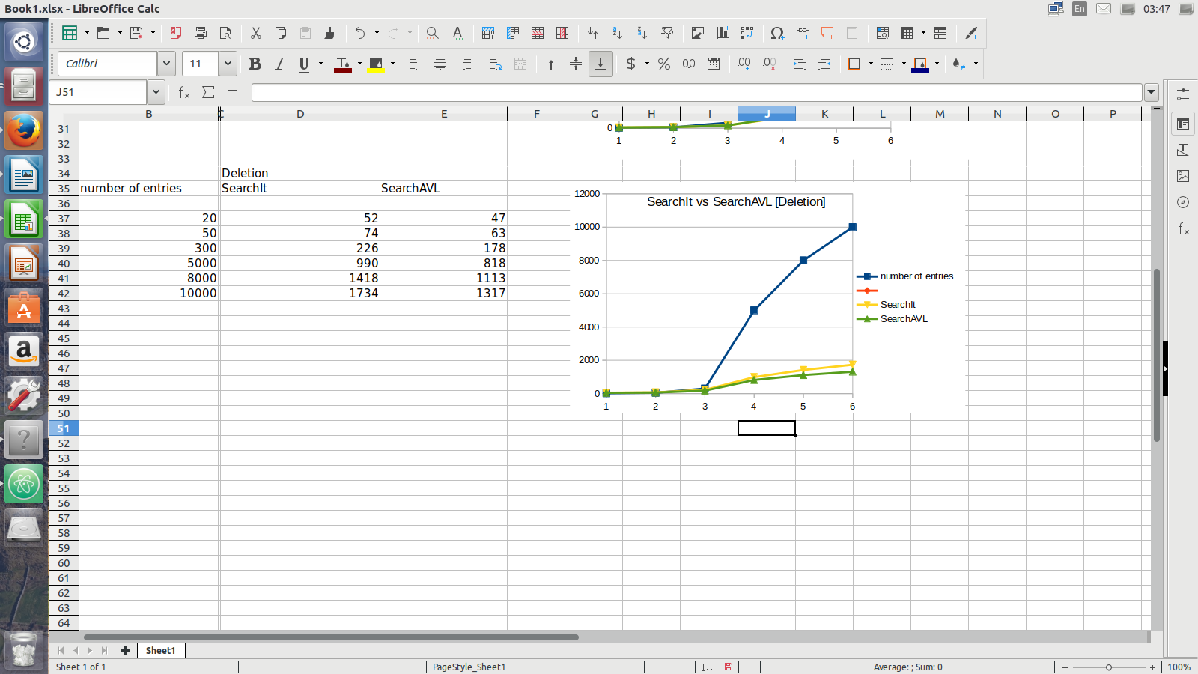
The above results were conducted under the conditions of fixed queryfile of about 20 entries of fullname and the data structures were loaded with data from 20 entries up to 10 000 entries.

The blue line represents number of entries, and shows a significant exponential growth overtime. The yellow line represents SearchIt and the green line represents SearchAVL for three operations.

For insertion, the model shows that the BinarySearchTree and AVLTree data structures are more or less the same in terms of duration. For search operation, SearchAVL was faster to perfom this operation compared to SearchIt, also for the deletion SearchAVL was more faster than SearchIt.

This concludes that AVLTrees are more efficient that BinarySearchTree especially when it comes to operations that involves traversals along the tree. This may be because AVLTrees are are more structured or rather balanced than BinarySearchTrees, hence the time it takes to perfom such operations will be small.

