HARSHIT SRIVASTAVA

19BCE0382

LAB CAT 2 JAVA (29-04-2021)

Q4 Write a class TouristSpot that has the data members; name of tourist spot, state in which it lies. Create an array list of n places and write a function that takes array list as an argument to identify a state that has more than one tourist spot.

CODE:

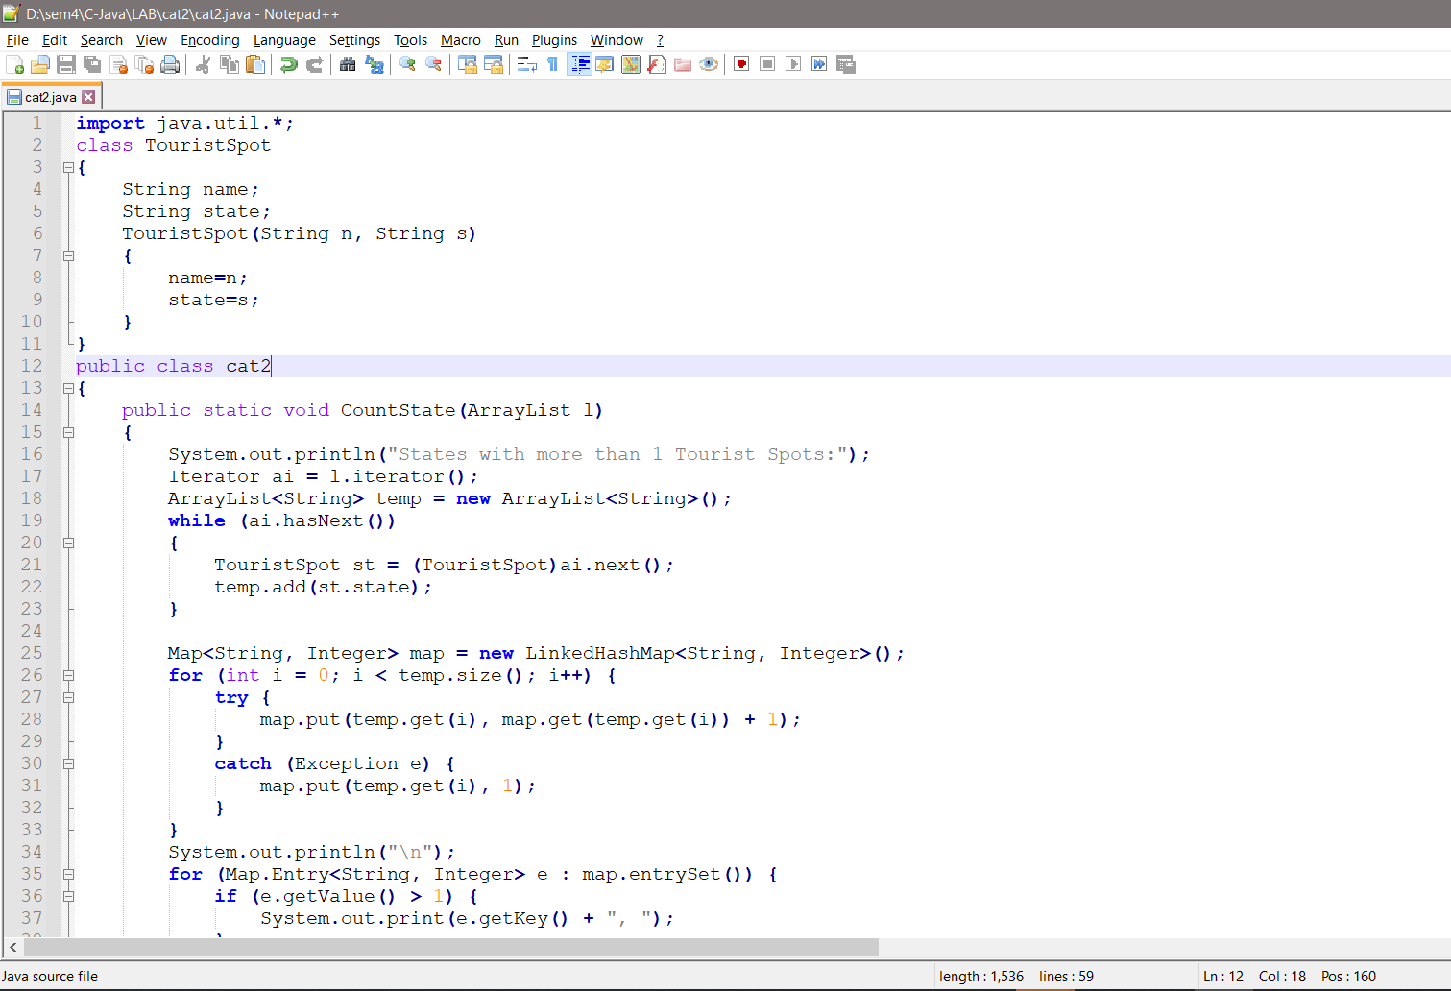

P.T.O

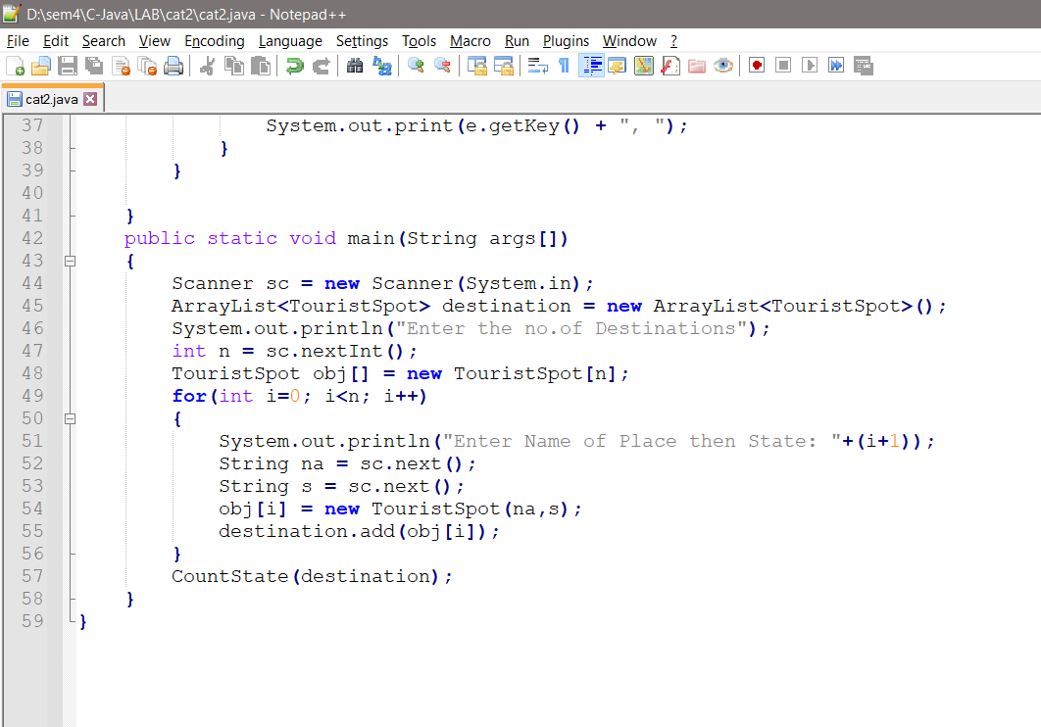

CODE IN TEXT FORMAT:

import java.util.\*;

class TouristSpot

{

String name;

String state;

TouristSpot(String n, String s)

{

name=n;

state=s;

}

}

public class cat2

{

public static void CountState(ArrayList l)

{

System.out.println("States with more than 1 Tourist Spots:");

Iterator ai = l.iterator();

ArrayList<String> temp = new ArrayList<String>();

while (ai.hasNext())

{

TouristSpot st = (TouristSpot)ai.next();

temp.add(st.state);

}

Map<String, Integer> map = new LinkedHashMap<String, Integer>();

for (int i = 0; i < temp.size(); i++) {

try {

map.put(temp.get(i), map.get(temp.get(i)) + 1);

}

catch (Exception e) {

map.put(temp.get(i), 1);

}

}

System.out.println("\n");

for (Map.Entry<String, Integer> e : map.entrySet()) {

if (e.getValue() > 1) {

System.out.print(e.getKey() + ", ");

}

}

}

public static void main(String args[])

{

Scanner sc = new Scanner(System.in);

ArrayList<TouristSpot> destination = new ArrayList<TouristSpot>();

System.out.println("Enter the no.of Destinations");

int n = sc.nextInt();

TouristSpot obj[] = new TouristSpot[n];

for(int i=0; i<n; i++)

{

System.out.println("Enter Name of Place then State: "+(i+1));

String na = sc.next();

String s = sc.next();

obj[i] = new TouristSpot(na,s);

destination.add(obj[i]);

}

CountState(destination);

}

}

OUTPUT:

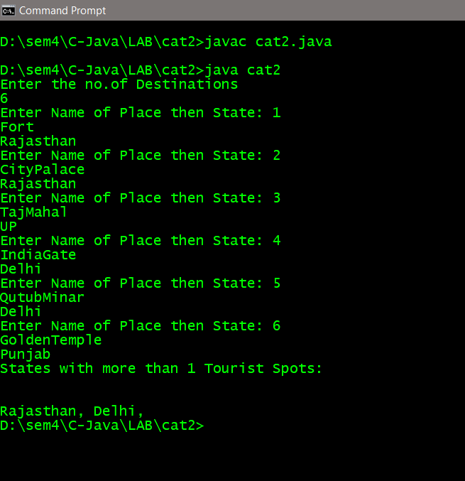

No. of States with more than one tourist spot printed in last line as shown in above screenshot