Everything realted database will be reported in this document.

**UPDATE 1**

The database is designed as figure 1.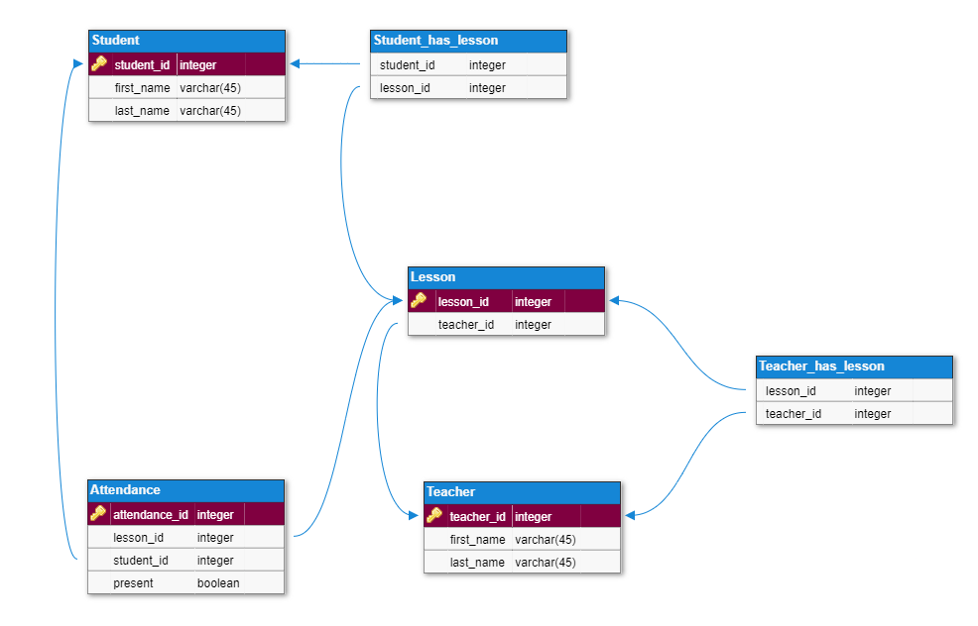

**Figure 1: Database scheme**

The database will be implemented by MySQL technology as it has relational structure and is installed by default. For this database design, authentication will be done seperatly for teacher and student. Because their authentication unique keys are stored in different database tables. The needed SQL querries is attached to same directory.

**Muhammed Cihad ARSLANOĞLU**

**20.02.2022**