- D8 and D4 diodes should be replaced with a MOSFET-based solution or a proper power OR-ing design.

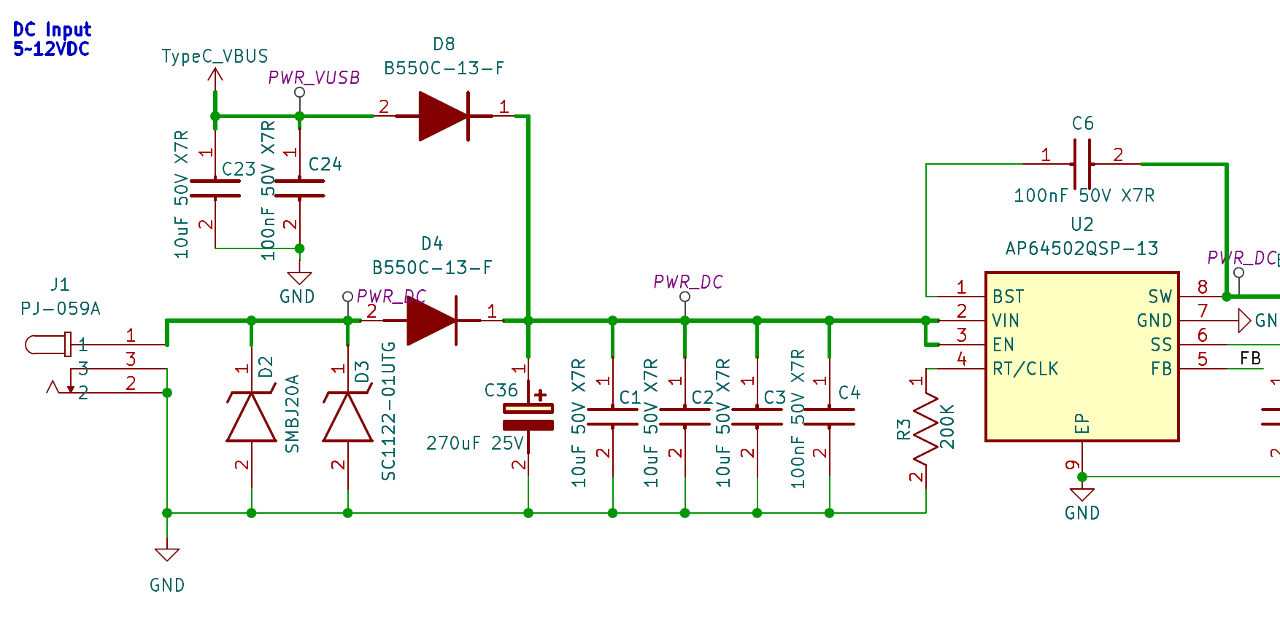

- The R112 resistor should be set to 10K.
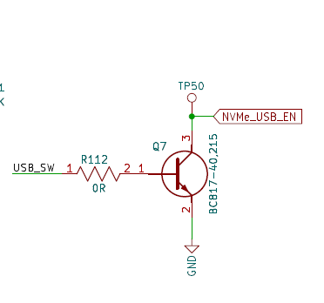
- The D1 diode should be replaced with a MOSFET-based switching circuit.
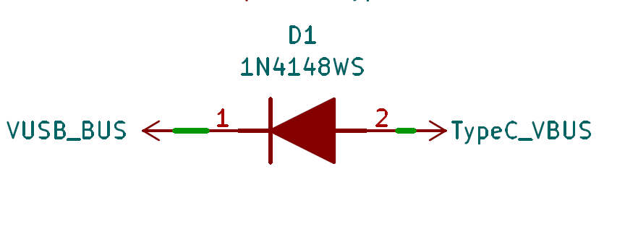
- C149 should be used as 2.2 µF.
