**To Configure SAM logs, Performance Monitoring Logs and PDQ logs in MDM**

Go to the following path C:\IBM\WebSphere\AppServer\profiles\AppSrv01\installedAssets\com.ibm.mdm.server.resources.properties-E001.jar\BASE and take the asset jar and edit the following properties file to setup the respective log configurations.

1. **To setup pdq logs change the configurations in pdq.properties file.**

pdq.traceFile=C:/IBM/WebSphere/AppServer/profiles/AppSrv01/logs/server1/pdq.log

pdq.traceLevel=ALL

The available trace levels are mentioned below, set it according to the need. ALL should be fine as it captures everything.

# * OFF

# * SEVERE

# * WARNING

# * INFO

# * CONFIG

# * FINE

# * FINER

# * FINEST

# * ALL

# The default level is OFF.

1. **To setup performance logs and sam log change the configurations in JDKLog.properties file.**

The below settings include mentioning log capture location in the system.

# Performance Monitor Logging Configurations

com.dwl.base.logging.handlers.PerfMonitorFileHandler.pattern=C:/IBM/WebSphere/AppServer/profiles/AppSrv01/logs/server1/performancemonitor.n%g.log

## Request Response Logging Configurations

com.dwl.base.logging.handlers.ReqRespFileHandler.pattern=C:/IBM/WebSphere/AppServer/profiles/AppSrv01/logs/server1/RequestResponseMessage.n%g.log

## TransactionDataListener logger Logging Configurations (SAM Logs)

com.dwl.base.logging.handlers.TransactionDataListenerFileHandler.pattern=C:/IBM/WebSphere/AppServer/profiles/AppSrv01/logs/server1/transactiondata.n%g.log

For performance monitoring and SAM log configuration there is an additional configurations settings need to be done on DB CONFIGELEMENT table.

#Performance Monitoring

UPDATE CONFIGELEMENT SET VALUE = 'true', LAST_UPDATE_DT = CURRENT_TIMESTAMP WHERE

NAME = '/IBM/DWLCommonServices/PerformanceTracking/enabled';

UPDATE CONFIGELEMENT SET VALUE = '-1', LAST_UPDATE_DT = CURRENT_TIMESTAMP WHERE

NAME = '/IBM/DWLCommonServices/PerformanceTracking/level';

COMMIT;

#SAM Logs

UPDATE configelement SET value = 'true', last_update_dt = CURRENT_TIMESTAMP WHERE name IN ('/IBM/DWLCommonServices/Report/Listener/enabled', '/IBM/DWLCommonServices/Report/Broadcaster/enabled');

COMMIT;

For performance monitoring please set following log detail level in Logs and Trace section of WAS Console.

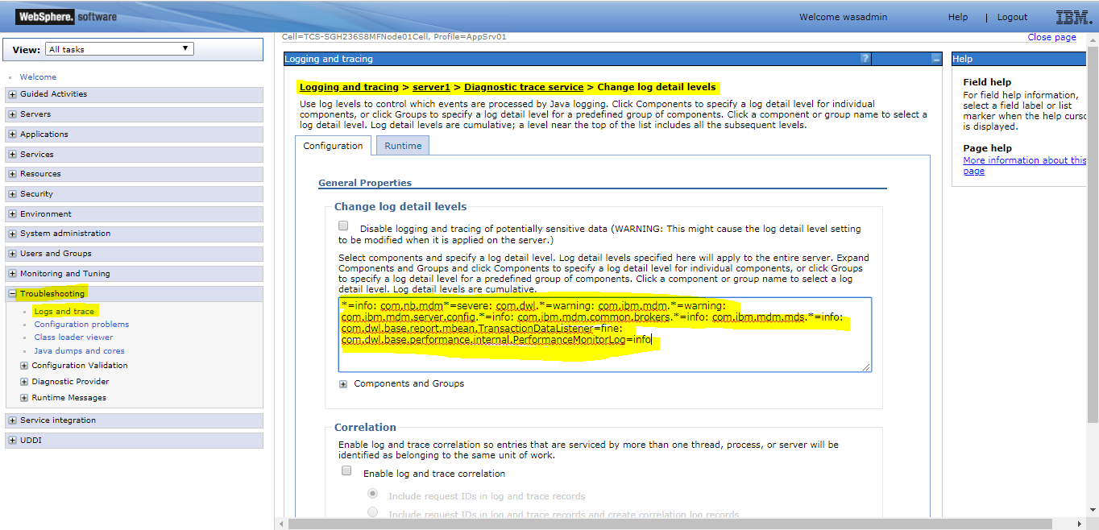

Include the following property as mentioned in above image.

com.dwl.base.performance.internal.PerformanceMonitorLog=info

Note each property is separated by colon.

Save this in both Configuration and runtime tabs and click on apply and then save.

1. **Deploy new asset.**
2. **Restart your system and hit any transactions you would see the below logs populated in the mentioned location.**

