Updating WAS Console to deploy com.ibm.mdm.server.resources.properties-E001.jar

- Login into Admin console using proper credentials.

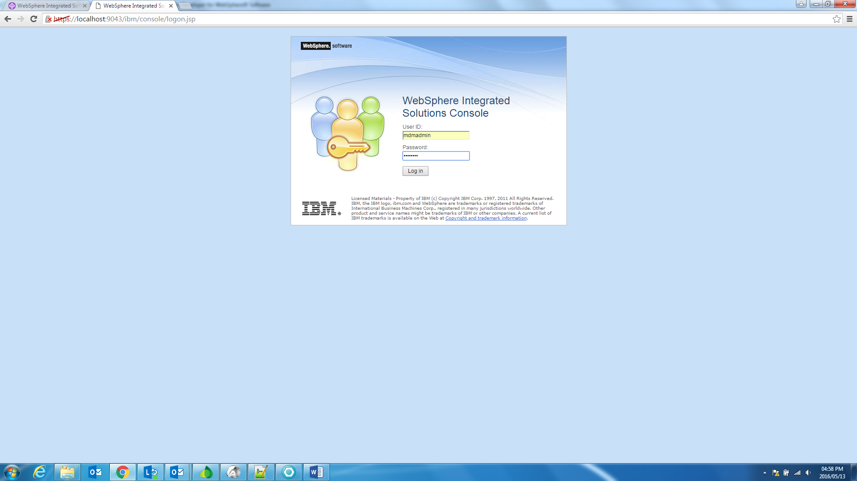

- Go to the Applications-> Application Types -> Assets and select the ‘com.ibm.mdm.server.resources.properties-E001.jar’ file and click update.

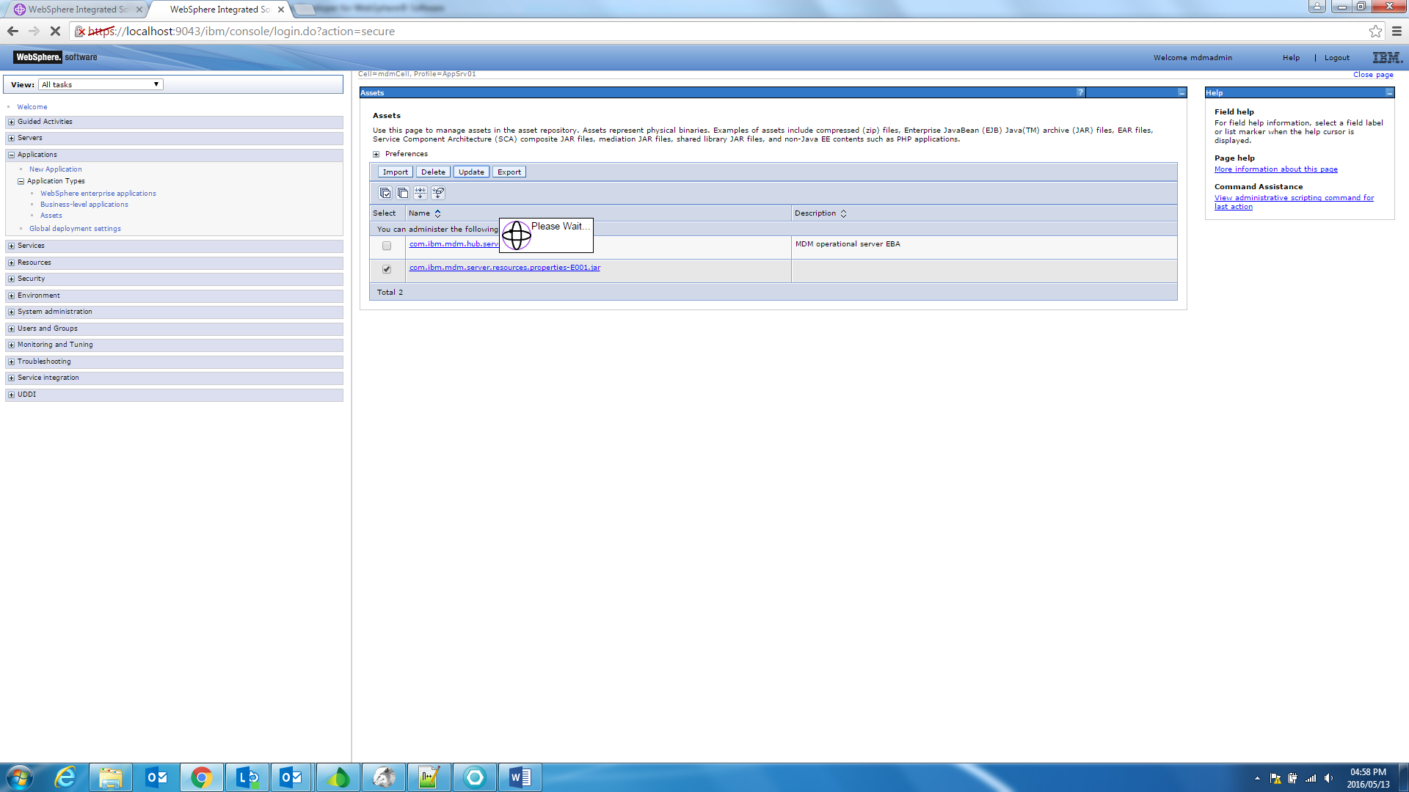

- Browse and select the locally saved com.ibm.mdm.server.resources.properties-E001.jar file to update into the server.

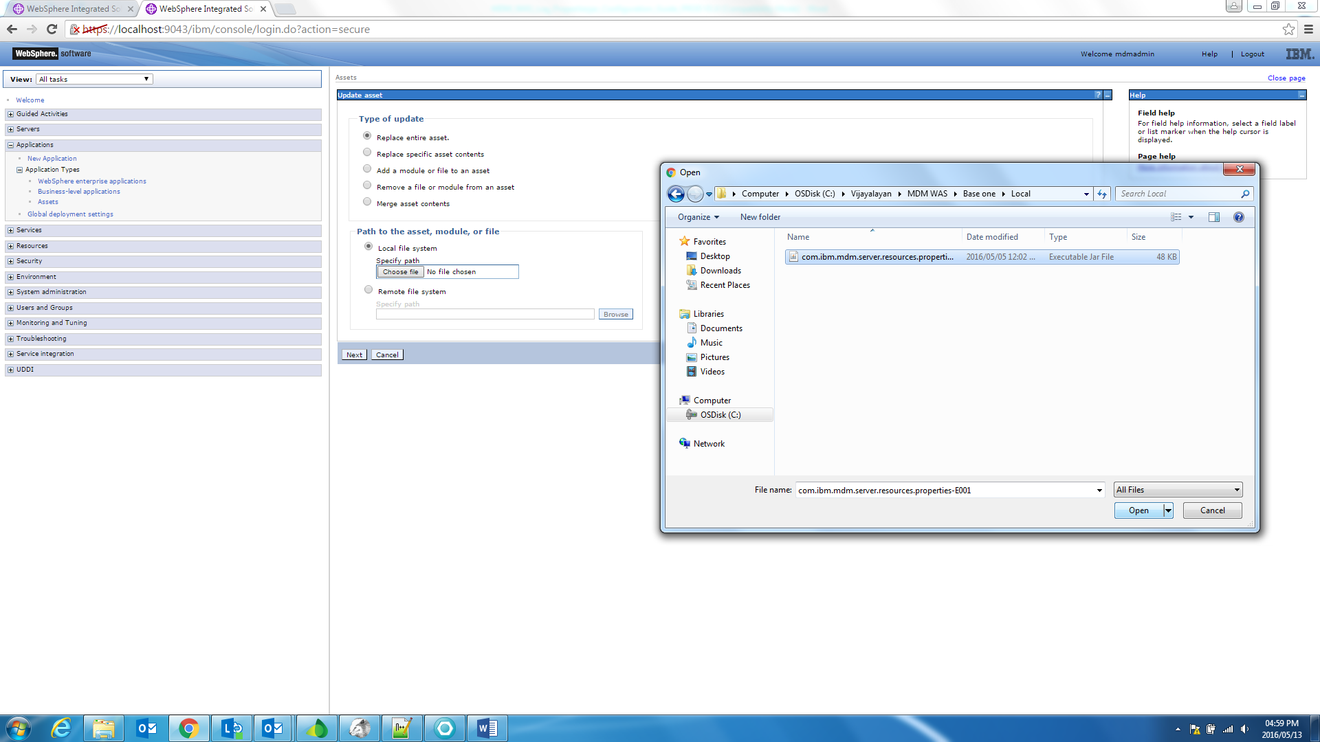

- Click ‘Next’ to import asset to the asset repository.
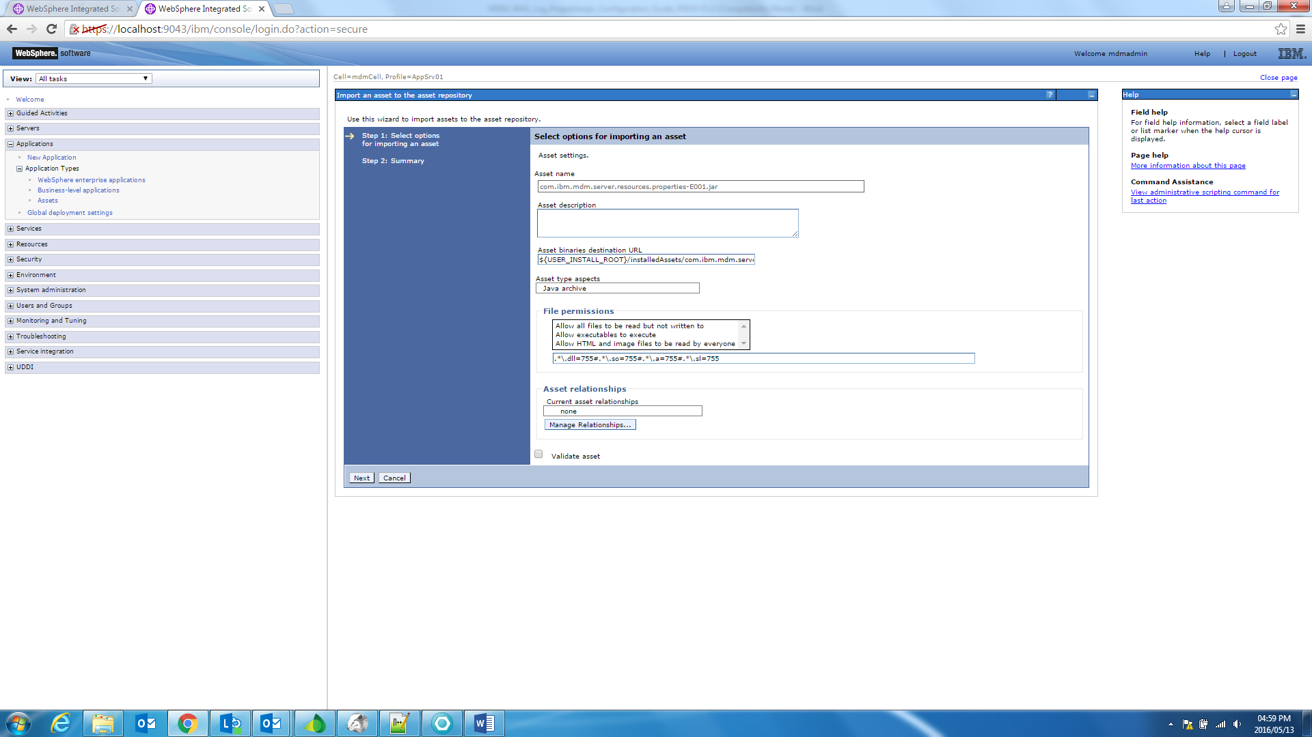

- Click ‘Finish’ to complete the application creation in the server.
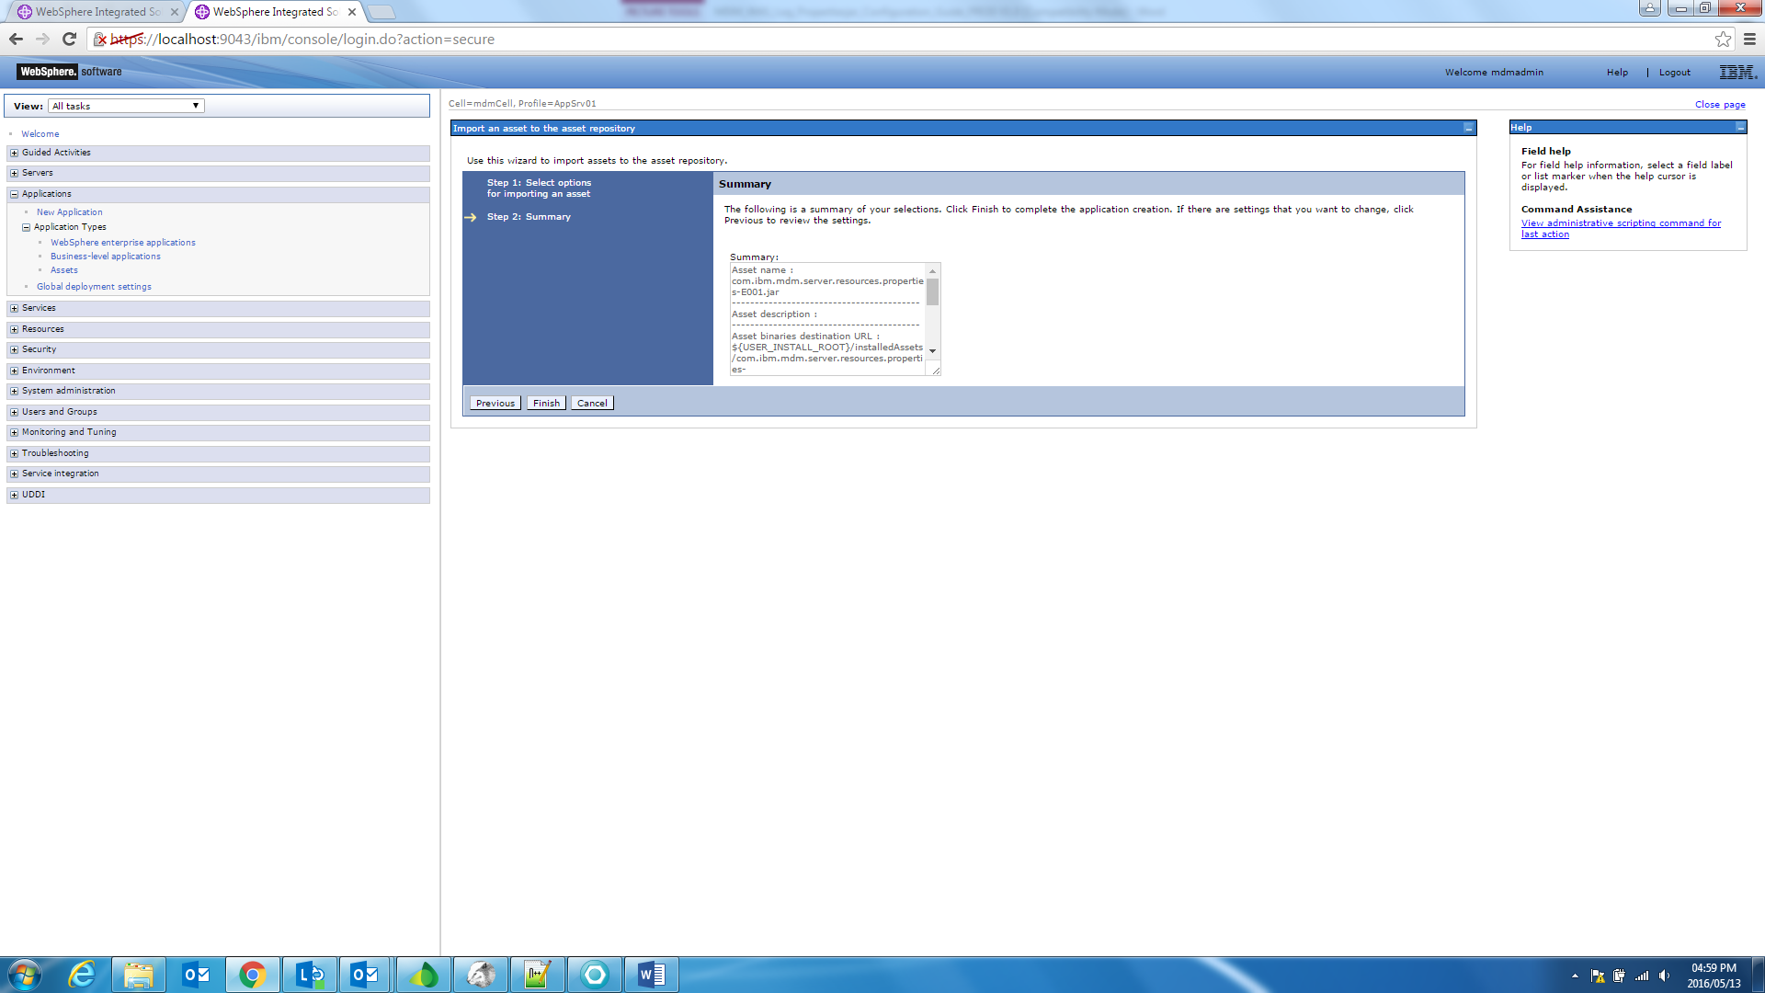

- Click ‘save’ to update directly to the master configuration.
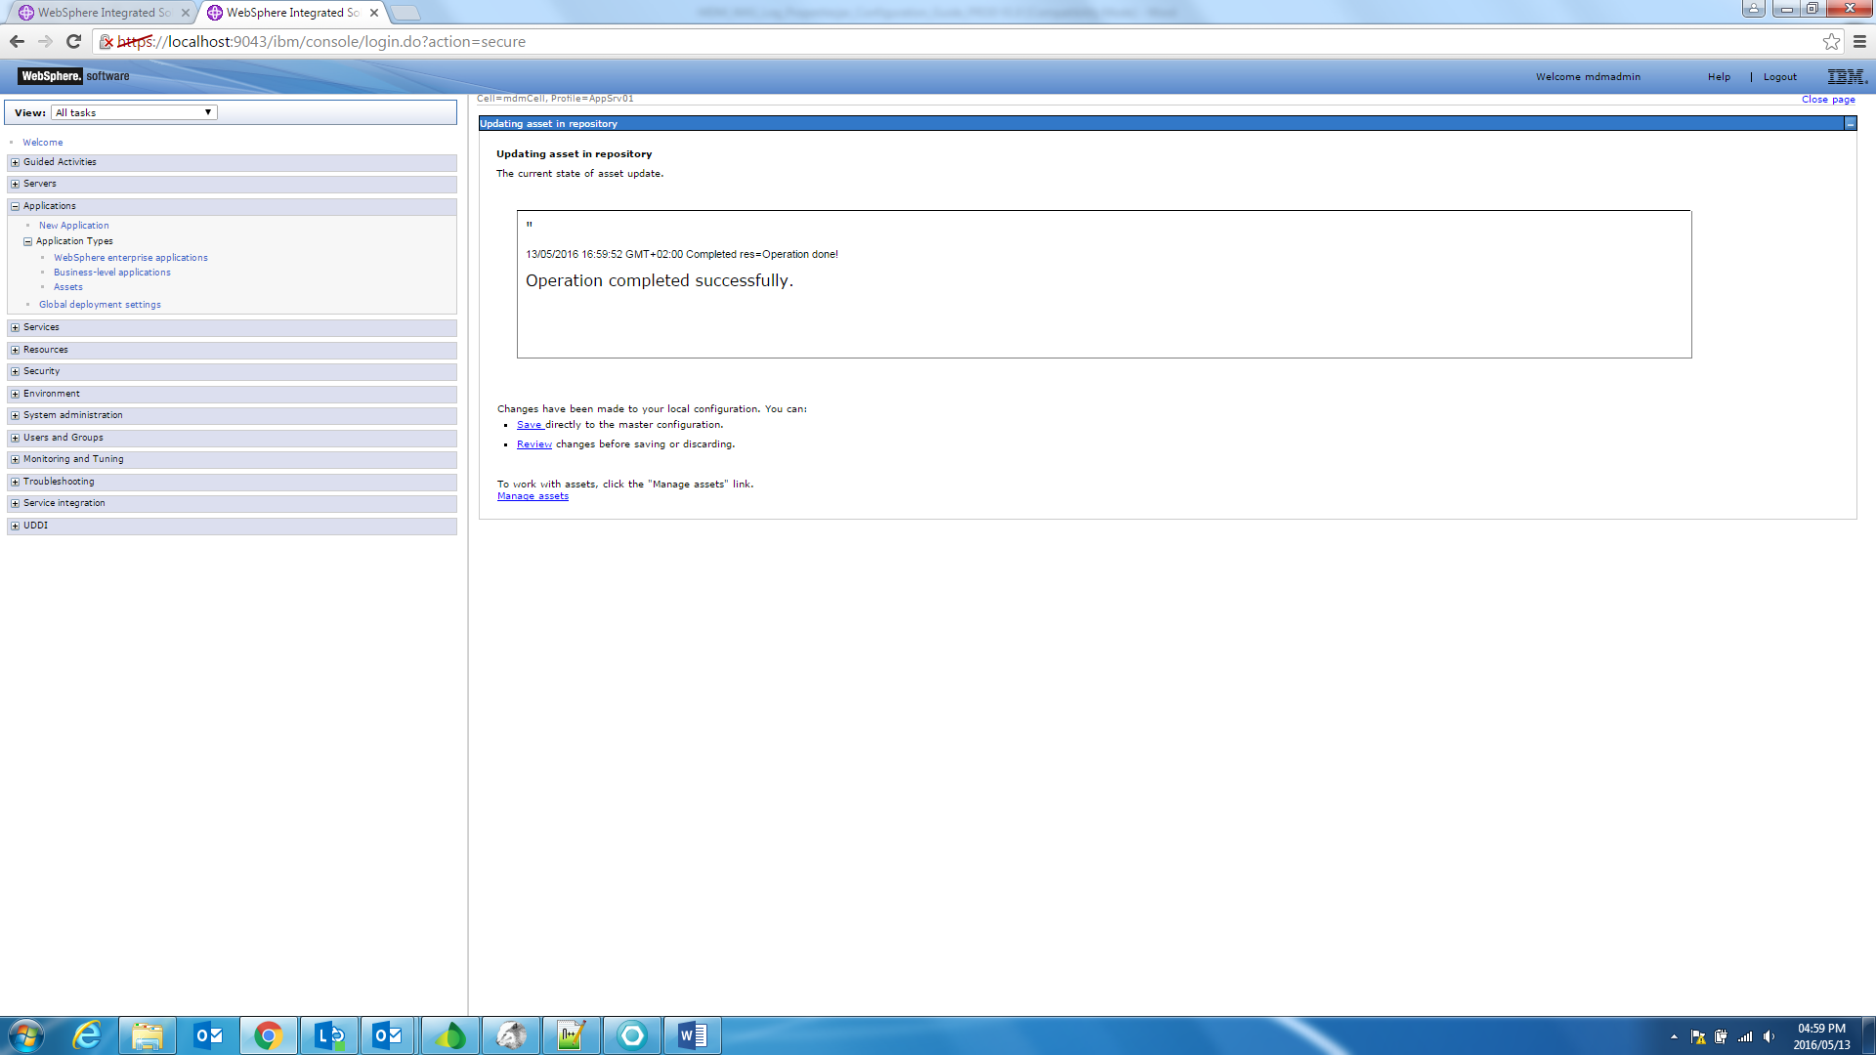

- Go to the Applications-> Application Types -> Business-level applications and click the ‘MDM-operational-server-EBA-E001’ application.

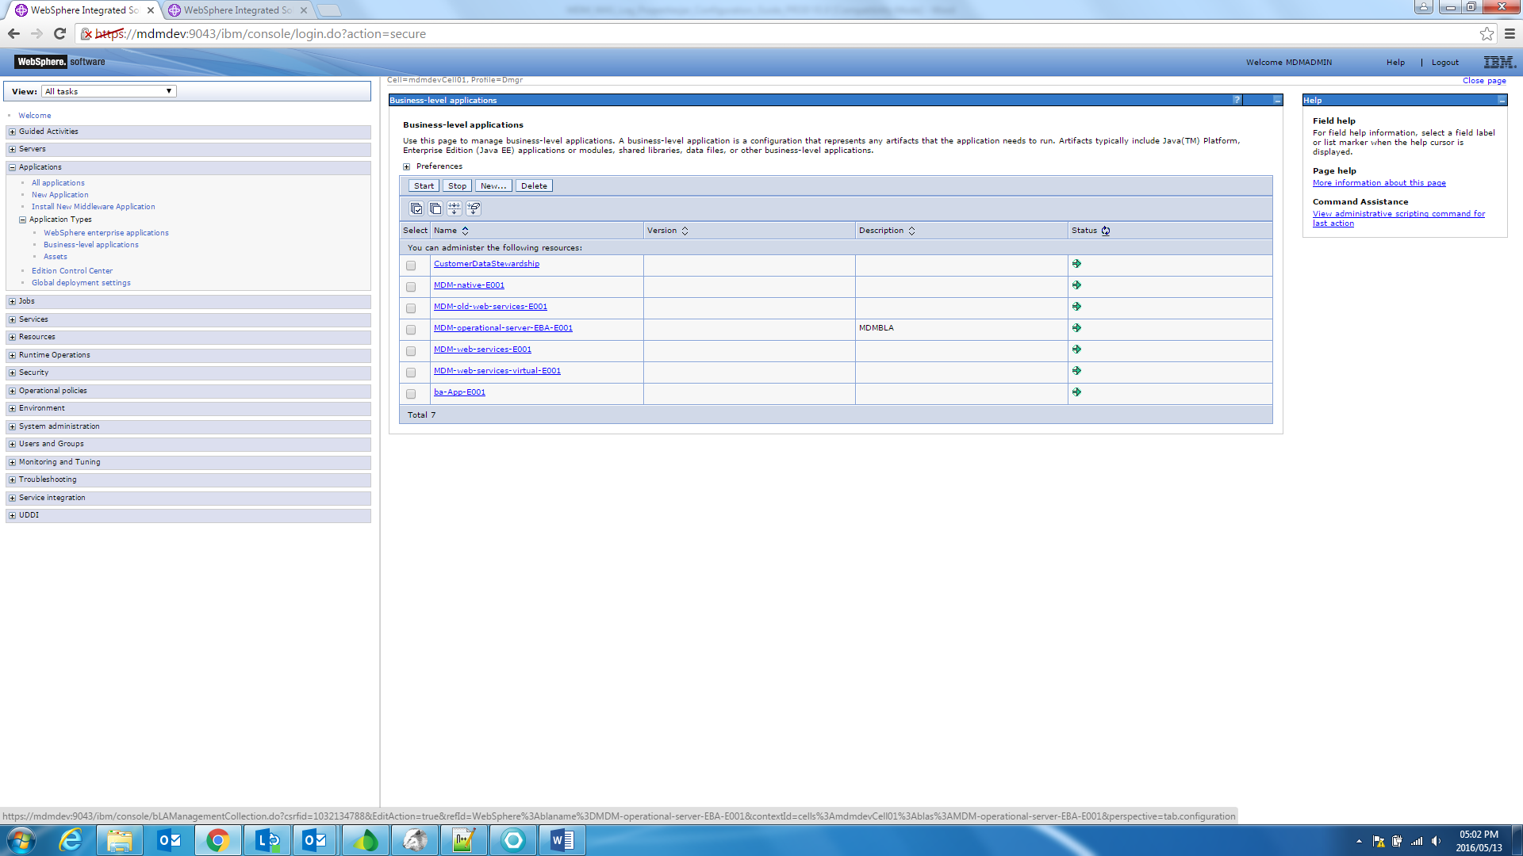

- Select the com.ibm.mdm.server.resources.properties-E001.jar and click delete to remove the properties file.
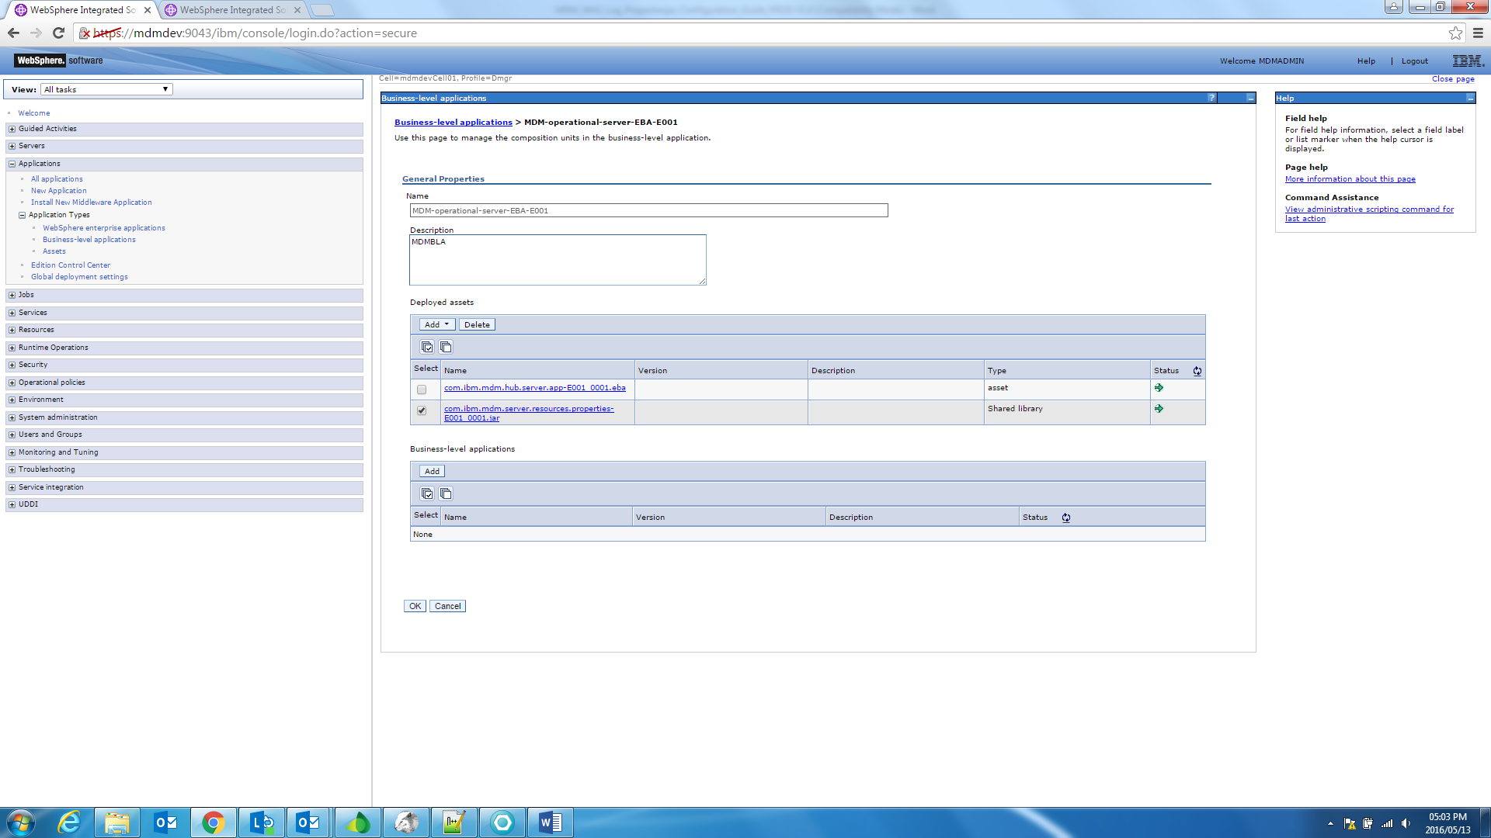

- Select the ‘Add Shared Library’ option from the Add dropdown list to add the newly imported properties jar file.

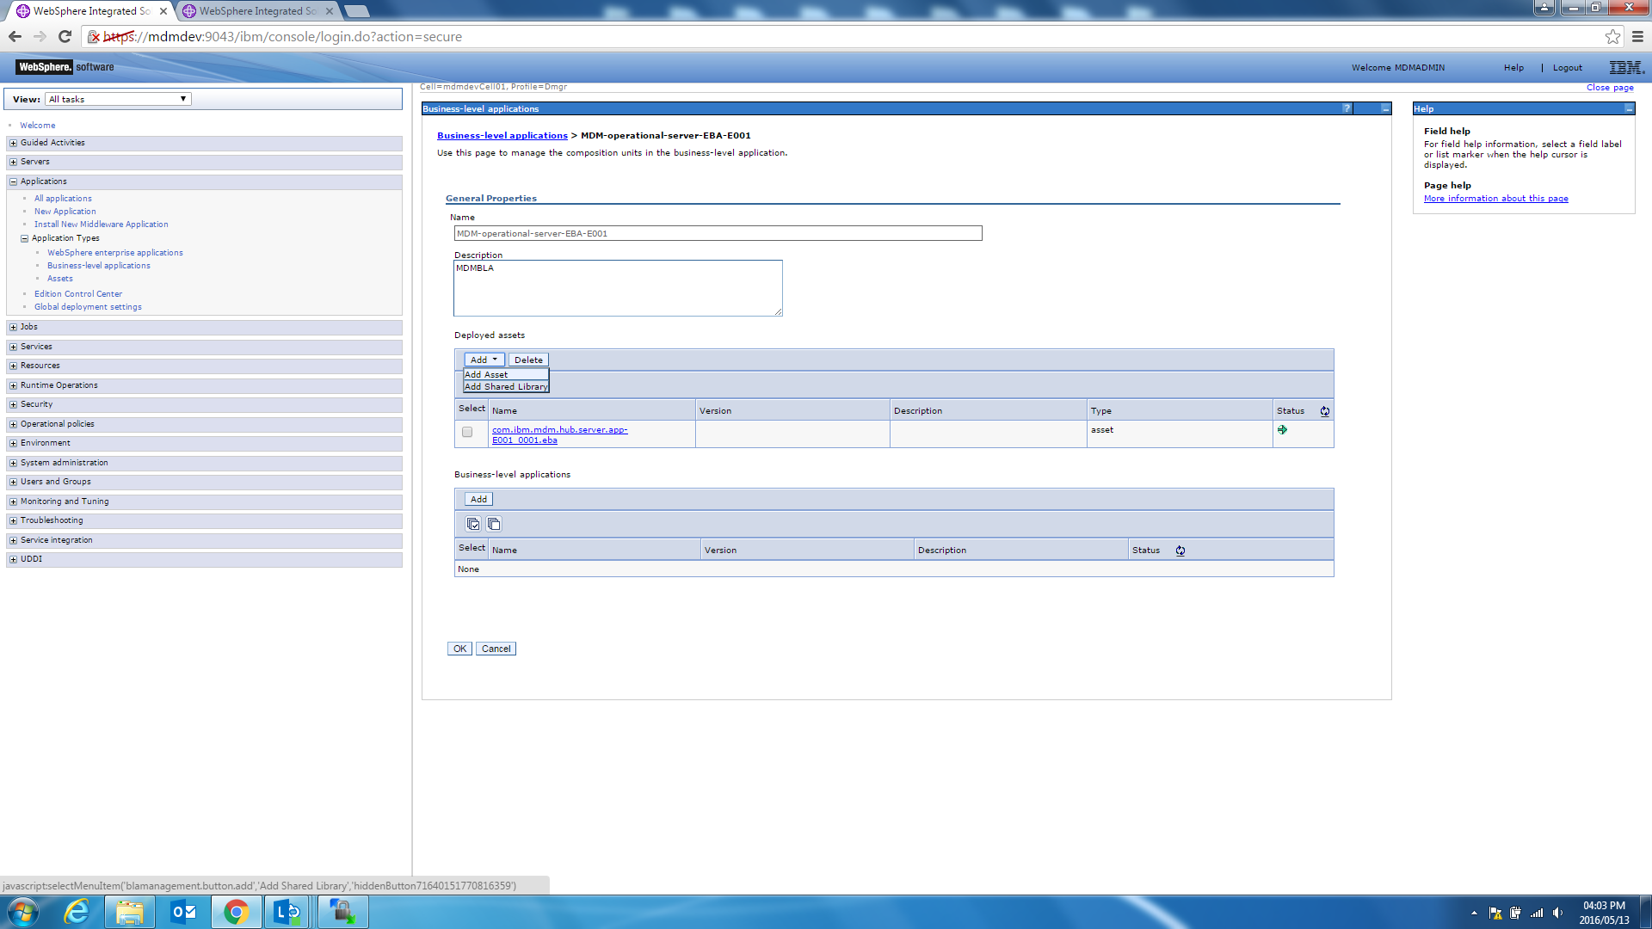

- Select the com.ibm.mdm.server.resources.properties-E001.jar and click ‘Continue’.

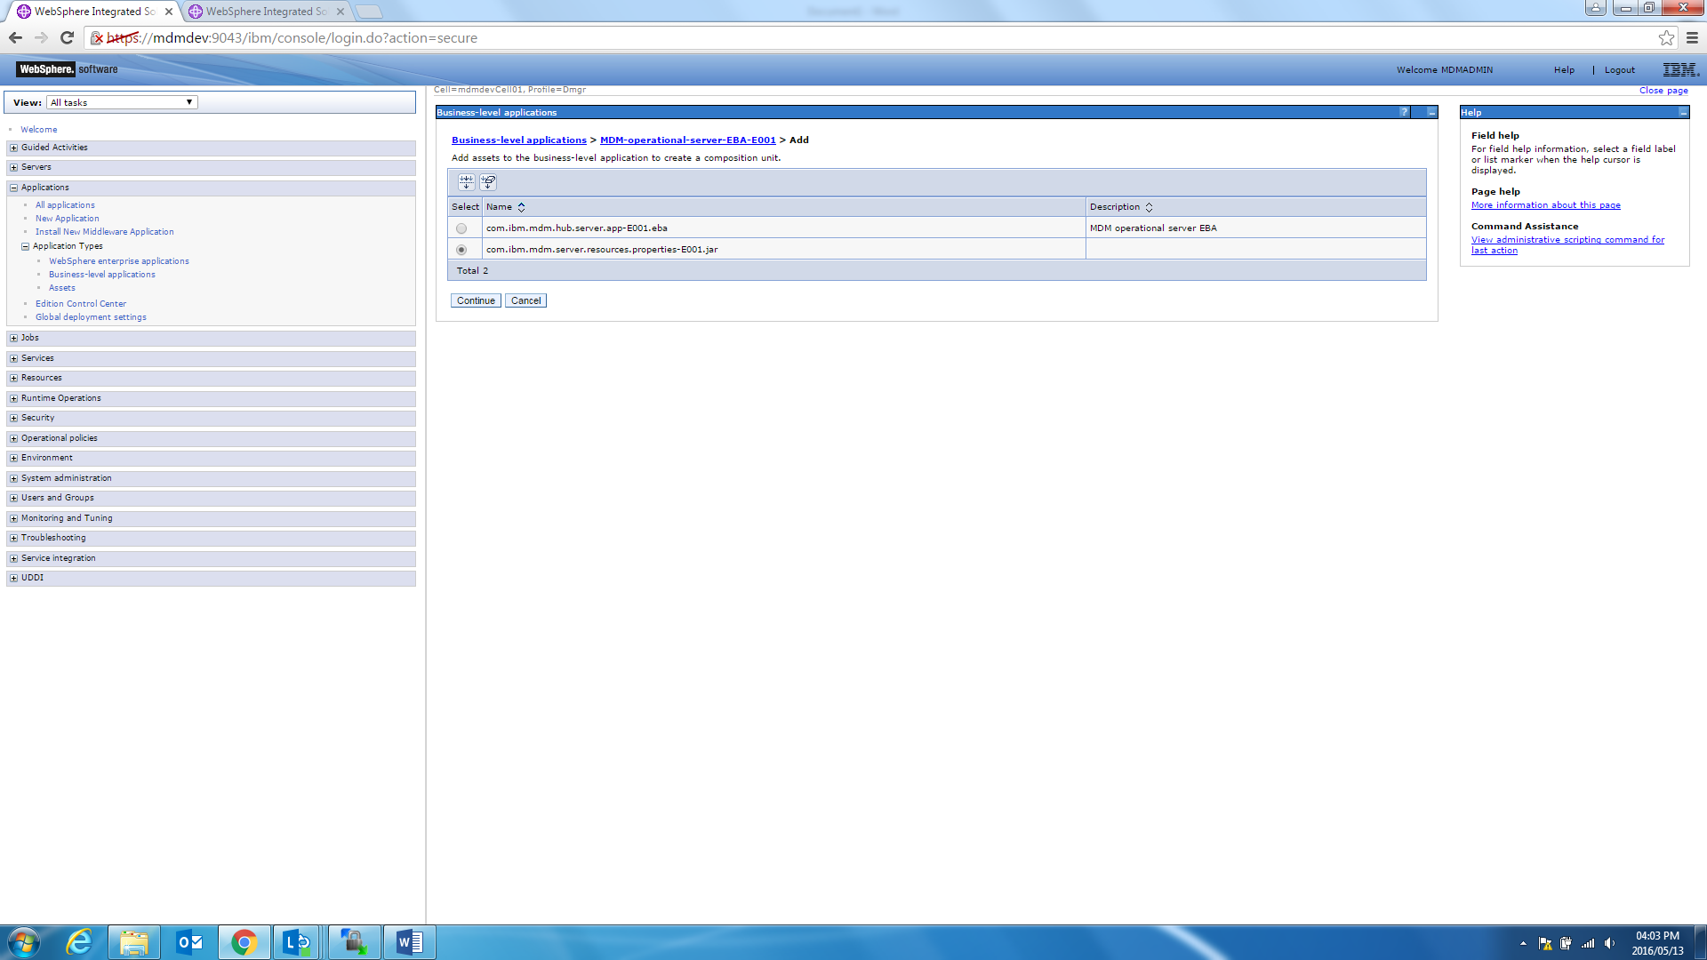

- Click ‘Next’ to map composition unit to a target.

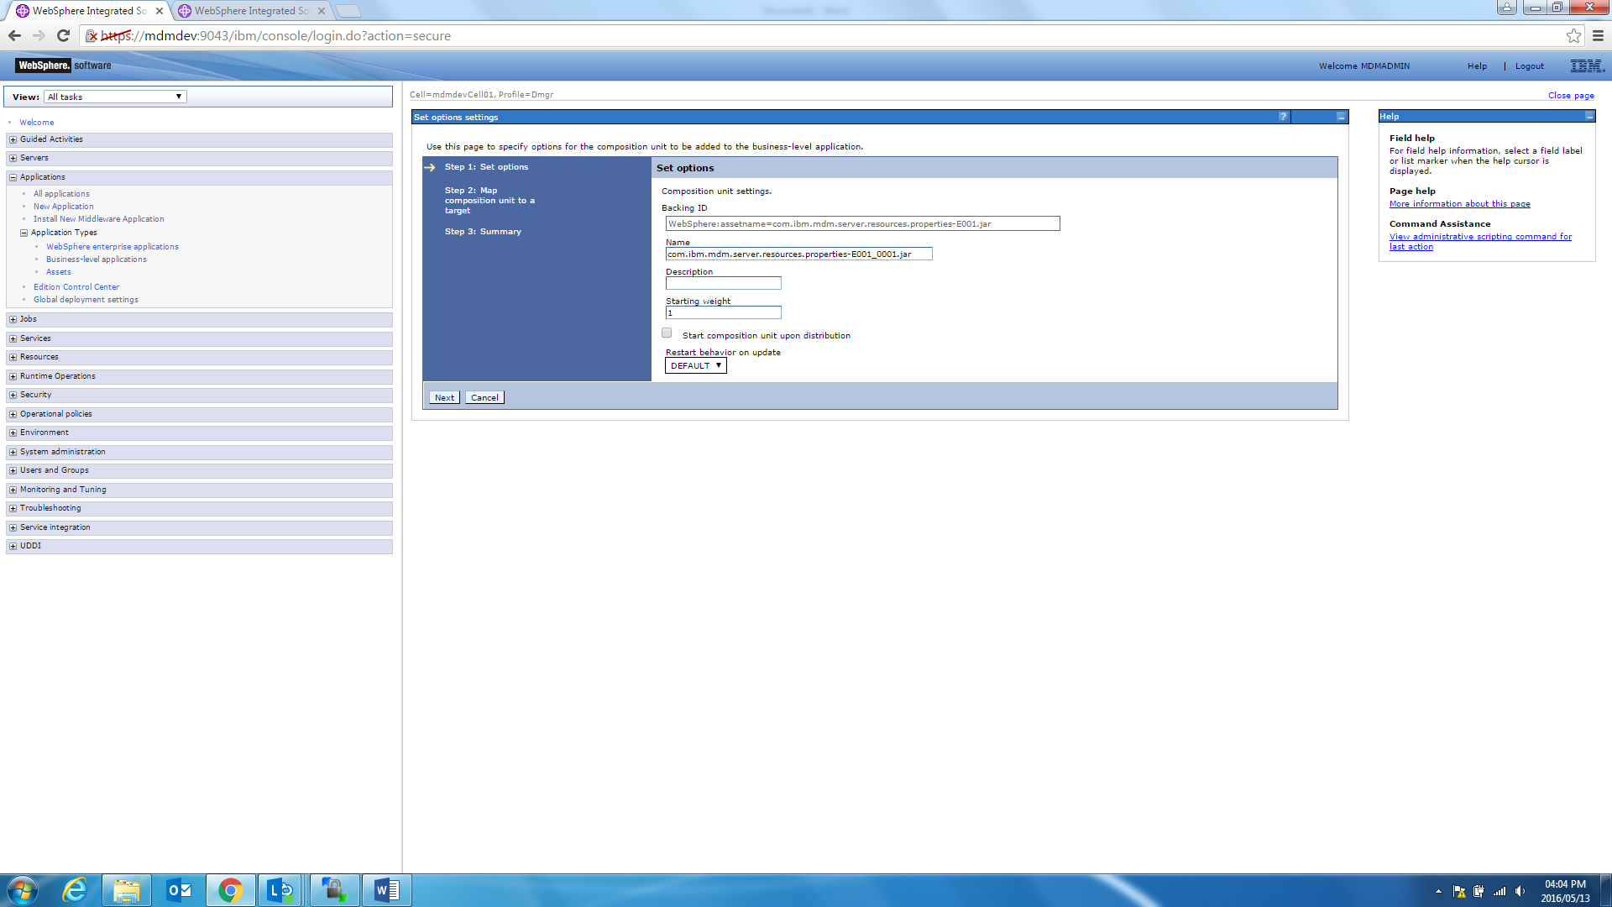

- Move the ‘WebSphere:cluster=OpCluster’ option to the selected area box for mapping the composition unit to a target.

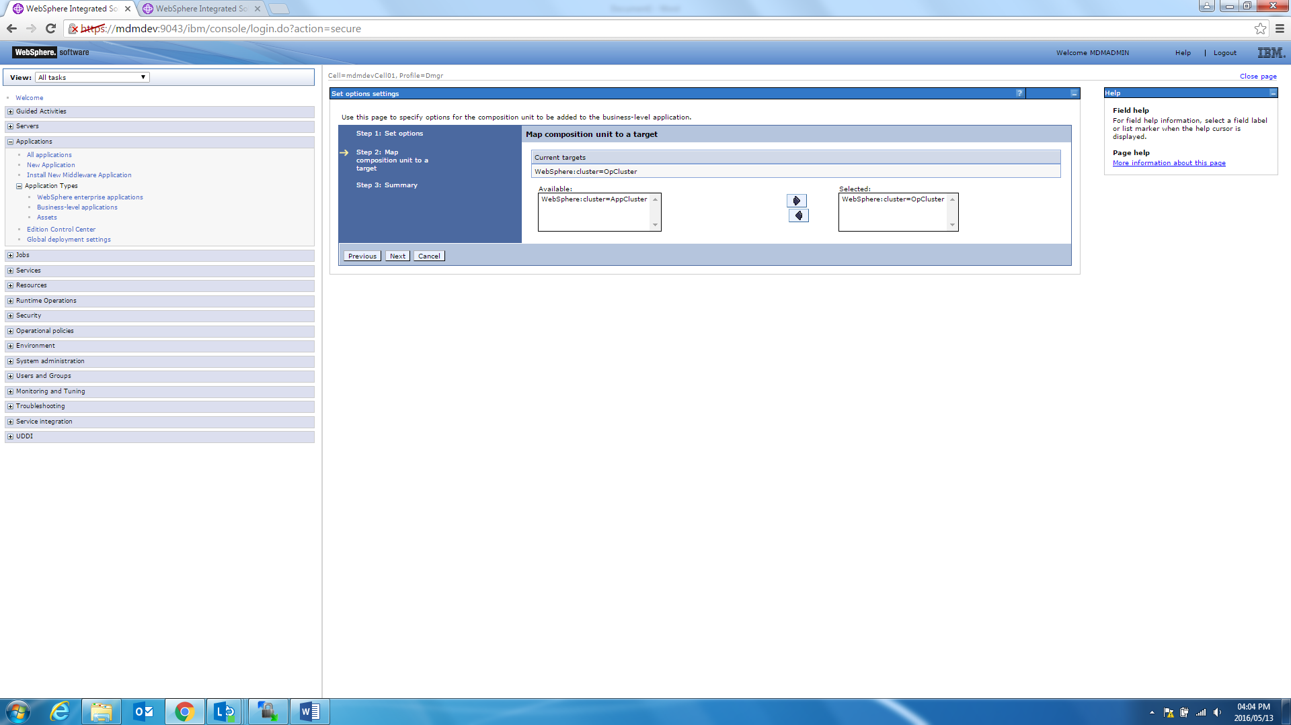

- Click ‘Finish’ to map the composition unit.

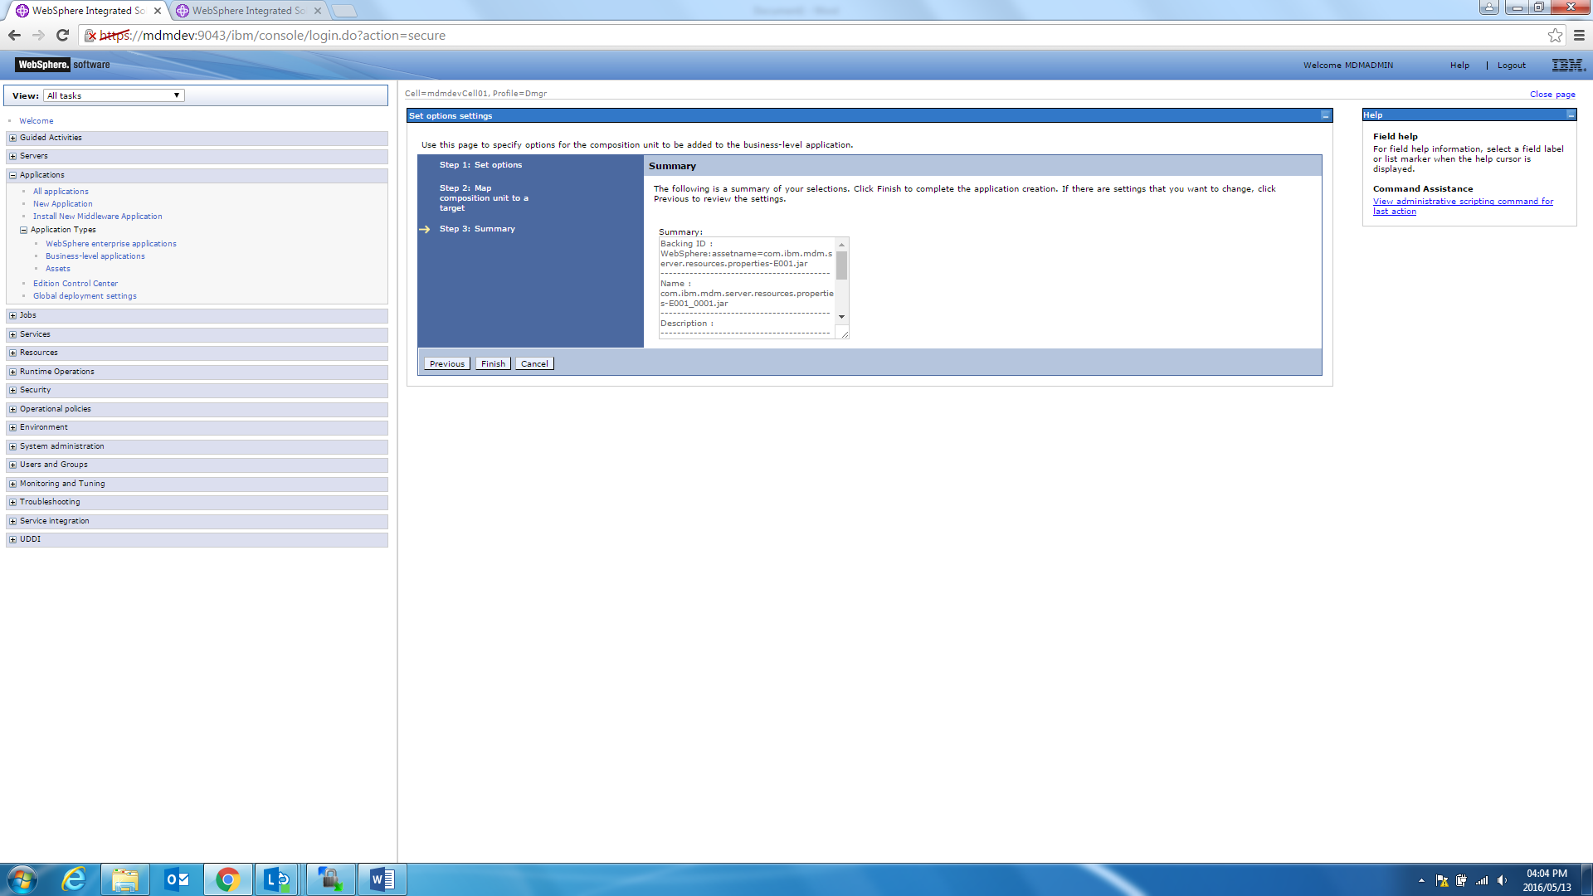

- Click ‘save’ to update directly to the master configuration.

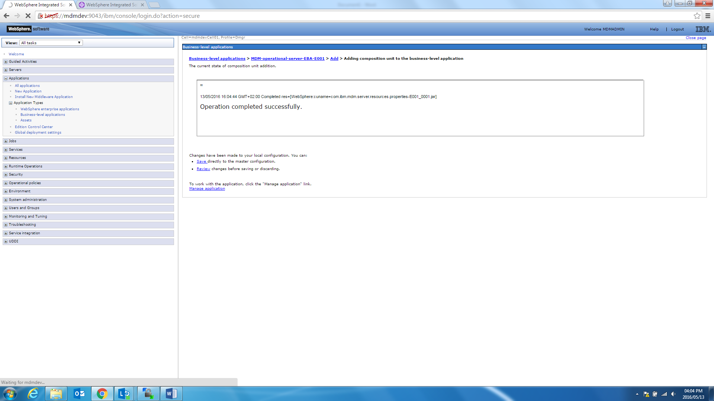

- Go to the Applications-> Application Types -> Business-level applications and select the ‘MDM-operational-server-EBA-E001’ application and start it.
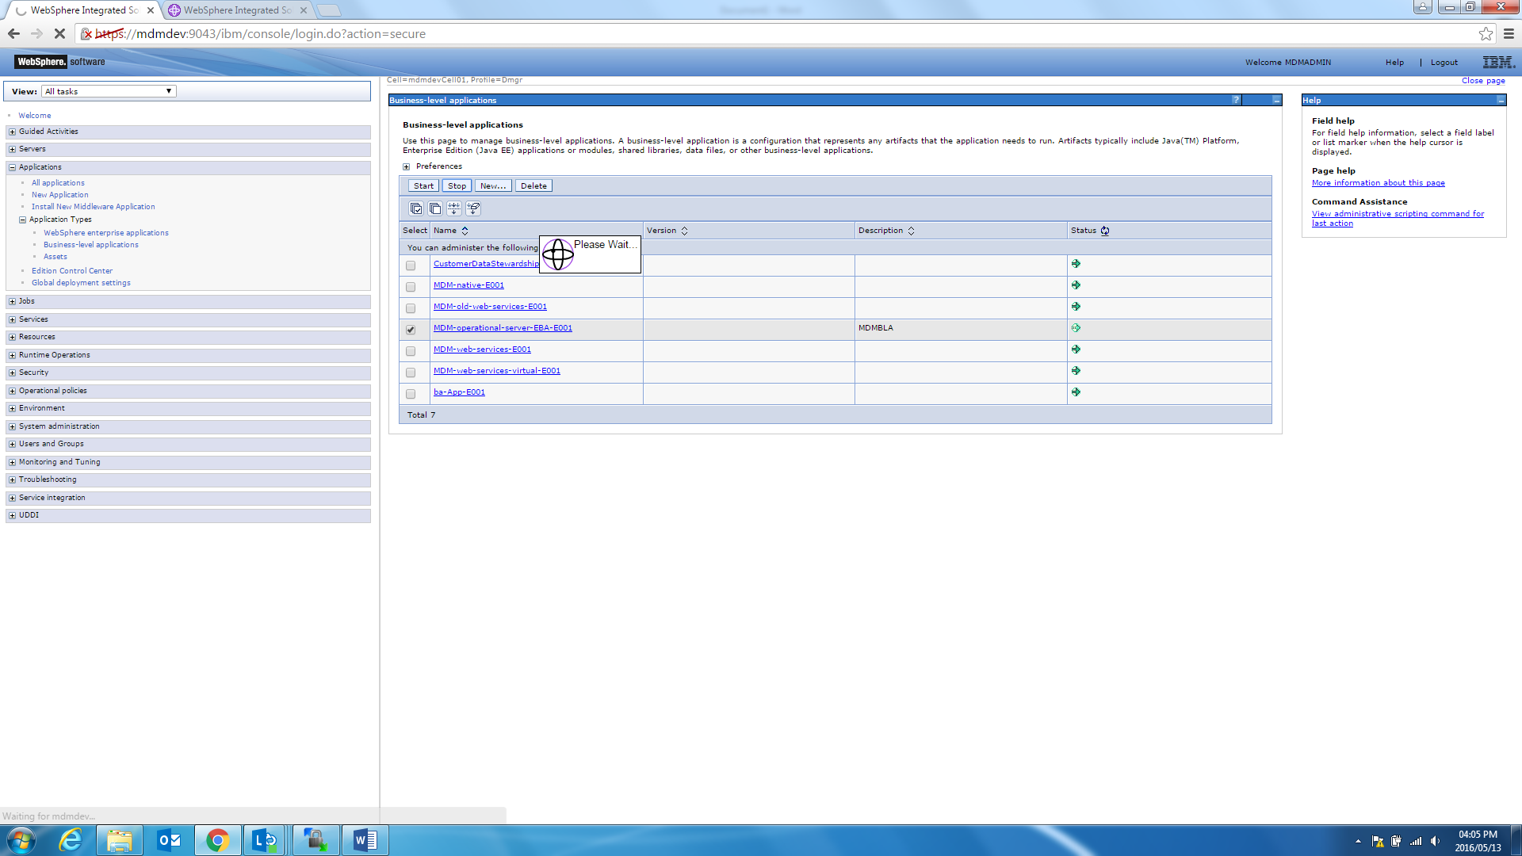

- Restart the MDM WAS server once the deployment completed.

