Cognizant - upGrad Training Program
uGE_DotNet FSD (Python)
Weekly Submission Document
Week_ 7
Trainee Information
Name: Mula Chennaiah Gari Jayaprakash Reddy
Email: mcjayaprakashreddy8309@gmail.com
Batch Name: B1_Python
Course: UGE DotNet FSD (Python)
Training Duration: 16th Feb 2026 - 26th May 2026
Session Timings: 9:30 AM – 6:30 PM
Faculty: Kunal

================ PROJECT: CacheApp ================

===== FILE: CacheItem.cs =====
namespace CacheApp.Models
{
public class CacheItem
{
public object Value { get; }
public DateTime Expiry { get; }

public CacheItem(object value, DateTime expiry)
{
Value = value;
Expiry = expiry;
}
}
}

===== FILE: InMemoryCache.cs =====
using System.Collections.Concurrent;
using CacheApp.Models;

namespace CacheApp.Services
{
public class InMemoryCache
{
// Singleton
private static readonly Lazy<InMemoryCache> _instance =
new Lazy<InMemoryCache>(() => new InMemoryCache());

public static InMemoryCache Instance => _instance.Value;

private readonly ConcurrentDictionary<string, CacheItem> _cache;

private InMemoryCache()
{
_cache = new ConcurrentDictionary<string, CacheItem>();

// Start background cleanup
Task.Run(CleanupExpiredItems);
}

// SET
public void Set(string key, object value, TimeSpan expiry)
{
var item = new CacheItem(value, DateTime.UtcNow.Add(expiry));

_cache.AddOrUpdate(key, item, (k, old) => item);
}

// GET
public object? Get(string key)
{
if (_cache.TryGetValue(key, out var item))
{
// Lazy expiration (IMPORTANT FIX)
if (item.Expiry <= DateTime.UtcNow)
{
_cache.TryRemove(key, out _);
return null;
}

return item.Value;
}

return null;
}

// Background cleanup
private async Task CleanupExpiredItems()
{
while (true)
{
foreach (var kvp in _cache)
{
if (kvp.Value.Expiry <= DateTime.UtcNow)
{
_cache.TryRemove(kvp.Key, out _);
}
}

await Task.Delay(5000); // every 5 seconds
}
}
}
}

================ PROJECT: CustomHashMapDemo ================

===== FILE: BadHashMap.cs =====
using System;
using System.Collections.Generic;

public class BadHashMap<K, V>
{
private List<KeyValuePair<K, V>>[] buckets;
private int size;

public BadHashMap(int capacity = 4)
{
buckets = new List<KeyValuePair<K, V>>[capacity];
}

private int GetIndex(K key)
{
// BAD HASH FUNCTION (constant hash)
return 0;
}

public void Add(K key, V value)
{
int index = GetIndex(key);

if (buckets[index] == null)
buckets[index] = new List<KeyValuePair<K, V>>();

buckets[index].Add(new KeyValuePair<K, V>(key, value));
size++;
}

public V Get(K key)
{
int index = GetIndex(key);

if (buckets[index] != null)
{
foreach (var kv in buckets[index])
{
if (kv.Key.Equals(key))
return kv.Value;
}
}

throw new Exception("Key not found");
}
}

===== FILE: CustomHashMap.cs =====
using System;
using System.Collections.Generic;

public class CustomHashMap<K, V>
{
private LinkedList<KeyValuePair<K, V>>[] buckets;
private int capacity;
private int size;
private const double loadFactorThreshold = 0.75;

public CustomHashMap(int initialCapacity = 8)
{
capacity = initialCapacity;
buckets = new LinkedList<KeyValuePair<K, V>>[capacity];
}

private int GetIndex(K key)
{
int hash = key.GetHashCode();
return Math.Abs(hash) % capacity;
}

public void Add(K key, V value)
{
int index = GetIndex(key);

if (buckets[index] == null)
buckets[index] = new LinkedList<KeyValuePair<K, V>>();

foreach (var kv in buckets[index])
{
if (kv.Key.Equals(key))
{
// Update existing
buckets[index].Remove(kv);
buckets[index].AddLast(new KeyValuePair<K, V>(key, value));
return;
}
}

buckets[index].AddLast(new KeyValuePair<K, V>(key, value));
size++;

if ((double)size / capacity > loadFactorThreshold)
{
Resize();
}
}

public V Get(K key)
{
int index = GetIndex(key);

if (buckets[index] != null)
{
foreach (var kv in buckets[index])
{
if (kv.Key.Equals(key))
return kv.Value;
}
}

throw new Exception("Key not found");
}

public void Remove(K key)
{
int index = GetIndex(key);

if (buckets[index] != null)
{
var node = buckets[index].First;

while (node != null)
{
if (node.Value.Key.Equals(key))
{
buckets[index].Remove(node);
size--;
return;
}
node = node.Next;
}
}

throw new Exception("Key not found");
}

private void Resize()
{
Console.WriteLine("Resizing...");

int newCapacity = capacity * 2;
var newBuckets = new LinkedList<KeyValuePair<K, V>>[newCapacity];

foreach (var bucket in buckets)
{
if (bucket != null)
{
foreach (var kv in bucket)
{
int newIndex = Math.Abs(kv.Key.GetHashCode()) % newCapacity;

if (newBuckets[newIndex] == null)
newBuckets[newIndex] = new LinkedList<KeyValuePair<K, V>>();

newBuckets[newIndex].AddLast(kv);
}
}
}

capacity = newCapacity;
buckets = newBuckets;
}

public void PrintStats()
{
Console.WriteLine($"Size: {size}, Capacity: {capacity}");
}
}

================ PROJECT: DeadlockDemo ================

===== FILE: DeadlockDemo.cs =====
using System;
using System.Threading;

public class DeadlockDemo
{
private static readonly object resource1 = new object();
private static readonly object resource2 = new object();

public static void Run()
{
Thread t1 = new Thread(Thread1);
Thread t2 = new Thread(Thread2);

t1.Start();
t2.Start();

t1.Join();
t2.Join();
}

private static void Thread1()
{
lock (resource1)
{
Console.WriteLine("Thread1 locked Resource1");

Thread.Sleep(1000);

Console.WriteLine("Thread1 waiting for Resource2");

lock (resource2)
{
Console.WriteLine("Thread1 locked Resource2");
}
}
}

private static void Thread2()
{
lock (resource2)
{
Console.WriteLine("Thread2 locked Resource2");

Thread.Sleep(1000);

Console.WriteLine("Thread2 waiting for Resource1");

lock (resource1)
{
Console.WriteLine("Thread2 locked Resource1");
}
}
}
}

===== FILE: DeadlockDetector.cs =====
using System;
using System.Threading;

public class DeadlockDetector
{
private static readonly object resource1 = new object();
private static readonly object resource2 = new object();

public static void Run()
{
Thread t1 = new Thread(() => Work(resource1, resource2));
Thread t2 = new Thread(() => Work(resource2, resource1));

t1.Start();
t2.Start();

t1.Join();
t2.Join();
}

private static void Work(object first, object second)
{
bool lock1 = false;
bool lock2 = false;

try
{
lock1 = Monitor.TryEnter(first, 1000);

if (!lock1)
{
Console.WriteLine("Failed to acquire first lock");
return;
}

Console.WriteLine(Thread.CurrentThread.ManagedThreadId + " got first lock");

Thread.Sleep(500);

lock2 = Monitor.TryEnter(second, 1000);

if (!lock2)
{
Console.WriteLine(Thread.CurrentThread.ManagedThreadId + " timeout on second lock → avoiding deadlock");
return;
}

Console.WriteLine(Thread.CurrentThread.ManagedThreadId + " got both locks");
}
finally
{
if (lock2) Monitor.Exit(second);
if (lock1) Monitor.Exit(first);
}
}
}

===== FILE: DeadlockFixed.cs =====
using System;
using System.Threading;

public class DeadlockFixed
{
private static readonly object resource1 = new object();
private static readonly object resource2 = new object();

public static void Run()
{
Thread t1 = new Thread(ThreadWork);
Thread t2 = new Thread(ThreadWork);

t1.Start();
t2.Start();

t1.Join();
t2.Join();
}

private static void ThreadWork()
{
lock (resource1)
{
Console.WriteLine(Thread.CurrentThread.ManagedThreadId + " locked Resource1");

Thread.Sleep(500);

lock (resource2)
{
Console.WriteLine(Thread.CurrentThread.ManagedThreadId + " locked Resource2");
}
}
}
}

================ PROJECT: JwtAuthAPI ================

===== FILE: AuthController.cs =====
using Microsoft.AspNetCore.Mvc;
using JwtAuthAPI.DTOs;
using JwtAuthAPI.Services;
using JwtAuthAPI.Data;

namespace JwtAuthAPI.Controllers;

[ApiController]
[Route("api/auth")]
public class AuthController : ControllerBase
{
private readonly JwtService _jwtService;
private readonly RefreshTokenService _refreshService;

public AuthController(JwtService jwtService, RefreshTokenService refreshService)
{
_jwtService = jwtService;
_refreshService = refreshService;
}

[HttpPost("login")]
public IActionResult Login(LoginRequest request)
{
var user = InMemoryData.Users
.FirstOrDefault(u => u.Username == request.Username && u.Password == request.Password);

if (user == null)
return Unauthorized();

var accessToken = _jwtService.GenerateToken(user.UserId, user.Role);
var refreshToken = _refreshService.GenerateRefreshToken(user.UserId);

return Ok(new TokenResponse
{
AccessToken = accessToken,
RefreshToken = refreshToken
});
}

[HttpPost("refresh")]
public IActionResult Refresh(string refreshToken)
{
var storedToken = _refreshService.Validate(refreshToken);

if (storedToken == null)
return Unauthorized();

var user = InMemoryData.Users.First(u => u.UserId == storedToken.UserId);

var newAccessToken = _jwtService.GenerateToken(user.UserId, user.Role);

return Ok(new { AccessToken = newAccessToken });
}
}

===== FILE: SecureController.cs =====
using Microsoft.AspNetCore.Authorization;
using Microsoft.AspNetCore.Mvc;

namespace JwtAuthAPI.Controllers;

[ApiController]
[Route("api/secure")]
public class SecureController : ControllerBase
{
[Authorize]
[HttpGet]
public IActionResult GetData()
{
return Ok("You are authenticated!");
}
}

===== FILE: InMemoryData.cs =====
using JwtAuthAPI.Models;

namespace JwtAuthAPI.Data;

public static class InMemoryData
{
public static List<User> Users = new()
{
new User { UserId = "1", Username = "admin", Password = "123", Role = "Admin" }
};

public static List<RefreshToken> RefreshTokens = new();
}

===== FILE: LoginRequest.cs =====
namespace JwtAuthAPI.DTOs;

public class LoginRequest
{
public string Username { get; set; } = string.Empty;
public string Password { get; set; } = string.Empty;
}

===== FILE: TokenResponse.cs =====
namespace JwtAuthAPI.DTOs;

public class TokenResponse
{
public string AccessToken { get; set; } = string.Empty;
public string RefreshToken { get; set; } = string.Empty;
}

===== FILE: RefreshToken.cs =====
namespace JwtAuthAPI.Models;

public class RefreshToken
{
public string Token { get; set; }
public string UserId { get; set; }
public DateTime ExpiryDate { get; set; }
}

===== FILE: User.cs =====
namespace JwtAuthAPI.Models;

public class User
{
public string UserId { get; set; } = string.Empty;
public string Username { get; set; } = string.Empty;
public string Password { get; set; } = string.Empty;
public string Role { get; set; } = string.Empty;
}

===== FILE: launchSettings.json =====
﻿{
"$schema": "http://json.schemastore.org/launchsettings.json",
"iisSettings": {
"windowsAuthentication": false,
"anonymousAuthentication": true,
"iisExpress": {
"applicationUrl": "http://localhost:57304",
"sslPort": 44358
}
},
"profiles": {
"http": {
"commandName": "Project",
"dotnetRunMessages": true,
"launchBrowser": true,
"launchUrl": "swagger",
"applicationUrl": "http://localhost:5179",
"environmentVariables": {
"ASPNETCORE_ENVIRONMENT": "Development"
}
},
"https": {
"commandName": "Project",
"dotnetRunMessages": true,
"launchBrowser": true,
"launchUrl": "swagger",
"applicationUrl": "https://localhost:7226;http://localhost:5179",
"environmentVariables": {
"ASPNETCORE_ENVIRONMENT": "Development"
}
},
"IIS Express": {
"commandName": "IISExpress",
"launchBrowser": true,
"launchUrl": "swagger",
"environmentVariables": {
"ASPNETCORE_ENVIRONMENT": "Development"
}
}
}
}

===== FILE: JwtService.cs =====
using System.IdentityModel.Tokens.Jwt;
using System.Security.Claims;
using System.Text;
using Microsoft.IdentityModel.Tokens;

namespace JwtAuthAPI.Services;

public class JwtService
{
private readonly IConfiguration _config;

public JwtService(IConfiguration config)
{
_config = config;
}

public string GenerateToken(string userId, string role)
{
var claims = new[]
{
new Claim("UserId", userId),
new Claim(ClaimTypes.Role, role)
};

var key = new SymmetricSecurityKey(
Encoding.UTF8.GetBytes(_config["Jwt:Key"])
);

var creds = new SigningCredentials(key, SecurityAlgorithms.HmacSha256);

var keyString = _config["Jwt:Key"]
?? throw new Exception("JWT Key missing");

var token = new JwtSecurityToken(
issuer: _config["Jwt:Issuer"],
audience: _config["Jwt:Audience"],
claims: claims,
expires: DateTime.UtcNow.AddMinutes(15),
signingCredentials: creds
);

return new JwtSecurityTokenHandler().WriteToken(token);
}
}

===== FILE: RefreshTokenService.cs =====
using JwtAuthAPI.Models;
using JwtAuthAPI.Data;

namespace JwtAuthAPI.Services;

public class RefreshTokenService
{
public string GenerateRefreshToken(string userId)
{
var token = Guid.NewGuid().ToString();

InMemoryData.RefreshTokens.Add(new RefreshToken
{
Token = token,
UserId = userId,
ExpiryDate = DateTime.UtcNow.AddDays(7)
});

return token;
}

public RefreshToken? Validate(string token)
{
return InMemoryData.RefreshTokens
.FirstOrDefault(t => t.Token == token && t.ExpiryDate > DateTime.UtcNow);
}
}

================ PROJECT: Notification.API ================

===== FILE: NotificationController.cs =====
using Microsoft.AspNetCore.Mvc;
using Notification.API.Models;
using Notification.API.Services;

namespace Notification.API.Controllers
{
[ApiController]
[Route("api/[controller]")]
public class NotificationController : ControllerBase
{
private readonly BulkNotificationService _bulkService;

public NotificationController(BulkNotificationService bulkService)
{
_bulkService = bulkService;
}

[HttpPost("send")]
public async Task<IActionResult> SendBulk(List<NotificationRequest> requests)
{
await _bulkService.SendBulkAsync(requests);
return Ok("Processing completed");
}
}
}

===== FILE: ILoggerService.cs =====
namespace Notification.API.Interfaces
{
public interface ILoggerService
{
void LogError(string message);
}
}

===== FILE: INotificationFactory.cs =====
namespace Notification.API.Interfaces
{
public interface INotificationFactory
{
INotificationStrategy GetStrategy(string type);
}
}

===== FILE: INotificationStrategy.cs =====
using Notification.API.Models;

namespace Notification.API.Interfaces
{
public interface INotificationStrategy
{
string Type { get; }
Task SendAsync(NotificationRequest request);
}
}

===== FILE: NotificationRequest.cs =====
namespace Notification.API.Models
{
public class NotificationRequest
{
public string Type { get; set; } = string.Empty;
public string Message { get; set; } = string.Empty;
public string Recipient { get; set; } = string.Empty;
}
}

===== FILE: launchSettings.json =====
﻿{
"$schema": "http://json.schemastore.org/launchsettings.json",
"iisSettings": {
"windowsAuthentication": false,
"anonymousAuthentication": true,
"iisExpress": {
"applicationUrl": "http://localhost:20859",
"sslPort": 44308
}
},
"profiles": {
"http": {
"commandName": "Project",
"dotnetRunMessages": true,
"launchBrowser": true,
"launchUrl": "swagger",
"applicationUrl": "http://localhost:5090",
"environmentVariables": {
"ASPNETCORE_ENVIRONMENT": "Development"
}
},
"https": {
"commandName": "Project",
"dotnetRunMessages": true,
"launchBrowser": true,
"launchUrl": "swagger",
"applicationUrl": "https://localhost:7238;http://localhost:5090",
"environmentVariables": {
"ASPNETCORE_ENVIRONMENT": "Development"
}
},
"IIS Express": {
"commandName": "IISExpress",
"launchBrowser": true,
"launchUrl": "swagger",
"environmentVariables": {
"ASPNETCORE_ENVIRONMENT": "Development"
}
}
}
}

===== FILE: BulkNotificationService.cs =====
using Notification.API.Models;

namespace Notification.API.Services
{
public class BulkNotificationService
{
private readonly NotificationService _service;

public BulkNotificationService(NotificationService service)
{
_service = service;
}

public async Task SendBulkAsync(List<NotificationRequest> requests)
{
var tasks = requests.Select(async r =>
{
try
{
await _service.SendAsync(r);
}
catch (Exception ex)
{
Console.WriteLine($"Final Failure: {ex.Message}");
}
});

await Task.WhenAll(tasks);
}
}
}

===== FILE: LoggerService.cs =====
using Notification.API.Interfaces;

namespace Notification.API.Services
{
public class LoggerService : ILoggerService
{
public void LogError(string message)
{
Console.WriteLine($"LOG ERROR: {message}");
}
}
}

===== FILE: NotificationFactory.cs =====
using Notification.API.Interfaces;

namespace Notification.API.Services
{
public class NotificationFactory : INotificationFactory
{
private readonly Dictionary<string, INotificationStrategy> _strategies;

public NotificationFactory(IEnumerable<INotificationStrategy> strategies)
{
_strategies = strategies.ToDictionary(s => s.Type, s => s);
}
public INotificationStrategy GetStrategy(string type)
{
if (!_strategies.ContainsKey(type))
throw new ArgumentException("Invalid notification type");

return _strategies[type];
}
}
}

===== FILE: NotificationService.cs =====
using Notification.API.Interfaces;
using Notification.API.Models;

namespace Notification.API.Services
{
public class NotificationService
{
private readonly INotificationFactory _factory;
private readonly RetryService _retryService;

public NotificationService(INotificationFactory factory, RetryService retryService)
{
_factory = factory;
_retryService = retryService;
}

public async Task SendAsync(NotificationRequest request)
{
var strategy = _factory.GetStrategy(request.Type);

await _retryService.ExecuteAsync(
() => strategy.SendAsync(request),
request.Type
);
}
}
}

===== FILE: RetryService.cs =====
namespace Notification.API.Services
{
public class RetryService
{
public async Task ExecuteAsync(Func<Task> action, string type)
{
try
{
await action();
}
catch (Exception ex)
{
Console.WriteLine($"Retrying {type}: {ex.Message}");

try
{
await action();
}
catch (Exception retryEx)
{
Console.WriteLine($"FAILED after retry: {retryEx.Message}");
}
}
}
}
}

===== FILE: EmailNotification.cs =====
using Notification.API.Interfaces;
using Notification.API.Models;

namespace Notification.API.Strategies
{
public class EmailNotification : INotificationStrategy
{
public string Type => "Email";

public async Task SendAsync(NotificationRequest request)
{
await Task.Delay(500);

if (new Random().Next(0, 2) == 0)
throw new Exception("SMTP failure");

Console.WriteLine($"Email sent to {request.Recipient}");
}
}
}

===== FILE: PushNotification.cs =====
using Notification.API.Interfaces;
using Notification.API.Models;

namespace Notification.API.Strategies
{
public class PushNotification : INotificationStrategy
{
public string Type => "Push";

public async Task SendAsync(NotificationRequest request)
{
await Task.Delay(200);
Console.WriteLine("Push sent");
}
}
}

===== FILE: SmsNotification.cs =====
using Notification.API.Interfaces;
using Notification.API.Models;

namespace Notification.API.Strategies
{
public class SmsNotification : INotificationStrategy
{
public string Type => "SMS";

public async Task SendAsync(NotificationRequest request)
{
await Task.Delay(300);

Console.WriteLine($"SMS sent to {request.Recipient}");
}
}
}

================ PROJECT: RateLimiterAPI ================

===== FILE: TestController.cs =====
using Microsoft.AspNetCore.Mvc;

namespace RateLimiterAPI.Controllers;

[ApiController]
[Route("api/test")]
public class TestController : ControllerBase
{
[HttpGet]
public IActionResult Get()
{
return Ok("Request successful");
}
}

===== FILE: RateLimitingMiddleware.cs =====
using RateLimiterAPI.Services;

namespace RateLimiterAPI.Middleware;

public class RateLimitingMiddleware
{
private readonly RequestDelegate _next;

public RateLimitingMiddleware(RequestDelegate next)
{
_next = next;
}

public async Task Invoke(HttpContext context, RateLimiterService rateLimiter)
{
var key = context.Connection.RemoteIpAddress?.ToString() ?? "unknown";

if (!rateLimiter.IsAllowed(key))
{
context.Response.StatusCode = 429;
context.Response.ContentType = "application/json";

await context.Response.WriteAsync("Rate limit exceeded");
return;
}

await _next(context);
}
}

===== FILE: RateLimitEntry.cs =====
namespace RateLimiterAPI.Models;

public class RateLimitEntry
{
public List<DateTime> Requests { get; set; } = new();
}

===== FILE: launchSettings.json =====
﻿{
"$schema": "http://json.schemastore.org/launchsettings.json",
"iisSettings": {
"windowsAuthentication": false,
"anonymousAuthentication": true,
"iisExpress": {
"applicationUrl": "http://localhost:46894",
"sslPort": 44323
}
},
"profiles": {
"http": {
"commandName": "Project",
"dotnetRunMessages": true,
"launchBrowser": true,
"launchUrl": "swagger",
"applicationUrl": "http://localhost:5272",
"environmentVariables": {
"ASPNETCORE_ENVIRONMENT": "Development"
}
},
"https": {
"commandName": "Project",
"dotnetRunMessages": true,
"launchBrowser": true,
"launchUrl": "swagger",
"applicationUrl": "https://localhost:7025;http://localhost:5272",
"environmentVariables": {
"ASPNETCORE_ENVIRONMENT": "Development"
}
},
"IIS Express": {
"commandName": "IISExpress",
"launchBrowser": true,
"launchUrl": "swagger",
"environmentVariables": {
"ASPNETCORE_ENVIRONMENT": "Development"
}
}
}
}

===== FILE: RateLimiterService.cs =====
using System.Collections.Concurrent;
using RateLimiterAPI.Models;

namespace RateLimiterAPI.Services;

public class RateLimiterService
{
private readonly ConcurrentDictionary<string, RateLimitEntry> _store = new();

private const int LIMIT = 5;
private static readonly TimeSpan WINDOW = TimeSpan.FromSeconds(10);

public bool IsAllowed(string key)
{
var now = DateTime.UtcNow;

var entry = _store.GetOrAdd(key, _ => new RateLimitEntry());

lock (entry) // 🔥 Thread-safe
{
// Remove old requests
entry.Requests.RemoveAll(t => now - t > WINDOW);

if (entry.Requests.Count >= LIMIT)
return false;

entry.Requests.Add(now);
return true;
}
}
}

Frontend Project-Outputs
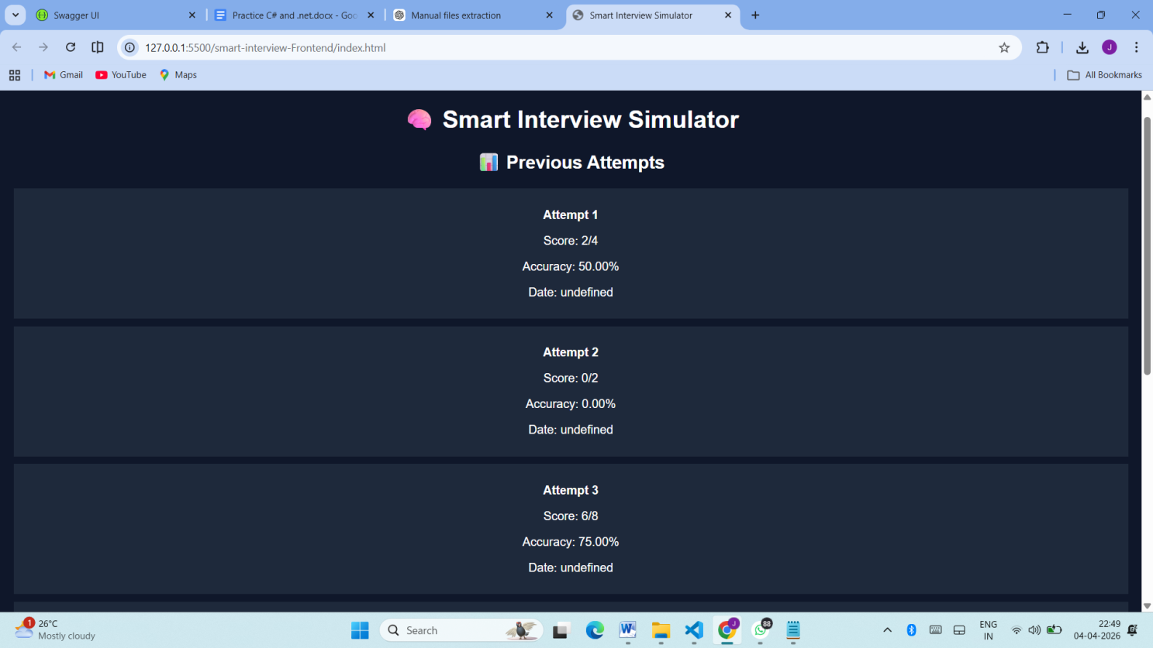

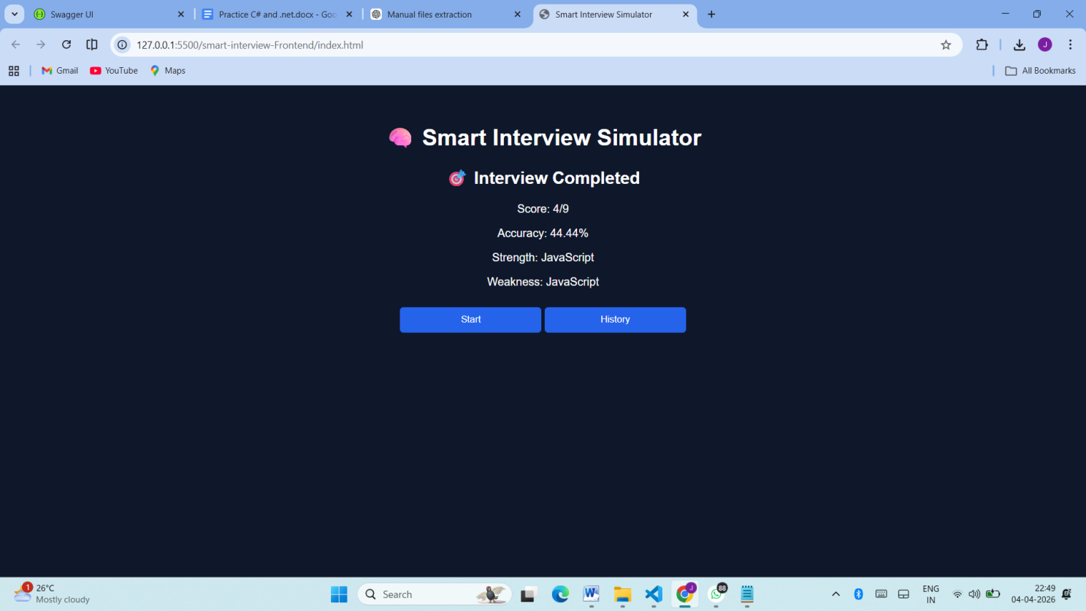
Backend Project-Outputs
