Press Release
September 13, 2013

First Presbyterian Church of Fairfield, 2475 Easton Turnpike, Fairfield
Contact: Katie Parisi
Phone: (203) 374-6176

Event Date: September 28, 2012, 4:30 – 8:30 p.m.

Annual Hoe-Down and Chili Cook-Off Announced

Fairfield, CT: First Presbyterian Church of Fairfield is pleased to announce its First Annual Hoe-Down and Chili Cook-Off, to be held Saturday, September 28, 2013. Doors open at 4:30 and features live music, dancing, dinner, and a chili competition. First Presbyterian Church is located at 2475 at the First Presbyterian Church of Fairfield, 2475 Easton Turnpike.

First Presbyterian Church member and Committee Chairman Michael James said, “Our intent is to make this a community-wide event, something people look forward to every year, where they bring along family and friends. It’s important to build community in this day and age of cultural fragmentation. Chili and barbeque pork are the perfect cool weather foods and country dancing is just good old-fashioned fun.”

This event is open to the public and offers an entertaining evening for the entire family. Festivities include: Traditional Barn Dancing (square and line dancing) with a live caller and band featuring Patricia Campbell and The Reel Thing (photo below), chili cook-off competition, barbeque pork dinner, dessert and coffee.

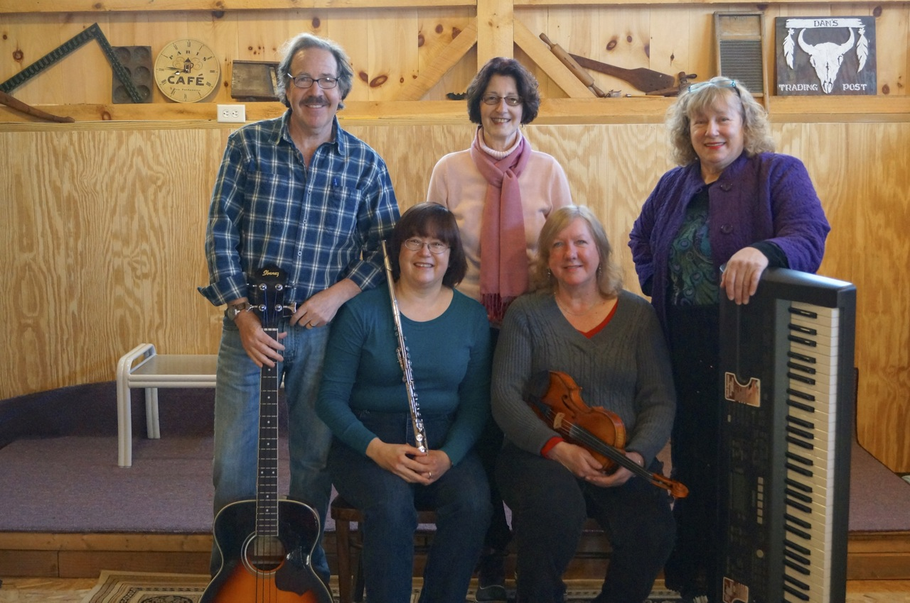
Schedule is as follows:
4:30-6:15 Chili tasting
5:30-6:15 Band & Dancing
6:15-6:45 Dinner
6:45-7:30 Band & Dancing
7:30-8:30 Dessert

There is a suggested donation of $10/person, $15/couple or $20/family.

Plenty of parking is available. For more information, contact the Church at 374-6176.

###

