Mitchell Jonker

Hunter Frady

CSCE-313-002 Embedded Systems

02/03/2023

Project 2

1.0

A system on a chip (SoC) is an integrated circuit (IC) that contains all the necessary components for a computer system, such as a processor, memory, and peripherals, on a single chip. It is used in embedded systems and other applications where space and power consumption are important considerations.

2.0

The Avalon Memory Mapped interface is a high-performance, low-latency, point-to-point connection protocol. It is used to connect the sub-components of a system-on-chip (SoC). It is used to transfer data between components, such as the processor cores, memory locations, and peripheral devices. In Project 2 we used the peripheral devices such as the LEDs and Switches, and the memory locations to run store data, and the processor unit to manipulate and work with the data.

3.0

Bare metal applications are applications that run directly on the hardware without an operating system. These kinds of applications are common in embedded systems. Bare Metal apps are written in low-level languages such as assembly code or C. Bare metal applications can control hardware directly and provide a high level of control. Performance from bare metal applications is improved due to not requiring an intermediary (operating system). In Project 2 the C hardware code is directed through the HAL and is run directly on the hardware. This is why reconfiguring the board once or twice may be required.

4.0

Screenshot below shows the hardware C code.

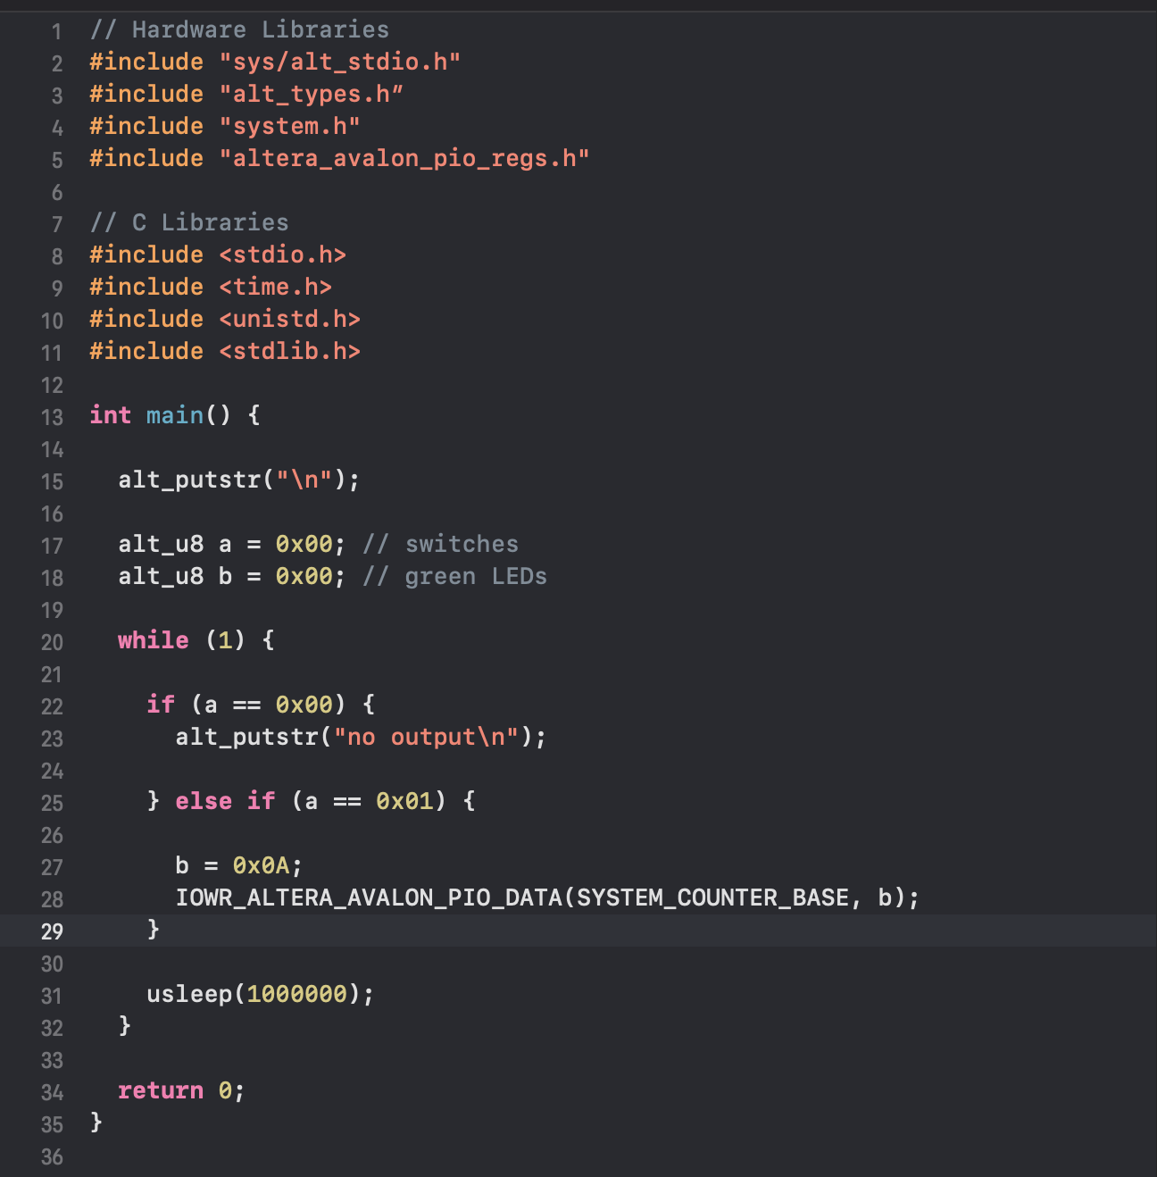

5.0

|  |  |  |  |
| --- | --- | --- | --- |
| Logical Elements | Registers | Total Pins | Memory Bits |
| 3183 | 1889 | 31 | 604672 |

6.0

Mode 1 -

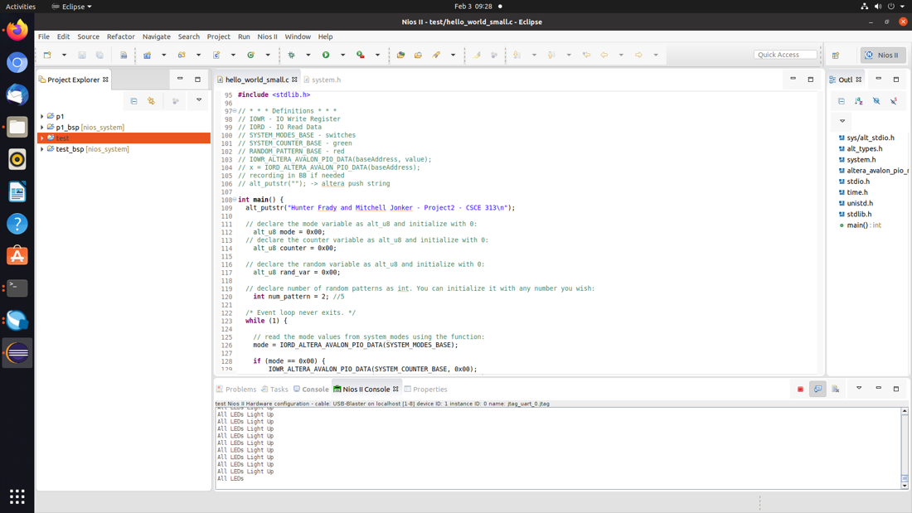

Mode 2 -

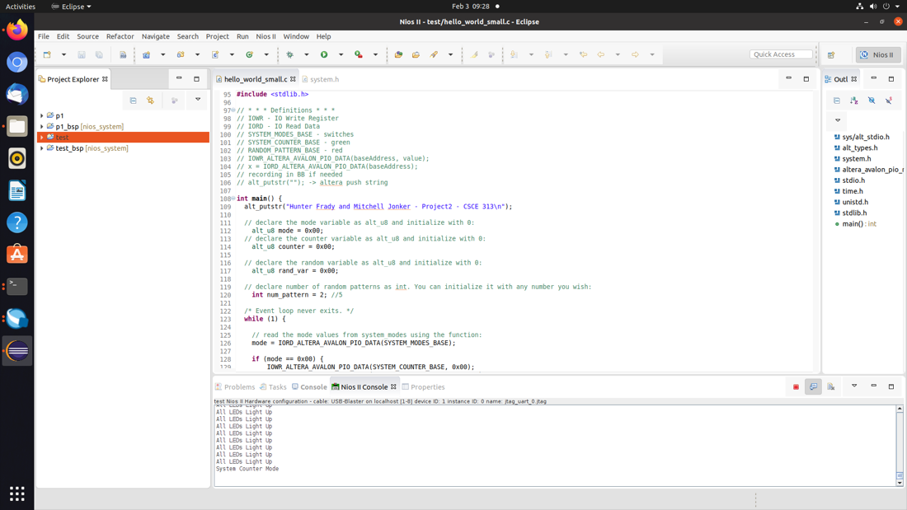

Mode 3 -

