McKesson Final Project Deep Azure

Service Fabric

# Problem statement

A Company is wanting to expand their infrastructure, and one of the initiatives is to create a scalable service fabric for their client facing web service. Create a service fabric cluster containing 1 node and deploy a web service application which will return a row from the dataset.

# Overview

Microsoft Azure Service Fabric gives the user the ability to easily package and deploy applications and services. As well, Service Fabric clusters provide high scalability and reliability for these applications and services. Service Fabric is highly customizable. For instance, you can create a cluster that has multiple VMs each being a node, or you can have a single VM with multiple nodes attached. Applications can be deployed quickly once a Service Fabric cluster is created, unlike traditional deployments where a VM needs to be created every time.

# Steps

1. Install Service Fabric SDK
2. Create Service Fabric Cluster
3. Create sample application
4. Deploy application to Service Fabric Cluster
5. Run application web service

# Data

<https://catalog.data.gov/dataset/age-adjusted-death-rates-for-the-top-10-leading-causes-of-death-united-states-2013>

# Hardware

Windows 7 64 bit on Core I5-6300HQ

# Software

* Service Fabric SDK
* Microsoft Visual Studio

# Lessons learned pros/cons

* Customizable and fast deployment can alleviate the problems of standing up VMs for every need
* In my experience, can be a bit tricky to implement properly

Github link: <https://github.com/mck-isaac/azurefinal>

Install the Service Fabric SDK from Microsoft. The SDK allows for the development of Service Fabric services and applications. <https://docs.microsoft.com/en-us/azure/service-fabric/service-fabric-get-started>

Next, create a Service Fabric cluster using Azure Portal. Click New > Compute > Service Fabric Cluster

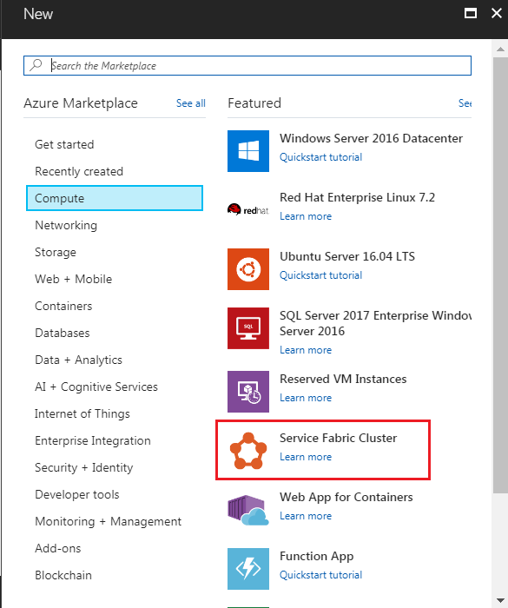

This will bring up the setup. In the Basics section, fill in the cluster information:

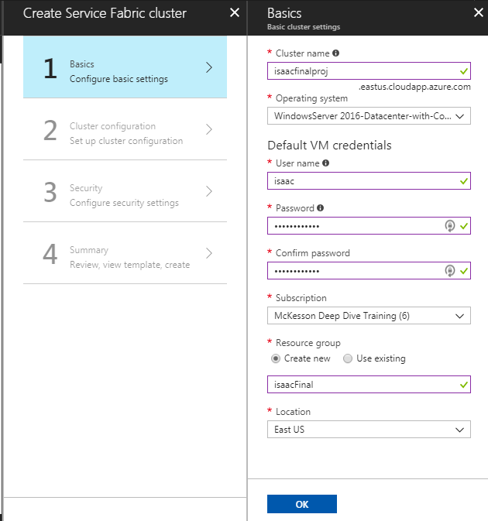

Next is the Cluster Configuration. There can be multiple different node type setups if there is a need to have different types of VMs within the cluster.

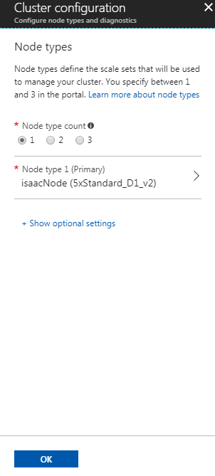

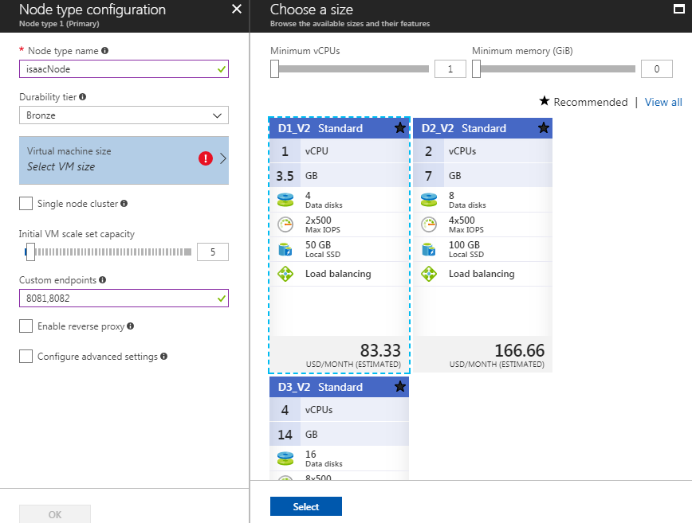

In the Security settings, a key vault needs to be used in order to generate and store the certificates that the cluster will be using:

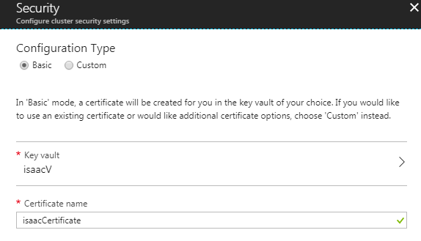

When creating the key vault, be sure the box for Enable access to Azure Virtual Machines for deployment is checked.

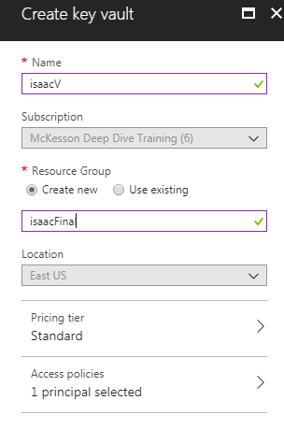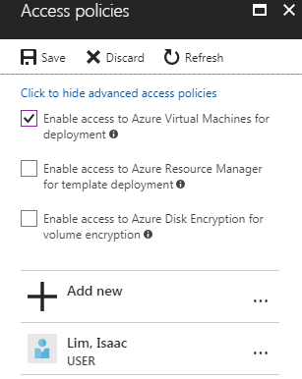

This deployment takes some time as it is creating 5 VMs to make up the cluster.

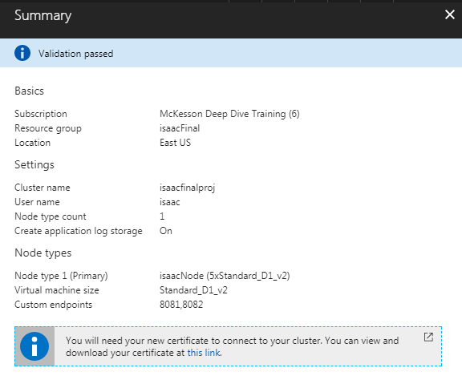

Once the cluster is deployed, the explorer can be accessed from the browser using port 19080. <https://isaacfinalproj.eastus.cloudapp.azure.com:19080/Explorer>

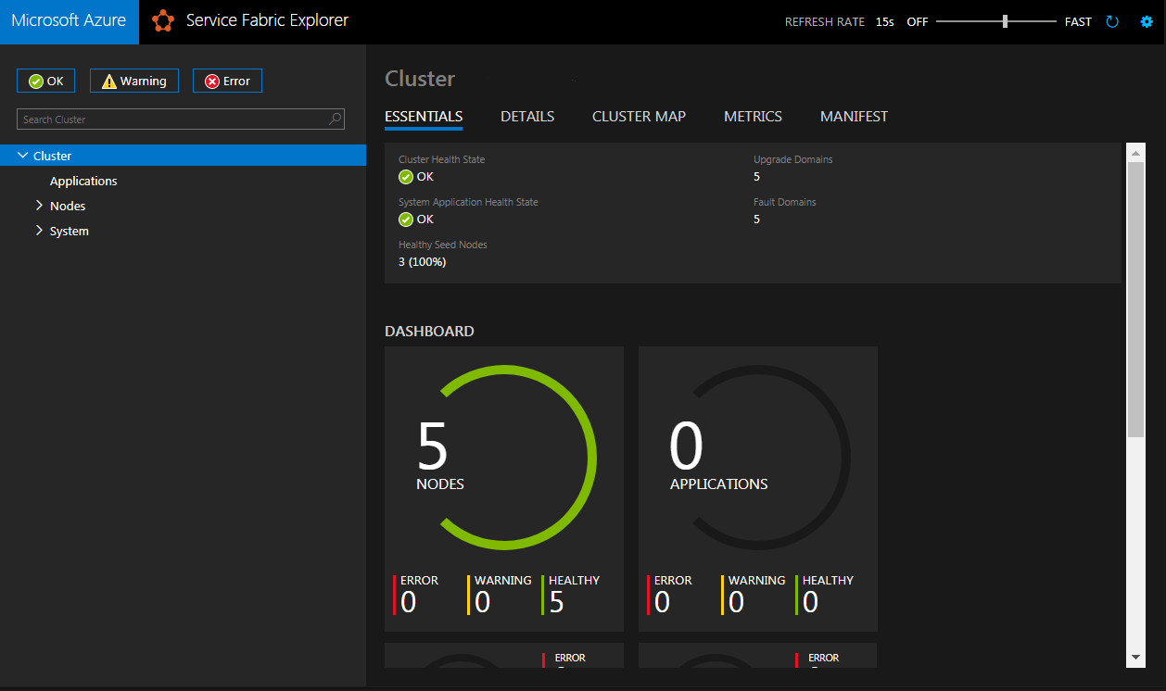

To create the application, go to Visual Studio. File > New > Project:

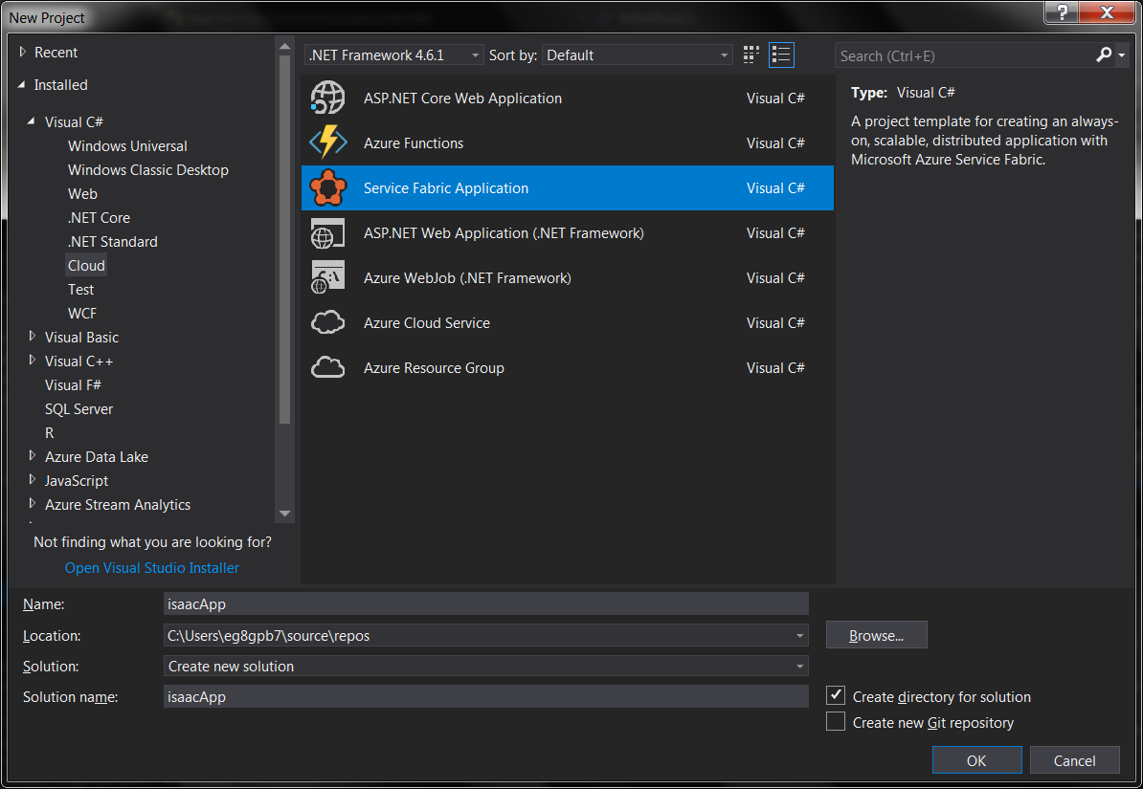

Next it will prompt to create the Service Fabric service, choose Stateless ASP.NET Core:

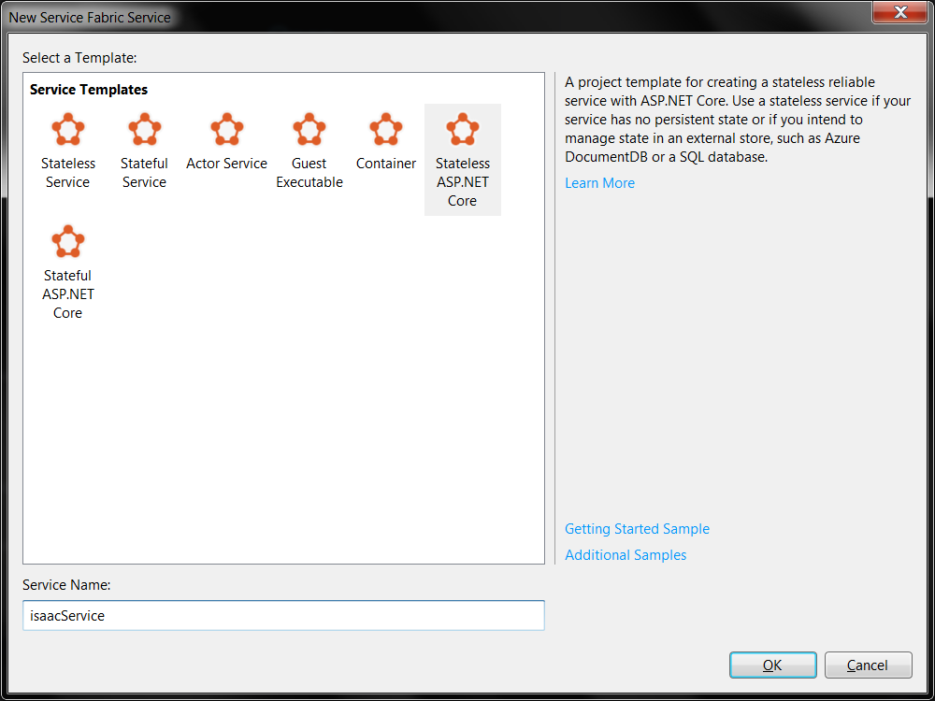

Also choose what kind of Web App, Web API:

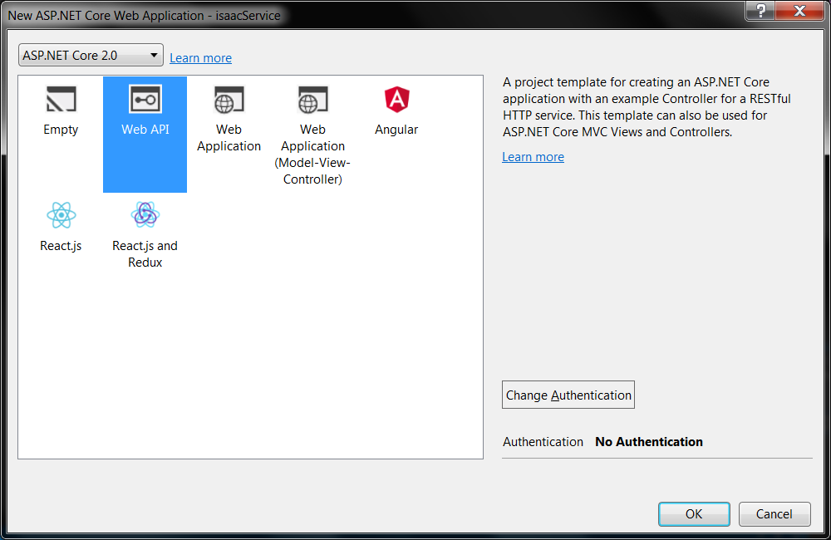

This takes some time to create the project. Create a new Controller to access the data. Expand the service application (isaacService) > right click on Controllers folder > Add > Controller. Create an MVC Controller:

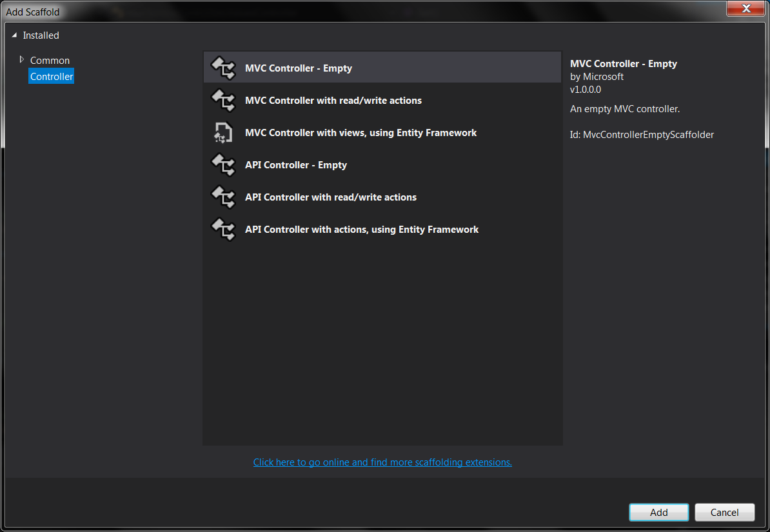

The relevant code is below that will read the dataset and return a random record as a JSON object.

|  |
| --- |
| namespace isaacService.Controllers  {  class Cause  {  public String Year { get; set; }  public String Name { get; set; }  public String State { get; set; }  public String Deaths { get; set; }  public String Age { get; set; }  }  [Route("api/[Controller]")]  public class isaacController : Controller  {  List<Cause> causes = new List<Cause>();  public IActionResult IndexIsaac()  {  var fileName = @"NCHS_-_Leading_Causes_of_Death__United_States.csv";  var file = System.IO.File.ReadLines(fileName).ToList();  int count = file.Count();  Random rnd = new Random();  int skip = rnd.Next(0, count);  string line = file.Skip(skip).First();  String[] contents = line.Split('|');  Cause cause = new Cause()  {  Year = contents[0],  Name = contents[2],  State = contents[3],  Deaths = contents[4],  Age = contents[5]  };  causes.Add(cause);  return new JsonResult(causes);  } |

Right click on the Solution and click Build Solution. When that builds successfully, right click on the app (isaacApp) and click Publish:

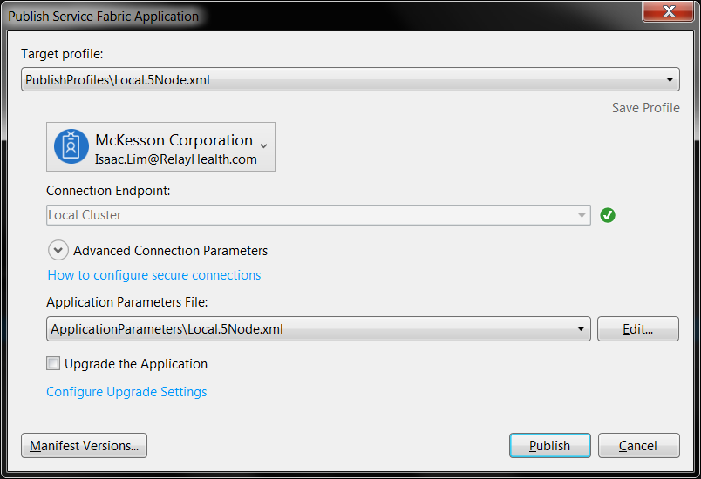

Here is a sample of the data used:

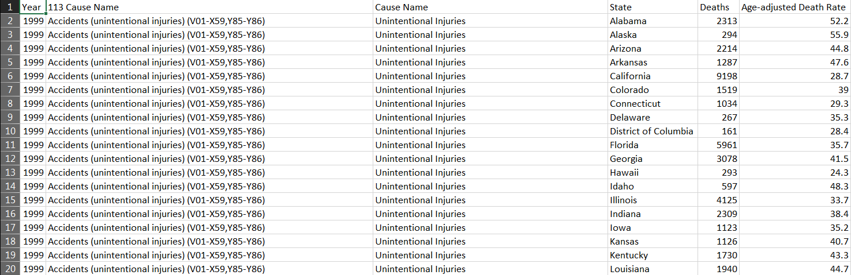

The display of on the web service would have been the contents of one of those rows picked at random.

If everything is setup correctly, the service is deployed across the 5 nodes, and the controller is now accessible. Unfortunately for my case, I was not able to get this configured 100% correctly. I had multiple issues, mainly dealing with the site certificates. I could not get it to work, and that lead the result not being able to be displayed.