Macintosh HD:Users:katierosemccarthy:Desktop:IKEA.pdf 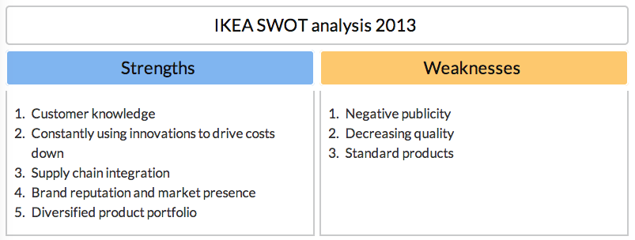

**Brand**

IKEA's vision is “To create a better everyday life for people.”

To meet its vision IKEA provides many well-designed, functional products for the home**. It prices its products low so that as many people as possible can afford to buy them**

Its products are manufactured in a responsible way.

Approximately 50% of IKEA's 9,500 products are made from wood or wood fibres. This is a good resource as long as it comes from sustainable sources. It can be **recycled** and is a **renewable** resource.

**IKEA creates many design solutions to minimize the use of materials.**

For example:

* some tables are made out of recycled plastic
* some rugs are made of material clippings that would otherwise be wasted
* products such as water cans are designed to be stacked. This means that more can be transported in each load, reducing the number of lorry journeys and therefore lowering fuel costs.

The IKEA store is built on a concept of **'you do half, we do half; together we save money'.** This refers to, for example, the customer assembling furniture at home.

**In 2006 IKEA UK recycled more than 70% of its waste products. Its goal is to recycle 90% of materials. To reduce environmental impact, in 2006 IKEA UK started to charge for carrier bags. This reduced the use of carrier bags by 95%. In June 2007 IKEA UK removed carrier bags from its stores completely.**

**Audience**

**Homeowners, Young Adults, College Students in dorms, People who live in apartments**

**Competitors**

**Argos, Ashley Furniture Home Stores, B&Q, Bob’s Discount, John Lewis, Pier 1 Import, Rooms To Go and many others.**

**Katie McCarthy**

**IKEA**

