Internet applications

Assignment Two

23W LIB2024 010

Dr. Huthaifa Abderahman

Olivia McKeen

March 10th, 2023

Table of contents Page 2

Introduction Page 3

Script blocks and Elements Page 4-5

Photographic evidence Page 6-7

Conclusion Page 7

Reference Page 8

Introduction Page 3

Assignment 2 was a lot harder than assignment 1. I felt like I had finally gotten a hold of understanding how to set up the basic code and then CSS was necessary for this assignment and I was lost again. This assignment took me weeks to figure out with lots of aid from W3schools and from classmates and even now I’m still not sure I entirely understand what I have done. The basic code was easy enough to remember and it is nice that sublime will show you things you’ve already done when you open a new bracket and they will close it with the one they think you need. Learning and applying CSS was quite a challenge but I did like that I could change aspects of the webpage to make it look prettier and more well rounded. For assignment 2 I chose to keep with the theme of the example and do a webpage about cars. I chose 8 images, one at the top for the text to wrap around one under the paragraph of text that I rounded and centered. And the other 6 were to represent small icons I could fit into a table. You’ll notice on my webpage that the text wrapping around the image is not legible, it is in fake Latin so that there would be no copyright issue.

Script blocks

<!DOCTYPE HTML> This sets this document as an HTML.

<html lang="en"> Sets language to English.

<head>

<meta charset="utf-8">

<title> Assignment 2 March 10th 2022 </title>

<style type="text/css"> This allows us to change the font of the document.

h1 { The H1 makes it so that the font will only change in the header.

font-family: helvetica;

border-style: solid; This puts a box around our header.

border-width:5px; This indicates how thick the box lines will be.

text-align: center; This centers in on the page.

}

.container { I named my div tag around my first image container so I could reshape the image and have it move to the left.

shape-outside: circle(50%);

float: left; Page 4

}

table, td { I created a table around 6 images and put a div around it in order to edit the table.

border: 1px solid; This indicates the thickness of the box.

}

.center { I named the div around my table center and this allowed me to move it over and almost center it, I didn’t quite succeed in making it perfect. But I made sure the images in the box were centered.

margin: auto;

text-align: center;

width: 40%;

padding: 10px;

}

.car { This allowed me to center my image of the WRX .

display: block;

margin-left: auto;

margin-right: auto;

}

.placeholder { This was a div I created around the WRX image in order to attempt a water mark, as you can see it did not work, sadly.

background-image: src="images/watermark2.jpg";

}

p {

font-family: helvetica;

}

</style>

</head>

<body>

<h1> Deals You Can't Beat With Subawoo </h1>

<div> The Div is a division tag it basically encloses sections of the tag so you can edit them individually.

<img class="container" src="images/cardeal.jpg" width="235" height="243" alt="car deal image">

<p> Lorem ipsum dolor sit amet, consectetur adipiscing elit, sed do eiusmod tempor incididunt ut labore et dolore magna aliqua. Turpis tincidunt id aliquet risus feugiat in. Erat nam at lectus urna duis convallis. Vulputate ut pharetra sit amet aliquam id. </p>

Page 5

<p> pn fermentum leo vel orci porta. Lectus quam id leo in vitae turpis massa. Ipsum consequat nisl vel pretium lectus. Sed faucibus turpis in eu. Mattis enim ut tellus elementum sagittis vitae et. Nulla malesuada pellentesque elit eget gravida cum sociis natoque penatibus. Diam maecenas sed enim ut sem viverra aliquet eget. Aliquam ultrices sagittis orci a scelerisque purus semper eget. Justo laoreet sit amet cursus sit amet.</p>

<p> Ut placerat orci nulla pellentesque dignissim enim sit amet. Facilisi nullam vehicula ipsum a arcu cursus vitae congue. Turpis in eu mi bibendum neque. Mauris ultrices eros in cursus. Dignissim diam quis enim lobortis scelerisque fermentum dui faucibus in. Vitae purus faucibus ornare suspendisse sed nisi lacus. Pulvinar neque laoreet suspendisse interdum consectetur libero id faucibus. </p>

<p> Aet purus gravida quis blandit turpis cursus. Auctor neque vitae tempus quam pellentesque nec. Facilisis magna etiam tempor orci eu. Elementum pulvinar etiam non quam lacus. In eu mi bibendum neque egestas congue quisque egestas diam. Iaculis nunc sed augue lacus viverra. Facilisis gravida neque convallis a. Ornare lectus sit amet est placerat. Mi in nulla posuere sollicitudin. </p>

</div>

<div class="placeholder">

<img class="car" style="border-radius: 50% ;" src="images/wrx.jpg" width="512" height="278" alt="image of a WRX">

</div>

<div class="center">

<table>

<tr>

<td> <img src="images/caricon.png" width="52" height="52" alt="image of a car"> </td>

<td> <img src="images/emailicon.png" width="44" height="46" alt="image of email icon"> </td>

<td> <img src="images/iconman.png" width="52" height="52" alt="Icon of a man"> </td>

</tr>

<tr>

<td> <img src="images/iconthing.png" width="52" height="52" alt="Icon of a location pin"> </td>

<td> <img src="images/phoneicon.jpg" width="63" height="54" alt="phone icon"> </td>

<td> <img src="images/rocketicon.png" width="53" height="53" alt="rocket picture"> </td>

</tr>

</table>

</div>

</body>

<h2>Copyright Olivia McKeen </h2>

Photographic evidence Page 6

Page 7

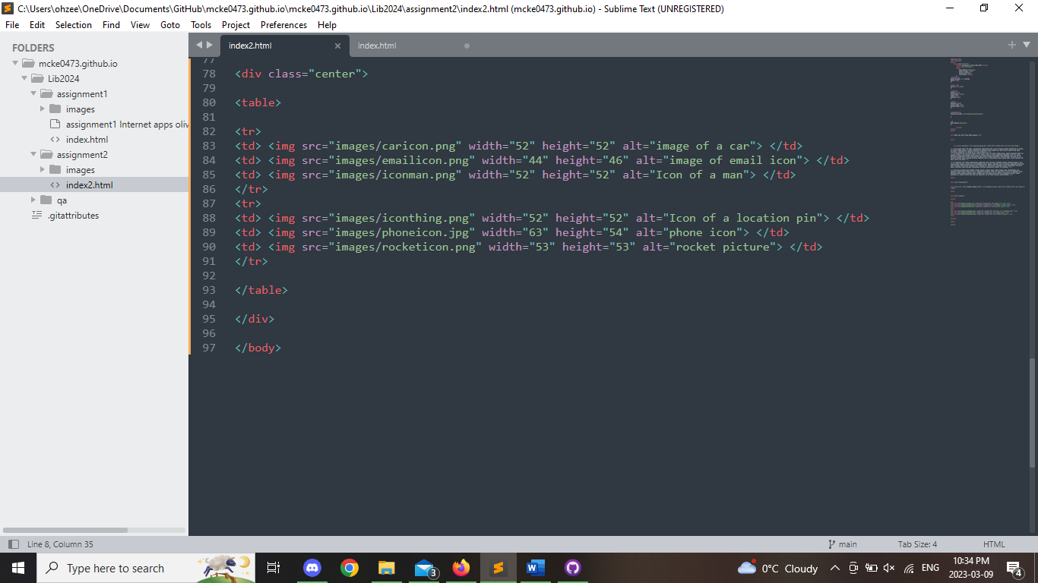

Conclusion

In conclusion this assignment was a lot harder than the first but just as I had anticipated. Learning what a div was and applying them around certain blocks of my script it allowed for controlled styling which was very exciting once I had worked it out. Applying the style of text was my favourite part, watching it go from the default to a new one made me realize that I could do the rest. Applying styles to the images was satisfying, rounded images are a lot nicer than blocky ones. The table was my least favorite part to create solely because I could not get it to center on my page.

References Page 8

Anderson, Brad. “These Two Subaru Impreza WRX STI Type RS Are Proper Road-Going Rally Cars.” *Carscoops*, 31 Dec. 2021, https://www.carscoops.com/2021/12/these-two-subaru-impreza-wrx-sti-type-rs-are-proper-road-going-rally-cars/.

“Car Deal Logo Design Template Element with Car and Handshake Illustration Stock Vector.” *Adobe Stock*, https://stock.adobe.com/ca/images/car-deal-logo-design-template-element-with-car-and-handshake-illustration/256947972.

“Download Free Vectors, Clipart Graphics, Vector Art & Design Templates.” *Vecteezy*, https://www.vecteezy.com/free-vector/static.

*HTML Tutorial*, https://www.w3schools.com/html/.

“Lorem Ipsum Generator.” *Lorem Ipsum*, https://loremipsum.io/generator/?n=5&t=p.

“Phone Icon.” *Phone Icon*, https://louisville.edu/enrollmentmanagement/images/phone-icon/image_view_fullscreen.

“Profile Free Icons Designed by Freepik.” *Flaticon*, 19 June 2020, https://www.flaticon.com/free-icon/profile_3135715.

UXWing. “Email Symbol Icon PNG and SVG Vector Free Download.” *UXWing*, 11 Mar. 2021, https://uxwing.com/email-symbol-icon/.