Internet applications

Assignment Three

23W LIB2024 010

Dr. Huthaifa Abderahman

Olivia McKeen

March 20th, 2023

Table of contents Page 2

Introduction Page 3

Script blocks and Elements Page 4-5

Photographic evidence Page 6-7

Conclusion Page 7

Reference Page 8

Introduction Page 3

Assignment 3 was a challenge. I really enjoyed that I could make it about whatever I wanted, I chose to make my webpage about my favourite book series *Outlander* by Diana Gabaldon. I soon realized I didn’t need to make it as in depth as I did but alas here we are. I added some CSS to make some of my images rounded and bordered, changed fonts both in style and size, as well as made a table to house some images and text. I used 2 pieces of JavaScript as it doesn’t entirely make sense to me, I made 2 buttons, one that reveals an answer and one that triggers a moving square in a box, it doesn’t quite match my webpage theme, but it is in there and I am proud of it.

Script blocks

<!DOCTYPE HTML> This sets this document as an HTML.

<html lang="en"> Sets language to English.

<head>

<meta charset="utf-8">

<title> Assignment 2 March 20th 2023 </title>

<style type="text/css"> This allows us to change colours, fonts, add boxes etc. of the document.

h1 {

font-family: helvetica; This allows the title of the page to sit centered in a purple box in a different font and size.

font-size: 30px;

border-style: solid;

border-width:3px;

text-align: center;

border-color: blueviolet; }

p {

font-family: helvetica;

font-size: 15px; }

.books I’ve named my first image to differentiate it from others in css.

{ border-radius: 50%;

border-style: double;

border-width:2px;

border-color: green; Page 4

display: block;

margin-left: auto;

margin-right: auto;

width: 50%;

} The script in this specific block allows the image to be round with a coloured border and centered on the page.

.main { I’ve named the second image main and done the same thing as above because I like the rounded look.

border-radius: 50%;

border-style: double;

border-width:4px;

border-color: green;

display: block;

width: 20%;

float: left;

padding: 15px;

shape-outside: circle(50%);

margin: auto;

}

.main2 { Main2 is for the text block that I have wrapped around the ‘main’ image.

text-align: justify;

font-size: 15px;

font-family: helvetica;

}

table, td { This is for the table border.

border: 1px solid;

}

.table { This helps allow the table to be centered and the items inside to be centered as well.

margin: auto;

text-align: center;

width: 100%;

padding: 10px;

font-family: helvetica;

font-size: 15px; Page 5

}

#box { This is the box for my animation, it is much like the example in W3schools but I have changed the sizes and colours.

width: 200px;

height: 200px;

position: relative;

background: cadetblue;

}

#animate { This is the box within the above box.

width: 25px;

height: 25px;

position: absolute;

background-color: lightpink;

}

<body>

<h1> Why Outlander is my favourite book series of all time. </h1>

<h5>Copyright Olivia McKeen </h5>

<p> Outlander by Diana Gabaldon is by far the best book series I have ever read in my entire life. It is jam packed full of history, adventure, trauma, true love and most importantly time travel. </p>

<div>

<img class="books" src="images/outlanderseries.jpg" width="379" height="212" alt="complete book series">

</div>

<img class="main" src="images/claireandjamie.jpg" width="279" height="279" alt="the main characters">

<div class="main2">

<p> Claire and Jamie are the fated lovers in this series. Claire accidentally travels through a standing stone circle in 1945 in the Scottish Highlands and ends up in 1743. She stumbles upon the Scots when running from the English army, in particular an English officer called Black Jack Randall who bares a striking resemblance to her husband back in 1945. The Scots take her in as a protection for herself and for them as they believe she could be a spy for the English being English herself. Claire struggles to fit in in the 18th century and continually gets into trouble due to her foul language, her views on men and her healing ability as it was unheard of for women to be doctors in that time. Jamie and herself form a friendship after she heals his injuries from fighting with the English. Jamie, as it turns out is also running from the English Officer Black Jack as he has a personal vendetta against him. In order to protect both Jamie and Claire from Black Jack, Jamie's uncle decides they should be married, reluctantly Claire agrees. After their marriage Claire slowly falls inlove with Jamie and Jamie reveals that he has had feelings for her since the first day they met. </p>

Page 6

<p> The two of them go through so much together in the first 3 years they are married, which include moving to france and then back to Scotland and then failing to stop the uprising and Claire having to go back to her original time in order to save their unborn child. She then raises Brianna, who is named for Jamie's father, with Frank in America due to Frank's job being there. Claire then becomes a doctor and stays with Frank until his death when Bri was 19. They then head to Scotland where Claire learns with the help of Roger that Jamie is actually alive still and she heads back through the stones to him. They then go to America and stay there. </p>

</div>

<div class="table"> This is for the css part of the table

<table> This is the table itself, I organized it so the images are on top and the text is below.

<tr>

<td><img class="baby" src="images/briannafraser.jpg" width="300" height="300" alt="brianna, jamie and claire's daughter"></td>

<td><img class="best" src="images/ianmurray.jpg" width="315" height="179" alt="jenny's son and jamie's nephew"></td>

<td><img class="worst" src="images/rogermackenzie.jpg" width="293" height="191" alt="the man that brianna marries"> </td>

</tr>

<td><p> Brianna is the daughter of Jamie and Claire Fraser. Bri was concieved in Scotland in 1745 but was born in America in 1948. </p> </td>

<td><p> Ian Murray 'Junior' is arguably one of the best characters, we first meet him as a quirky 14 year old and he grows into a very galant young man over the course of the books </p> </td>

<td><p> Roger is one of the worst characters, he isn't a bad man he is just annoying and has very few redeeming qualities. To top it off he and Brianna end up married with 2 kids. </p> </td>

</table>

</div>

<div>

<h2 id="Ian"> Who is the best character? </h2> This is the question that goes with the button.

<button type="button" onclick="myFunction()">Click for answer</button> This is the button itself, when pressed it says the answer to the above question.

<script type="text/javascript">

function myFunction() {

document.getElementById("Ian").innerHTML = "Ian Murray!";

}

</script>

</div>

<p><button onclick="myMove()">Click Me!</button></p> This button moves the ‘animation’

<div id ="box">

<div id ="animate"></div> Page 7

</div>

<script>

function myMove() {

let id = null;

const elem = document.getElementById("animate");

let pos = 0;

clearInterval(id);

id = setInterval(frame, 5);

function frame() {

if (pos == 150) {

clearInterval(id);

} else {

pos++;

elem.style.top = pos + "px";

elem.style.left = pos + "px";

}

}

}

</script>

</body>

Photographic evidence Page 8

Page 9

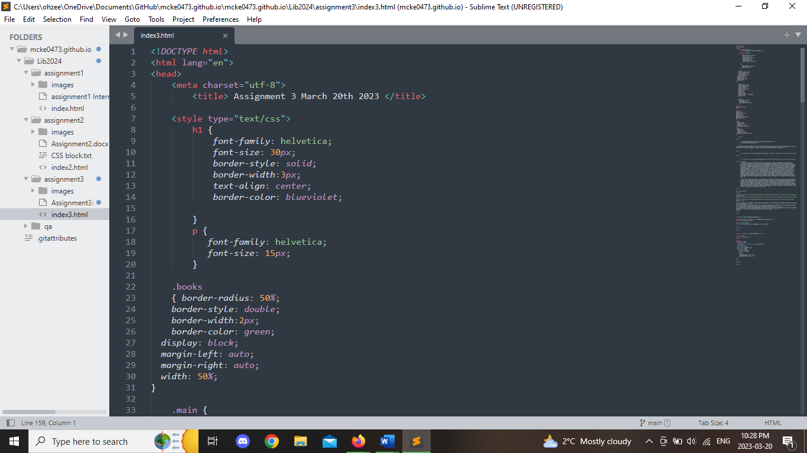

Page 10

Conclusion Page 11

In conclusion I really enjoyed the content I created for my page as it is about my favourite book series. I really got the hang of adding CSS to different elements of the webpage, I really like making tables now especially because I got it to work the first time. Changing the colours of boxes is also quite satisfying. The JavaScript really threw me off in this one, I always find that I kind of get the hang of the previous thing like CSS and then something else is added and it gets me all messed up again. It took me a very long time to get both of my buttons to work, I think for the next assignment I will focus harder on that rather than the rest of the content.

References Page 12

*HTML Tutorial*, https://www.w3schools.com/html/.

*JavaScript HTML dom animation*. JavaScript DOM Animate. (n.d.). Retrieved March 18, 2023, from https://www.w3schools.com/js/js_htmldom animate.asp