**Switch on computer (Jas told me to add this haha)**

**Log in to website here:**

[www.cometogethercollective.co.uk/admin](http://www.cometogethercollective.co.uk/admin)

**Email address:** [cometogethercollectivemcr@gmail.com](mailto:cometogethercollectivemcr@gmail.com)

**Password:** unknown - think someone else has set this - this document is editable so please add here and save :)

Or use your own account

**Please note** that when you publish a change it will take a minute or so for the site to build and show up. You will have to refresh the CMS and the web page to see your new event or blog post.

If you still don’t see the blog or event post try a hard refresh in your browser. Info on this here:

<https://www.getfilecloud.com/blog/2015/03/tech-tip-how-to-do-hard-refresh-in-browsers/#.Xs1_HmhKiM8>

If it still hasn’t worked then let me know there might have been a build error.

On our free plan we get 300 build minutes a month. Each time you publish a change it needs to build the site. Each build takes about a minute. I haven’t got close to using them yet but worth bearing in mind :)

We also get 100 form submissions for free a month on free plan.

**DEV WORK**

I’ll let you know when i’m doing any dev work. When I do I take a copy of the site and then push it back so if in that intervening time you have added anything to the site my changes might override it when I push the changes back.

**EVENTS**

There is an event in the CMS - please don’t delete this. There needs to be at least one event in or the website breaks. Don’t worry though the one in the CMS won’t show up on the site. You can add and delete other events as you wish. You’ll have to delete an event when it is passed.

To add a new event go to event down the left and click new event:

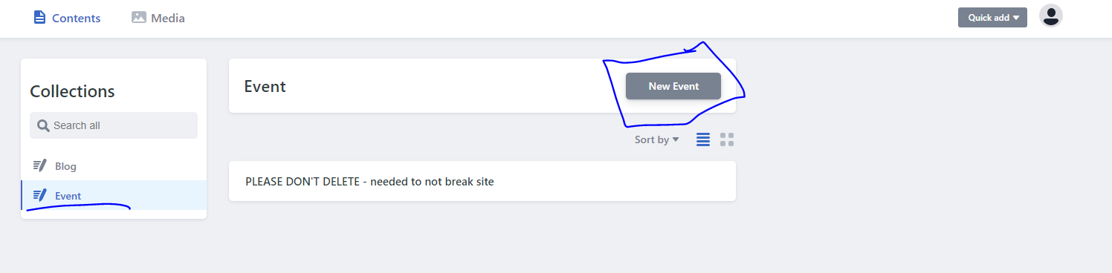

Complete fields.

The image alt tag is for search engine optimisation and accessibility (people using screen readers - it will tell them the description of the image). Please just describe the image you are using for the event. You don’t need to say “**An image of** people having fun”. Just say “People having fun”.

The link to eventbrite - just copy and paste the web address of the event page into this field.

**Images - see below**

The other fields should be pretty self-explanatory.

Click publish in top right.

Once an event has passed please remove the event. Click into the event and hit delete entry at top (or I can do some dev work to remove events where the date has passed):

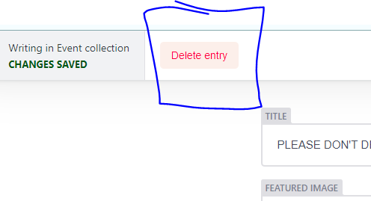

**Please note** that when you publish a change it will take a minute or so for the site to build and show up. You will have to refresh the CMS and the web page to see your new event or blog post.

If you still don’t see the blog or event post try a hard refresh in your browser. Info on this here:

<https://www.getfilecloud.com/blog/2015/03/tech-tip-how-to-do-hard-refresh-in-browsers/#.Xs1_HmhKiM8>

If it still hasn’t worked then let me know there might have been a build error.

**BLOG**

There needs to be one blog on the site or it will break. This shouldn’t be an issue as you don’t need to remove them.

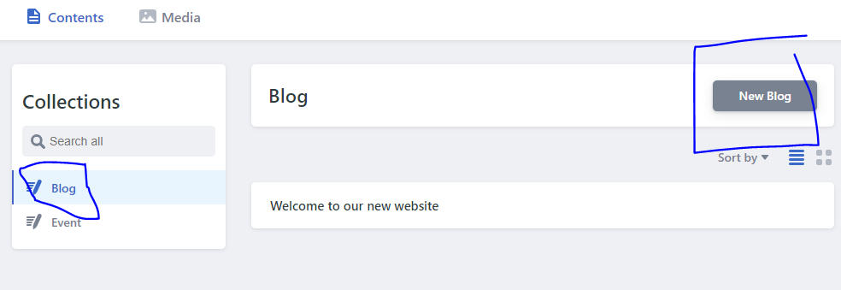

Hopefully most of fields are self-explanatory.

The image alt tag is for search engine optimisation and accessibility (people using screen readers - it will tell them the description of the image). Please just describe the image you are using for the event. You don’t need to say “**An image of** people having fun”. Just say “People having fun”.

The publish date is used to order the blogs for newest first so if you want to change the order of blogs on the site you will need to change this.

When there are ten blogs on the site only the first ten will show and a button will appear to show the next ten blogs and so on until all are shown.

The description is used here:

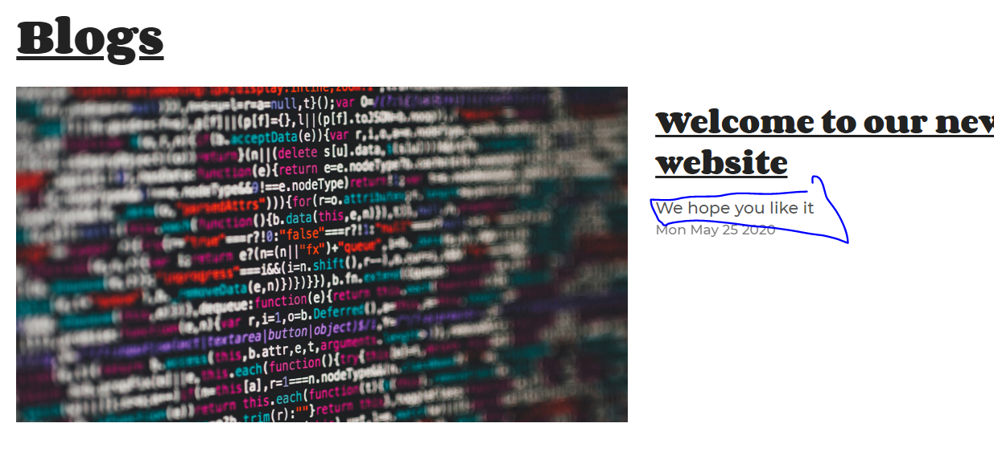

I would suggest keeping it fairly short - like a tweet length tops.

Image (see below).

For the body - you can copy and paste text into this from word or a web page but please copy your text into notepad first - then copy that text and paste it into the body. If you copy from word or a website you also potentially copy some code styling which would then override the style on our website.

If any text on the website looks a bit weird this is probably why.

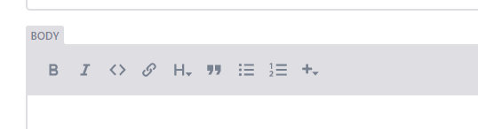]

You can format text using bold, itallic etc. The H means headings.

Heading 1 is biggest and heading 6 is smallest.

To use the bullet or number list hit enter twice to use bullets on the next line.

Using the plus you can add an image into the body text (there will already be one at top of the page).

You can also add code using the code block but this isn’t working so i’ll look into this.

I will look into adding youtube videos also.

The code button isn’t showing code for some reason. I’ll look into this also:

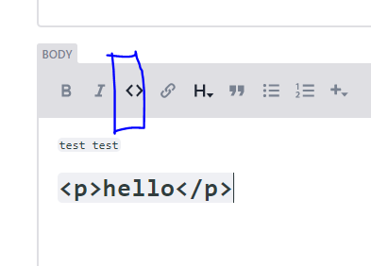

To add a hyperlink highlight the text you want to be a link and click the chain / link icon:

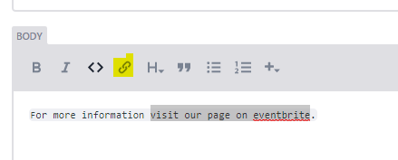

A pop up should launch.

Copy and paste the web address (including https:// at the start) into this field and click OK

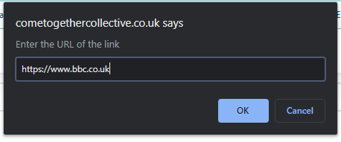

When you are linking a piece of text it is best to be descriptive with the text you are linking.

**Good** - **Visit our event brite page for further information on our next event.**

**Bad -** our next event is coming up. **Click here** for further information.

**Good** - **Find out more about our newest recruit.**

**Bad** - **Click here** to find out more about our newest recruit.

For the bad examples above the screen reader would just read out click here and the user would have no context about what clicking that link would take them to.

People with poor / no eyesight use screen readers and often skip from link to link on a page. The screen reader reads out just the link and not the text before or after it.

Click publish in top right.

**Please note** that when you publish a change it will take a minute or so for the site to build and show up. You will have to refresh the CMS and the web page to see your new event or blog post.

If you still don’t see the blog or event post try a hard refresh in your browser. Info on this here:

<https://www.getfilecloud.com/blog/2015/03/tech-tip-how-to-do-hard-refresh-in-browsers/#.Xs1_HmhKiM8>

If it still hasn’t worked then let me know there might have been a build error.

**IMAGES**

Images should be 1300 wide by 715 pixels high.

You can resize images using photoshop. If you don’t have that use this website:

<https://picresize.com/>

Upload your image and click continue to edit picture.

You can use crop tool to select the area you want to focus on or you can leave as is.

On the dropdown for size select custom and enter 100 pixels width and 715 height.

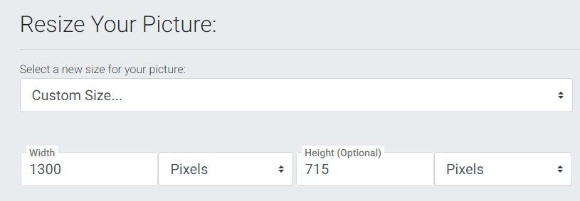

At the bottom you can choose image quality.

Web design is about getting the best looking image whilst also getting the smallest image file size for faster downloading.

For images that are real e.g. taken by a camera - use jpeg. For a graphic with block colours - e.g. something not too complex which has been designed on a computer use png or gif. If it’s a complex illustration with lots of overlapping colours etc. go with jpeg.

If using jpeg set the max filesize to 150 kilobytes.

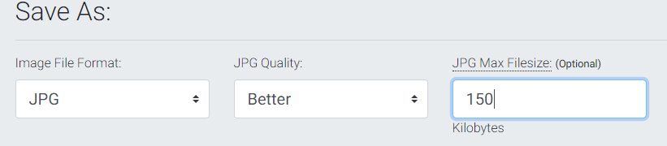

Download the image

If the image doesn’t look great try upping the filesize to 200kb.

**UPLOADING IMAGES**

You can upload images using the media folder or directly on a blog or event.

Hopefully it is pretty self-explanatory :)

If you add an image in the body of a blog it should automatically display full width.

**FORM SUBMISSIONS**

These should come through to the come together gmail account. I’ll add a recaptcha soon so that bots can’t use the form and spam us.

**ANALYTICS**

[**https://analytics.google.com/analytics/web/#/**](https://analytics.google.com/analytics/web/#/)

Have a mess around you can’t break anything. Just need to be logged into your gmail account.

**SEO - search engine optimisation**

If you are posting something like a new blog on facebook or instagram it is worth linking back to the blog post or link to the website from an event on event brite.

You can set up a site but you need to drive people towards it to help it climb google rankings. The more people who use the site and share content from it etc. the better your site is ranked.

Adding blogs etc. will show google your website is useful - as will linking to it from various sources.

I’ll add some stuff in future to allow people to comment on blog posts etc. and share content directly to facebook, twitter or instagram if you want.

Stick it on a wishlist if you want it.