- Login
To enter the Login click the Admin Home tab located on the top navigation.
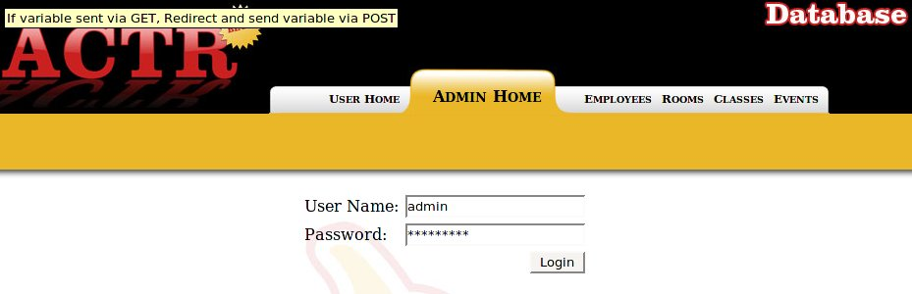
- Logging In
Enter your User Name and Password then click the Login button

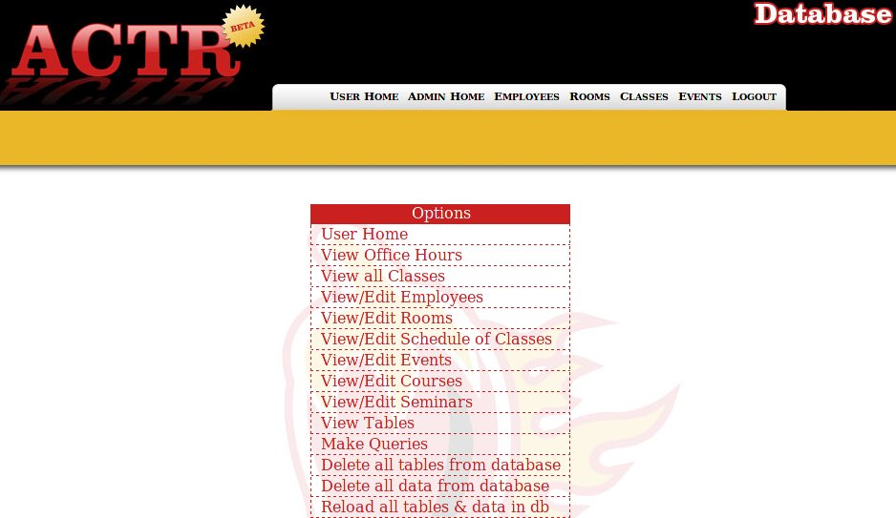

- Employee Management

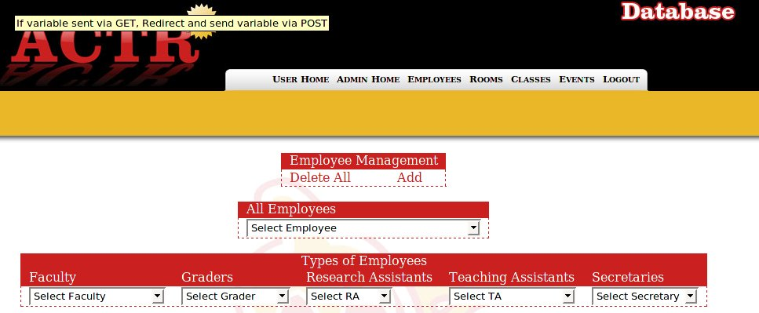
  - Edit

Select an Employee from one of the drop down boxes.

Click the Edit button located in the Employee Management Table.
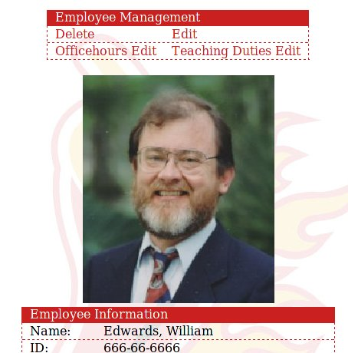

Change the desired fields of the Employee from the available listed items.
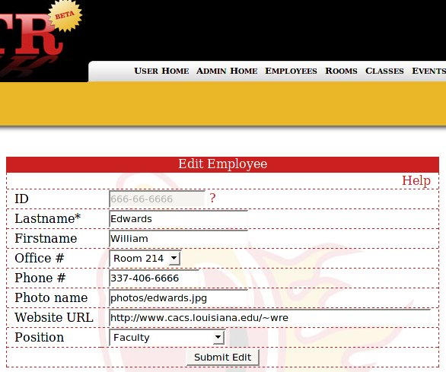

  - Delete

Click the Delete Button located in the Employee Management Table.
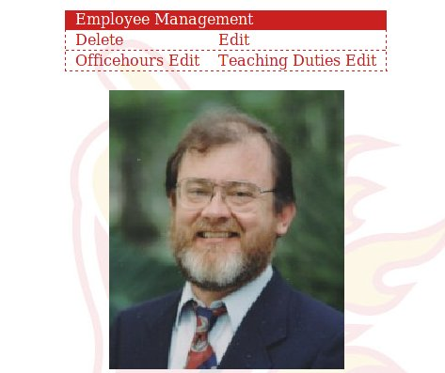

Click Confirm Deletion to delete The Employee records and all records associated with that employee.
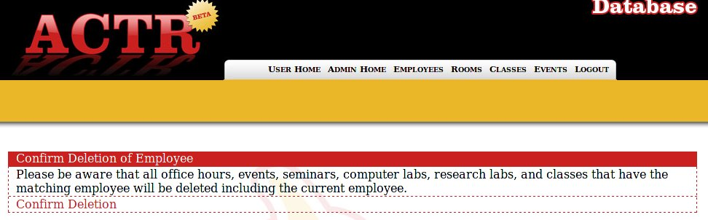
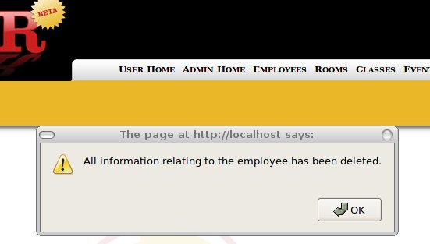

  - Editing Office Hours
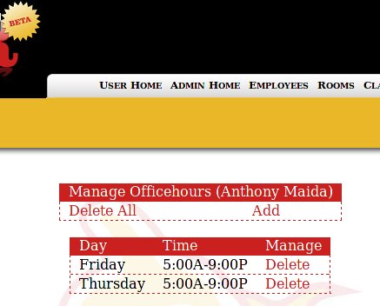

You will be given the following options for office hours.
From here you can Delete All office hours, Add office hours, or delete a listed office hour.

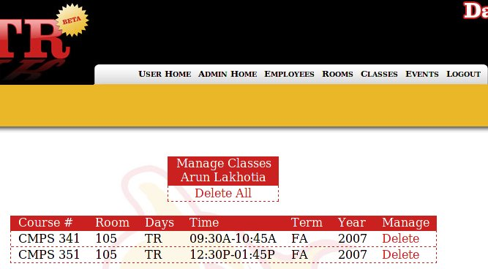
d. Edit Teaching duties

You will be given the option to delete all classes the Employee is teaching or delete a listed class the employee is teaching.

  - Add Employee

Click the Add button and fill in the required form fields. If the fields are not filled in correctly you will receive an error message and the employee will not be added.

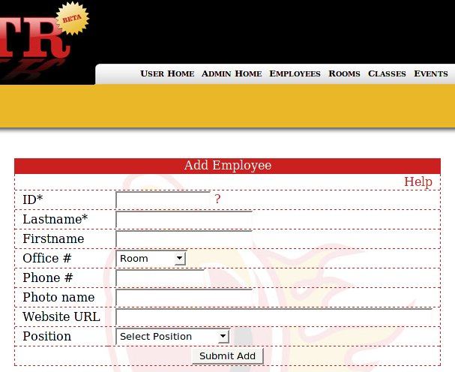

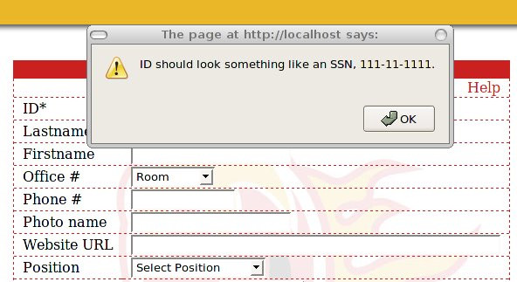

4. Room Management
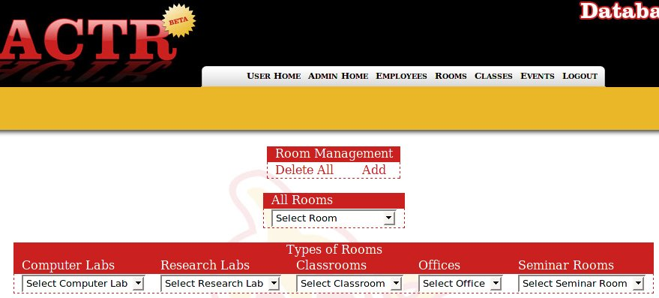
- Edit

Select an Room from one of the drop down boxes.

Click the Edit button located in the Room Management Table.

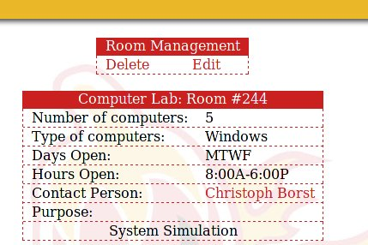

Click Edit room

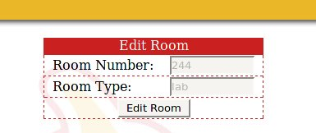

Change the desired fields of the Room from the available listed items.

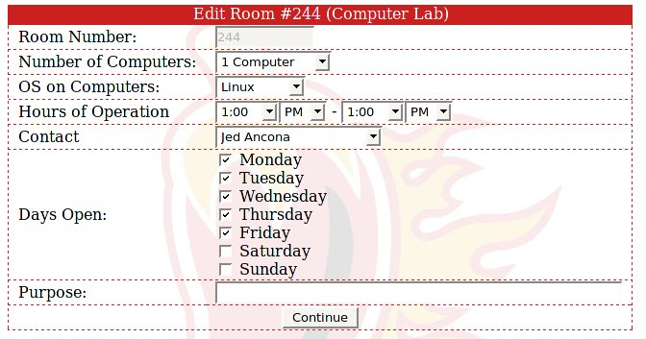

- Delete

Click the Delete Button located in the Room Management Table. Deletes all information related to that room.

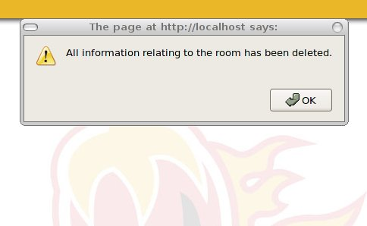

- Add Room

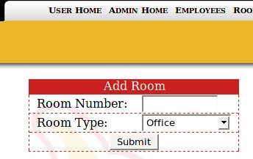

Click the Add button and fill in the required form fields. Click Submit to add room. You will then be taken to a room-specific form to fill out if it is required.

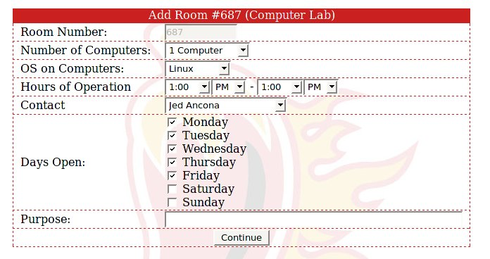

5. Class Management

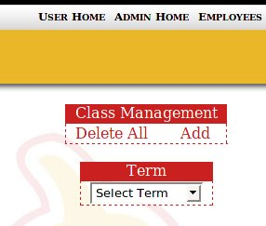

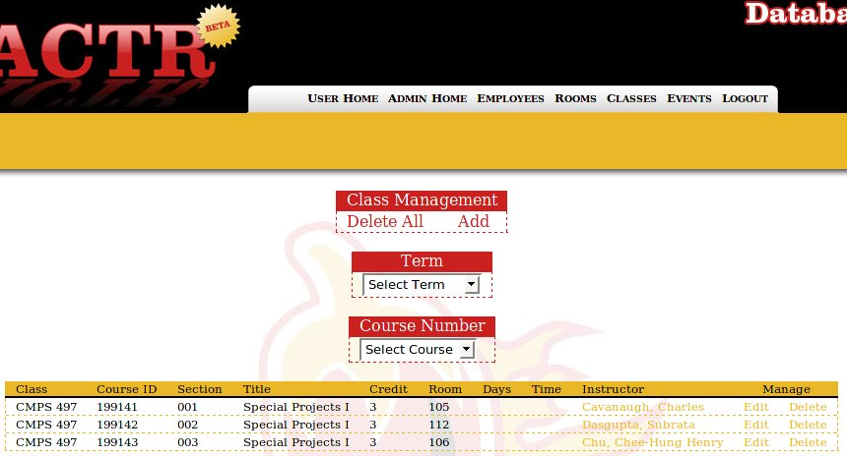

- Edit
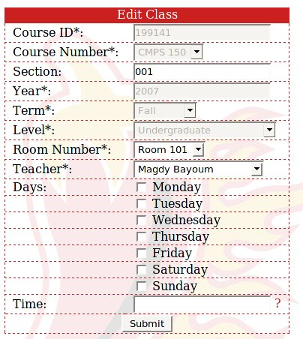

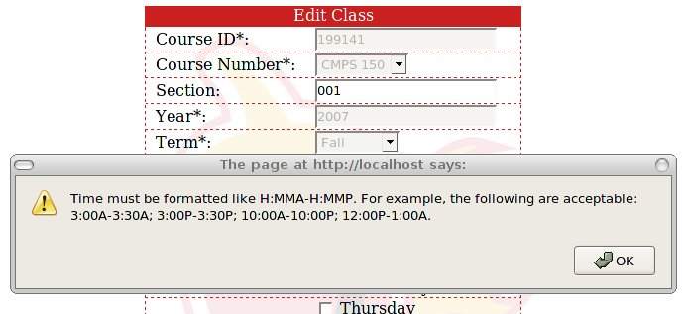

Select the term of the class that will be edited.

Then select the desired class to edit.

Next, Click the edit button next to the desired record that will be deleted.

Fill in the required fields to edit a class then click Submit. If any error occur in the required fields the record will not be added.

- Delete

Select the term of the class that will be edited.

Then select the desired class to delete. The class will then be deleted
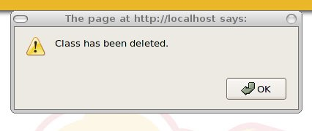

- Delete All

Click Delete all in the Class Management Table. You will then be prompted to confirm the deletion of all class. Confirm and all classes will be deleted.

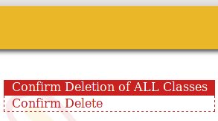

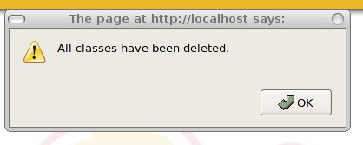

- Add

Click Add in the Class Management Table. Fill in the the required fields and the Class will be added. If the fields are not filled properly the user will be notified that the class was not added.

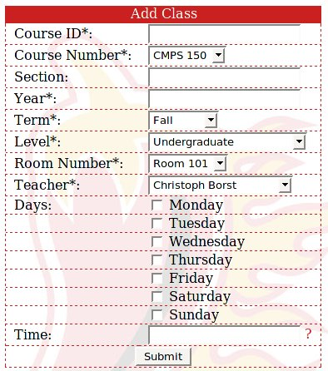

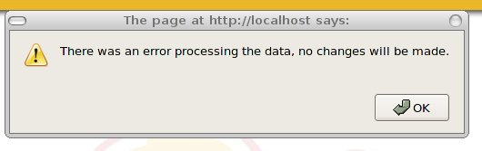

6. Events
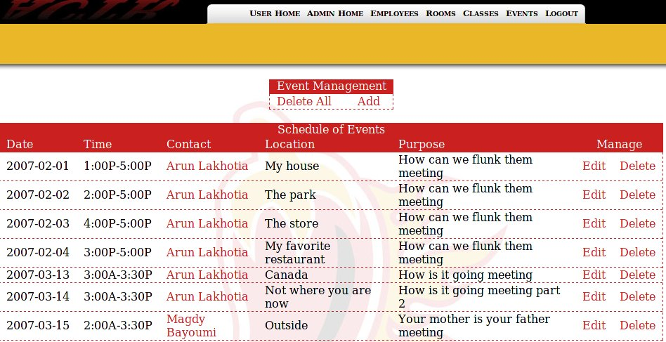
- Edit

Click the edit button next the record to be deleted.

Fill in the available fields for the event and Click Submit Edit.
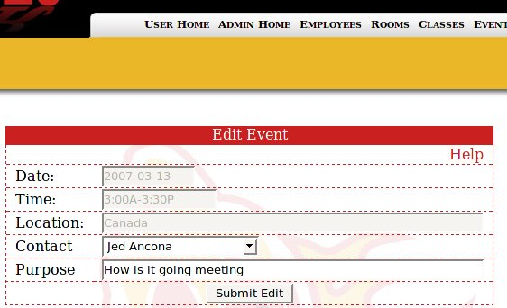

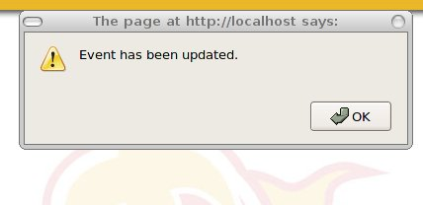

- Delete

Click the delete button next to the record to be deleted.
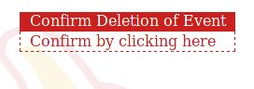

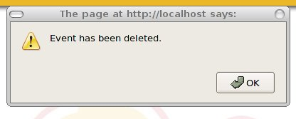

- Delete All

Click the Delete All button in the Event Management Table. You will then be prompted to confirm. Click confirm to for deletion to be final.
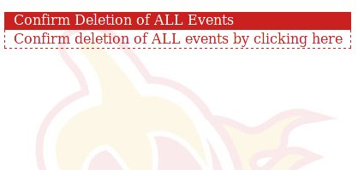

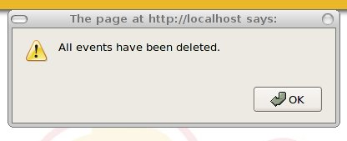

- Add

Click the Add button located in the Event Management Table. Fill in the Required field for the Event and click submit.
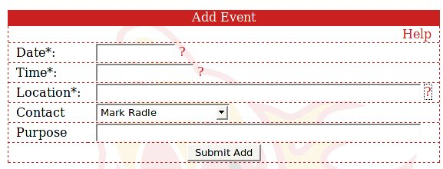

7. Admin Home/Extras
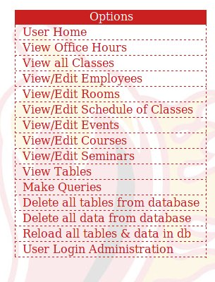

To view all office hours for all employees click the View Office Hours button.

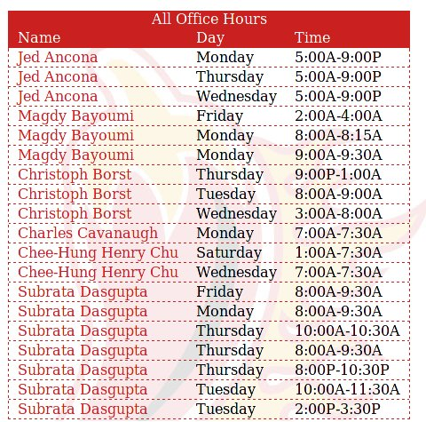

To view all Classes for all available terms click the View All Classes button.
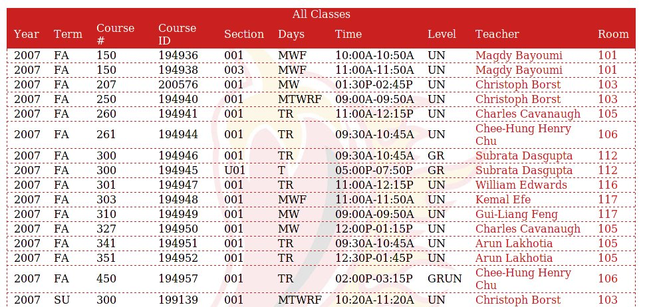
To Edit course click on the View/Edit Courses.

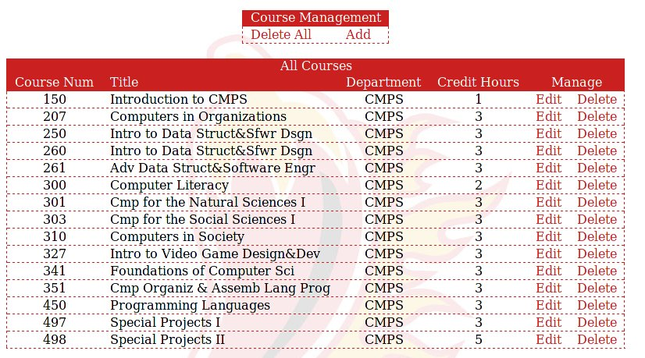
- Edit
To edit a course listing click the edit button next to the listed course
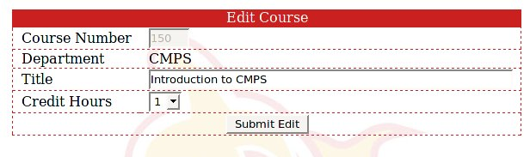

- Delete
To delete a course click delete next to the course to be delete, click confirm to fully delete.
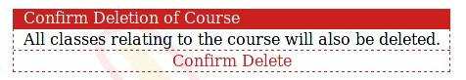

- Delete All

Click Delete All in the Course Management Table, then Confirm to fully delete.
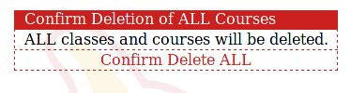

- Add

Click the Add button in the Course Management Table fill in the fields click Submit Add. To add the Course.

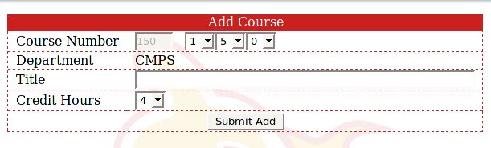
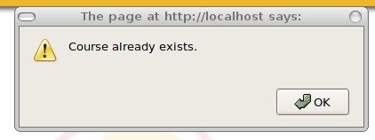

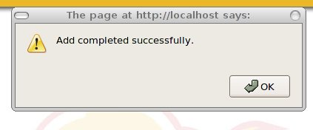

View Tables

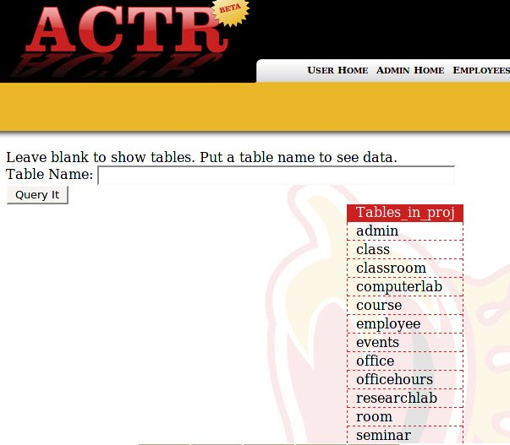

Click the view tables button. Type table name in text field to view all data in table.

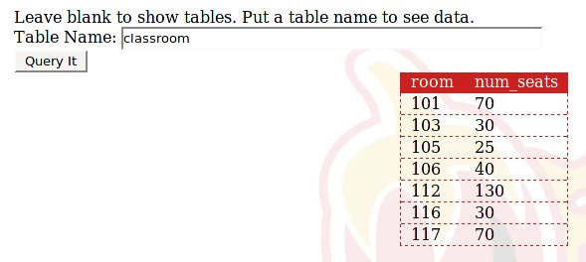

View Queries

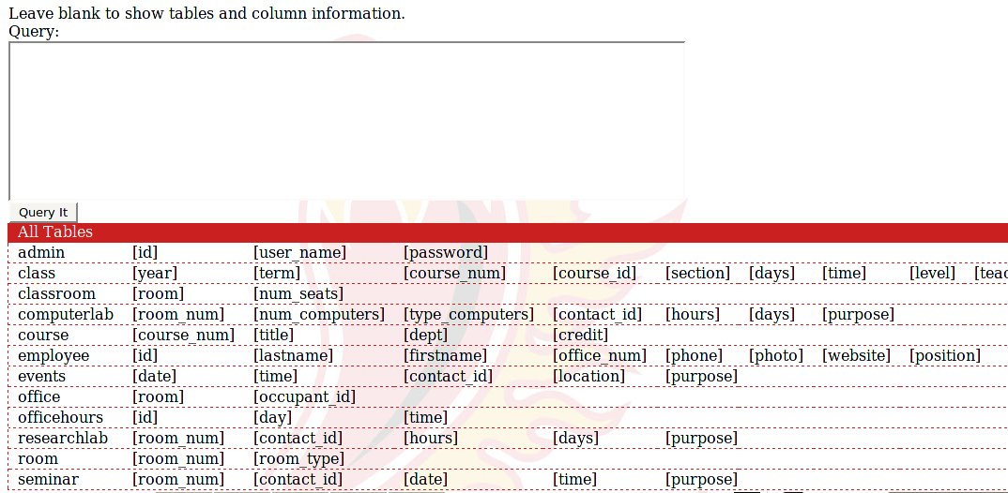
Type Query in Text Area click Query It to run Query.

User Login Administration

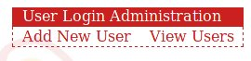

To view users click View Users.

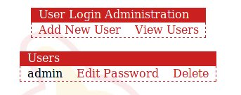

Click add to add to add an Administrator Username and Password
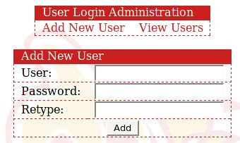

Click Delete on User Record to delete Administrator.

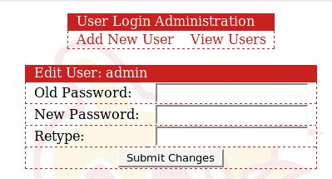
To Edit Password click Edit Password.

Reload Database.

