iBay
USER MANUAL

Last updated: April 13, 2009

Table of Contents
Welcome 3
Registration 3
Login / Logout 6
View/Edit/Delete Account 7
Viewing Own Profile 8
Viewing All Profiles 8
Viewing All Categories 8
Viewing a Category 8
Creating an Auction 8
Bidding on an Auction 10
Finalizing an Auction as Seller 10
Finalizing an Auction as Buyer 10
Administrative Features 11
Manage User Accounts 11
Manage Auction Listings 11
Manage Activities 11
Manage Bids 11

Welcome

On behalf of CMPS460 group I, welcome to iBay! Through the use of this website, you will be able to create an account for yourself and buy or sell anything that your little heart desires. If you have any trouble or questions, consult this robust user manual to for wisdom and guidance.

Registration
You must first become a registered user in order to navigate iBay. To do so, simply click on the link located in the left sidebar entitled “Register”. This will bring you to a form that you must fill out in order to become a user.

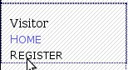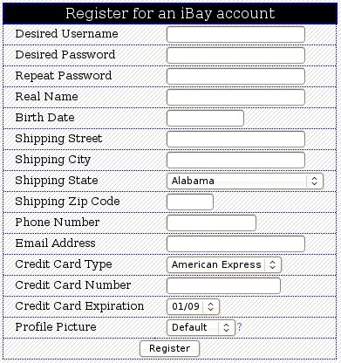

This form is fairly self-explanatory, but let's have a brief look at each field and what is expected.

Desired Username: This is where you are to enter the user name that you would like to have. If someone has already registered with a name that you choose, you will be asked to choose another name. This can be no more than 50 characters long.

Password: This is an entry that only you will know the value of, as it is your password to enter iBay. The password that you choose must be no longer than 50 characters. You will be asked to repeat your password to guarantee that you have entered it correctly

Real Name: In this field, you are asked to enter your first and last name as it appears on your driver's license, unless it happens to be longer than 100 characters, as this is the limit.

Birth Date: If you guessed that you are to enter the day of your birth in this field, than you have guessed correctly. Please use year-month-day method. Example: 1934-12-30

Shipping Street: This is where you enter the street address that you wish for your winnings to be shipped. This might look something like: 123 Main St. or 4321 Pete Rd Apt 30 The maximum length is characters.

Shipping City: This is the city in which the street address that you just entered belongs. The maximum length is 50 characters.

Shipping State: This is the state in which the city that you just entered belongs. The maximum length is 25 characters.

Shipping Zip Code: Enter the ZIP Code of the shipping street above. There is a 10 character limit.

Phone Number: Enter a phone number which can be used to reach you in case there is a need to contact you. You must do so in less than or equal to 12 characters.

Email Address: Enter your email address in this field. The max length for this entry is 50 characters

Credit Card Type: Select one of: American Express, Discover, Visa, or Master Card to reflect the reality of which card type you are going to pay with.

Credit Card Number: Enter the credit card number for the card that you are paying with. No more than 16 digits, please. Example: 1111222233334444

Credit Card Expiration: Select the month/day in which your credit card expires.

Profile Picture: You can select from a listing of pictures that you would like to use to represent you. If you choose not to pick one, the default picture will be set for you. You can click on the “?” link next to the selection box to preview all available profile pictures.

Now that you have filled in all of the fields for your account, just click the “Register” button at the bottom of the form. You will be asked if you wish to login, at which time you may do so by clicking the link for login.

Congratulations, and Welcome to iBay!



Login / Logout

***NOTE that in order to login you must have already registered as a user. See Registration
The processes of logging in and logging out are fairly straight forward.
To login, simply click the login link located in the left sidebar of the website. You will be taken to a login form.

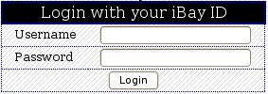

Enter your user name in the Username field and your password in the Password field. Finish by clicking the Login button at the bottom of the form. You will be sent to your user home page and are ready to navigate the site, edit your account or profile, bid on items, or create items as you wish.
In order to logout, simply click the logout link in the top, right-hand corner of the site. You will be returned to the website homepage.



Home

This is your own personal home page and the first page that you will see when logged in as a user. Here is where you can view all of your activities as well as any notifications that you have. From this page, you can navigate the site, edit your account or profile, bid on items, or create items as you wish.

View/Edit/Delete Account

If you would like to view your account information, edit any fields in your account information, or even delete your account altogether, then you need to click on the Account link. This will bring you to a similar form that was presented during registration with two major differences.

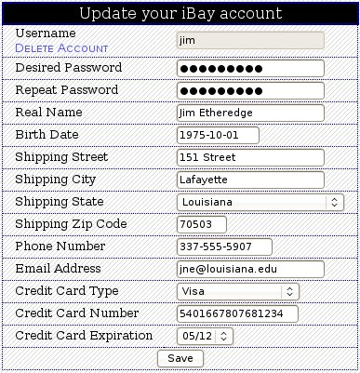

Firstly, you will notice that all of your information is shown for each field. You may change any of this information EXCEPT FOR THE USER NAME. The same rules apply for each field as in registration. When you are done, click the Save button at the bottom of the form. If all fields are correctly filled out, you will be notified of a successful update and given an option to display the new data.
Secondly, there is a link option just below the Username field title called “Delete Account”. Should you choose to delete you account, be warned that there is no undoing your action, and you will have to register again if you wish to participate in iBay.

***NOTE that you MAY NOT DELETE YOUR ACCOUNT IF YOU ARE PARTICIPATING IN AN AUCTION if you are the seller NOR if you are the the highest bidder. After deleting your account, you will only be able to view the iBay home page until you register again.

Viewing Own Profile

To view your own profile, click on the Profile link located in the left sidebar. By doing so, you will be brought to a view of your profile information. This includes your picture, description, and feedback that has been left for you by other users. There is also a log of your bid history.
Insert profile example

Viewing All Profiles

To view all user profiles, click on the Profile link located in the left sidebar. By doing so, you will be brought to a view of the profile information for all users.
Insert view all profile examples

Viewing All Categories

Insert view all categories example

Viewing a Category

There are seven categories under which an item might be listed: Art, Books, Clothing, Collectibles, Electronics, Entertainment, Jewelry, Sporting Goods, and Toys. You can navigate through each category to see the auction listings available for that category.

Insert view category example

Creating an Auction

If you would like to place item up for bid in an auction, click the Create Auction link located in the left sidebar. You will be brought to a form for creating a new auction.

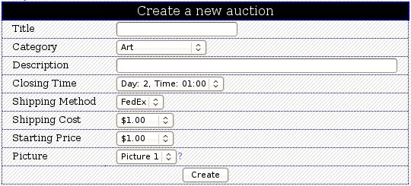

To complete a new auction form, the following fields are required:

Title: This is where the name of the auction is to be listed. Try to be descriptive but short, as the maximum length of input is 50 characters.

Category: This is a selection box from which you may choose which category the item is to be listed in. Select one from Art, Books, Clothing, Collectibles, Electronics, Entertainment, Jewelry, Sporting Goods, and Toys.

Closing Time: Select from the available options when you would like the auction to close. 10 days is the longest time that an auction can remain open.

Shipping Method: Select one of Air, FedEx, and UPS for the method by which you want to ship your item.

Shipping Cost: Select from the options in the box the cost of shipping for the auction item.

Starting Price: This is to be the starting price of the bidding for your auction. Select one from the available options in the selection box.

Picture: You can select from a listing of pictures that you would like to use to represent your auction item. If you choose not to pick one, a default picture will be set for you. You can click on the “?” link next to the selection box to preview all available item pictures for a specified category.

Now that you have filled in all of the fields for your account, just click the “Create” button at the bottom of the form. You will be asked if you wish to view the listing, which you may do by clicking on the link entitled “View” in the main page area. Otherwise, you may navigate the site as usual.

***NOTE that no two items can be created by the same seller with the same Title, Category, and Closing Time. If this happens, you will be notified and asked if you wish to try again, at which time you might consider changing either the closing time or the starting price.

Bidding on an Auction

To bid on an item, select an item from one of the seven categories. This will bring you to a detailed description of the item that you wish to bid on. To bid, select the bid amount from the selection box that you wish to bid, Then click the “Place Bid” button. After bidding, you will be shown an updated description of that item.

***NOTE that you will NOT HAVE THE OPTION TO BID if you are the seller of the item or if you are the highest bidder on that item already.

Finalizing an Auction as Seller

Congratulations! You have sold your item! There are a few things that you need to do to complete your item listing successfully. Firstly, make sure that you take care in packaging your item, as you wouldn't want to annoy your buyer. Remember, he is going to rate your performance and leave feedback for you! As a seller, it is your obligation to leave feedback for the buyer as well at the completion of an auction.

Insert sellerfeedbackforbuyerexample

Finalizing an Auction as Buyer

Congratulations! You were the highest bidder! Hope you don't have buyer's remorse! Now it is time to wrap everything up in order to receive your item and to receive positive feedback from the seller. First and foremost, the faster you pay, the happier the seller is and the faster you will get your item. The happier the seller is, the better your feedback will be. The better your feedback is, the better your success on on future iBay bids will be. Speaking of feedback, do not forget that you have to leave some for the seller as well as a rating. You have the opportunity to do so as soon as the auction is closed, but should probably wait until you receive your item.
Insert buyerfeedbackforsellerexample AND seller rating

Administrative Features

Administrators of iBay enjoy certain privileges not afforded to the typical user. In addition to everything that the regular user can do, the administrator can perform the following actions:

Manage User Accounts
TODO: view, edit, delete, login as users

Manage Auction Listings
TODO: view, edit, delete item listings with no bidders

Manage Activities
TODO: edit the description of activities

Manage Bids
TODO: edit the details of a bid

