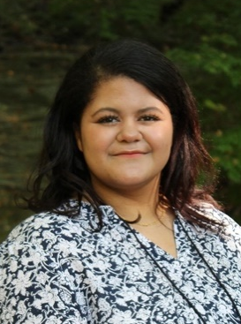

McKenna Bell

7621 Marcy RD NW
Lancaster, Ohio 43130
(740) 304-6332
GR25MBell@efcts.us

CAREER OBJECTIVE
Ambitious and flexible student who has a strong work ethic and maintains professionalism. Willing to provide assistance to those in need and establish rapport with those around while managing responsibilities.

EDUCATION

Graphic Design Certificate Anticipated May 2025

Eastland Career Center, Groveport, Ohio

Adobe Certified Associate using Photoshop CC 2023 (Visual Design) October 2023

Adobe Certified Associate using Illustrator CC 2023 (Graphic Design & Illustration) December 2023

Adobe Certified Professional in Visual Design 2023 December 2023

Adobe Certified Associate using InDesign CC 2024 (Print & Digital Media Publishing) December 2024

High School Diploma Anticipated May 2025
Bloom Carroll High School, Carroll, Ohio

TECHNICAL SKILLS
Adobe Illustrator
Adobe InDesign
Adobe Photoshop
Pin Design
Vector & Raster Graphics
Print Design
Advertising Design
Drawing & Illustration

EMPLOYMENT
The Original Frame Warehouse, Reynoldsburg, Ohio – Graphic Design Intern June – August 2024
- Designing promotional material
- Managing social media
- Greeting customers

HONORS & AWARDS

SkillsUSA – Member 2023 – Present
Eastland Career Center – Principal’s List. 2023 – Present
Fairfield County Commissioners – Certificate of Special Recognition for SkillsUSA Nationals September 2024
SkillsUSA National Promotional Bulletin Board Contest – First Place 2024

REFERENCES
Available upon request.

