Engine.h Reference Sheet
For Version Alpha 0.0.01

Dependencies:

- ncurses.h
- stdio.h
- stdlib.h

Non Static Functions:

Init
Description:
Initializes ncurses and generates colors. This function must be called for the engine to work.

Input:
NONE

Returns:
NONE

Usage:
Input();

Declaration:
void Init(void);

SetMaxYX
Description:
Allows the user to set the screen size instead of using the actual screen size.

Input: (2)
A Constant Unsigned Integer ‘y’ for the custom y axis (also known as col/height)
A Constant Unsigned Integer ‘x’ for the custom x axis (also known as row/width)

Returns:
NONE

Usage:
SetMaxYX(100, 100); //make the new screen size 100x100 chars

Declaration:
void SetMaxYX(const unsigned int y, const unsigned int x);

GenBox
Description:
Creates a box/menu in the center of the screen.

Input: (3)
A Constant Unsigned Integer ‘Width’ for the row size
A Constant Unsigned Integer ‘Height’ for the col size
A Constant Short ‘UseShadow’ determines if a shadow will be placed around the box

Returns:
NONE

Usage:
GenBox(20, 25, 0); //Creates a 20x25 box with no shadow

Declaration:
void GenBox(const unsigned int Width, const unsigned int Height, const short UseShadow);

PutTitle
Description:
Creates a title bar on top of a box with the inverse color of said box.

Input: (4)
A Constant Unsigned Integer ‘Width’ for the width of the box
A Constant Unsigned Integer ‘Height’ for the height of the box
A String ‘Msg’ to put on the center of the title bar
A Constant Unsigned Integer ‘Size’ for the ammount of chars in Msg (so they display centered)

Returns:
NONE

Usage:
/* Creates a title bar on a 20x25 box and displays “Testing” in the center */
PutTitle(20, 25, “Testing”, 7);

Declaration:
void PutTitle(const unsigned int Width, const unsigned int Height, char* Msg, const unsigned int Size);

Pause
Description:
Displays “Press any key to continue...” under the current cursor position and waits for a key press.

Input:
NONE

Returns:
NONE

Usage:
Pause();

Declaration:
void Pause(void);

DisableWarnings
EnableWarnings
Description:
Enables/Disables the engine from displaying warnings. Warnings are on by default

Input:
NONE

Returns:
NONE

Usage:
DisableWarnings(); //Turn OFF warnings
EnableWarnings(); //Turn ON warnings

Declaration:
void DisableWarnings();
void EnableWarnings();

Minimize()
Maximize()
Description:
Suspends/Resumes ncurses. Drops the user to the simple input/output terminal.

Input:
NONE

Returns:
NONE

Usage:
Minimize();
puts(“Now you see me”);
Maximize(); //now you don't

Declaration:
void Minimize();
void Maximize();

SetColor
Description:
Allows the user to set a custom default color for the menu. See the colors section for more info.

Input: (2)
A Constant Short ‘FColor’ sets the foreground color as defined in curses.h
A Constant Short ‘BColor’ sets the background color as defined in curses.h

Returns:
NONE

Usage:
SetColor(7, 1); //sets the default to white text on a red background

Declaration:
void SetColor(const unsigned short FColor, const unsigned short Bcolor);

GetTopY
GetTopX
Description:
Returns the top left corner of the box.

Input:(1) each
A Constant Unsigned Integer ‘Height’ for the height of the box
A Constant Unsigned Integer ‘Width’ for the width of the box

Returns:
An Unsigned Int of either the Y axis or X axis respectively

Usage:
unsigned int Top_y = GetTopY(20);
unsigned int Top_x = GetTopX(25);

Declaration:
unsigned int GetTopY(const unsigned int Height);
unsigned int GetTopX(const unsigned int Width);

SetWindowColor
Description:
Sets a color to use then overwrites the screen with spaces ‘ ‘, then returns to the default color.

Input:
A Constant Unsigned Short ‘FColor’ sets the foreground color as defined in curses.h
A Constant Unsigned Short ‘BColor’ sets the background color as defined in curses.h

Returns:
NONE

Usage:
SetWindowColor(2, 2); //Make the screen all green

Declaration:
void SetWindowColor(const unsigned short FColor, const unsigned short Bcolor)

Variables:
_USING_ENGINE
Description:
Tells the compiler that engine.h was already added to the program

_ENGINE_VERSION "Alpha 0.0.01"
Description:
Holds the current engine version.
_ENGINE_DEBUG 1
Description:
Toggles debugging. It makes the engine be more verbose.
ENGINE_NAME "Display Engine"
Description:
The human readable name of the engine.

static unsigned int Max_y, Max_x;
Description:
The user defined screen size. If the user does not define a screen size, this is set to the actual screen size. See SetMaxYX.
static unsigned int Real_Max_y, Real_Max_x;
Description:
Holds the actual screen size that is given from ncurses getmaxyx function.
static unsigned short UseWarn = 1;
Description:
Toggles the display of warnings from the engine. See DisableWarnings.

Colors (as defined by curses.h):
COLOR_BLACK 0
COLOR_RED 1
COLOR_GREEN 2
COLOR_YELLOW 3
COLOR_BLUE 4
COLOR_MAGENTA 5
COLOR_CYAN 6
COLOR_WHITE 7

For more information on curses or ncurses, click here.

Example Code (in C):

/* This program sets the screen color to blue
* Sets the default color to white text on a red background
* creates a box that is 10x14 with a shadow
* Adds a title in center saying “Testing”
* Moves the cursor to the top of the screen
* Pauses
* Exits
*/

/* - Start - */

#include "engine.h"
#define WIDTH 10
#define HEIGHT 14
#define TITLE "Testing"
#define USE_SHADOW 1

int main(){
Init();
SetWindowColor(COLOR_BLUE, COLOR_BLUE);
SetColor(COLOR_WHITE, COLOR_RED);
GenBox(WIDTH, HEIGHT, USE_SHADOW);
PutTitle(WIDTH, HEIGHT, TITLE, sizeof(TITLE)-1);
move(0,0);
Pause();
return 0;
}

/* - End - */
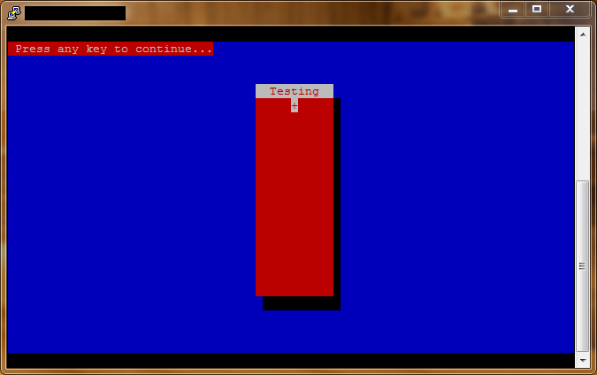
Example Code Output:

