This research looks at three major public universities in Texas and compares their football team’s win/loss ratio to the ratio of Texas applicants to total applicants between 2001 and 2018. The null hypothesis is that there is no correlation between the win/loss ratio of a Texas university and the ratio of Texas applicants to total applicants. The football season is over by the time applicants have made their decisions about which school to apply to, this research compares win/loss ratios to next year’s applicant pool. For example, the 2014 football season is compared to 2015 applicant data.

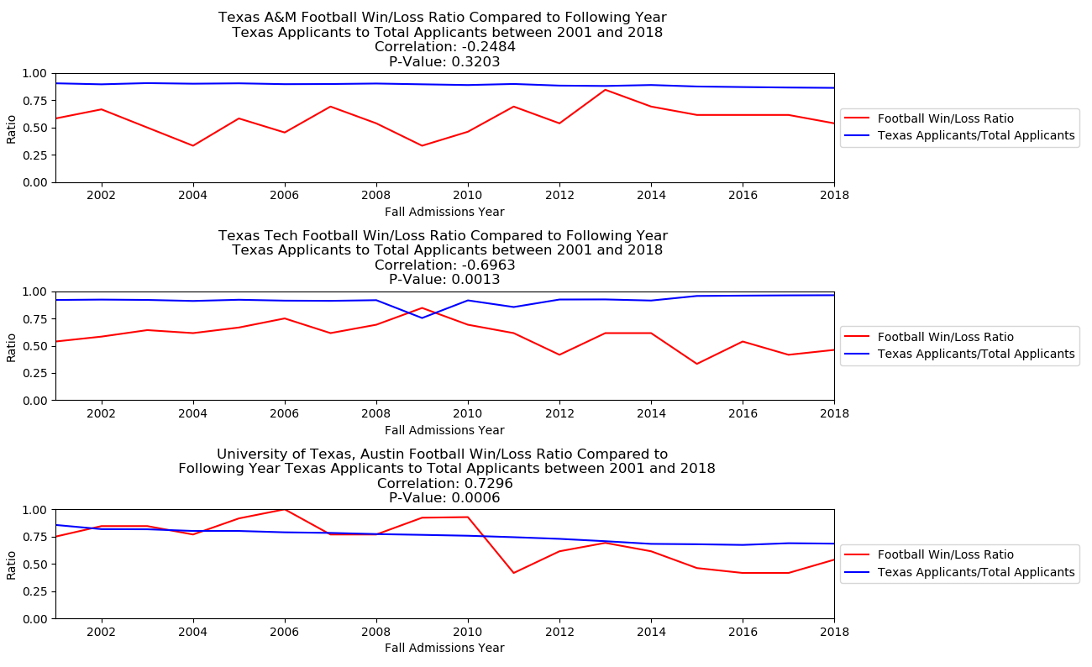

The visual above shows three subplots of win/loss ratio data and Texas applicants to total applicants. Texas Tech and the University of Texas at Austin have a p-value less than the significance level (0.05) and therefore we reject the null hypothesis. Texas Tech data shows that as the win/loss decreases there is an increase in Texas applicants, the opposite is true for the University of Texas at Austin. For Texas A&M, there is not enough evidence to reject the null hypothesis and there is a weak correlation between win/loss ratio and Texas applicants. There are many other factors that affect applicant decisions to apply and this topic needs further study. This graph does not mislead the viewer by scaling the y-axis to between 0-1. The functionally, beauty and insightfulness of this figure go together, it is simple and shows visually what the p-value and correlation coefficient tell us. Beauty is simplicity.

Sources:

UT: <https://en.wikipedia.org/wiki/List_of_Texas_Longhorns_football_seasons>

A&M: <https://en.wikipedia.org/wiki/List_of_Texas_A%26M_Aggies_football_seasons>

TT: <https://en.wikipedia.org/wiki/List_of_Texas_Tech_Red_Raiders_football_seasons>

Excel files pulled from this url for admissions data: <https://www.texaseducationinfo.org/PickList.aspx?Page=College+Admissions+&+Enrollment&ReportName=tpeir_hed_admission_instn&PickList=Report+Year&SubList=Institution&Title=Higher+Education+Admissions+-+University+First-time+Undergraduate+Applicant+and+Acceptance&Graph=N&from=Home%2fTopic%2fCollege+Admissions+and+Enrollment>