Tourism and Human Capital: Descriptive Statistics
  - Paper 3 — Jamaica Survey of Living Conditions
2026-04-22
Table of Contents
1. Sample Overview 1
2. Summary Statistics — School Outcomes 1
3. Summary Statistics — Tourism Exposure 1
4. Enrollment and Attendance Distributions 1
4a. Enrollment Rate by Year 1
4b. Days Sent to School per Month (Enrolled Children) 1
4c. Monthly Absence Rates by Reason 1
4d. Annual Kept-From-School Rates by Reason 1
5. Tourism Exposure over Time 1
5a. Mean Tourism Expenditure by Year (Across Development Areas) 1
5b. Distribution of Tourism Expenditure (Logged) 1
6. Correlation: Tourism Expenditure vs School Outcomes 1
6a. Tourism and Enrollment 1
6b. Tourism and Monthly Attendance (Days Sent, Days Absent) 1
6c. Tourism and Monthly Absence by Reason 1
6d. Tourism and Annual Kept-From-School by Reason 1
6e. Tourism and Grade Attainment 1
6f. Tourism and School Expenditure 1
7. Correlation: Bartik IV vs School Outcomes 1
8. Enrollment by Age and Year 1

1. Sample Overview
Total person-year observations | 114,786
School-age children (5–19), regression years | 18,495
of which: enrolled in school | 16,260
of which: not enrolled | 2,235
Unique development areas | 62
Years covered (regression sample) | 2006, 2009, 2010, 2012, 2013, 2014, 2017, 2018, 2019

2. Summary Statistics — School Outcomes
School-age children (5–19), regression years.
Summary Statistics: Education Outcome Variables
Variable | N | Mean | SD | Min | Median | Max
— All school-age (5-19) — | NA | NA | NA | NA | NA | NA
Enrolled in school | 18,495 | 0.879 | 0.326 | 0 | 1.000 | 1.000
Grade (harmonized, 1–6) | 15,496 | 3.276 | 1.360 | 1 | 3.000 | 6.000
Last grade completed (1–6) | 1,860 | 4.838 | 0.506 | 1 | 5.000 | 6.000
— Enrolled children only — | NA | NA | NA | NA | NA | NA
Any absence (month) | 15,492 | 0.392 | 0.488 | 0 | 0.000 | 1.000
Days sent to school (month) | 15,492 | 18.527 | 2.851 | 0 | 20.000 | 20.000
Days absent (month) | 15,492 | 1.473 | 2.851 | 0 | 0.000 | 20.000
Absent >1 week (month) | 15,492 | 0.061 | 0.239 | 0 | 0.000 | 1.000
Absent: illness (month) | 12,959 | 0.083 | 0.276 | 0 | 0.000 | 1.000
Absent: money prob. (month) | 13,592 | 0.124 | 0.329 | 0 | 0.000 | 1.000
Absent: transport (month) | 12,344 | 0.002 | 0.043 | 0 | 0.000 | 1.000
Absent: working (month) | 12,342 | 0.001 | 0.025 | 0 | 0.000 | 1.000
Kept home: illness (annual) | 13,323 | 0.356 | 0.479 | 0 | 0.000 | 1.000
Kept home: money (annual) | 13,323 | 0.252 | 0.434 | 0 | 0.000 | 1.000
Kept home: transport (annual) | 13,323 | 0.007 | 0.084 | 0 | 0.000 | 1.000
Kept home: work (annual) | 13,323 | 0.001 | 0.030 | 0 | 0.000 | 1.000
Money absence, occ/freq (ann) | 13,323 | 0.083 | 0.276 | 0 | 0.000 | 1.000
IHS tuition | 14,037 | 0.764 | 2.085 | 0 | 0.000 | 8.994
IHS transport expenses | 14,939 | 4.097 | 3.057 | 0 | 5.802 | 9.200
IHS uniform expenses | 15,309 | 4.650 | 1.412 | 0 | 4.955 | 9.296
IHS books expenses | 15,367 | 3.891 | 2.117 | 0 | 4.682 | 8.700
IHS lunch/snacks expenses | 15,418 | 6.289 | 1.662 | 0 | 6.725 | 9.722

3. Summary Statistics — Tourism Exposure
Development-area level. DA_EXP_ = tourism expenditure (millions USD, real 2024). offcl_b = Bartik shift-share instrument.
Summary Statistics: Tourism Exposure Variables (DA × Year Level)
Variable | N | Mean | SD | Min | Median | Max
Tourism expenditure, DA (M USD) | 372 | 28.372 | 87.812 | 0.000 | 0 | 807.397
Tourism expenditure, lag 1 | 366 | 26.353 | 79.667 | 0.000 | 0 | 757.102
Bartik IV (offcl_b) | 372 | 0.023 | 0.104 | -0.427 | 0 | 0.859
Bartik IV, lag 1 (offcl_b_lag1) | 366 | 0.009 | 0.068 | -0.427 | 0 | 0.638

4. Enrollment and Attendance Distributions

4a. Enrollment Rate by Year
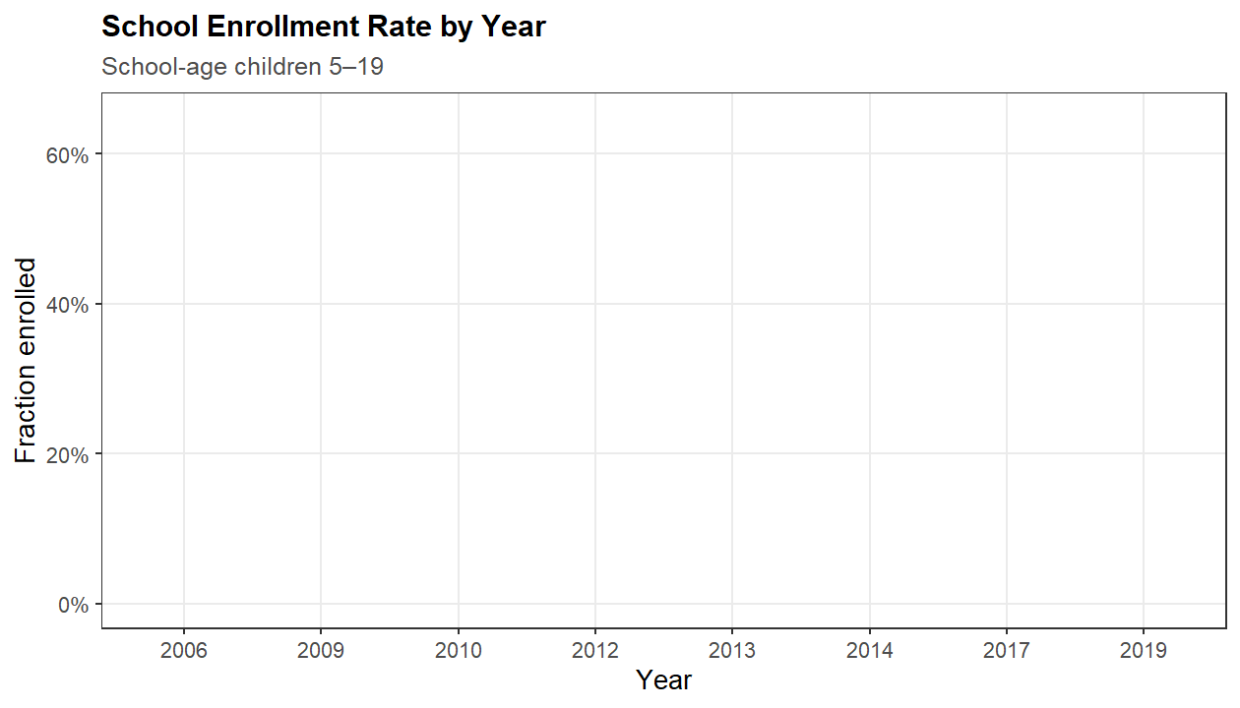

4b. Days Sent to School per Month (Enrolled Children)
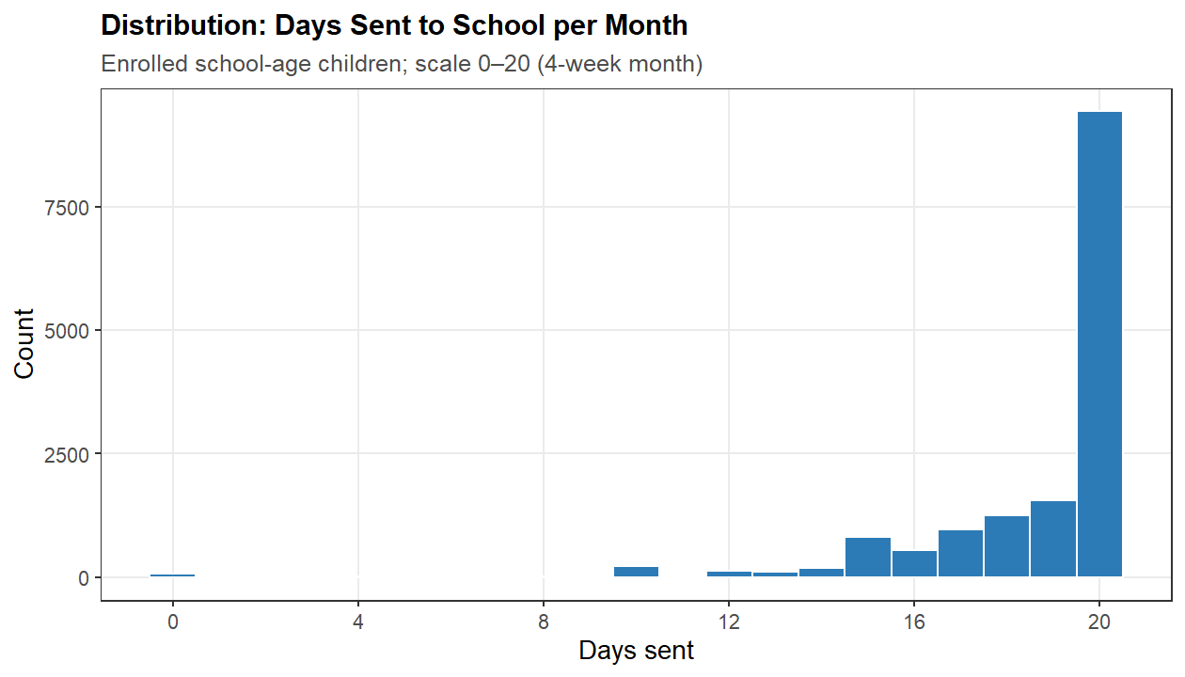

4c. Monthly Absence Rates by Reason
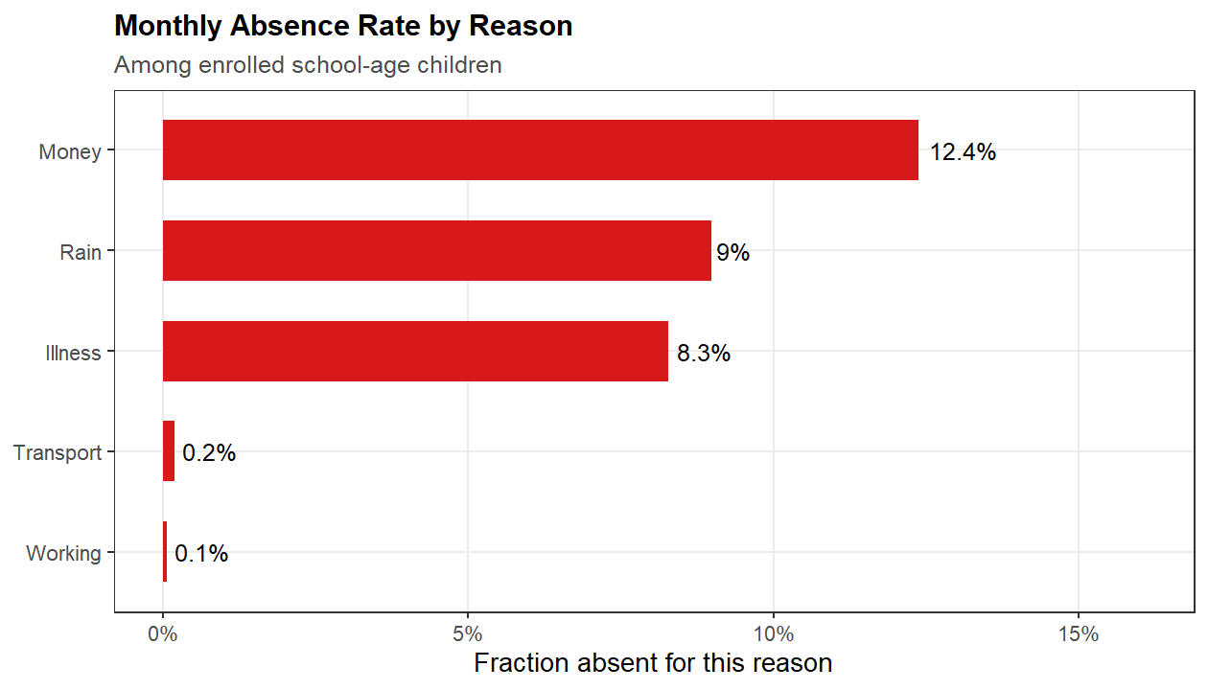

4d. Annual Kept-From-School Rates by Reason
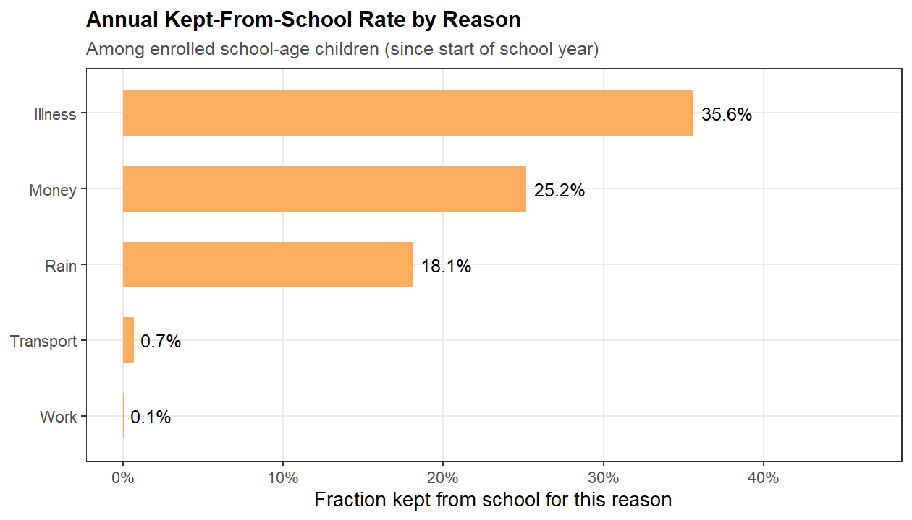

5. Tourism Exposure over Time

5a. Mean Tourism Expenditure by Year (Across Development Areas)
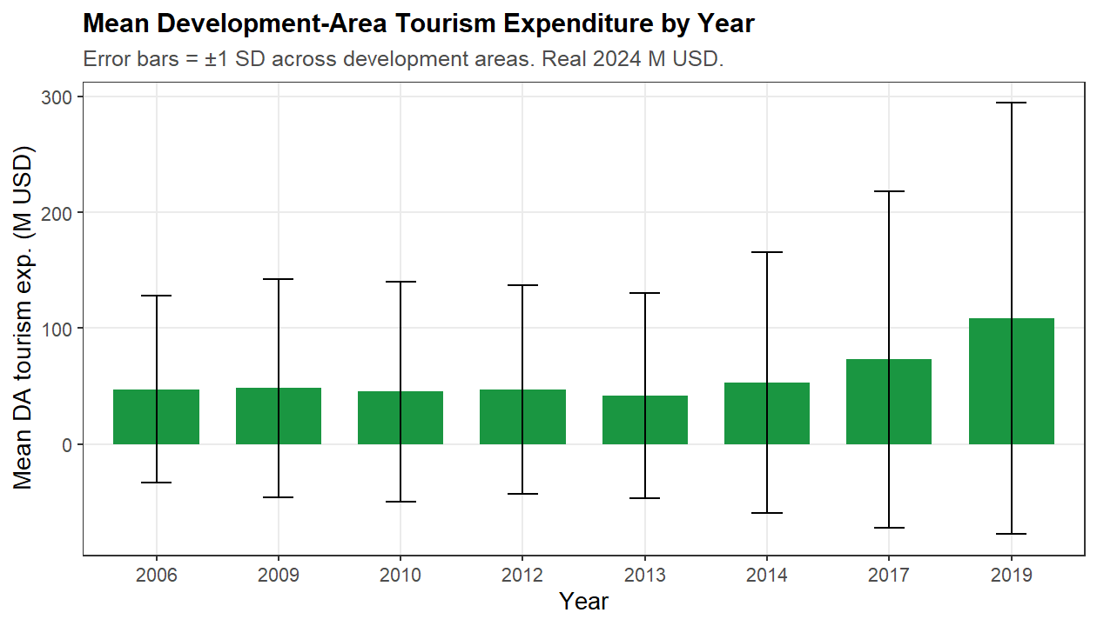

5b. Distribution of Tourism Expenditure (Logged)
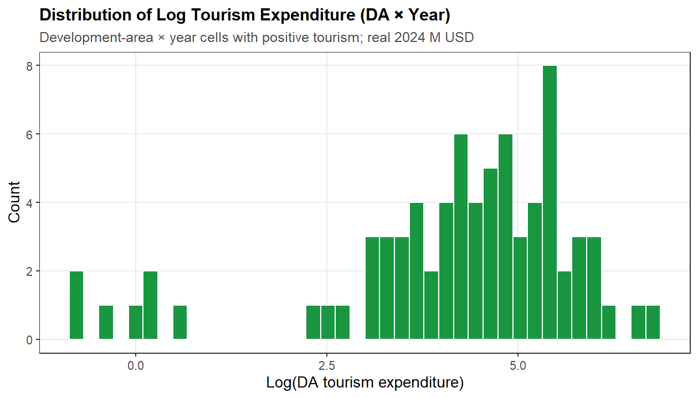

6. Correlation: Tourism Expenditure vs School Outcomes
Each point is a development-area × year cell. Outcome = mean within cell. Blue line = OLS fit. Useful for raw (uninstrumented) correlation — not causal.

6a. Tourism and Enrollment
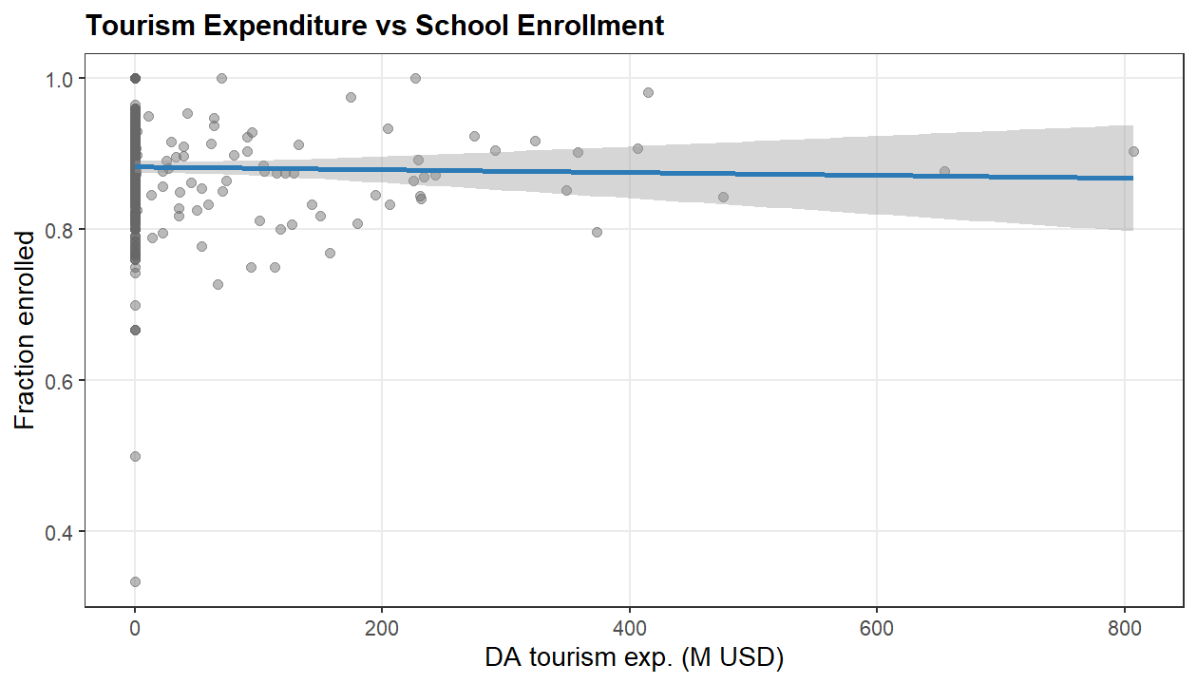

6b. Tourism and Monthly Attendance (Days Sent, Days Absent)
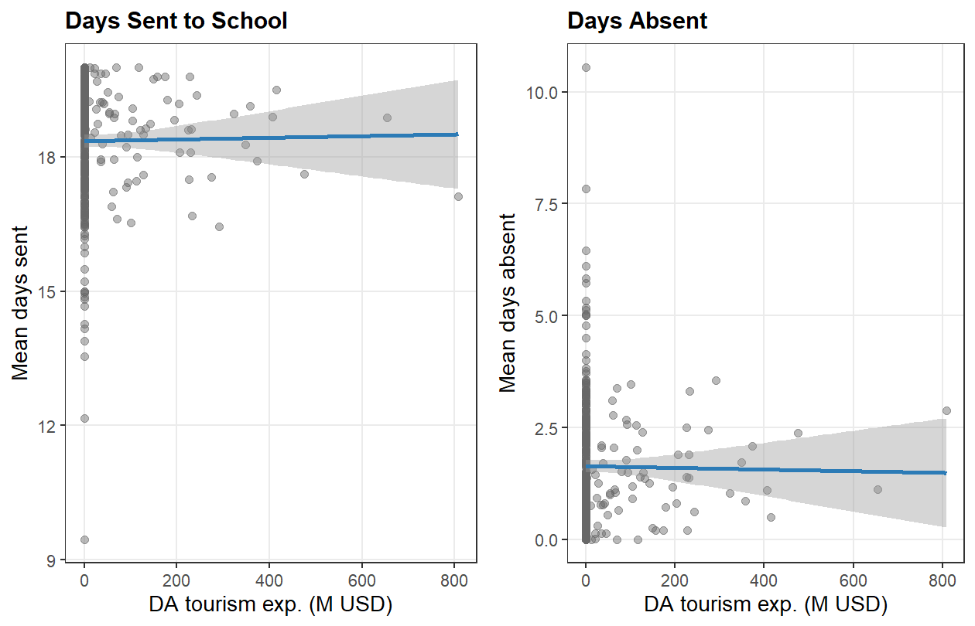

6c. Tourism and Monthly Absence by Reason
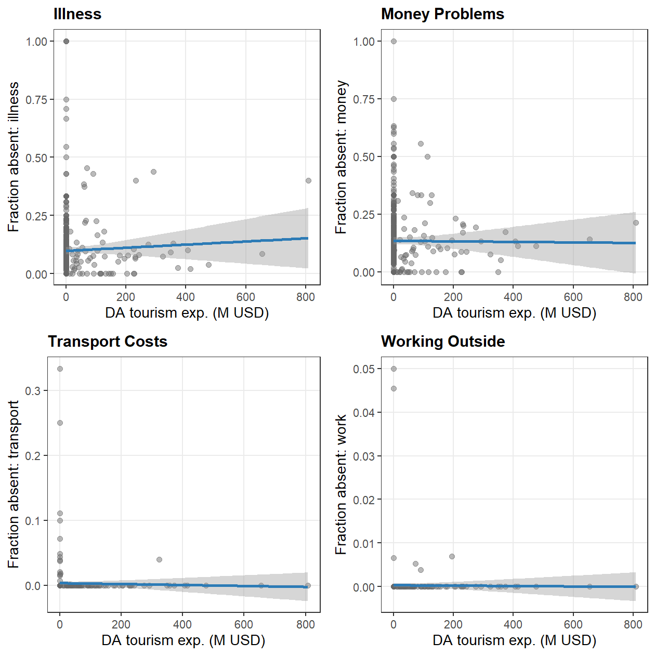

6d. Tourism and Annual Kept-From-School by Reason
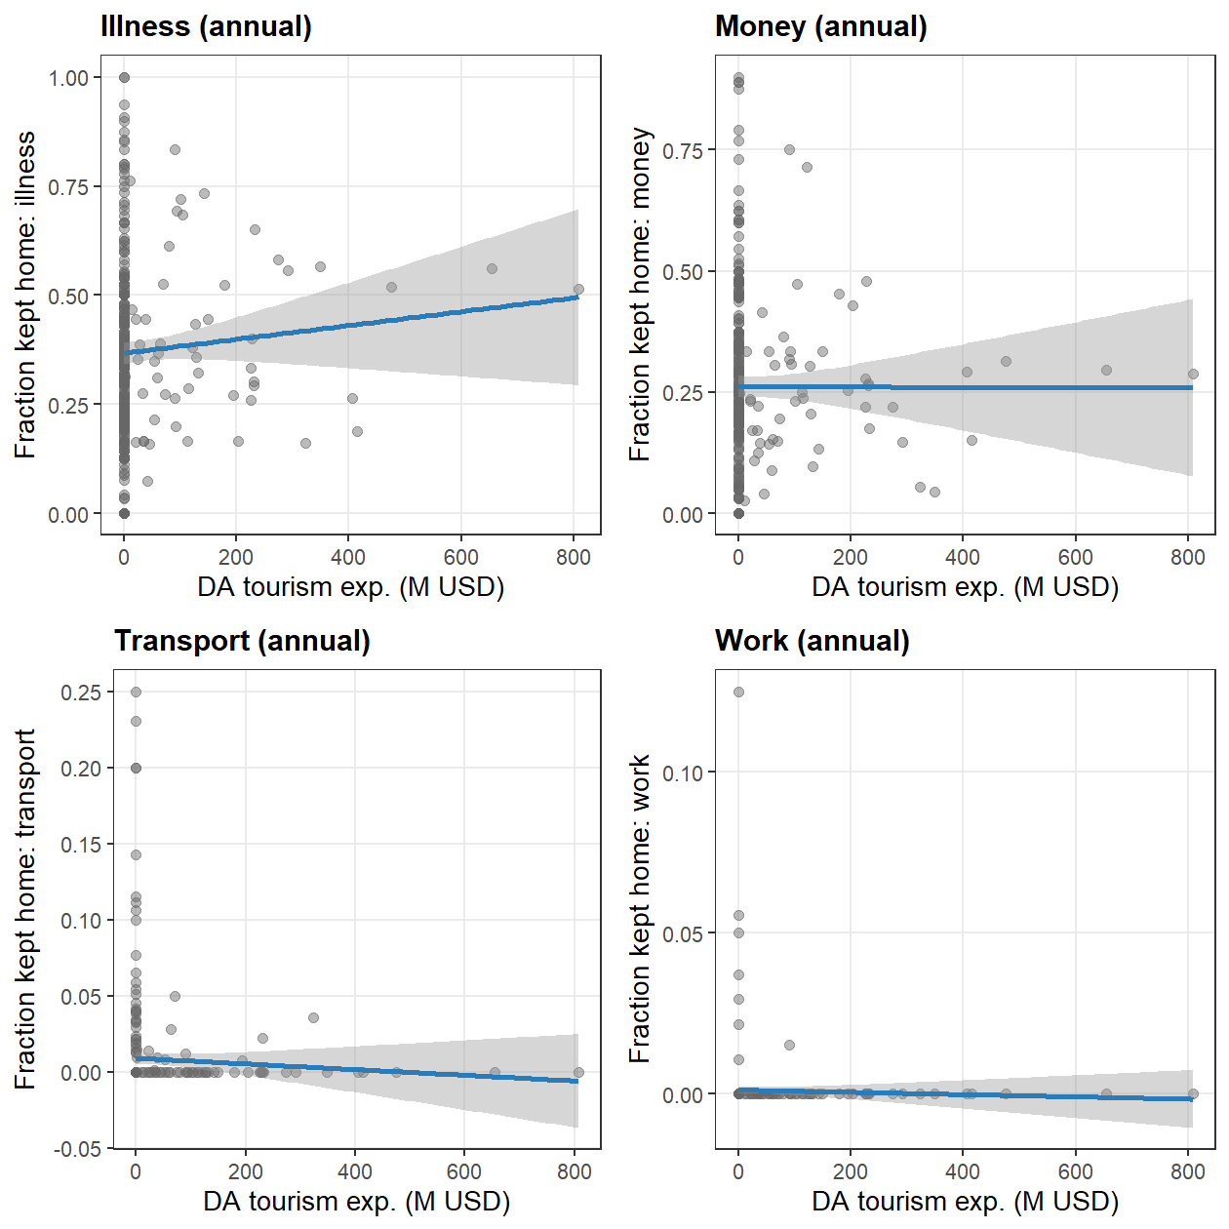

6e. Tourism and Grade Attainment
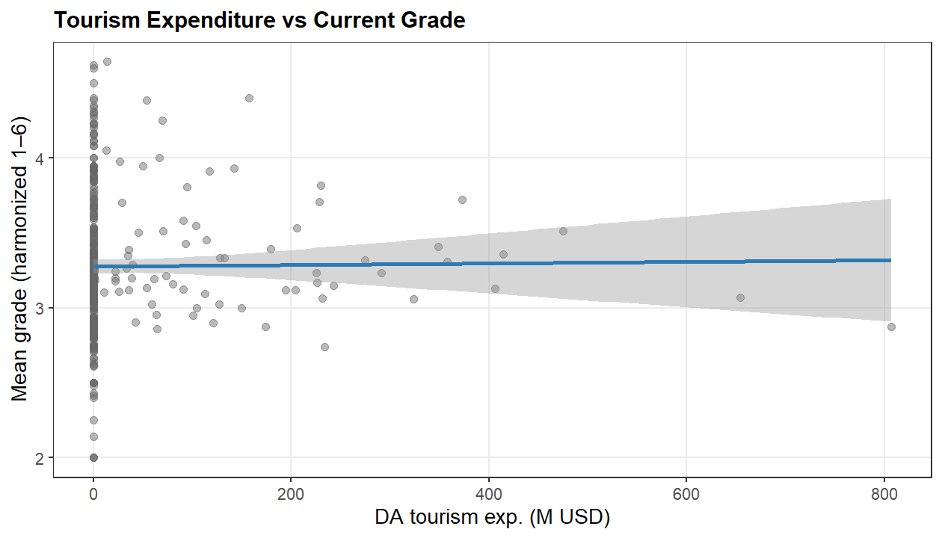

6f. Tourism and School Expenditure
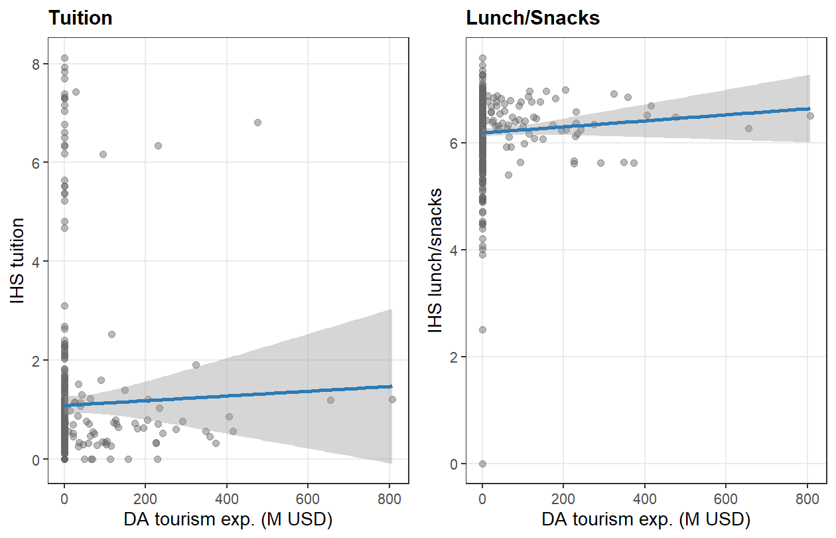

7. Correlation: Bartik IV vs School Outcomes
Same as Section 6 but using the shift-share instrument (offcl_b) on the x-axis. This is the “reduced-form” relationship that drives the IV estimates.
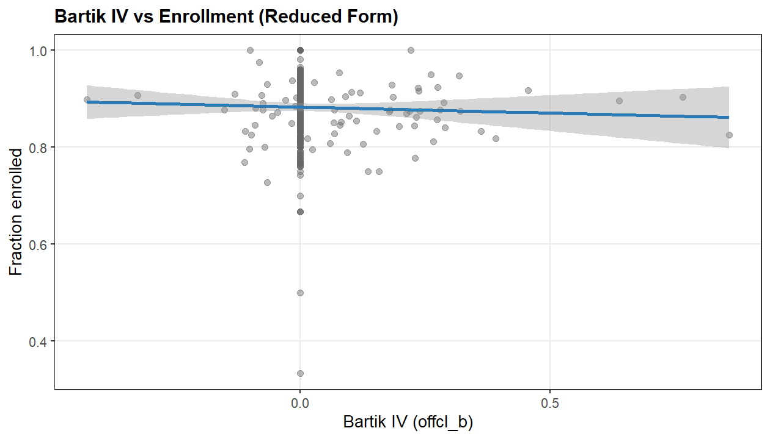
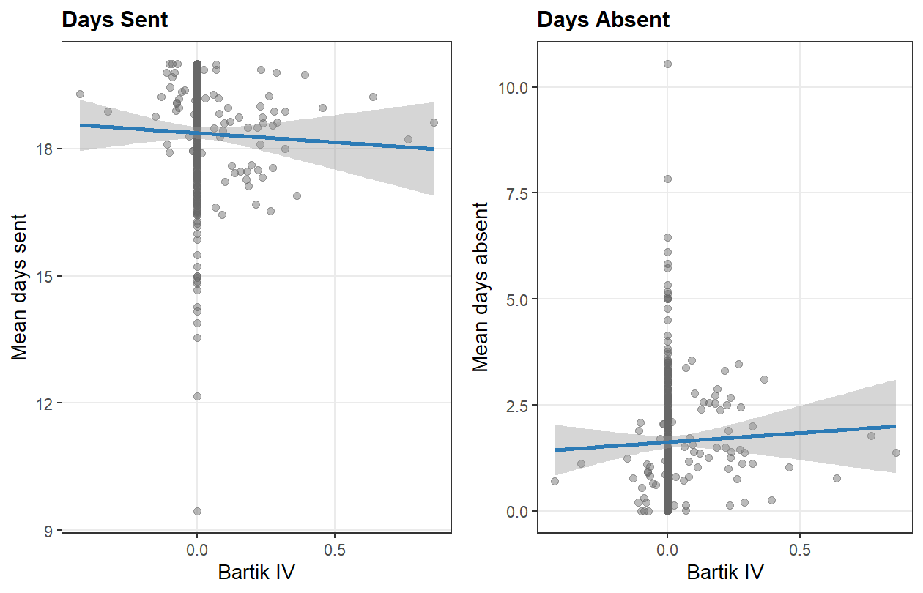
## $`1`
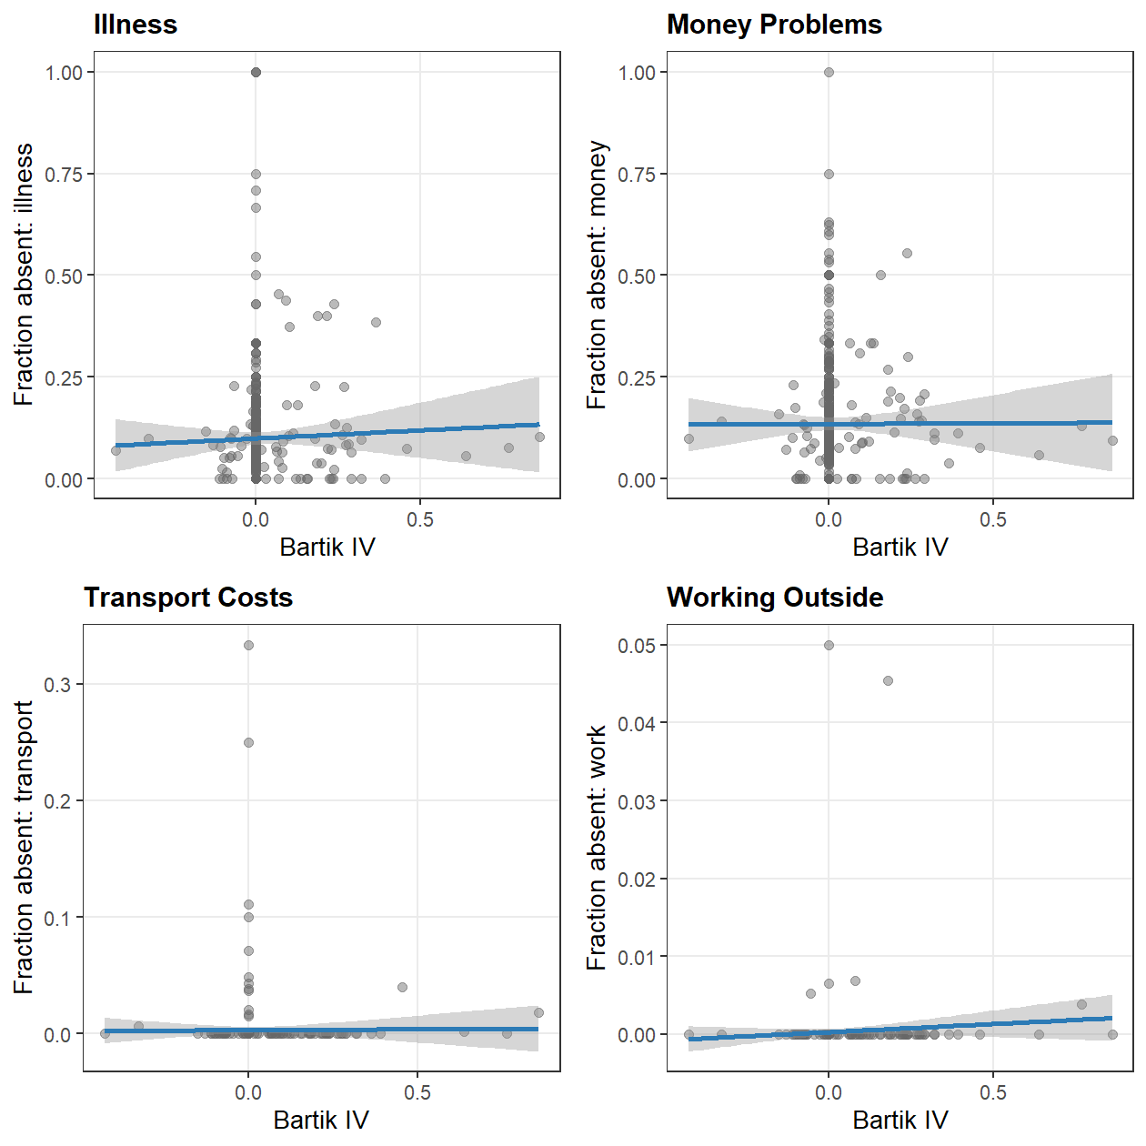
##
## $`2`

##
## attr(,"class")
## [1] "list" "ggarrange"
## $`1`
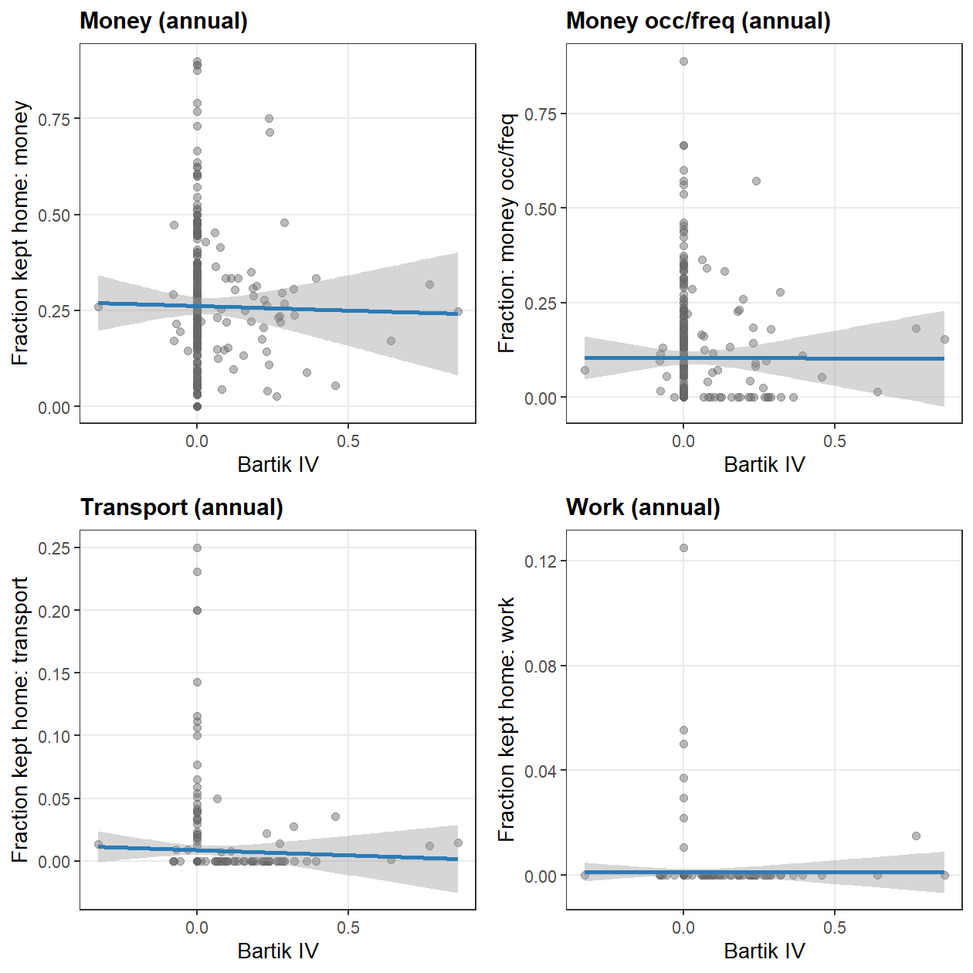
##
## $`2`

##
## attr(,"class")
## [1] "list" "ggarrange"

8. Enrollment by Age and Year
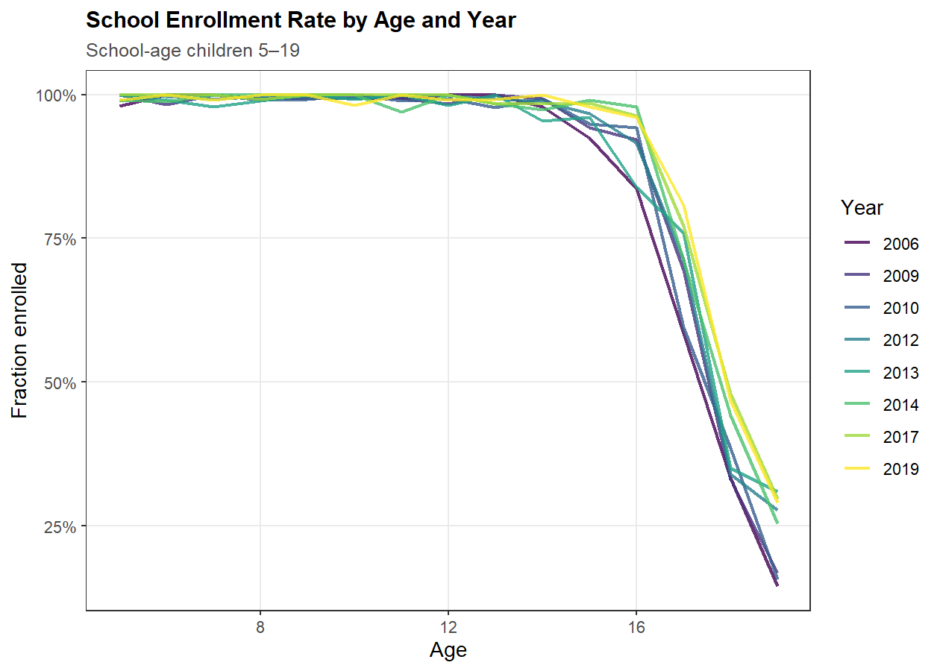

Generated: 2026-04-22 22:46:12.410548

