**1. SVD**

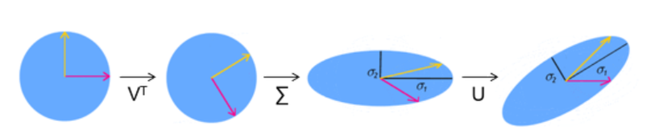

Find independent components was the main purpose of ICA (Independent Component Analysis)

**2. Intro & Ideas**

Well known method takes some time and many operations to calculate U, S, and V

Using two signals, or N signals for N dimension matrices, it is able to reconstruct easily and more statistically, regardless of accuracy!

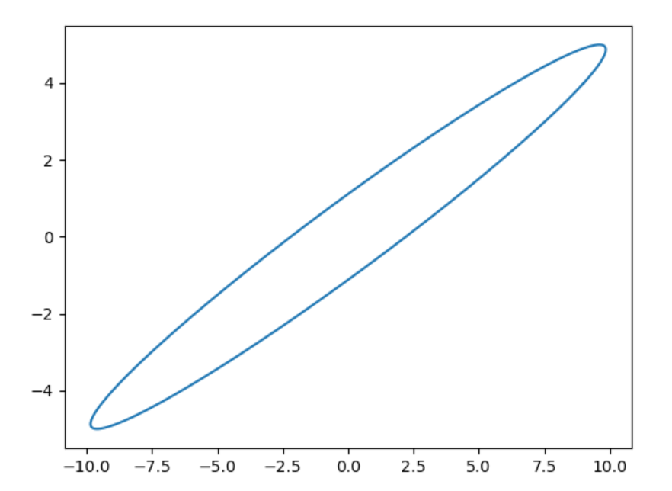

Original Data

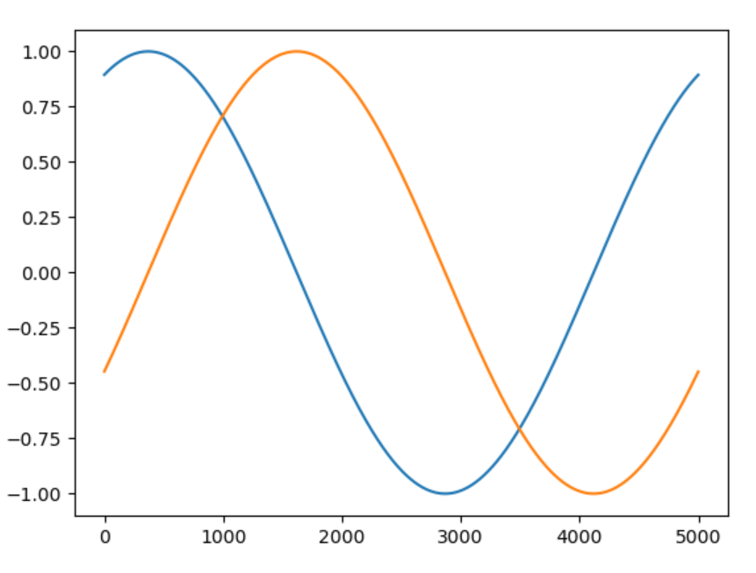

Phase difference: Before calibration

**Further research**

Rotation and stretching sequence don’t matter in 2-dimension matrix problems. However, in 3-dimension problem it matters: Another algorithm needed! ^^

**From**

<https://towardsdatascience.com/independent-component-analysis-ica-in-python-a0ef0db0955e>